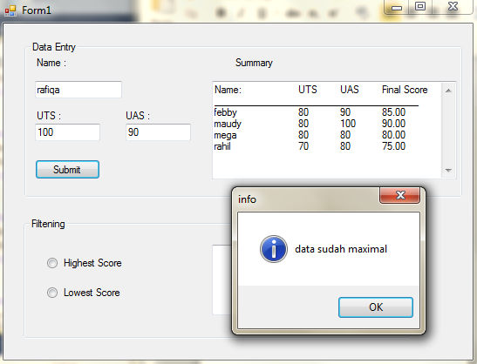

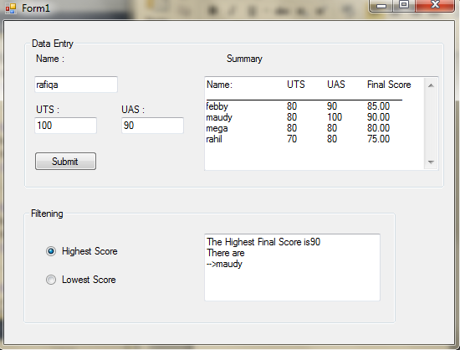

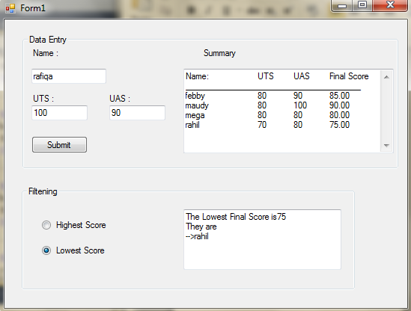

Public Class Form1

Private nama(3) As String

Private nilai(3, 1) As Integer

Private counter As Integer = 0

Private score(3) As Double

Private Sub Form1_Load(ByVal sender As System.Object, ByVal e As System.EventArgs) Handles MyBase.Load

Button1.Enabled = False

TextBox4.AppendText("Name:" & vbTab & vbTab & "UTS" & vbTab & "UAS" & vbTab & "Final Score" & vbCrLf & "_______________________________________" & vbCrLf)

End Sub

Private Sub Button1_Click(ByVal sender As System.Object, ByVal e As System.EventArgs) Handles Button1.Click

If counter > nama.GetUpperBound(0) Then

MsgBox("data sudah maximal", vbInformation, "info")

Else

nama(counter) = TextBox1.Text

nilai(counter, 0) = Val(TextBox2.Text)

nilai(counter, 1) = Val(TextBox3.Text)

score(counter) = (Val(TextBox2.Text) + Val(TextBox3.Text)) / 2

TextBox4.AppendText(TextBox1.Text & vbTab & vbTab & TextBox2.Text & vbTab & TextBox3.Text & vbTab & FormatNumber(score(counter), 2) & vbCrLf)

TextBox1.Clear()

TextBox2.Clear()

TextBox3.Clear()

TextBox1.Focus()

counter += 1

End If

End Sub

Private Sub RadioButton1_CheckedChanged(ByVal sender As System.Object, ByVal e As System.EventArgs) Handles RadioButton1.CheckedChanged

Dim tinggi As Double = 0

For a = 0 To score.GetUpperBound(0)

If score(a) > tinggi Then

tinggi = score(a)

End If

Next

TextBox5.Text = "The Highest Final Score is" & tinggi & vbCrLf & "There are" & vbCrLf

For a = 0 To score.GetUpperBound(0)

If score(a) = tinggi Then

TextBox5.Text &= "-->" & nama(a) & vbCrLf

End If

Next

End Sub

Private Sub TextBox2_TextChanged(ByVal sender As System.Object, ByVal e As System.EventArgs) Handles TextBox2.TextChanged

If TextBox1.Text & TextBox2.Text & TextBox3.Text <> String.Empty Then

Button1.Enabled = True

End If

End Sub

Private Sub TextBox3_TextChanged(ByVal sender As System.Object, ByVal e As System.EventArgs) Handles TextBox3.TextChanged

If TextBox1.Text & TextBox2.Text & TextBox3.Text <> String.Empty Then

Button1.Enabled = True

End If

End Sub

Private Sub TextBox1_TextChanged(ByVal sender As System.Object, ByVal e As System.EventArgs) Handles TextBox1.TextChanged

If TextBox1.Text & TextBox2.Text & TextBox3.Text <> String.Empty Then

Button1.Enabled = True

End If

End Sub

Private Sub RadioButton2_CheckedChanged(ByVal sender As System.Object, ByVal e As System.EventArgs) Handles RadioButton2.CheckedChanged

Dim rendah As Double = 100

For a = 0 To score.GetUpperBound(0)

If score(a) < rendah Then

rendah = score(a)

End If

Next

TextBox5.Text = "The Lowest Final Score is" & rendah & vbCrLf & "They are" & vbCrLf

For a = 0 To score.GetUpperBound(0)

If score(a) = rendah Then

TextBox5.Text &= "-->" & nama(a) & vbCrLf

End If

Next

End Sub

End Class