**Nama : Febby Novanti Azhara**

**NIM : 1182002002**

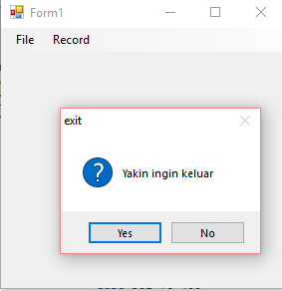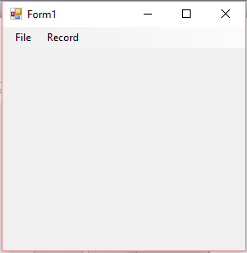**Form 1**

Public Class Form1

Private Sub ExitToolStripMenuItem_Click(ByVal sender As System.Object, ByVal e As System.EventArgs) Handles ExitToolStripMenuItem.Click

If MsgBox("Yakin ingin keluar", vbQuestion + vbYesNo, "exit") = vbYes Then Application.Exit()

End Sub

Private Sub DisplayToolStripMenuItem_Click(ByVal sender As System.Object, ByVal e As System.EventArgs) Handles DisplayToolStripMenuItem.Click

Form3.Show()

End Sub

Private Sub AddToolStripMenuItem_Click(ByVal sender As System.Object, ByVal e As System.EventArgs) Handles AddToolStripMenuItem.Click

Form2.Show()

End Sub

End Class

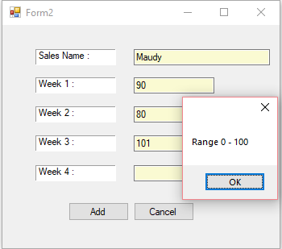**Form 2**

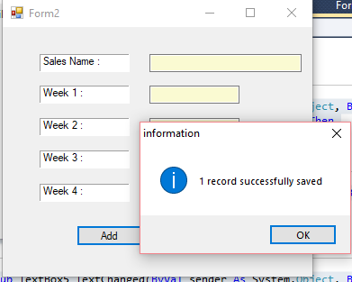

Imports System.IO

Public Class Form2

Private Sub Button1_Click(ByVal sender As System.Object, ByVal e As System.EventArgs) Handles Button1.Click

Dim fw As StreamWriter

fw = New StreamWriter("data1.txt", True)

fw.WriteLine(TextBox1.Text & ";" & TextBox2.Text & ";" & TextBox3.Text & ";" & TextBox4.Text & ";" & TextBox5.Text)

fw.Close()

TextBox1.Clear()

TextBox2.Clear()

TextBox3.Clear()

TextBox4.Clear()

TextBox5.Clear()

MsgBox(" 1 record successfully saved", vbInformation, "information")

End Sub

Private Sub Button2_Click(ByVal sender As System.Object, ByVal e As System.EventArgs) Handles Button2.Click

Me.Close()

Form1.Show()

End Sub

Private Sub TextBox2_TextChanged(ByVal sender As System.Object, ByVal e As System.EventArgs) Handles TextBox2.TextChanged

If Val(TextBox2.Text) > 100 Or Val(TextBox2.Text) < 0 Then

MessageBox.Show("Range 0 - 100")

End If

End Sub

Private Sub TextBox3_TextChanged(ByVal sender As System.Object, ByVal e As System.EventArgs) Handles TextBox3.TextChanged

If Val(TextBox3.Text) > 100 Or Val(TextBox3.Text) < 0 Then

MessageBox.Show("Range 0 - 100")

End If

End Sub

Private Sub TextBox4_TextChanged(ByVal sender As System.Object, ByVal e As System.EventArgs) Handles TextBox4.TextChanged

If Val(TextBox4.Text) > 100 Or Val(TextBox4.Text) < 0 Then

MessageBox.Show("Range 0 - 100")

End If

End Sub

Private Sub TextBox5_TextChanged(ByVal sender As System.Object, ByVal e As System.EventArgs) Handles TextBox5.TextChanged

If Val(TextBox5.Text) > 100 Or Val(TextBox5.Text) < 0 Then

MessageBox.Show("Range 0 - 100")

End If

End Sub

End Class

**Form 3**

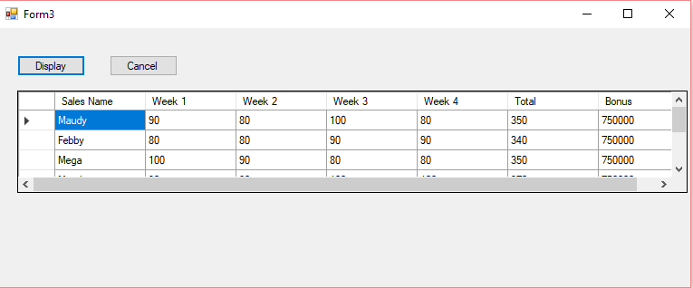

Imports System.IO

Public Class Form3

Private Sub Button2_Click(ByVal sender As System.Object, ByVal e As System.EventArgs) Handles Button2.Click

Me.Hide()

End Sub

Private Sub Button1_Click(ByVal sender As System.Object, ByVal e As System.EventArgs) Handles Button1.Click

Dim fr As StreamReader

fr = New StreamReader("data1.txt")

DataGridView1.Rows.Clear()

DataGridView1.ColumnCount = 7

DataGridView1.Columns(0).Name = "Sales Name"

DataGridView1.Columns(1).Name = "Week 1"

DataGridView1.Columns(2).Name = "Week 2"

DataGridView1.Columns(3).Name = "Week 3"

DataGridView1.Columns(4).Name = "Week 4"

DataGridView1.Columns(5).Name = "Total"

DataGridView1.Columns(6).Name = "Bonus"

Do While Not fr.EndOfStream

Dim rec As String

rec = fr.ReadLine()

Dim f() As String

f = rec.Split(";")

Dim ttl As Integer = Val(f(1)) + Val(f(2)) + Val(f(3)) + Val(f(4))

Dim bonus As Integer

Select Case ttl

Case 200 To 250

bonus = 300000

Case 251 To 300

bonus = 500000

Case 301 To 400

bonus = 750000

Case Is < 200

bonus = 0

End Select

rec &= ";" & ttl & ";" & bonus

f = rec.Split(";")

DataGridView1.Rows.Add(f)

Loop

fr.Close()

End Sub

End Class