**Nama : Febby Novanti Azhara**

**NIM : 1182002002**

1. **Query Array Dengan Primitive Data Type**

Public Class Form1

Dim values() As Integer = {3, 1, 4, 5, 2, 1, 5, 8, 9, 7, 8, 6}

Private Sub Form1_Load(ByVal sender As System.Object, ByVal e As System.EventArgs) Handles MyBase.Load

TextBox1.AppendText("Original Array Element: " & vbCrLf)

For Each v In values

TextBox1.AppendText(" " & v)

Next

TextBox1.AppendText(vbCrLf & vbCrLf)

End Sub

Private Sub Button1_Click(ByVal sender As System.Object, ByVal e As System.EventArgs) Handles btnsort.Click

Dim rec =

From v In values

Where v > 3

Select v

TextBox1.AppendText("Array Values > 3" & vbCrLf)

For Each element In rec

TextBox1.AppendText(" " & element)

Next

TextBox1.AppendText(vbCrLf & vbCrLf)

btn3.enabled = False

End Sub

Private Sub Button2_Click(ByVal sender As System.Object, ByVal e As System.EventArgs) Handles btn3.Click

Dim rec =

From v In values

Order By v

Select v

TextBox1.AppendText("Sorting Array Element: " & vbCrLf)

For Each element In rec

TextBox1.AppendText(" " & element)

Next

TextBox1.AppendText(vbCrLf & vbCrLf)

btnsort.Enabled = False

End Sub

Private Sub Button1_Click_1(ByVal sender As System.Object, ByVal e As System.EventArgs) Handles btnsort.Click

Dim rec =

(From v In values

Order By v

Select v).Distinct

TextBox1.AppendText("Distinc Element: " & vbCrLf)

For Each element In rec

TextBox1.AppendText(" " & element)

Next

TextBox1.AppendText(vbCrLf & vbCrLf)

btndisc.Enabled = False

End Sub

Private Sub Button1_Click_2(ByVal sender As System.Object, ByVal e As System.EventArgs) Handles btnsort.Click

Dim rec =

(From v In values

Select v).Count

TextBox1.AppendText("Total Element: " & vbCrLf)

TextBox1.AppendText(" " & rec)

TextBox1.AppendText(vbCrLf & vbCrLf)

btncount.enabled = False

End Sub

Private Sub Button1_Click_3(ByVal sender As System.Object, ByVal e As System.EventArgs) Handles btnsort.Click

Dim rec =

(From v In values

Select v).Sum

TextBox1.AppendText("Total Value Element: " & vbCrLf)

TextBox1.AppendText(" " & rec)

TextBox1.AppendText(vbCrLf & vbCrLf)

btnsum.enabled = False

End Sub

Private Sub btnmax_Click(ByVal sender As System.Object, ByVal e As System.EventArgs) Handles btnmax.Click

Dim rec =

(From v In values

Select v).Max

TextBox1.AppendText("Max Element: " & vbCrLf)

TextBox1.AppendText(" " & rec)

TextBox1.AppendText(vbCrLf & vbCrLf)

btnmax.Enabled = False

End Sub

Private Sub btnmin_Click(ByVal sender As System.Object, ByVal e As System.EventArgs) Handles btnmin.Click

Dim rec =

(From v In values

Select v).Min

TextBox1.AppendText("Min Element: " & vbCrLf)

TextBox1.AppendText(" " & rec)

TextBox1.AppendText(vbCrLf & vbCrLf)

btnmin.Enabled = False

End Sub

End Class

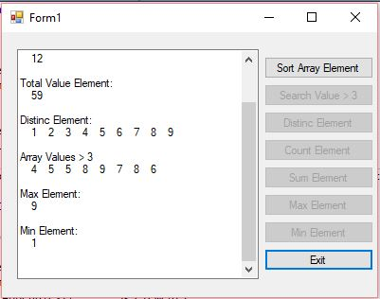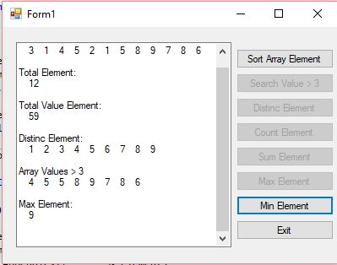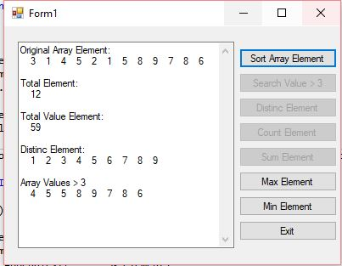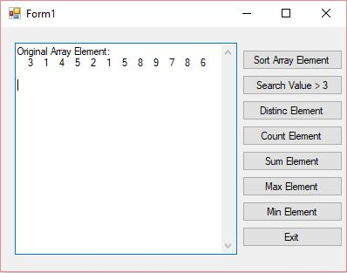

1. **Query Array Dengan Reference Data Type**

Public Class Form2

Private Sub Form2_Load(ByVal sender As System.Object, ByVal e As System.EventArgs) Handles MyBase.Load

Dim reclist = New List(Of Tuple(Of String, String, Double))

reclist.Add(New Tuple(Of String, String, Double)("Igun", "Depok", 5000))

reclist.Add(New Tuple(Of String, String, Double)("Dewi", "Maharaja", 3500))

reclist.Add(New Tuple(Of String, String, Double)("Gintan", "Maharaja", 4000))

reclist.Add(New Tuple(Of String, String, Double)("Gilang", "Jakarta", 4250))

reclist.Add(New Tuple(Of String, String, Double)("Ghaisani", "Depok", 5100))

Dim rs1 =

From element In reclist

Where element.Item2 = "Maharaja"

Select element

TextBox1.AppendText("Record Dengan Kota Maharaja: " & vbCrLf)

For Each v In rs1

TextBox1.AppendText(" " & v.Item1 & ", " & v.Item2 & ", " & "$" & v.Item3 & vbCrLf)

Next

Dim rs2 =

From element In reclist

Where element.Item3 >= 4000

Select element

TextBox1.AppendText(vbCrLf & "Record Dengan Gaji >= 4000: " & vbCrLf)

For Each v In rs2

TextBox1.AppendText(" " & v.Item1 & ", " & v.Item2 & ", " & "$" & v.Item3 & vbCrLf)

Next

Dim rs3 =

From element In reclist

Where element.Item3 > 3000 AndAlso element.Item3 < 4000

Select element

TextBox1.AppendText(vbCrLf & "Record Dengan Gaji >= 4000: " & vbCrLf)

For Each v In rs3

TextBox1.AppendText(" " & v.Item1 & ", " & v.Item2 & ", " & "$" & v.Item3 & vbCrLf)

Next

End Sub

End Class

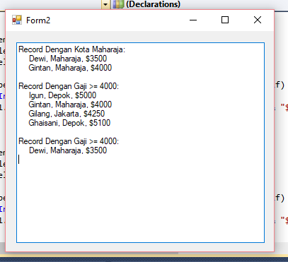

**Kesimpulan :**

Pada Query Array Dengan Primitive Data Type jika kita mengklik “sort array element” button “search value >3”, button “distinct element”, button “count element”, dan button “sum element” tidak akan bisa diklik karena button “sort array element” sudah mencakup dari ke-4 button tersebut dan tampilan saat menklik “sort array element” akan mengeluarkan hasil dari ke-4 button tersebut. Tetapi untuk button “Min Element” dan “Max Element” mesti kita klik satu persatu. Saat kita menklik “Min Element” akan muncul data dari yang terkecil sebaliknya jika menklik “Max Element” akan muncul data dari yang terbesar.

Pada Query Array Dengan Reference Data Type, tampilan data lebih sederhana karena kita hanya memasukan data melalui source kode. Dan tidak perlu untuk menklik button seperti Query Array Dengan Primitive Data Type.