MSC 16/17 - Android App
“Location and Language Aware Messaging App – LLAMA”



Client: https://github.com/feberhard/LLAMA v. 1.0
Server: https://github.com/woernsn/LLAMAServer

Application description and targeted audience
LLAMA helps to communicate with persons in different languages in different locations.
It is a multi-feature messenger app that allows to chat with friends in their native language, even if you don’t speak it yourself. It also contains a map, where you see other LLAMA users nearby and can start a conversation easily. Besides that, you can display a lot of information about your chat partner’s location.
Additionally, you can learn your conversational partners’ languages while chatting with them.
The targeted audience for LLAMA are students abroad, tourists who want to make friends with locals, festival visitors, etc.

Contexts
- Language
Messages are translated automatically to the target users’ languages. When you receive a new message, you can display it in it’s original language to gain a learn effect.
- Location
Determine the users’ locations to get information about the local time, weather and show their position in a map. (see “People nearby”)
- Date/Time
To get the local time of your chat partners.
- Weather
To get the local weather information of your chat partners.
- People nearby
If other users of our application are nearby, they get visible in a map with informations about their default language, username and mood. From there, a new chat can be created.
- Activity (= “Mood”)
To see other users’ current interests (want to party, to study, to do sport, etc.)

Features
- Chat with each other in different languages
- Learn new languages
- Get in touch with people nearby
- Possibility to set privacy level
- Get information about your chat partners
  - Local date/time
  - Local weather
  - Current mood
  - Current location
  - Nationality
  - Known languages
  - Picture
- Group chats
- Multimedia content sharing
- Find groups by common interests, languages, locations, etc.
- Ability to invite friends from social networks
- Login via OAuth2.0, so you don’t have to create another account

Implementation
Google Log-In
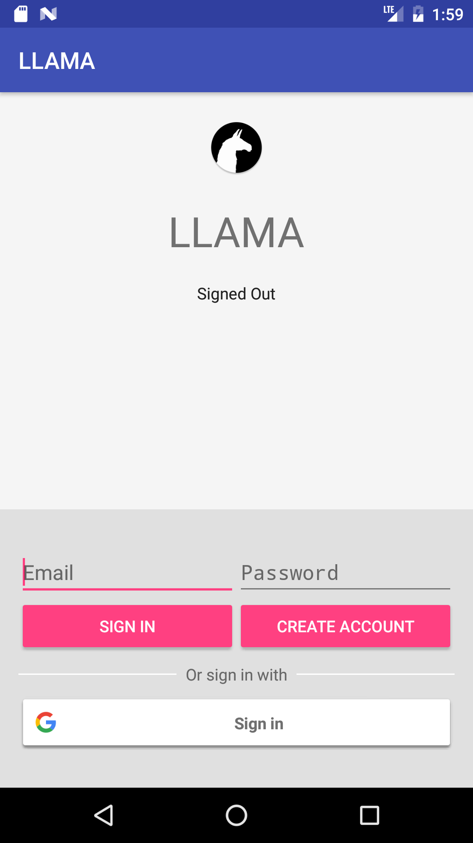 | Felix
Settings
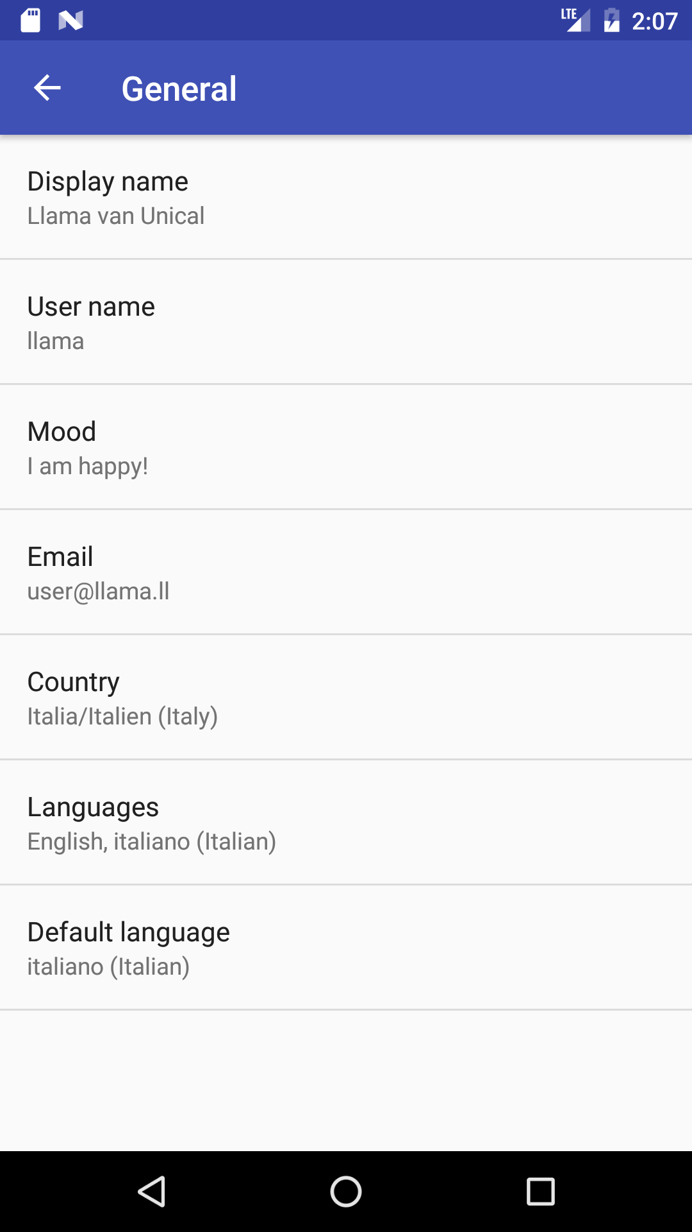 | Dd
Dialog and Group chats
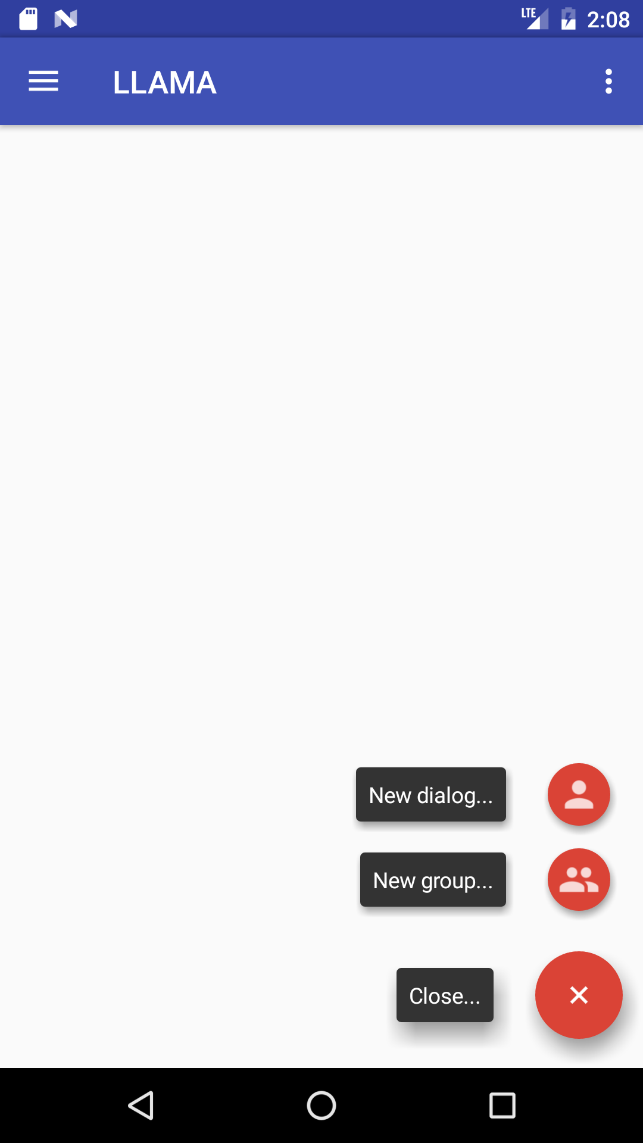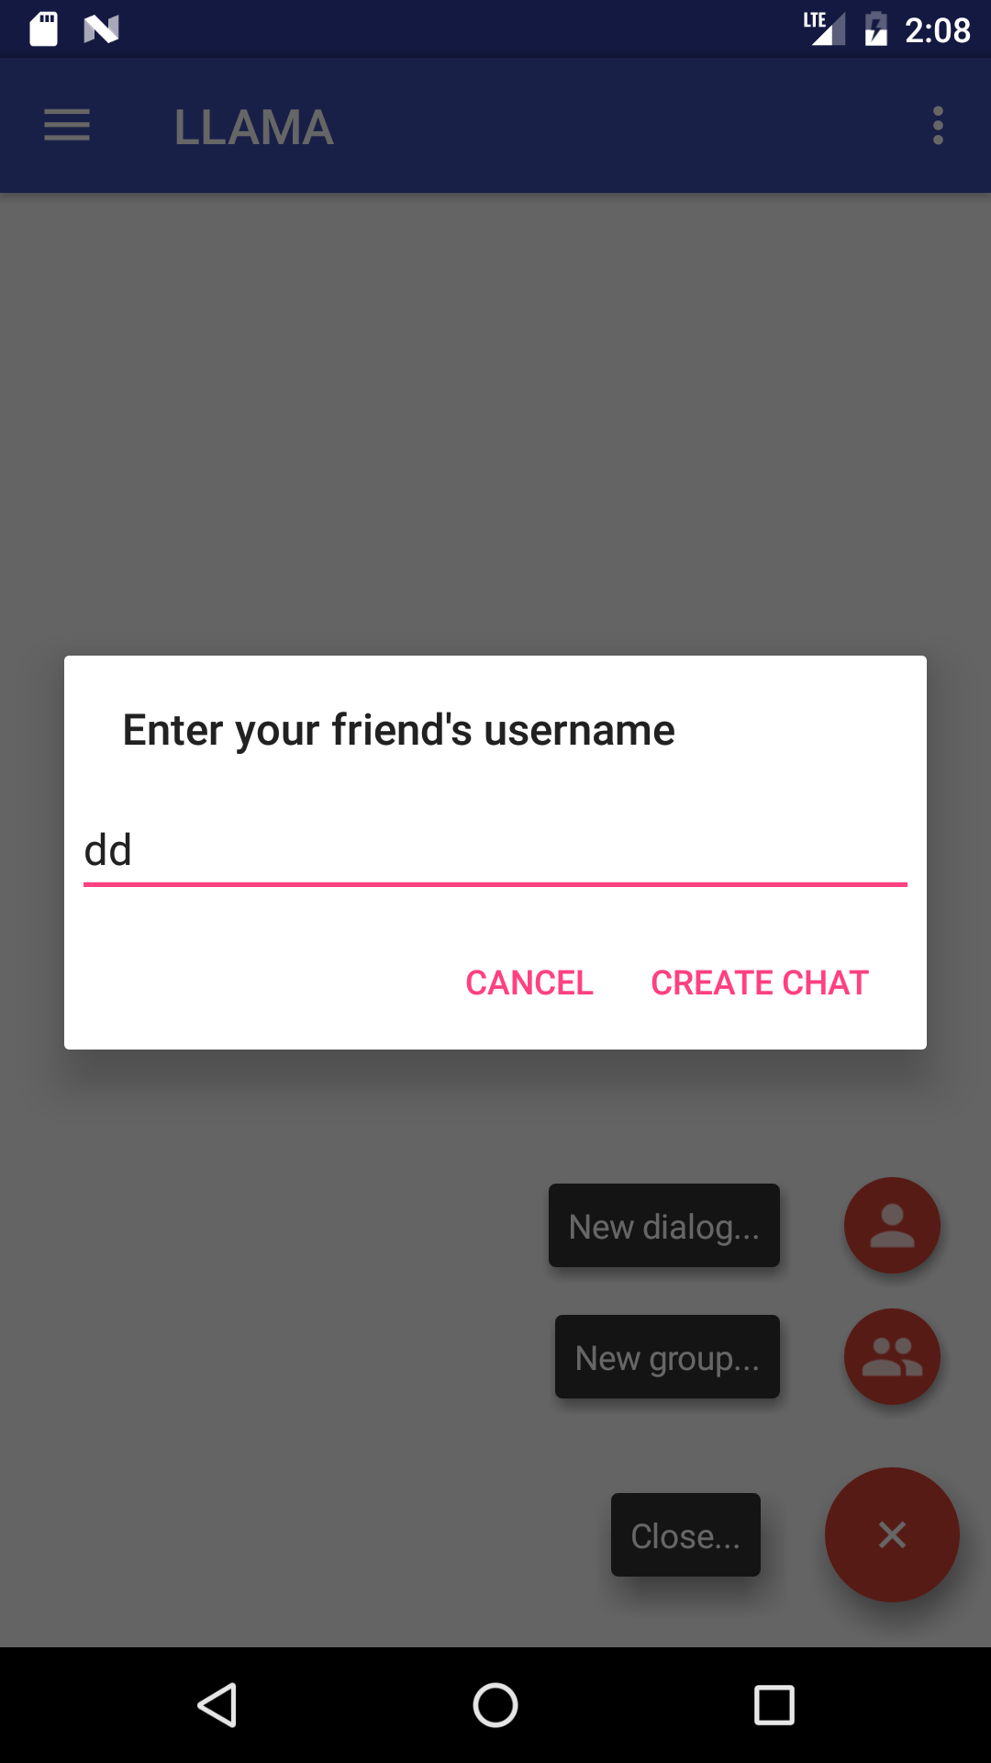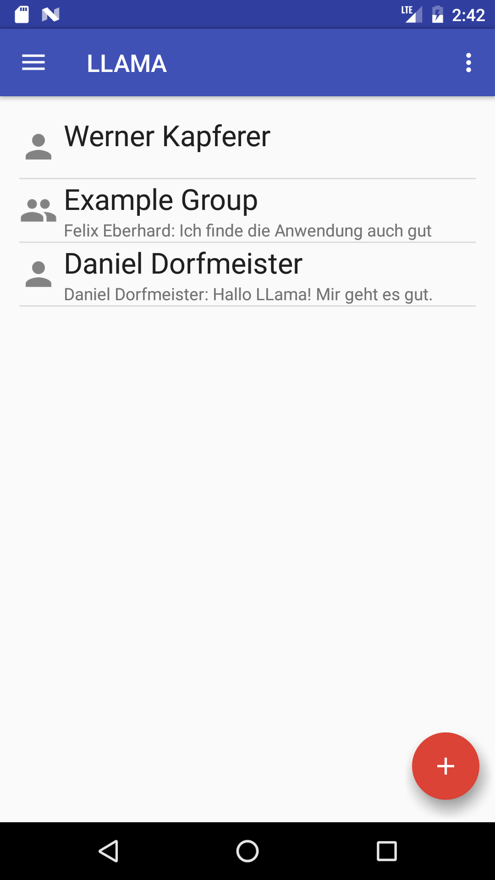 | Werner
Automatic translation in your language
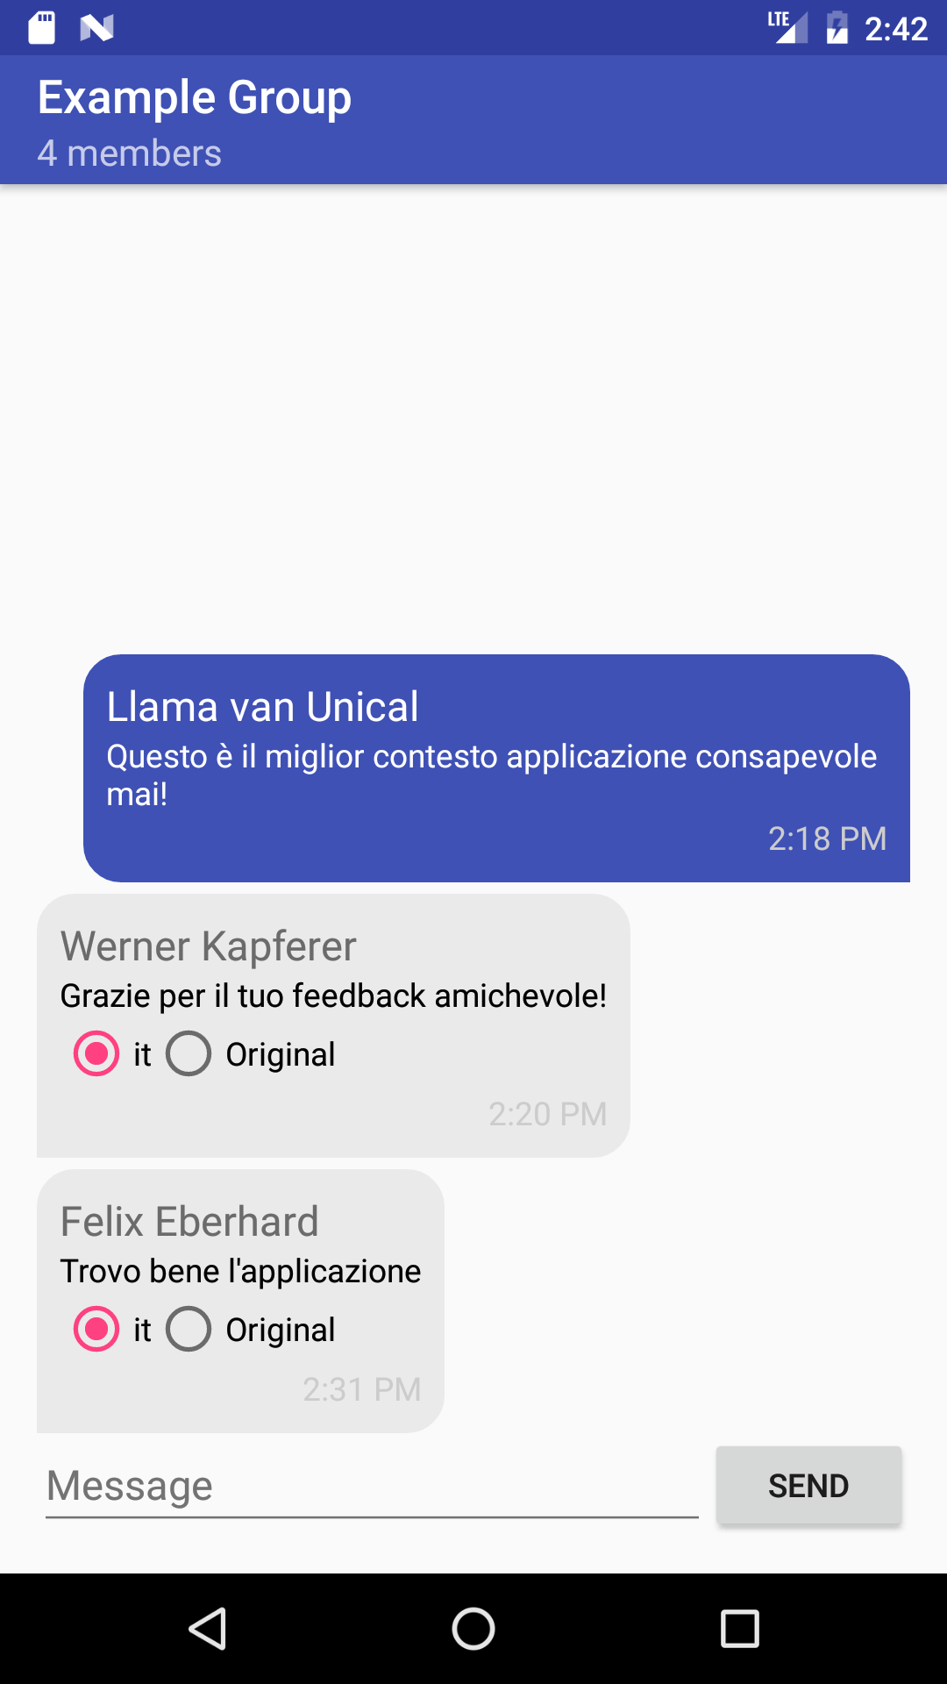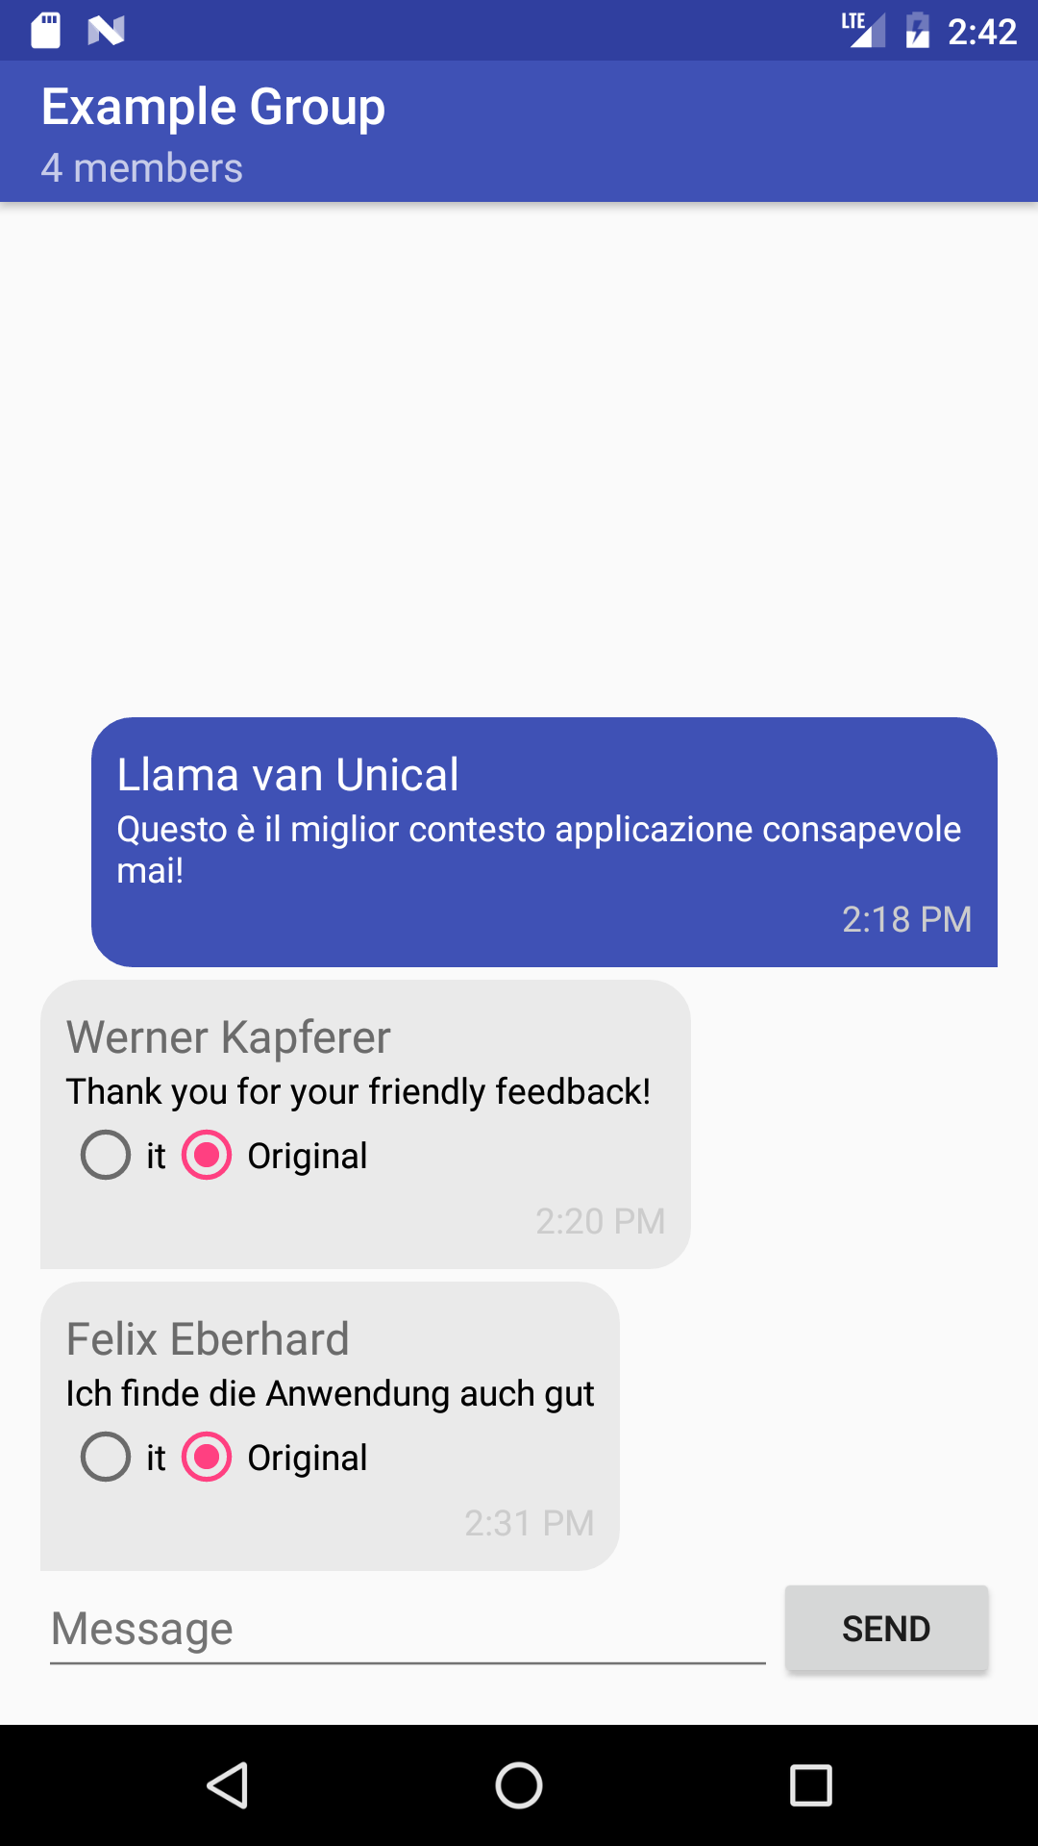 | Felix
Group details
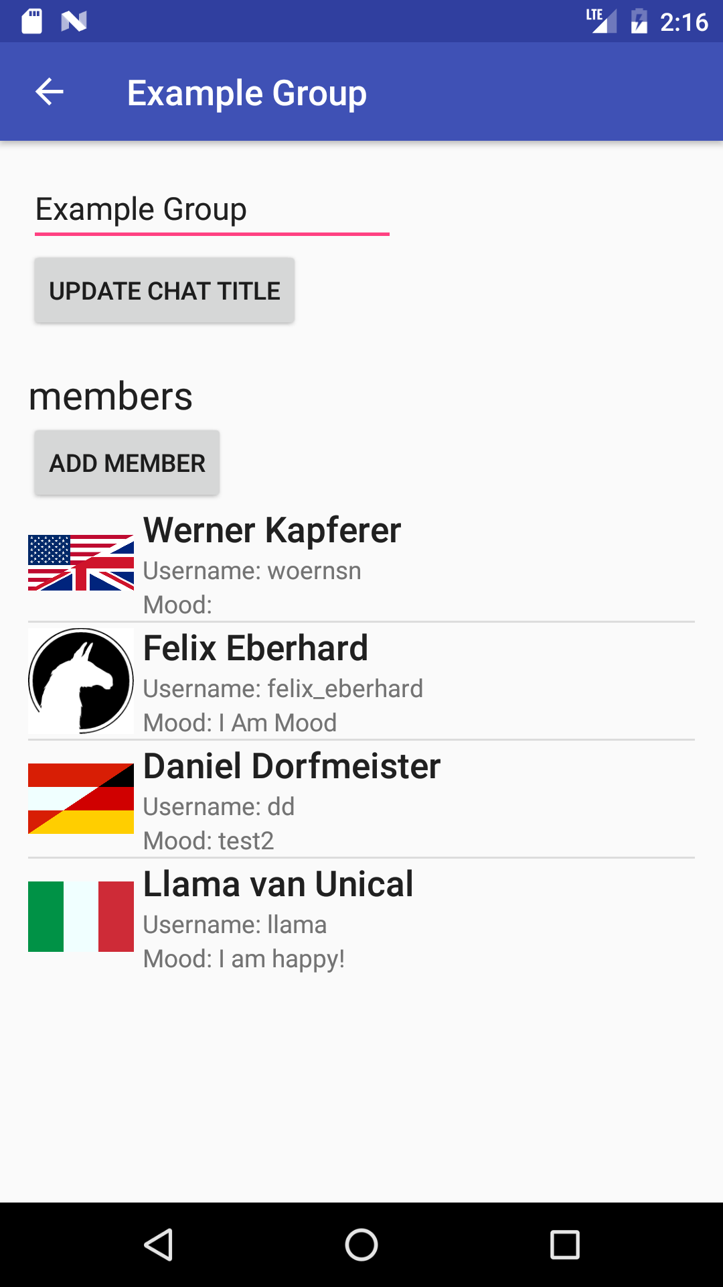 | Felix
Showing users and their username, country and mood in a map
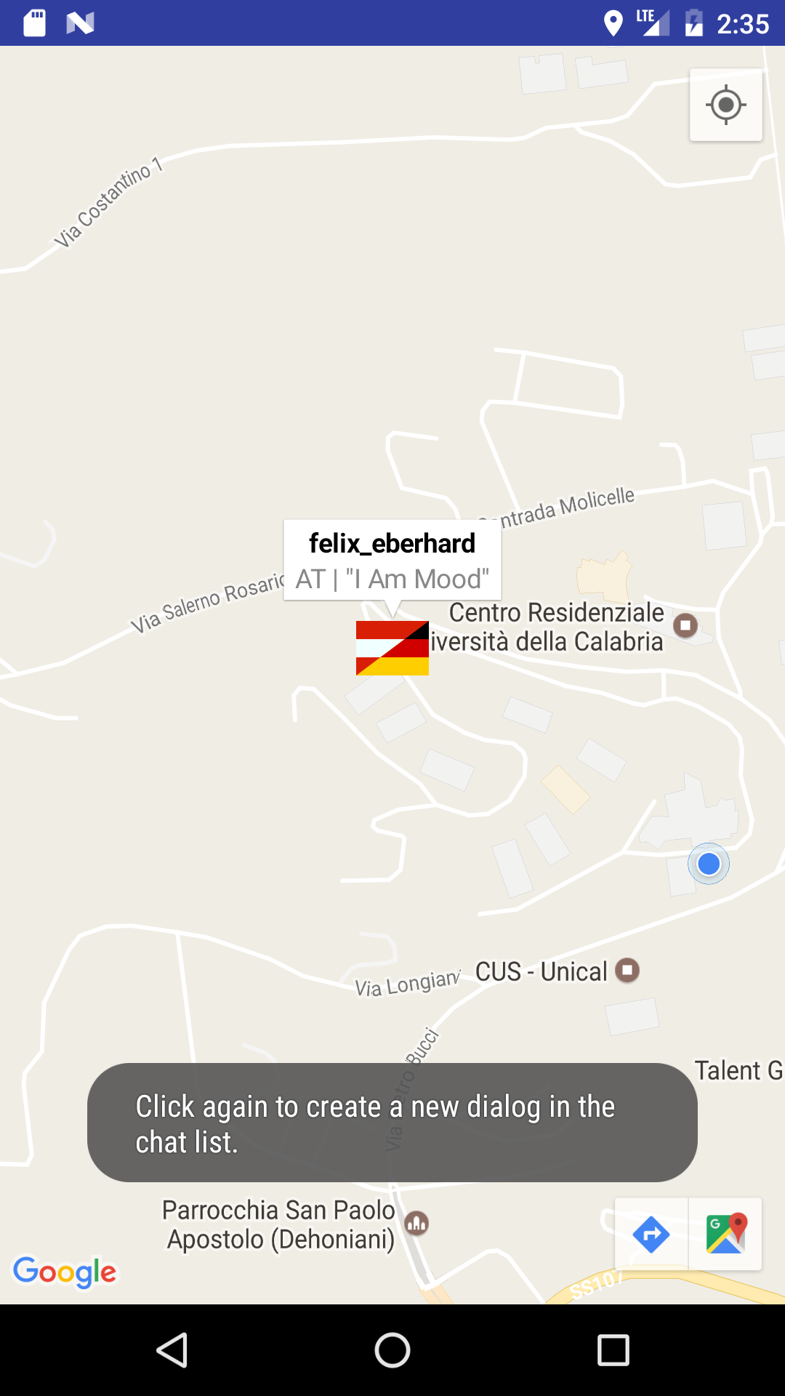 | Werner
Create new chat from the map
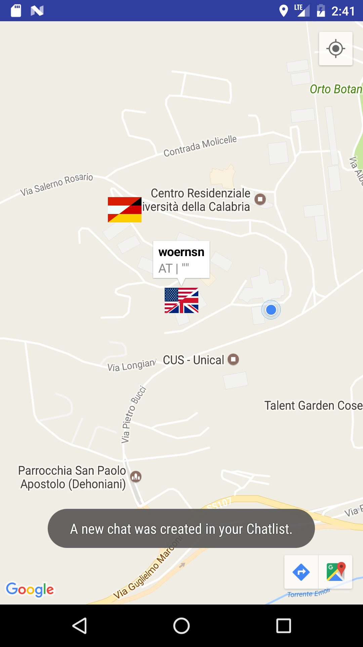 | Werner
Easter egg (Llama as Language)
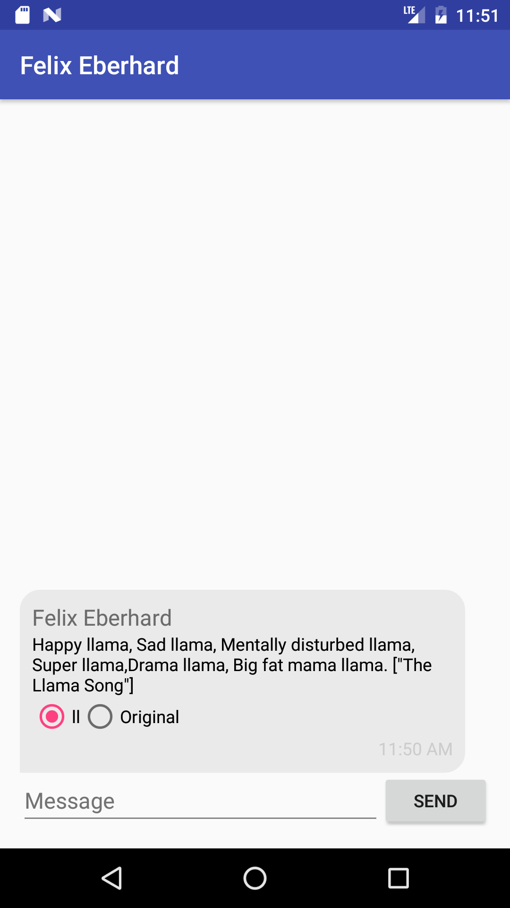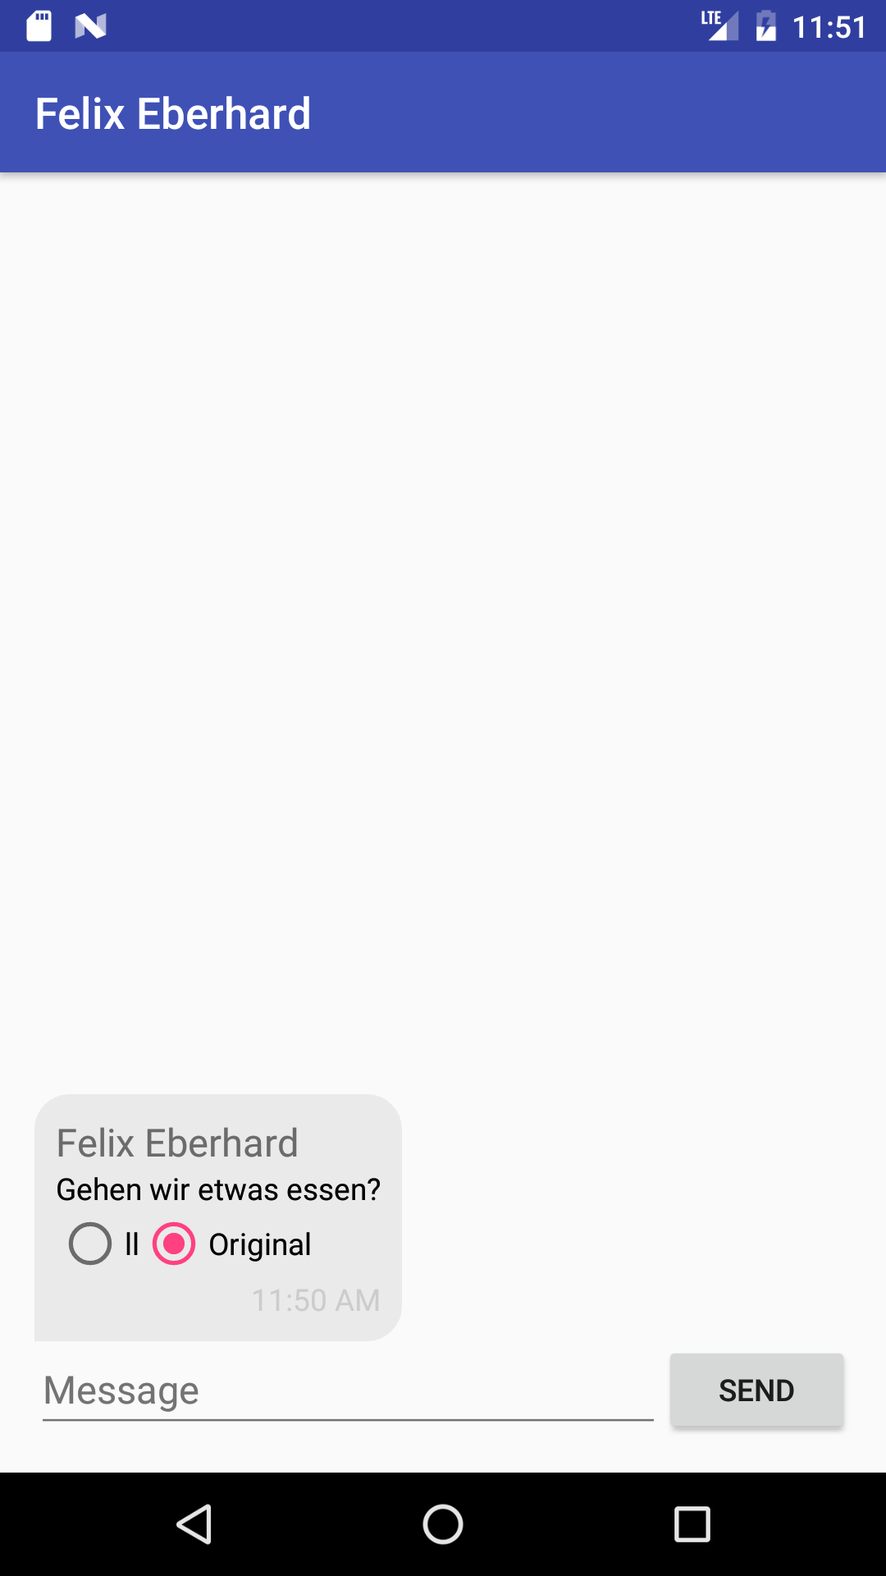

Related Work
- ChatLah
https://play.google.com/store/apps/details?id=com.chatlah
- Skype (Translator)
(Web and desktop version)
- Duolingo
https://play.google.com/store/apps/details?id=com.duolingo

Future Work
The ability to see your chat partner’s details like local date/time or weather at his location. He could also set his own profile picture (like other messenger apps) or set an image for groups.
The mood could be translated to the other users’ languages.
In future you can also make multi-language calls and images with texts in it will be translated automatically.
To get your best friends to this amazing app, you can invite them via Facebook and G+. If you want to make new friends, you can filter the map for common interests, languages or hobbies.

Members
- Dorfmeister Daniel
daniel.dorfmeister@students.fh-hagenberg.at
- Eberhard Felix
felix.eberhard@students.fh-hagenberg.at
- Kapferer Werner
werner.kapferer@students.fh-hagenberg.at

