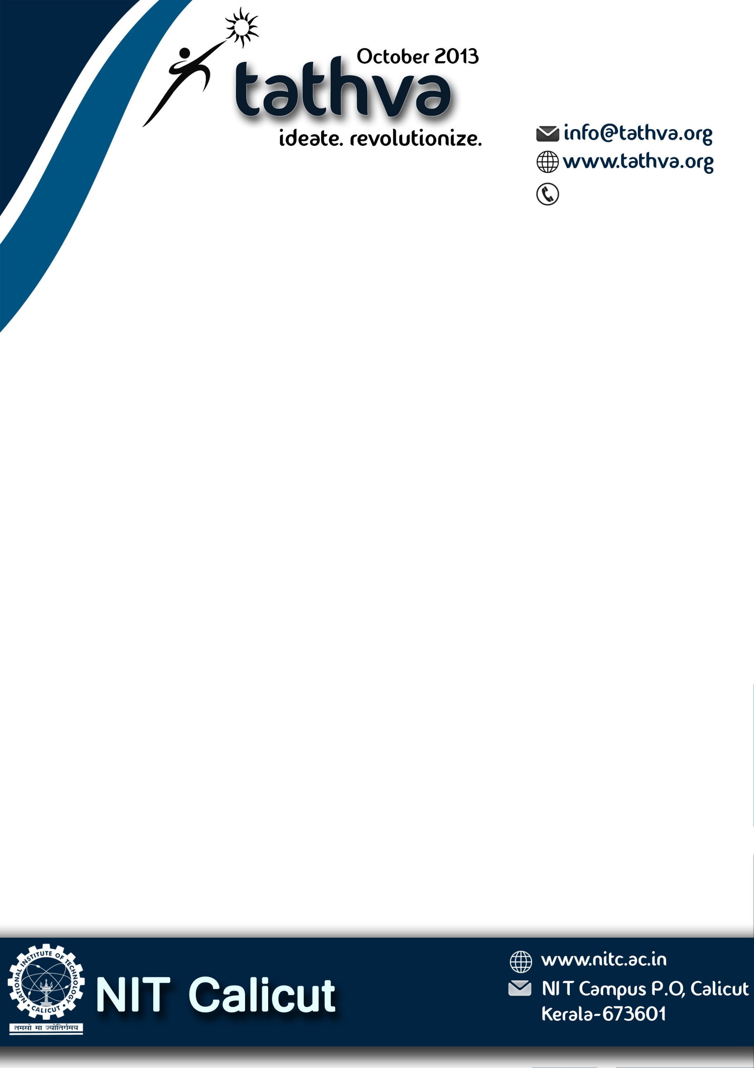

+91 9961 666 458

Respected Sir/Madam,

The National Institute of Technology, Calicut is all set to host its annual techno-management fest Tathva from 17-21st of October. Tathva attracts not just students from reputed engineering colleges and technical institutes across India, but also visiting professors, industry experts, delegations from peer educational institutions, and general public. Our fest presents an excellent opportunity for students to interact with peers and also take part in a variety of challenging competitions and enriching events.

As part of our pre-publicity programmes in order to reach out to fellow students in colleges around us, we distribute pre-posters publicizing our fest. Kindly permit us to display the same in your college notice board and also consider this as an official invitation to be part of our prestigious fest.

For our humble endeavors to be successful, we need whole-hearted support and participation from institutions like yours. We hope that you will respond to this invitation by sending representatives to participate in Tathva 13.

Thanking you

Yours sincerely

Convener

Tathva 13