Design Patterns - Strategy Pattern

In Strategy pattern, a class behavior or its algorithm can be changed at run time. This type of design pattern comes under behavior pattern.

In Strategy pattern, we create objects which represent various strategies and a context object whose behavior varies as per its strategy object. The strategy object changes the executing algorithm of the context object.

Implementation

We are going to create a Strategy interface defining an action and concrete strategy classes implementing the Strategy interface. Context is a class which uses a Strategy.

StrategyPatternDemo, our demo class, will use Context and strategy objects to demonstrate change in Context behaviour based on strategy it deploys or uses.

Strategy Pattern UML Diagram

Step 1

Create an interface.

Strategy.java

public interface Strategy {

public int doOperation(int num1, int num2);

}

Step 2

Create concrete classes implementing the same interface.

OperationAdd.java

public class OperationAdd implements Strategy{

@Override

public int doOperation(int num1, int num2) {

return num1 + num2;

}

}

OperationSubstract.java

public class OperationSubstract implements Strategy{

@Override

public int doOperation(int num1, int num2) {

return num1 - num2;

}

}

OperationMultiply.java

public class OperationMultiply implements Strategy{

@Override

public int doOperation(int num1, int num2) {

return num1 \* num2;

}

}

Step 3

Create Context Class.

Context.java

public class Context {

private Strategy strategy;

public Context(Strategy strategy){

this.strategy = strategy;

}

public int executeStrategy(int num1, int num2){

return strategy.doOperation(num1, num2);

}

}

Step 4

Use the Context to see change in behaviour when it changes its Strategy.

StrategyPatternDemo.java

public class StrategyPatternDemo {

public static void main(String[] args) {

Context context = new Context(new OperationAdd());

System.out.println("10 + 5 = " + context.executeStrategy(10, 5));

context = new Context(new OperationSubstract());

System.out.println("10 - 5 = " + context.executeStrategy(10, 5));

context = new Context(new OperationMultiply());

System.out.println("10 \* 5 = " + context.executeStrategy(10, 5));

}

}

Step 5

Verify the output.

10 + 5 = 15

10 - 5 = 5

10 \* 5 = 50

Design Patterns - Decorator Pattern

Decorator pattern allows a user to add new functionality to an existing object without altering its structure. This type of design pattern comes under structural pattern as this pattern acts as a wrapper to existing class.

This pattern creates a decorator class which wraps the original class and provides additional functionality keeping class methods signature intact.

We are demonstrating the use of decorator pattern via following example in which we will decorate a shape with some color without alter shape class.

Implementation

We're going to create a *Shape* interface and concrete classes implementing the *Shape* interface. We will then create an abstract decorator class *ShapeDecorator* implementing the *Shape* interface and having *Shape* object as its instance variable.

*RedShapeDecorator* is concrete class implementing *ShapeDecorator*.

*DecoratorPatternDemo*, our demo class will use *RedShapeDecorator* to decorate *Shape* objects.

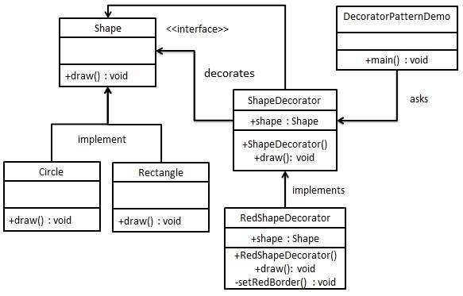

Step 1

Create an interface.

*Shape.java*

public interface Shape {

void draw();

}

Step 2

Create concrete classes implementing the same interface.

*Rectangle.java*

public class Rectangle implements Shape {

@Override

public void draw() {

System.out.println("Shape: Rectangle");

}

}

*Circle.java*

public class Circle implements Shape {

@Override

public void draw() {

System.out.println("Shape: Circle");

}

}

Step 3

Create abstract decorator class implementing the *Shape* interface.

*ShapeDecorator.java*

public abstract class ShapeDecorator implements Shape {

protected Shape decoratedShape;

public ShapeDecorator(Shape decoratedShape){

this.decoratedShape = decoratedShape;

}

public void draw(){

decoratedShape.draw();

}

}

Step 4

Create concrete decorator class extending the *ShapeDecorator* class.

*RedShapeDecorator.java*

public class RedShapeDecorator extends ShapeDecorator {

public RedShapeDecorator(Shape decoratedShape) {

super(decoratedShape);

}

@Override

public void draw() {

decoratedShape.draw();

setRedBorder(decoratedShape);

}

private void setRedBorder(Shape decoratedShape){

System.out.println("Border Color: Red");

}

}

Step 5

Use the *RedShapeDecorator* to decorate *Shape* objects.

*DecoratorPatternDemo.java*

public class DecoratorPatternDemo {

public static void main(String[] args) {

Shape circle = new Circle();

Shape redCircle = new RedShapeDecorator(new Circle());

Shape redRectangle = new RedShapeDecorator(new Rectangle());

System.out.println("Circle with normal border");

circle.draw();

System.out.println("\nCircle of red border");

redCircle.draw();

System.out.println("\nRectangle of red border");

redRectangle.draw();

}

}

Step 6

Verify the output.

Circle with normal border

Shape: Circle

Circle of red border

Shape: Circle

Border Color: Red

Rectangle of red border

Shape: Rectangle

Border Color: Red