**PostView**

V E R S I O N 2.0

**USER’S MANUAL**

*Last updated: May 17, 2017*

# TABLE OF CONTENTS

TABLE OF CONTENTS 2

Chapter 1- Getting Started 3

1.1 Overview of PostView 3

1.2 Running PostView 3

Chapter 2- A Quick Tour 4

2.1 Starting PostView 4

2.2 Opening a File 4

2.3 Navigating the Model Viewer 5

2.4 The Graphics View 6

2.5 Animating the Model 6

2.6 Saving a Screenshot 7

Chapter 3- The PostView Environment 8

3.1 An Overview of the PostView GUI 8

3.2 The Menu 9

3.3 The Main Toolbar 11

3.4 The Post Toolbar 12

3.5 The Font Toolbar 12

3.6 The Animation Toolbar 12

Chapter 4- The Graphics View 14

4.1 Elements of the GV 14

4.2 Customizing the GV 14

4.3 Saving Graphics 16

4.4 The View Settings 17

4.5 Camera Control 18

Chapter 5- The Tab Window 20

5.1 The File Viewer 20

5.2 The Model Viewer 21

5.3 The Material Viewer 21

5.4 The Data Manager 22

5.5 The State Manager 23

5.6 The Tools panel 24

Chapter 6- Post Processing 25

6.1 Properties of the Model 25

6.2 Displacement Map 25

6.3 Color Map 26

6.4 Plane Cuts 27

6.5 Vector Plot 28

6.6 Isosurface plot 28

6.7 Slice plot 29

Chapter 7- Additional Tools 30

7.1 Summary Window 30

7.2 Graph Window 31

7.3 Integration Tool 32

# Getting Started

## Overview of PostView

PostView is a finite element (FE) post-processing application that is designed to view *FEBio* output files. It offers many post-processing capabilities, such as generation of surface plots, isosurface plots, plane cuts, and many more. Further, it offers a user-friendly graphical interface that shows 3D visualization and animation of finite element models. It has a customizable Graphics View and users can take snapshots and make recordings. In addition to reading FEBio output files, PostView can read several other file formats, including LSDYNA keyword and database files, NIKE3D input and output files, FEBio input files, VTK files and several other formats. It also allows the user to import user defined data, offering a flexible tool to accommodate the analysis of results from other FE software programs in PostView. Other file formats are often added based on the needs of our user community, so if a format that you need is not yet supported, please contact us through the PostView forums to log a feature request (http://mrl.sci.utah.edu/forums/).

## Running PostView

### System Recommendations

PostView runs on most Windows platforms, MAC OSX and Linux. In order to run PostView, a memory size of at least 512 Mb is recommended. Larger models may require more memory. A processor speed of at least 1 GHz is also recommended. The computer’s graphics card must support the OpenGL library, since the application makes extensive use of it.

### Command Line Options

When starting PostView from the command line, the full syntax for the command is:

>postview [*filename*]

Here, *filename* is the optional name of a FEBio plot file. If a filename is specified, the file will be loaded into the PostView environment when PostView starts.

# A Quick Tour

This chapter introduces the reader to the PostView user interface by using a sample FEBio output file that comes with the PostView distribution. The sample is called “*sample.xplt*” and shows a cylinder contacting a deformable box.

## Starting PostView

When PostView starts, the GUI will look something like Figure 1. At the top of the screen you’ll find the menu and toolbars. On the left side you’ll see different panels that can be used to do various things such as opening files, add various plots to the model, filter data, and more. The big area in the center is called the *Graphics View* and will show a rendering of the model after a file is loaded. See Chapter 3 for a detailed overview of the GUI components of PostView.

## Opening a File

After you start PostView, you should see something like the screen below. On the left side of the screen the *File Viewer* is displayed. The *File Viewer* can be used to navigate through your folder structure. To open a file, simply locate the file in the *File Viewer* and double click on it. Alternatively, if you prefer to use the more familiar File Open dialog, you can do so by selecting the *File\Open* menu or by clicking the corresponding button on the toolbar.

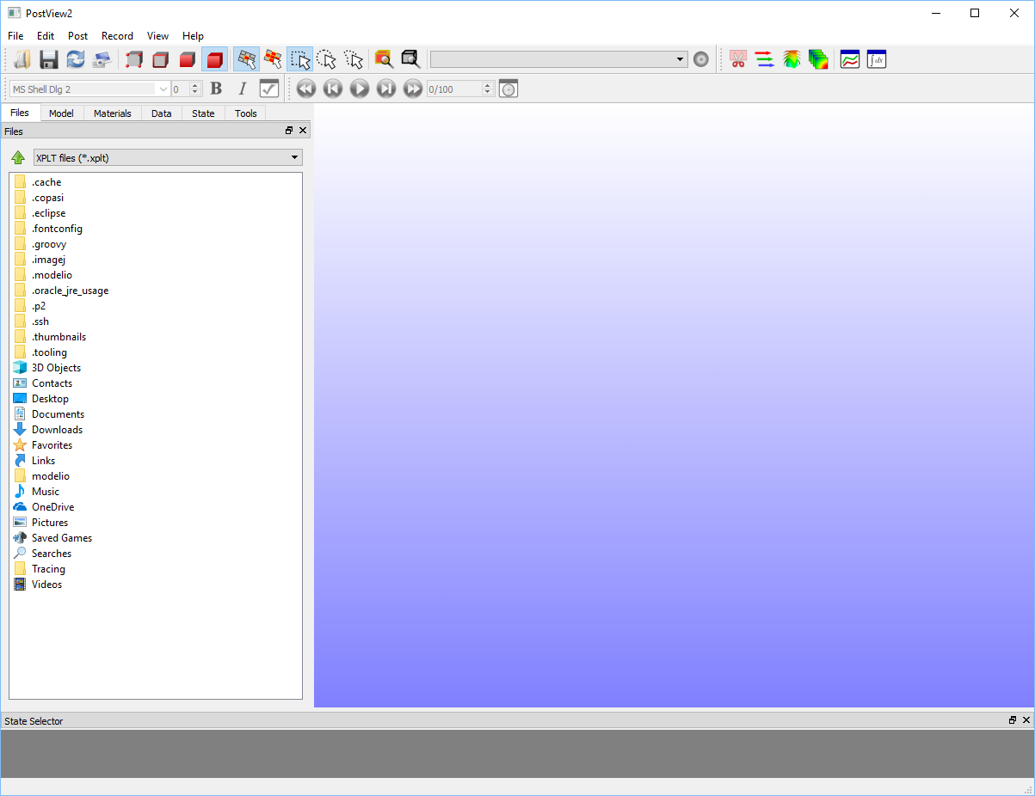

Figure 1. The PostView window after the program has started.

## Navigating the Model Viewer

Open the sample file *sample.xplt* that is located in the Examples folder of your PostView installation folder. After the file is loaded, the screen should look something like figure 2. You’ll notice that the left side now shows the *Model Viewer*. If it is not showing you can activate this window by clicking on the second tab from the left in the upper left corner of the tab window (below the toolbar).

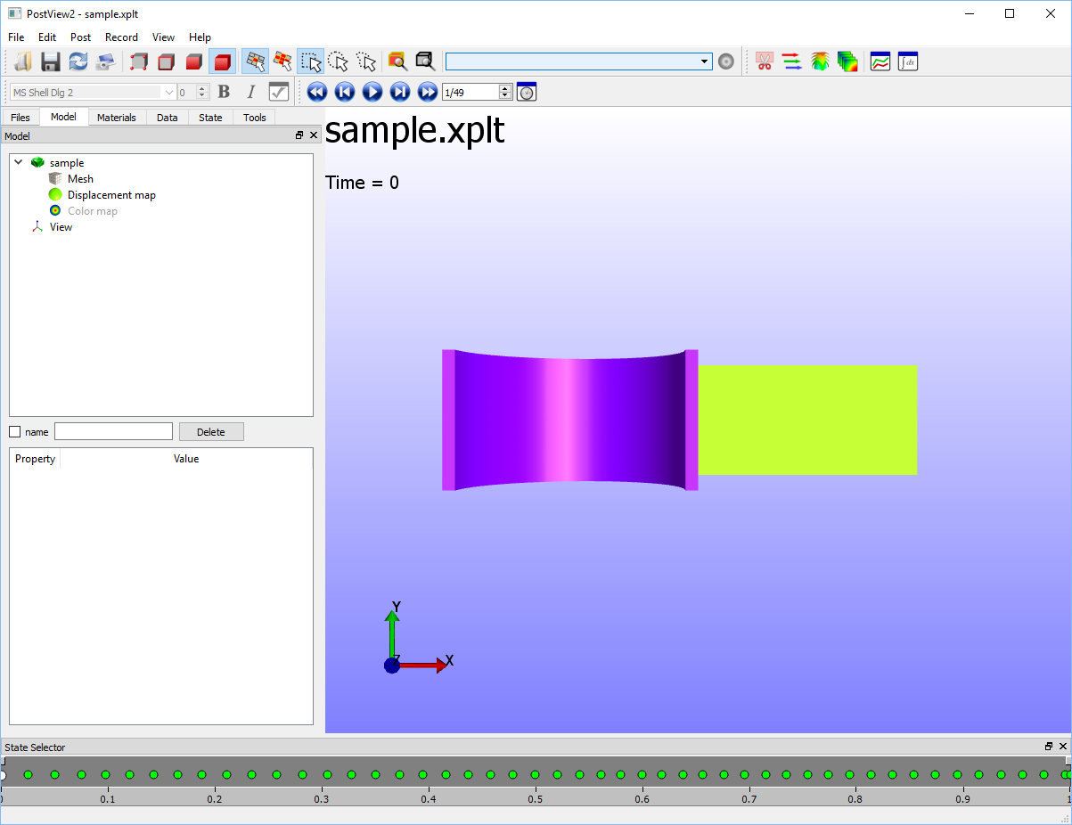

Figure 2. PostView with a file loaded. The *Model Viewer* is active and shows a hierarchical overview of the components of the currently loaded model.

The *Model Viewer* shows a hierarchical overview of the contents of the model. By default, PostView will assign a *Displacement map* and a *Color map* to your model. The *Displacement map* defines a map that will deform the model, and the *Color map* will define the color displayed on the model. Selecting any item in the *Model Viewer* will display its properties list below the *Model Viewer*.

Select the *Color map* item in the *Model Viewer*. In the property list, find the *Data field* member. This parameter determines the data field that will be used to color the model. You can select the data field to display by clicking on the *Data field* member and selecting an item from the drop down list. To activate the color map click the check button next to the name of the name field. Note that you can also select the data field from the main toolbar as well. When you select the data field from the main toolbar you can also press the *Toggle Color map* button, located next to the data selection field on the toolbar.

## The Graphics View

The big part of the screen that shows a 3D rendering of your model is called the *Graphics View*. When a file is loaded, PostView will display the model in a standard view that shows the entire model. The user can change the view using the mouse and the mouse buttons.

* To rotate the view, hold down the left mouse button while dragging the mouse.
* To pan the view, (that is, to move it left or right) use the middle mouse button while dragging.
* To zoom the view in or out press the right button while dragging.

PostView also defines six default views, namely: top, bottom, left, right, front and back. The numeric keys on the keypad can be used to select these views. For example, the “1” button selects the front view, the “3” button the right view and “7” selects the top view. The opposite views can be activated by holding down the *ctrl* button when pressing the keypad buttons. For example, to activate the bottom view, press ctrl+7. The left view (ctrl+3) and back (ctrl+1) can be accessed similarly. Note that this only works with the numbers on the keypad. The numeric keys at the top of your keyboard do nothing. If you have trouble remembering these shortcuts (or if you don’t have a keypad on your keyboard), you can right-click on the *Graphics View,* which brings up a popup menu from which you can select the default views. Alternatively, you can also find these options in the View menu.

## Animating the Model

Usually the file will contain the results of a finite element analysis which may have stored the state of the model for several time steps. If that is the case, the *State Controller* will be displayed at the bottom of the window. The *State Controller* allows you to select different results by clicking inside the dark grey area of the *State Controller*. The *Animation* toolbar can also be used to animate the model or to step through the different time steps.

In Figure 3 you can see what your model should look like at the last time step if you selected the *Effective Lagrange Strain* data field.

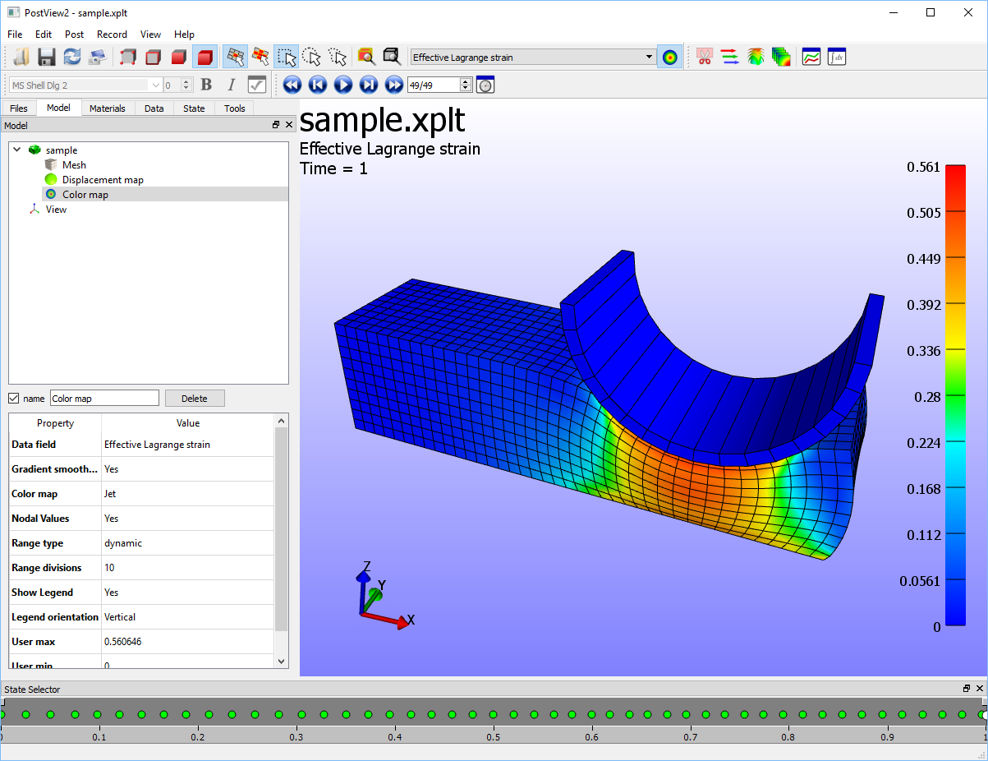

Figure 3. Sample file showing the Effective Lagrange strain at the last time step.

## Saving a Screenshot

PostView allows you to take a snapshot of the *Graphics View* and save it to file. This can be done by either selecting *File/Snapshot* from the menu (or pressing the shortcut *ctrl+p*) or by pressing the *Snapshot* toolbar button. A standard file dialog box now appears that allows you to select a file type and enter a filename.

# The PostView Environment

This chapter presents a more detailed overview of the PostView GUI and a description of the menu bar and the toolbar.

## An Overview of the PostView GUI

PostView has a Graphical User Interface (GUI) that offers an easy and intuitive way to interact with the FE model. Figure 4 shows the GUI after the program has started and the sample file is loaded.

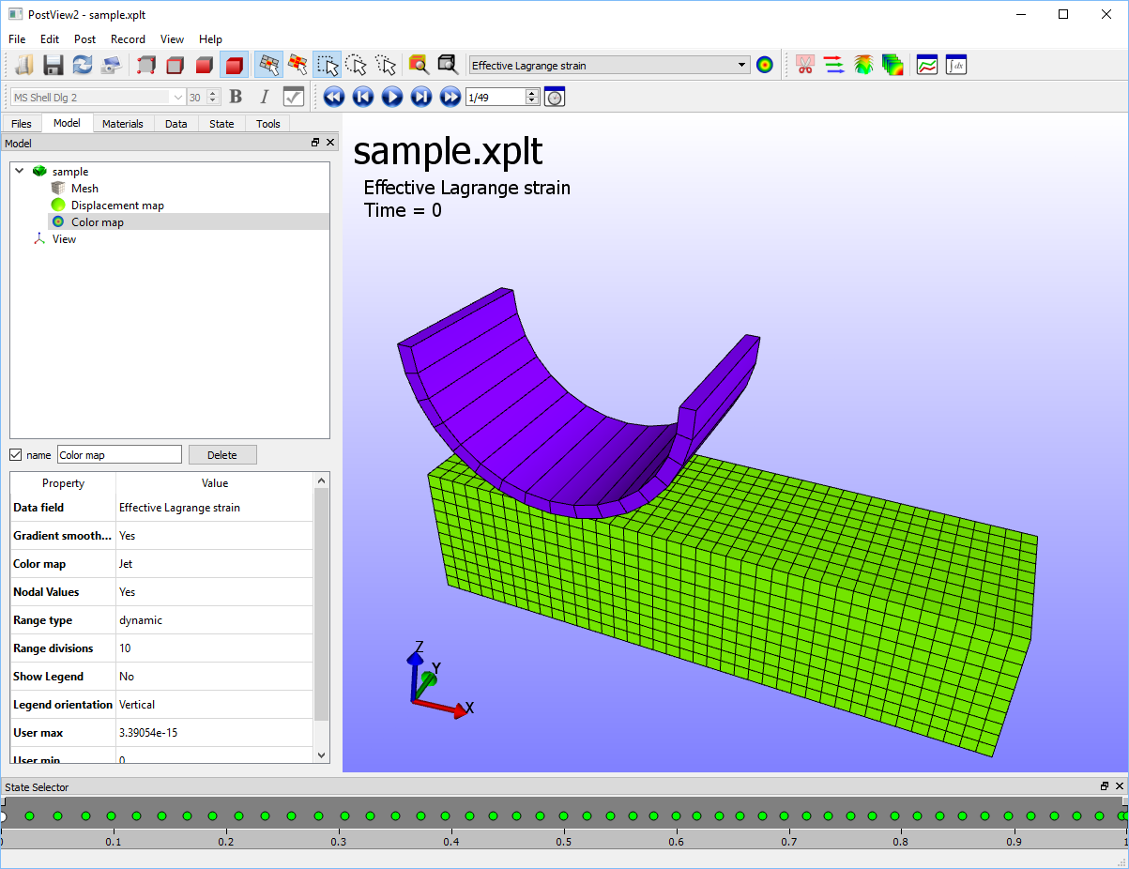

Figure 4. The PostView GUI after a file has been loaded.

The GUI consists of several components. The *Menu Bar* at the top allows access to the various PostView options and settings. Located below the menu bar are several toolbars. The *Graphics View* (GV), the big central area of the window, shows a 3D view of the FE model. At the bottom, the *State Controller* is used to select the model state that is being displayed. The left side of the window shows additional panels that are organized in a tabulated list. By clicking the tabs at the top of the window (below the tool bar) you can activate each panel. The panels are:

* *File Viewer:* allows the user to navigate file folders and open files.
* *Model Viewer:* shows the contents of opened files.
* *Material viewer:* displays an overview of the different materials or parts of the model.
* *Data Manager:* allows users to remove, add, or filter data fields.
* *State Manager:* lists all the states in the model and can be used to remove states.
* *Tools panel:* displays some useful tools.

Note that the panels can be detached and docked to other parts of the screen. To detach a panel, click the corresponding title bar and drag it away from the tab window. To dock the panel just move it to another part of the screen. A blue rectangle will appear where the panel can be docked. Note that toolbars can also be moved around.

Each of the UI components described above will be describe in more detailed in subsequent chapters. The menu and toolbars are described in the following sections.

## The Menu

In this section we will give an overview of the different menu items that can be found in PostView. The main menu bar, located at the top of the window, consists of the following menus:

* *File -* file operations, such as opening and saving data.
* *Edit -* options that apply to the current selection, such as hiding, un-hiding, etc.
* *Post -* contains some post-processing operations.
* *Record -* records an animation of the current Graphics View.
* *View* *-* provides options to customize the *Graphics View.*
* *Help -* allows access to PostView help and the About dialog box.

A more in-depth description of the different menu items follows.

### The File Menu

The file menu gives access to file operations and has the following menu items:

* *Open* - opens a model file.
* *Save -* saves the data to file.
* *Update -* reloads the last loaded data file.
* *File Info -* displays information about the currently loaded file.
* *Snapshot -* takes a snapshot of the current GV and save it to file.
* *Open Session -* continue a previously saved PostView session.
* *Save Session -* save the current PostView session.
* *Exit -* quits the application.

### The Edit Menu

The edit menu gives access to operations that apply on the current selection:

* *Select Nodes*: switch to node selection mode
* *Select Edges*: switch to edge selection mode
* *Select Faces*: switch to face selection mode
* *Select Elements*: switch to element selection mode
* *Hide Selected -* hides the currently selected items.
* *Hide Unselected -* hides the non-selected items.
* *Invert Selection -* inverts the current selection. All selected items become unselected and vice-versa.
* *Unhide All -* un-hides all the previously hidden items.
* *Select All -* selects all visible items. (Hidden items remain unselected.)
* *Select Range -* select items based on their current values.
* *Clear Selection -* clears the current selection.
* *Find -* find items from their ID’s.
* *Delete -* deletes the currently selected object from the GV.
* *Properties -* modify the properties of the currently selected GV object.

### The Post Menu

The post menu allows the user to set many of the options that effect what is being displayed.

* *Plane Cut -* add a clipping plane to the model.
* *Vector plot -* adds a vector plot object to the model.
* *Isosurface plot -* adds an isosurface plot object to the model.
* *Slice plot -* adds a slice plot object to the model.
* *Displacement map -* add a displacement map to the model.
* *New Graph -* opens a new graph window.
* *Summary -* provides 2D plots of minimum, maximum and average of the data fields.
* *Statistics -* displays a bar chart of the currently displayed data.
* *Integrate -* showsthe integration tool.

### The Record Menu

The Record menu gives the user access to the recording capabilities of PostView.

* *New* - selects a new target file for the recording.
* *Start recording* - starts recording the GV and stores the frames to a file.
* *Pause recording* - pauses the current recording.
* *Stop recording* - stops the current recording and closes the target file.

### The View Menu

The view menu allows the user to choose options that customize the display.

* *Settings* - sets foreground and background colors and style
* *Toggle Capture Frame* - displays or hides the capture frame
* *Orthographic Projection* - toggle between orthographic and perspective projection
* *Show Mesh lines* – toggles the mesh lines on or off
* *Show tags* - toggles the tags on or off
* *Show outline -* toggles the outline of the model
* *Color smoothing* – toggles between continuous and discrete gradient smoothing.
* *Front*: Rotate view to front view (XZ-plane)
* *Back*: Rotate view to back view (XZ-plane)
* *Right*: Rotate view to right view (YZ-plane)
* *Left*: Rotate view to left view (YZ-plane)
* *Top*: Rotate view to top view (XY-plane)
* *Bottom*: Rotate view to bottom view (XY-plane)
* *Track selection* – when activated, the camera will follow the current selection
* *Save viewpoint*: Store the current camera position.
* *Prev viewpoint*: set the view to the last stored camera position
* *Next viewpoint*: set the view to the next camera position.

### The Help Menu

The help menu allows access to the help features available in PostView and access to the software version and developers information.

* *Online Help* - opens PostView help in a browser.
* *About* - displays the about box.

## The Main Toolbar

The main *toolbar* is located below the menu bar and allows quick access to several menu items:



 Opens an existing file.

 Saves the currently loaded model.

 Reloads the currently loaded file.

 Saves a screenshot to file.

 Switches to node-selection mode.

 Switches to edge-selection mode.

 Switches to face-selection mode.

 Switches to element-selection-mode.

 Activates single item selection mode

Activates connected item selection mode



 Activates rectangular rubber banding selection

 Activates circular rubber banding selection

 Activates free rubber banding selection

 Zooms in on the selection.

 Zooms to the extents of the model.

Activate the contour plot



## The Post Toolbar

The *Post* toolbar offers various shortcuts to the Post menu items.



 Adds a plane cut plot to the model

 Adds a vector plot to the model

 Adds a isosurface plot to the model

 Adds a slice plot to the model

 Opens a new graph window

 Opens the Integrate window

## The Font Toolbar

The font toolbar allows users to easily modify the font of the selected graphics widget.



 Make the font **bold**

 Make the font *italic*

 Open the widget properties dialog box

## The Animation Toolbar

The *Animation* toolbar can be used to animate the model over time or step through the time steps of the model.



 Return to the first time step

 Step back by one step

 Start (and stop) the animation

 Step forward by one step

 Go to the last time step

 Open the time dialog box

# The Graphics View

The Graphics View (GV) is the area of the screen where the model is displayed.

## Elements of the GV

Aside from a 3D rendering of the model, the GV has several other components to it. These components are referred to as widgets. The image below displays the GV and all of its default widgets.

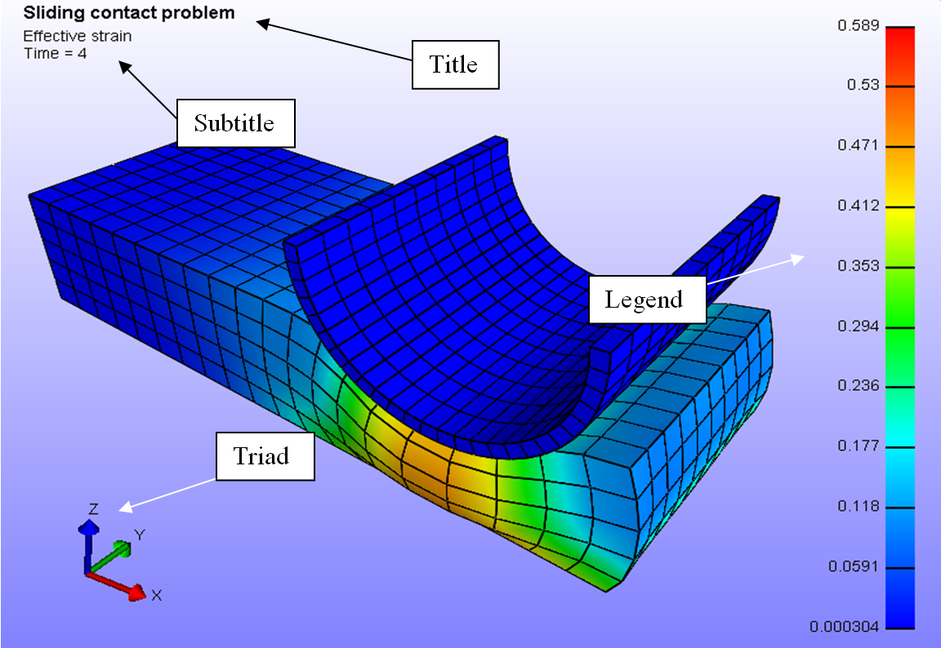

Figure 5. The Graphics View components.

The *Title* widget displays the title of the model. The *Subtitle* displays additional information, such as selected field and current time value. The *Triad* indicates the current orientation of the scene. Finally, the *Legend* displays a colored bar and the range of the selected field.

## Customizing the GV

The user can customize the GV by selecting and moving the different widgets around, and by adding new widgets. This section describes how the user can customize the GV. The following GV widgets are currently available:

* *Text box* - displays a user-defined text.
* *Triad* - displays the orientation of the current view.
* *Legend* - displays a colored legend bar.

### Selecting and moving widgets

You can select a GV widget by clicking on it with any mouse button. A selection box appears over the widget. The widget can be moved by dragging the box, while holding the mouse button down. If you click and drag the small triangular shaped area in the lower right corner of the selection box, you can resize the widget. Double-clicking on a widget brings up a properties dialog box, where you can modify the widget’s properties.

### Setting the GV widget’s properties

After selecting a widget, you can alter its properties by selecting Edit/Properties from the menu. A dialog box appears. You can also bring up this dialog box by double-clicking the widget. Below is an example of the properties dialog box for a text widget.



Figure 6. Text properties dialog box.

The font type, font size, font color and attributes can be set in this dialog box. You can also set the text to be displayed in the box. The text can consist of literal text and keywords. The keywords, which start with a percentage sign (%), will be replaced by a predefined text. The available keywords are listed in table 1.

|  |  |
| --- | --- |
| **keyword** | **description** |
| *%title* | Title of the problem. The title is set in the File/Model Info dialog box. |
| *%field* | The field variable currently being displayed. |
| *%time* | The time value of the current state. |
| *%state* | The current state number. |
| *%filename* | The name of the file. |
| *%filetitle* | The title of the file, i.e. the filename without the extension. |
| *%filepath* | The path of the file. |

Table 1. Text box keywords.

You can also use escape sequences, which start with a backslash (\).

* \n - start a new line.
* \t - start the following text at the next tab position.

### Adding GV Widgets

PostView starts with a predefined set of GV widgets. You can add new widgets by clicking one of the GV buttons in the toolbar. Currently, PostView only supports the addition of a new text widget by clicking on the “Add text box” button, located on the main toolbar.

### Deleting GV Widgets

GV widgets can be removed by first selecting them and then selecting Edit/Delete from the menu bar. Note that you cannot delete the predefined widgets, namely the title, subtitle, legend and triad. However, you can hide these objects by selecting the corresponding button on the toolbar.

## Saving Graphics

### The Capture Frame

When storing graphics, it is important to understand the concept of the *capture frame*. The capture frame is the area of the screen that will be captured when taking a screen shot or recording an animation. The capture frame is not always visible, but can be displayed by selecting the *View/Toggle Capture Frame* from the menu. The same menu will hide it again. The capture frame can be shown by selecting the keypad-‘0’ shortcut. When visible, the capture frame can be moved and resized by selecting one of the borders and dragging the mouse button. To resize it, you must grab the little triangular area in the lower right corner of the capture frame. If you wish to specify the location and size more accurately, you can open the properties dialog box, by selecting the *Edit/Properties* menu or by double-clicking on one of its borders.

### Taking a snapshot

To take a snapshot of the current Graphics View, select the *File*/*Snapshot* menu. Alternatively, you can press the *ctrl+p* shortcut or push the *snapshot* button on the toolbar. A standard *Save* dialog box appears and the desired filename can be entered or selected. Images can be saved as BMP, TIFF or JPEG images.

### Recording an animation

PostView has the capability to record an animation of the current GV.To record an animation, first position and resize the capture frame so that it covers the desired area of the GV that will be captured. Next, select the *Record/New* menu. This opens a standard file dialog box where you can select a file format and enter the target filename. If the selected file format is an image format (.bmp, .tiff, etc.), the target filename will be the file template from which the actual filenames will be generated. Each frame will be stored in a separate file, where the frame number is appended to the file template.

After you have selected a target file, you are ready for recording. Note that the capture frame will now be locked, so you can no longer move or resize it. If it is visible, it will turn red. The recording will begin in a paused state, allowing you to make some changes to the GV before recording begins.

To start recording, select *Record/Start* from the menu or press the corresponding shortcut. Now, all the action in the GV will be recorded to the target file. For example, if you press the play button, the GV will loop over all timesteps and each step will be recorded to the file. You can also rotate the GV and this will also be recorded to the file.

To pause the recording, select *Record/Pause* from the menu. To finally stop the recording, select *Record/Stop* from the menu. This will close the target file and unlock the capture frame.

## The View Settings

The *View Settings* dialog box (fig. 7 below) controls the settings that affect the GV. You can invoke it by selecting the *View*/*Settings* menu.

It allows you to select the following options:

* *Rendering*
  + *Render style**-* selects a style with some predefined rendering settings.
  + *Perspective projection**-* toggles between perspective and orthographic projection.
  + *Line smoothing –*anti-alias line rendering
  + *Line thickness –*set the thickness of lines
  + *Point size –*sets the size of the nodes
* *Background*
  + *Background color 1**-* sets the first background color.
  + *Background color 2**-* sets the second background color.
  + *Background style -* sets the style of the background.
* *Lighting*
  + *Enable Lighting -* turns lighting on or off.
  + *Diffuse Intensity -* **s**ets the diffuse intensity of the light for each material.
  + *Ambient Intensity -*sets the ambient intensity of the light for each material.
  + *Render shadows -* renders shadows cast by the objects in the scene, using the current light position. (*Enable Lighting* must be checked.)
  + *Shadow Intensity -*sets the shadow intensity as a number between zero and one.
* *Camera*
  + *Animate Camera –* animatethe camera when moving between viewpoints
  + *Animation Speed –*setsthe speed of the camera animation
  + *Animation Bias –*setsthe bias of the camera motion (this affects the acceleration and deceleration when the camera approaches its next viewpoint)
* *Selection*
  + *Select connected:* switches between single item or connected item selection mode
  + *Tag info:*selects how much information is displayed when selecting items.
  + *Select backfacing items:*sets whether backfacing items will be selected when region selecting
  + *Ignore interior items:*Select interior items when region selecting (only works for element selection)
* *Pallette*
  + This tab can be used to create, load, and save custom color palettes, which are used for coloring the different parts (i.e. materials) of the model
* *Colormap*
  + This tab can be used to modify or create custom colormaps.

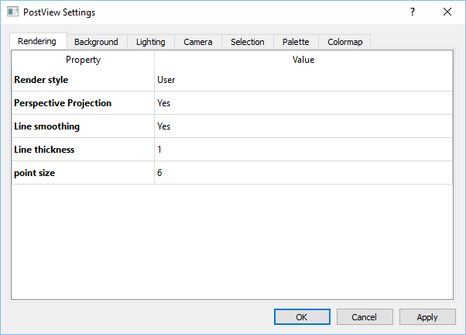

Figure 7. View Settings dialog box.

## Camera Control

In PostView, the camera determines the position and orientation from which the model is viewed. The user can position and orient the camera in several ways. Camera positions can also be saved to make it easier to recover certain preferred positions.

### Basic Camera control

The easiest way to position the camera (and thus change the view) is by using the mouse. Moving the mouse while holding down one of its buttons will modify the view. The action depends on which mouse button is held down. The following lists the possible actions.

|  |  |
| --- | --- |
| **Action** | **Mouse/Keyboard** |
| To rotate the view | Left MB |
| To pan the view | Middle MB or ALT+Right MB |
| To zoom | Right MB |
| To rotate in the plane of view | ALT+Left MB |
| To rotate view left/right by small increment | Left/Right arrow key |
| To rotate view up/down by small increment | Up/Down arraw key |

Table 2. Mouse and keyboard shortcuts to control view.

The camera position and orientation is displayed under the View item in the Model Viewer. By selecting this item in the Model Viewer, the current camera position and orientation is shown in the properties panel under the Model Viewer. All these fields can be edited manually for precision control over the camera.

### Element tracking

The element tracking feature in PostView allows you to track the position and orientation of an element. The camera will then move with this element as it deforms through time.

In order to use element tracking, first select the element that you wish to track. Then, select the *View🡪Track Selection* menu item. To stop element tracking, clear the selection and then select the same menu item (or use the Ctrl+T shortcut).

### Camera key-framing

The current position of a camera can be stored in what is called a *viewpoint*. Simply select the *View🡪Save viewpoint* menu item and a new key item will be created in the Model Viewer. As with the View item, selecting a Key item allows you to edit the position and orientation of that stored camera position. In addition, by selecting the *View🡪Prev/Next viewpoint,* you can smoothly interpolate between camera key positions. This feature comes in handy when recording an animation and different camera positions need to be visited in a repeatable manner. Camera keys are stored in the PostView session file so they can be retrieved later.

# The Tab Window

The *Tab Window* is the window on the left side of the screen that has several tabs at the top. These tabs give the user access to several other panels which will be described next.

## The File Viewer

The *File Viewer* allows the user to navigate the computer’s file structure. The File Viewer is located in the tab window on the left and can be activated by clicking the corresponding tab button at the top of the tab window.

The largest area of the File Viewer presents a list of folders and files in the current folder. The user can move to a subfolder by double-clicking the folder name. Double-clicking on a file will open the file in PostView. The tool button with the up-arrow icon can be used to go up one level in the file hierarchy. The dropdown box can be used to select a file filter.

Note that the user can also open a file from the File/Open menu, which will display the familiar File Open dialog box.

## The Model Viewer

The *Model Viewer* gives an overview of the contents of the model. It also gives access to the property window which is used to set many of PostView’s display settings. The Model Viewer is accessed by clicking the “Model” tab button on the Tab Window.

The top part of the Model Viewer shows a tree-view of the contents of the model. Each item can be selected, and when selected, the property window at the bottom lists the available properties for the selected item. Properties can be edited by selecting the corresponding item in the value column.

The name edit field in the middle of the Model Viewer can be used to change the name that refers to the selected item. The *delete* button next to the name field can be used to delete a selected item. Note that this only works for items that the user has added to the model. See Chapter 6 for more details on adding items to a model. The *enable* button, the checkbox located next to the name field, can be used to activate the selected item in the Graphics View. What this precisely means will depend on the particular item, but in general this means that if enabled, the item will be displayed in the Graphics View, and if disabled it will be hidden. Note that if an item is disabled, its name will be drawn in italics in the model viewer.

## The Material Viewer

The *Material Viewer* gives an overview of the different materials (or parts) in the model. It can be accessed by selecting the “Materials” tab.

All the materials in the model are listed in the large window on the left. A material can be selected by clicking on the entry in the list. Multiple materials can be selected by holding down the shift button or the ctrl button.

The name of the material can be modified by first selecting it, and then editing the name field, which is located in the center of the material viewer. The enable button, next to the name field, can be used to toggle the state of the material. When a material is disabled, the corresponding part will not be evaluated when visualizing the model data. In that case, it will display with the material colors as defined in the Material Viewer. When enabled, the part will be evaluated, and will be colored according to the local node or element values. See Chapter 6 for more details on this process. The *visible* button, next to the *enable* button, can be used to toggle the visibility of the corresponding part in the Graphics View.

When a material is selected, the property window on the bottom of the material viewer, lists the available properties that the user can change. The options are:

* *Diffuse* - sets the diffuse color of the material. By clicking on the colored button, the Color Selector dialog is opened and the color can be changed. Closing the Color Selector will automatically update the color in the Graphics view.
* *Ambient -:* sets the ambient color for the material. Click the colored button next to it to change the ambient color.
* *Specular* - sets the specular color for the material. Click the colored button next to it to change the specular color.
* *Emission -* sets the emission color for the material. Click the colored button next to it to change the emission color.
* *Mesh Color -* sets the mesh color for the material. Click the colored button next to it to change the mesh color.
* *Shininess -* sets the shininess value for the material. Slide the slide bar to change the shininess value.
* *Transparency -* sets the transparency value for the material. Slide the bar to change the transparency value.
* *Show Mesh -* if checked, the mesh lines will be drawn on top of the model.
* *Cast Shadows -* allows the material to cast shadows on other materials. This has only an effect when shadows are enabled. Shadows can be enabled by selecting the corresponding button on the toolbar.
* *Clip -* allows the material to be clipped when a clip plane is defined for the model.

## The Data Manager

The *Data Manager* lists all the available data fields that are defined in the model in a table with three columns. The *Data Field* column gives the name of the data field. The *Type* of the field identifies the type of the data. The following types are currently defined:

* *float*: single precision floating point
* *vec3f*: a 3D vector with three floatcomponents
* *mat3fs*: a 3D symmetric matrix with six float components

The *Class* column identifies the region type for which the data field is defined:

* NODE: data is defined at the nodes of the model
* ELEM: data is defined for each element in the model

In addition, new data fields can be added by clicking the Add button. A menu shows up from which the user can select from several options:

* Standard: select from a list of pre-defined data fields.
* From file: load a data field from a data file.

By selecting the “from file” option, a dialog box appears that can be used to load data from a text file.

Figure 8. Add Data from file dialog box.

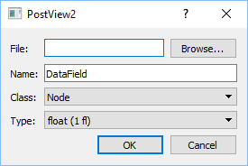

The text file containing the data can be selected using the Browse button. The data must be formatted using a comma delimited list, each line corresponds to one item (node, element) and each value on each line corresponds to a single state. The *Name* edit box is used to give a name to the user field, the *class* list identifies whether the data corresponds to a node, element or face, and the *type* list is used to define whether the data is a scalar (float), 3D vector (vec3f) or 3D matrix (mat3fs).

For example, assuming *class* is node, and *type* is float.

1, 0.1, 0.2, 0.3

2, 3.2, 3.3, 3.4

3, 1.2, 2.3, 2.4

This file defines for nodes 1, 2 and 3 three values, one for each state (assuming the model has three states). Another example, assuming *class* is element, *type* is vec3f.

1234, 0.1, 0.2, 0.3, 0.4, 0.5, 0.6

1235, 0.7, 0.8, 0.9, 1.0, 1.1, 1.2

1236, 1.3, 1.4, 1.5, 1.6, 1.7, 1.8

This file defines for three elements (elements 1234, 1235 and 1236) a vec3f value for two states: element 1234 has the value (0.1, 0.2, 0.3) for state 1 and (0.4, 0.5, 0.6) for state 2.

## The State Manager

The *State Manager* allows users to see all states defined in the model. It shows a table and lists in each row the state and its corresponding time value. At the top of the panel several buttons are shown that allow users to modify the state content of the model.

To delete a state, select the state in the table and press the Delete button. This will remove the state from the list.

A state’s time value can be edited by pressing the *Edit* button. A dialog box opens where the user can edit the time value.

A new state can also be added. Select the *Add* button. A dialog box appears where a time value can be entered for the new state. The new state will be inserted on the defined time point.

## The Tools panel

The *Tools* panel shows a list of additional tools that can be used to calculate certain metrics or edit the model content.

* *Pt. Distance*: evaluate the distance between two selected nodes
* *3Point Angle*: measure the angle between the lines defined by three nodes
* *4Point angle*: measure the angle between the lines defined by four nodes
* *Plane tool*: define a plane from three nodes.
* *Plot Mix*: Combine several plot files into one. (Currently only grabs last state from each plot file)
* *Measure Area*: calculate the area from a selection of faces
* *Import lines*: tool for importing line data that can be superimposed on the model
* *Kinemat*: Can be used to apply kinematics data to a model file
* *Distance Map*: Calculates a data field that measures the distance between two surfaces.
* *Curvature Map*: Calculates a data field that measures the curvature.
* *Pt*. *Congruency*: Evaluate the congruency at a point
* *Add 3D image*: load a 3D image data that will be rendered on top of the model via a volume rendering approach.
* *Sphere Fit*: Fit a sphere do the model
* *Transform*: Apply a translation to the model
* *Shell Thickness*: Can be used to set the shell thickness of the model
* *Add Point*: Displays a point at the specified coordinates
* *Import Points*: Load a point set from file

# Post Processing

In this chapter the different post-processing tools are discussed that PostView offers to display the model’s data. The user can define a displacement map that PostView will use to deform the model. The user can also define a colormap that defines the color of the different parts of the model according to the corresponding element or nodal value. The user can also add different types of plots to display data. Plane cuts can be made to conveniently hide parts of the model and to inspect the interior of the model.

## Properties of the Model

When selecting the *Model* item in the Model Viewer, the user can edit the properties of the Model. The following properties are defined.

* *Element subdivisions:* defines the number of subdivision levels. PostView subdivides the elements in the model to improve the quality of the renderings. However, increasing the number of subdivisions will also increase the time it takes to render the model so use this property judiciously.
* *Render mode:* Sets the render mode to solid or wireframe.
* *Render undeformed outline:* when selected *yes*, PostView will draw an outline of the model in its undeformed state.
* *Outline color:* set the color for the model outlines
* *Node color:* set the color of the nodes
* *Selection color:* set the color of selected items
* *Render smooth -* when selected *yes*, PostView will render the model smoothly. This means that it will vary the surface normal of the model to create a smooth surface. When selected *no*, flat shading is used to render the model. Note that smooth shading can be significantly slower than flat shading due to the additional calculations that PostView needs to do.
* *Shells as hexes -* renders all shells as hexahedral elements using the shell thickness (if available) to extrude the shell surface in the normal direction.
* *Shell reference surface -* defines how PostView needs to interpret the shell surface in relation to the shell volume.
* *Smoothing angle -* identifies the hard edges in the model. Edges with adjoining faces that have a surface normal, whose angle is more than the smoothing angle, are considered hard.

## Displacement Map

PostView uses the displacement map to define the deformation of the model at each state. The displacement map can be accessed in the Model Viewer by selecting the item entitled *displacement map* (this is a sub-item of the *model* item). Click on it to display the properties in the Properties Window, located at the bottom of the Model Viewer. The Displacement map has two parameters that the user can change.

* *Data field:* is the data field that PostView will use to calculate the model’s deformation.
* *Scale Factor:* sets the displacement scale factor, which can be used to scale the displacements when displaying the model in the Graphics View. (This scale factor does affect strain measures.)

Note that you must enable the displacement map by clicking on the *enable* button in the Model Viewer (this is the button with the checkmark). Similarly, by clicking the button again the displacement map can be deactivated in which case PostView will not deform the model when displaying the different time steps.

## Color Map

The *Color Map* defines how PostView will calculate the color that is used to display the model in the Graphics View. The Color Map’s properties can be accessed by selecting the item in the Model Viewer entitled *Color Map*. The properties will then be listed in the Properties Window below. The following properties are defined for the color map.

* *Data field -* allows the user to select the data field that PostView will use to define the color of the model. The color of the model is defined by the data field and the color gradient (see below).
* *Gradient smoothing -* PostView colors the material by drawing a fringe plot of the selected data field. When gradient smoothing is on, the fringe colors are smoothed to produce a continuous transition between fringes. When this option is off, a discrete set of colors is used instead.
* *Color map:* defines the color map that PostView will use to color the model.
* *Nodal values -* PostView defines nodal data and element data. When displaying element data, PostView will first project the element data to the nodes to produce a smooth rendering of the data. However, when this option is turned of, element data will be displayed by using a single color for each element. This will produce a discretized drawing of the data, but will be truer to the actual data since the element data is not interpolated before displaying.
* *Range type -* PostView keeps track of the range of the selected data field (that is the minimum and maximum values). The user can use this option to select a *dynamic* range (range is updated for each state independently), a *static* range (range is calculate over all the states) or *user* range (user defines the minimum and maximum values).
* *Range divisions -* changes the number of fringes that PostView will draw on the model.
* *Show legend -* allows you to toggle the displaying of the legend bar in the Graphics View.
* *Legen Orientation:* sets the orientation of the legend bar (horizontal or vertical)
* *User max/ User min -* defines the minimum and maximum range value when using the *user* range option for *range type*.

When PostView starts, the colormap is turned off by default. To activate it, select the *enable* button in the Model Viewer. Similarly, to disable the color mapping, simply press this button again. When the colormap is turned off, PostView will use the material colors to display the model in the Graphics View.

## Plane Cuts

PostView allows the user to add a plane cut to the model. The plane cut defines a clipping plane which will hide all geometry on the positive side of the plane. To add a plane cut to the model, select the *Post/Plane cut* from the menu. A new item will show up the Model Viewer that the user can select and edit the properties off. The following properties are defined for the plane cut.

* *Show plane -* shows or hides the plane in the Graphics View. Note that selecting *no* for this option does not disable the plane cut. It simply toggles the displaying of the plane. To disable the plane cut, you need to click the *enable* button (see below).
* *Cut hidden:* If yes, hidden parts will be cut. If no, hidden parts are not cut.
* *Show Mesh:* show the mesh on the plane cut.
* *Transparency:* Set the transparency value of the plane.
* *X-normal -* sets the *x* component of the plane normal. Aside from entering the value directly, this edit field can also be used as a slider. You can change the value by click+dragging with the left mouse button.
* *Y-normal -* sets the *y* component of the plane normal. Aside from entering the value directly, this edit field can also be used as a slider. You can change the value by click+dragging with the left mouse button.
* *Z-normal -* sets the *z* component of the plane normal. Aside from entering the value directly, this edit field can also be used as a slider. You can change the value by click+dragging with the left mouse button.
* *offset -* sets the relative position of the plane with respect to the center of the model. Aside from entering the value directly, this edit field can also be used as a slider. You can change the value by click+dragging with the left mouse button.

Multiple plane cuts can be added to the model (up to six) and each plane can be positioned independently of the others. Note that the color of the plane in the Graphics View hints to its orientation using a RGB color coding: a red plane is a plane whose normal is directed in the x-direction, a green plane has its normal in the y-direction and a blue plane has its normal in the z-direction. A general orientation uses a combination of red, green and blue to indicate the orientation. You can also hide the displaying of the plane by setting the *Show plane* property to the appropriate value.

To enable the plane cut, press the *enable* button in the Model Viewer. To disable it, press the button again. You can delete the plane cut altogether by clicking the *delete* button on the Model Viewer panel.

## Vector Plot

A *vector plot* of the model can be added by selecting the *Post/Vector plot* menu. This will add a vector plot item to the Model Viewer. The user can select the item in the Model Viewer to edit the properties of the vector plot. The following properties are defined.

* *Data field -* selects the vector field that will be rendered.
* *Allow clipping:* If yes, the vector field will be clipped by any active plane cuts.
* *Density -* sets the density of the vector field. A density of one will draw a vector at each node of the model. Lower values will draw a vector only at randomly selected nodes. The lower the value, the less vectors are drawn.
* *Glyph -* a small graphic that PostView will draw at each node to represent the vector. This option allows the user to select the glyph.
* *Glyph color -* allows the user to set how PostView will determine the color of each glyph. Currently, the options are:
  + *Solid -* draws each glyph in the same color (also see *Solid color*).
  + *Length -* draws the glyph with a color that relates to its length (also see *Gradient*).
  + *Orientation -* draws the glyph using RGB color coding to indicate the orientation of the vector.
* *Solid color -* is the color that PostView uses when *Solid* is selected as the glyph color.
* *Normalize -* when selected *yes*, PostView will normalize all vectors. This implies that all vectors will be drawn with the same length. Otherwise the size of the glyph will be representative to the size of the corresponding vector.
* *Auto-scale:* scale the vectors automatically.
* *Scale:* scales the size of the glyphs.

The *enable* button on the Model Viewer panel can be used to toggle the vector plot on and off. The *delete* button can be used to remove the vector plot from the model.

## Isosurface plot

An isosurface plot draws a surface through all the points of the model that have the same value. An isosurface plot can be added by selecting the *Post/Isosurface plot* from the menu. A new item will appear in the Model Viewer that the user can select to edit the surface plot’s properties. The following properties are defined.

* *Data field -* selects the data field that PostView will use to calculate the isosurfaces.
* *Allow clipping:* If yes, iso-surfaces will be clipped by any active plane cuts.
* *Gradient -* sets the color gradient that PostView will use to color the isosurfaces.
* *Slices -* defines the number of isosurfaces to draw.
* *Show legend -* shows a legend bar for the isosurface plot.
* *Smooth -* when selected *yes*, PostView will draw the surfaces using smooth shading. When selected *no*, the isosurfaces are drawn with flat shading. Note that when using smooth shading, additional calculations need to be performed which may slow down the rendering of the plot.

The isosurface plot is enabled by selecting the *enable* button on the Model Viewer panel. Similarly, disabling the plot can be done by pressing the same button again. You can delete the isosurface plot by pressing the *delete* button on the Model Viewer panel.

Since the isosurface plot is drawn inside the model, it is advisable to hide it. You can hide the model by hiding each individual material, or by clicking the *enable* button when the *model* is selected in the Model Viewer.

## Slice plot

A slice plot draws the intersection of the model with a series of planes. The planes can be oriented by the user. To add a slice plot, select the *Post/Slice plot* from the menu. A new item will show up in the Model Viewer which the user can select to edit the slice plot’s properties.

* *Data field -* selects the data field that PostView will use to color the planes.
* *Gradient -* sets the gradient that PostView will use to color the planes.
* *X-normal -* sets the *x* component of the plane normal.
* *Y-normal* - sets the *y* component of the plane normal
* *Z*-*normal* - sets the *z* component of the plane normal
* *Show legend -* shows or hides the legend bar for this plot.
* *Slices -* selects the number of slicing planes.

The slice plot can be enabled or disabled by pressing the *enable* button in the Model Viewer. The plot can be deleted by selecting the *delete* button. Since the slice plot is drawn inside the model, it is advisable to hide the model. You can hide the model by hiding each individual material, or by clicking the *enable* button when the *model* is selected in the Model Viewer.

# Additional Tools

## Summary Window

The Summary Window displays a graph of the minimum, maximum, and average values as a function of time for the selected expression. This summary of values can be calculated using only selected elements or nodes, or for the entire model when no elements or nodes are selected. It can be opened by selecting the *Post*/*Summary*. Figure 9 shows the *Summary Window*.

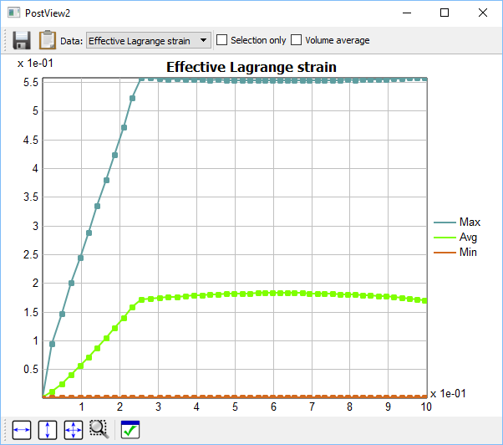

Figure 9. The Summary Window can be opened from the Post/Summary menu.

To select the expression to display, click on the drop-down box in the upper left corner and select the desired expression. Each data point can be selected by clicking on it. The exact values will appear next to a selected data point.

To save the summary data to file, click the *Save* button located at the bottom of the *Summary View*. This will open the File Save dialog box. After the user enters a filename, the data is saved to file as a simple ASCII file. The data can also be copied to the clipboard with the “Copy to Clipboard” option.

The *Options* button shows a dialog box where the user can change some options.

The graph area can be scaled or moved by click+dragging the right and left mouse button respectively. The buttons in the lower left corner of the Summary window can be used to restore the x-range, y-range or both.

## Graph Window

The Graph window can be used to show time history plots and scatter plots for selected items. To open a *Graph window*, select the *Post*/*new Graph* menu. Note that users can create as many graph windows as needed.

Figure 10. Trackview displaying the time history of selected elements.

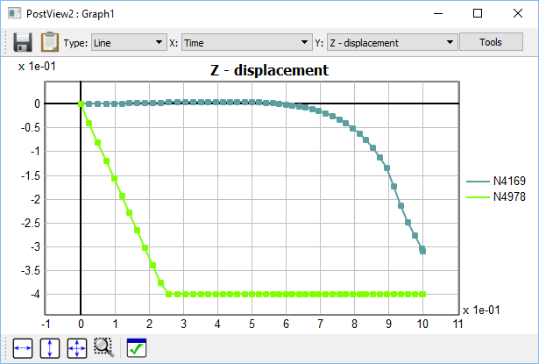

The *Graph window* displays the selected expression for the selected mesh items (see below on how to select mesh items). On the right, the item numbers (preceded by an ‘E’ for ‘element’, ‘N’ for ‘node’, ‘F’ for ‘face’, ‘C’ for edge) are shown in the same color as the corresponding curve. The *Clipboard* button can be used to store the data values on the clipboard. (This data can then be pasted in other software that allows clipboard operations.)

The *Type* allows the user to select from different types of plots. The following types are currently supported:

* *Line* - displays a curve that represents the evolution of the selected data field as a function of (pseudo-) time. For this type, the user can only select the value for the y-axis; the x-axis will show the time.
* *Scatter* - displays an x-y plot. In this case, the user can select different data fields for both the x- and y-axis.
* *Time*-scatter: like scatter plot, but points are connected by time value

The graph area can be scaled or moved by click+dragging the right and left mouse button respectively. The buttons in the lower left corner of the TrackView window can be used to restore the x-range, y-range or both.

### Selecting mesh items

You can select nodes, edges, faces, and elements. The item that will be selected is controlled by the selection buttons in the *Toolbar*:

 Switches to node-selection mode.

 Switches to edge-selection mode.

 Switches to face-selection mode.

 Switches to element-selection-mode.

To add an item to the current selection, just shift+click the item. When tags are enabled, a dot followed by the item’s number will appear next to the item. To enable the tags, select the corresponding button on the toolbar. To remove an item from the current selection, ctrl+click the node or element. You can (de-) select multiple items at the same time by dragging the mouse cursor while holding down the shift or ctrl key and the left mouse button. A colored rectangle will appear indicating what elements or nodes will be selected. Note that only *visible* elements or nodes that fall inside this rectangle will be selected. This means that only elements or nodes on the surface of the mesh can be selected.

When no other windows are open (such as e.g. Graph windows, etc.), pressing the ESC-key will clear the selection. You can also select the *Edit*/*Clear Selection* menu to clear the entire selection.

Also note that the *Edit* menu lists several options to manipulate the current selection, such as hiding, un-hiding, inverting, etc.

## Integration Tool

The *Integration tool* allows you to calculate the integral over a selected region. To use it, first select nodes, edges, faces, or elements. Then, activate the Integration tool from the Post/Integrate menu. A window appears with a graph that represents the integral of the selected region as a function of time. Depending on the selection, the graph represents different things. For nodes, it is the sum of the values all the selected nodes, for edges it is the line integral, for faces it is the surface integral of the selected surface, and for elements it is the volume integral over the volume of the selected elements. The *Save* button saves the results to a text file and the *Clipboard* button copies the data to the clipboard.

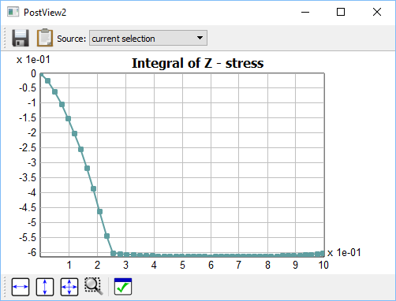

Figure 11. The Integration tool can be used to calculate the definite integral over the selected region.