NeuralMarket Technical Documentation

Overview
Neural Market is an online marketplace for AI models and datasets; it’s similar to an app store, but instead of a single company running it, the rules are handled automatically by code on a blockchain. Sellers have the capability to list their AI models, and the buyers pay to access them. This system makes sure that all are treated fairly without needing someone in the middle to referee. This was built to show all the pieces of a real platform. The features are a way to pay, a way to reward loyal users, a way for the community to vote on rule changes, a way to pull in trusted outside information, privacy, an ability to work across more than one blockchain, and finally automatic testing.

Architecture of the System

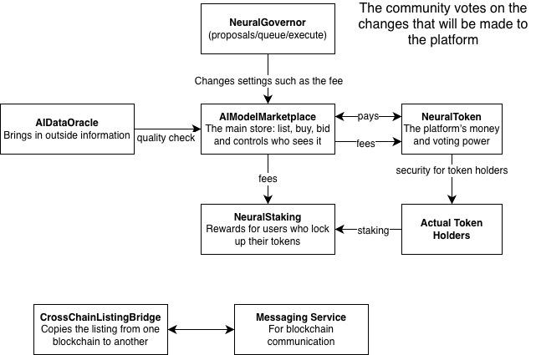

A seller will list their AI Model. Before it goes live, the system will check it for quality to make sure that it’s good enough. The buyer will pay for it using the platform’s token (NRL). A small fee will be taken out and sent to users, and the buyer gets access. For certain items, the buyer will be able to place secret bids. The entire community will vote on setting changes such as the fees.

What They Actually Do

NeuralToken (NRL)
The platform’s original token. People use it to pay for the models, and holding onto tokens is the power system for voting. There is a fixed max number that could exist, so there isn’t an endless amount.

AIDataOracle
Because of the nature of blockchains, they can’t see outside information; this part brings in safe information, such as an AI model’s quality score and refuses to use it if the data is wrong or is an old model.

AIModelMarketPlace
This is the most important part. Sellers can list models here, buyers purchase access, and a small fee is collected on all sales. It also has secret bidding and controls who is allowed to open items that have been purchased. Only approved individuals can list, and the community’s vote can change some of the key settings for this.

NeuralStaking
Users can lock up their tokens to earn rewards over time; it is similar to earning interest from a savings account. In order to discourage abuse, there’s a grace period before you can take locked tokens out.

NeuralGovernor
This allows a token to suggest changes, vote on them, and if a vote passes, puts them into effect automatically. There is also a grace period after a vote passes, so the community can react to major changes.

CrossChainListingBridge
The communication system between different blockchains. This part copies a listing from one blockchain to another, so the marketplace can reach users no matter where they are.

Deployment Plan
This is the order in which they would be launched, because the later ones build on the earlier ones

- Launch NRL with a max of 100 million
- Launch the oracle
- Launch the staking part
- Launch the governor
- Launch the main store, which connects all of the above
- Launch the blockchain communicator
- Approve sellers, set a minimum quality score, and connect the two blockchains

How it Would Actually Be Used by Role
- Seller gets approved, lists a model with a price, gets paid when someone buys it
- Buyer approves payment, buys the model, and automatically receives access. For a secret bid, they would submit their bid, reveal it later, gets access if the bid is valid
- Staker locks up the tokens, earns rewards over time, collects them to leave, requests a withdrawal, and waits for the grace period to end.
- Voter uses tokens to suggest the change and votes. If it passes, it will come into effect after the grace period.
- Cross-blockchain connects the two networks and sends a listing to the other one so that it will show up on the other.

Monitoring the System
All actions on the platform have a public record of all events. A real deployment would collect these into a dashboard and would be alerted if something weird happens.

