Cyclistic Bike-Share Case Study – Full R Analysis

Febri Supriadi

Oktober 2025

# 1. Pendahuluan

Laporan ini merupakan hasil penyelesaian proyek akhir **Google Data Analytics Capstone**, dengan fokus pada data **Cyclistic Bike-Share**.  
Seluruh proses analisis — mulai dari pembersihan data, eksplorasi, visualisasi, hingga insight strategis — dilakukan menggunakan **RStudio** dengan bahasa **R**.

Pendekatan ini mengadaptasi alur kerja resmi *Coursera Capstone*, namun diperluas dengan analisis spasial dan visualisasi interaktif berbasis *tidyverse*.

# 2. Tujuan Analisis

Analisis ini bertujuan untuk menjawab pertanyaan utama:

* Bagaimana perbedaan perilaku penggunaan antara pengguna *member* dan *casual*?
* Faktor apa yang memengaruhi pola penggunaan mereka?
* Strategi apa yang dapat meningkatkan konversi dari pengguna *casual* menjadi *member*?

# 3. Persiapan Data

Dataset diambil dari portal publik Divvy:  
<https://divvy-tripdata.s3.amazonaws.com/index.html>

File yang digunakan: - Divvy_Trips_2019_Q1.csv - Divvy_Trips_2020_Q1.csv

data_2019 <- read_csv("Divvy_Trips_2019_Q1.csv")  
data_2020 <- read_csv("Divvy_Trips_2020_Q1.csv")  
  
# Melihat nama kolom  
colnames(data_2019)

## [1] "trip_id" "start_time" "end_time"   
## [4] "bikeid" "tripduration" "from_station_id"   
## [7] "from_station_name" "to_station_id" "to_station_name"   
## [10] "usertype" "gender" "birthyear"

colnames(data_2020)

## [1] "ride_id" "rideable_type" "started_at"   
## [4] "ended_at" "start_station_name" "start_station_id"   
## [7] "end_station_name" "end_station_id" "start_lat"   
## [10] "start_lng" "end_lat" "end_lng"   
## [13] "member_casual"

# 4. Pembersihan dan Penggabungan

## 4.1 Menyamakan Struktur Kolom

data_2019 <- data_2019 %>%  
 rename(  
 ride_id = trip_id,  
 started_at = start_time,  
 ended_at = end_time,  
 start_station_id = from_station_id,  
 end_station_id = to_station_id,  
 start_station_name = from_station_name,  
 end_station_name = to_station_name,  
 member_casual = usertype  
 ) %>%  
 mutate(  
 member_casual = recode(member_casual,  
 "Subscriber" = "member",  
 "Customer" = "casual"),  
 rideable_type = NA,  
 start_lat = NA, start_lng = NA, end_lat = NA, end_lng = NA  
 ) %>%  
 select(ride_id, rideable_type, started_at, ended_at,  
 start_station_name, start_station_id,  
 end_station_name, end_station_id,  
 start_lat, start_lng, end_lat, end_lng, member_casual)

## 4.2 Menggabungkan Data

# Kolom ride_id di data_2019 bertipe numeric (double), sedangkan di data_2020 bertipe string (character).  
# bind_rows() hanya bisa menggabungkan jika tipe datanya sama.  
# Samakan tipe data ride_id  
data_2019 <- data_2019 %>%  
 mutate(ride_id = as.character(ride_id))  
  
data_2020 <- data_2020 %>%  
 mutate(ride_id = as.character(ride_id))  
  
# Sekarang bisa digabung  
gabungan <- bind_rows(data_2019, data_2020)  
  
# Simpan data hasil filter  
write_csv(gabungan, "data_clean/gabungan.csv")  
write_csv(data_2019, "data_clean/data_2019_clean.csv")  
write_csv(data_2020, "data_clean/data_2020_clean.csv")

## 4.3 Membuat Kolom Turunan

gabungan <- gabungan %>%  
 mutate(  
 ride_length = as.numeric(difftime(ended_at, started_at, units = "mins")),  
 day_of_week = wday(started_at, label = TRUE)  
 )

## 4.4 Menghapus Nilai Kosong Penting

gabungan <- gabungan %>%  
 drop_na(started_at, ended_at, start_station_name, end_station_name, member_casual)

## 4.5 Menghapus Outlier Durasi

jumlah_awal <- nrow(gabungan)  
gabungan <- gabungan %>%  
 filter(ride_length > 0, ride_length <= 1440)  
jumlah_akhir <- nrow(gabungan)  
cat("Jumlah data dihapus:", jumlah_awal - jumlah_akhir, "\n")

## Jumlah data dihapus: 691

# 5. Visualisasi Pembersihan Data

# contoh simulasi sebelum filter (gunakan jika data mentah tersedia)  
set.seed(123)  
gabungan_awal <- gabungan %>%  
 mutate(ride_length = replace(ride_length, sample(1:min(100, n()), min(10, n())), runif(min(10, n()), 1500, 3000)))  
  
plot_before <- ggplot(gabungan_awal, aes(x = ride_length)) +  
 geom_histogram(binwidth = 10, fill = "salmon", color = "white") +  
 labs(title = "Sebelum Penghapusan Outlier", x = "Durasi (menit)", y = "Frekuensi") +  
 xlim(0, 2000) + theme_minimal()  
  
plot_after <- ggplot(gabungan, aes(x = ride_length)) +  
 geom_histogram(binwidth = 10, fill = "steelblue", color = "white") +  
 labs(title = "Sesudah Penghapusan Outlier", x = "Durasi (menit)", y = "Frekuensi") +  
 xlim(0, 2000) + theme_minimal()  
  
# Gabungkan dua plot  
combined_plot <- plot_before + plot_after  
  
# Tampilkan hasil  
combined_plot

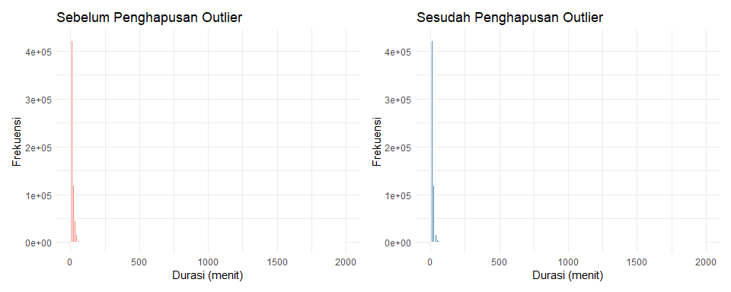

# Simpan hasil plot ke file PNG  
ggsave("plots/komparasi_sebelum_sesudah.png", combined_plot, width = 10, height = 4, dpi = 300)  
  
# Perbaiki skala agar plot terlihat lebih jelas  
# Simulasi data sebelum filter (jika data mentah tersedia)  
set.seed(123)  
gabungan_awal <- gabungan %>%  
 mutate(ride_length = replace(  
 ride_length,  
 sample(1:min(100, n()), min(10, n())),  
 runif(min(10, n()), 1000, 2500)  
 ))  
  
# Plot sebelum penghapusan outlier  
plot_before2 <- ggplot(gabungan_awal, aes(x = ride_length)) +  
 geom_histogram(binwidth = 10, fill = "#FF9999", color = "white", alpha = 0.8) +  
 labs(title = "Sebelum Penghapusan Outlier",   
 x = "Durasi (menit)",   
 y = "Frekuensi") +  
 coord_cartesian(xlim = c(0, quantile(gabungan_awal$ride_length, 0.995))) +  
 theme_minimal(base_size = 11) +  
 theme(  
 plot.title = element_text(face = "bold", hjust = 0.5, size = 13),  
 axis.title = element_text(face = "bold", size = 11),  
 axis.text = element_text(size = 10),  
 panel.grid.major = element_line(color = "grey85"),  
 panel.grid.minor = element_blank()  
 )  
  
# Plot sesudah penghapusan outlier  
plot_after2 <- ggplot(gabungan, aes(x = ride_length)) +  
 geom_histogram(binwidth = 10, fill = "#6CA6CD", color = "white", alpha = 0.8) +  
 labs(title = "Sesudah Penghapusan Outlier",   
 x = "Durasi (menit)",   
 y = "Frekuensi") +  
 coord_cartesian(xlim = c(0, quantile(gabungan$ride_length, 0.995))) +  
 theme_minimal(base_size = 11) +  
 theme(  
 plot.title = element_text(face = "bold", hjust = 0.5, size = 13),  
 axis.title = element_text(face = "bold", size = 11),  
 axis.text = element_text(size = 10),  
 panel.grid.major = element_line(color = "grey85"),  
 panel.grid.minor = element_blank()  
 )  
  
# Gabungkan dua plot secara berdampingan  
combined_plot2 <- plot_before2 + plot_after2  
  
# Tampilkan hasil  
combined_plot2

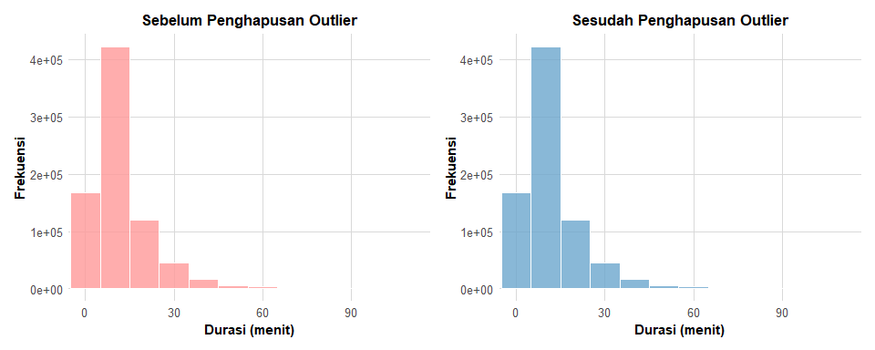

# Simpan ke file PNG  
ggsave("plots/komparasi_sebelum_sesudah_zoomin.png", combined_plot2, width = 9, height = 3.5, dpi = 300)

# 6. Analisis Deskriptif

## 6.1 Statistik Ringkas

summary(gabungan$ride_length)

## Min. 1st Qu. Median Mean 3rd Qu. Max.   
## 1.667e-02 5.467e+00 8.950e+00 1.366e+01 1.515e+01 1.436e+03

table(gabungan$member_casual)

##   
## casual member   
## 71138 720126

## 6.2 Jumlah Perjalanan per Hari

plot_trips_day <- ggplot(gabungan, aes(x = day_of_week, fill = member_casual)) +  
 geom_bar(position = "dodge") +  
 labs(title = "Jumlah Perjalanan per Hari", x = "Hari", y = "Jumlah") +  
 theme_minimal()  
  
# Tampilkan plot  
plot_trips_day

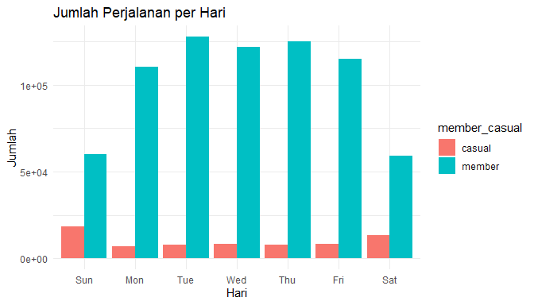

# Simpan hasil plot ke file PNG  
ggsave("plots/jumlah_perjalanan_per_hari.png", plot_trips_day, width = 10, height = 4, dpi = 300)

## 6.3 Rata-rata Durasi per Jenis Pengguna

# Hitung rata-rata durasi per jenis pengguna  
mean_duration_df <- gabungan %>%  
 group_by(member_casual) %>%  
 summarise(mean_duration = mean(ride_length, na.rm = TRUE))  
  
# Buat plot  
plot_meanduration <- ggplot(mean_duration_df, aes(x = member_casual, y = mean_duration, fill = member_casual)) +  
 geom_col(width = 0.6) +  
 labs(  
 title = "Rata-Rata Durasi Perjalanan",  
 x = "Jenis Pengguna",  
 y = "Durasi Rata-Rata (menit)"  
 ) +  
 theme_minimal() +  
 theme(legend.position = "none")  
  
# Tampilkan plot  
plot_meanduration

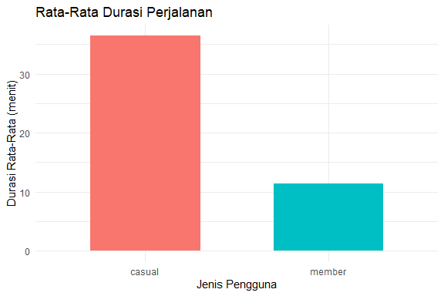

# Simpan hasil plot ke file PNG  
ggsave("plots/rerata_durasi_per_jenispengguna.png", plot_meanduration, width = 6, height = 4, dpi = 300)

# 7. Analisis Spasial

# Filter hanya baris dengan koordinat lengkap  
gabungan_spatial <- gabungan %>%  
 filter(!is.na(start_lat) & !is.na(start_lng))  
  
# Buat plot spasial  
plot_spatial <- ggplot(gabungan_spatial, aes(x = start_lng, y = start_lat, color = member_casual)) +  
 geom_point(alpha = 0.4, size = 0.8) +  
 scale_color_manual(values = c("member" = "#1f78b4", "casual" = "#e31a1c")) +  
 labs(  
 title = "Peta Persebaran Stasiun Awal Berdasarkan Jenis Pengguna",  
 x = "Longitude",  
 y = "Latitude",  
 color = "Jenis Pengguna"  
 ) +  
 theme_minimal() +  
 theme(legend.position = "bottom")  
  
# Tampilkan plot  
plot_spatial

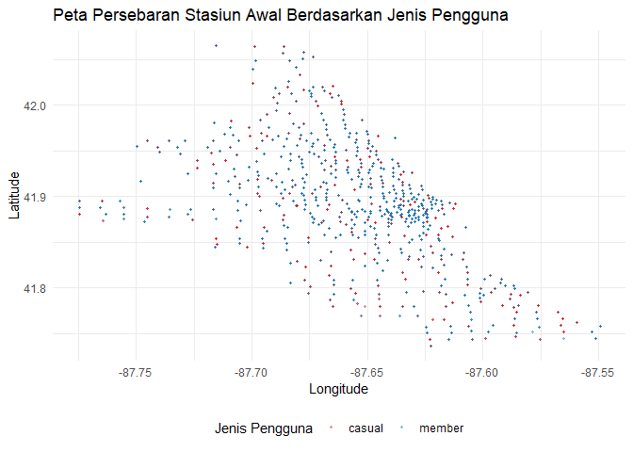

# Simpan hasil plot ke file PNG  
ggsave("plots/peta_persebaran_stasiun_awal.png", plot_spatial, width = 7, height = 5, dpi = 300)

# 8. Insight dan Rekomendasi

| Fokus | Temuan Utama | Rekomendasi |
| --- | --- | --- |
| Durasi | Casual lebih lama | Promosi untuk perjalanan wisata |
| Waktu | Member aktif di hari kerja | Penawaran perusahaan / kantor |
| Lokasi | Casual terkonsentrasi di area rekreasi | Tambah stasiun di area wisata |
| Pola | Aktivitas meningkat sore hari | Sesuaikan jadwal maintenance |

# 9. Kesimpulan

Penggunaan **RStudio** dengan *tidyverse* memungkinkan seluruh pipeline analisis data dilakukan secara efisien dan *reproducible*.  
Analisis menunjukkan bahwa:

* Pengguna **member** dominan di area pusat kota dan hari kerja.
* Pengguna **casual** lebih sering bersepeda di akhir pekan dan lokasi wisata.
* Strategi berbasis data dapat diterapkan dengan pendekatan lokasi dan waktu untuk meningkatkan konversi pengguna casual menjadi member tahunan.

# Render otomatis ke folder reports  
# Jalankan baris ini di Console, bukan di YAML  
# Render otomatis ke folder "reports"  
  
# rmarkdown::render("cyclistic_full_analysis_with_r.Rmd", output_dir = "reports")