**Android team: sharelife Project report**

Team members: Li Chenguang, Sun Yi, Liao Zengrui, Zhou Yingxi.   
Project name: Sharelife (app)

1. Product value analysis:

In a fast-paced society, some people are eager to share their thoughts with you. As a app, with the theme of "life sharing", we can use it to record our lives and share them with friends and even strangers, which is equivalent to implementing an interactive diary on the mobile side, and users are sending diaries. In the process of commenting on other people's diaries, at the same time, you can pay attention to people with the same interests.，it makes life more colorful, adding a lot of jokes and adding some hope to our own lives. In addition, we can increase our knowledge by understanding other people's lives and other people's feelings about life let us face the difficulties more confidently. What’s more ,through other people's interesting travel experiences, or simple life anecdotes, let yourself know more friends and know all kinds of anecdotes and anecdotes.

(b) UI basic design：

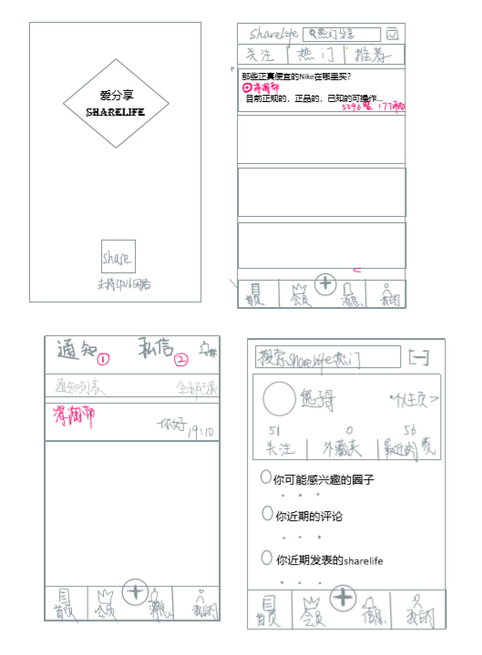

(c) Function introduction：

1. Registration and login function module: user registration, login and modification of personal registration information;   
2. Browsing function module: users browse the section and view articles;   
3. Publish articles, comment function module: users publish articles, comment articles, edit their own articles;   
4. The article management function module: the administrator edits, deletes, sets the top and assigns the essence post;   
5. Management block function module: the administrator creates, modifies and deletes the forum;   
6. User management module: administrators add, delete and set user rights.   
7. User interaction module: users can add friends to each other and send private messages.

8. Users can set the privacy level of the diary, such as everyone or friends, to achieve privacy protection.