Description: 2

1 Building package procedure on the External WSUS server 3

1.1. Determine the KBs needed per Group of Servers 3

1.2. Synchronize external WSUS server 3

1.3. Decline all updates on WSUS server 4

1.4. Delete WSUS content folder 4

1.5. Approve all needed KBs 5

1.6. Create the Update Package for the internal WSUS system 6

2 Deployment package procedure on the Internal WSUS server 7

2.1. Pass the new updates to WSUS content folder. 7

2.2. Pass meta data to WSUS DB 7

3 Improvements 9

4 Conclusion 10

Description:

It is a necessity, providing regularly Microsoft update packages, on Windows servers. When updates are to be installed in many machines WSUS servers are the best available MS tool. It is often needed for Windows server systems to both stay isolated behind firewalls without any interaction with outside world, but simultaneously stay updated especially with Microsoft security updates, KBs, through an offline WSUS server.

The current document briefly describes a method for updating Windows server systems, through an internal WSUS, in an offline way. In this case we will focus on a procedure for building such an Update package (it can contain any KBs) on a WSUS server connected to internet, and then the procedure, when transfer to isolated system, to install this package on the Internal WSUS server.

Some overcome difficulties, especially regarding the size of the package, will be explained and improvements will be quoted along with limitations. Automated PowerShell scripts will be provided.

Basic understanding of Microsoft’s WSUS system is needed.

1. Building package procedure on the External WSUS server
   1. Determine the KBs needed per Group of Servers

Initially we need to conclude on the appropriate KBs we need to include on out Package.

*In case we use the PowerShell scripts provided on the later sections, we can add the KBs we want on each WSUS server group we have configure on our WSUS server on the appropriate text files (eg: GroupA.txt, GroupB.txt as explained on ApproveAll section)*.

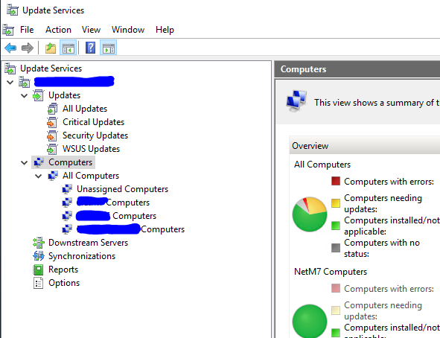

* 1. Sy**nchronize external WSUS server**

The first step is to run “Synchronize Now” on WSUS GUI (WSUS GUI 🡪 Update Services 🡪 “Name” of WSU Sserver 🡪 On the right pane, click on “Synchronize Now”).

On Download Status below, you should be seen “Updates needing files: 0”. Then you are ready for the next step.

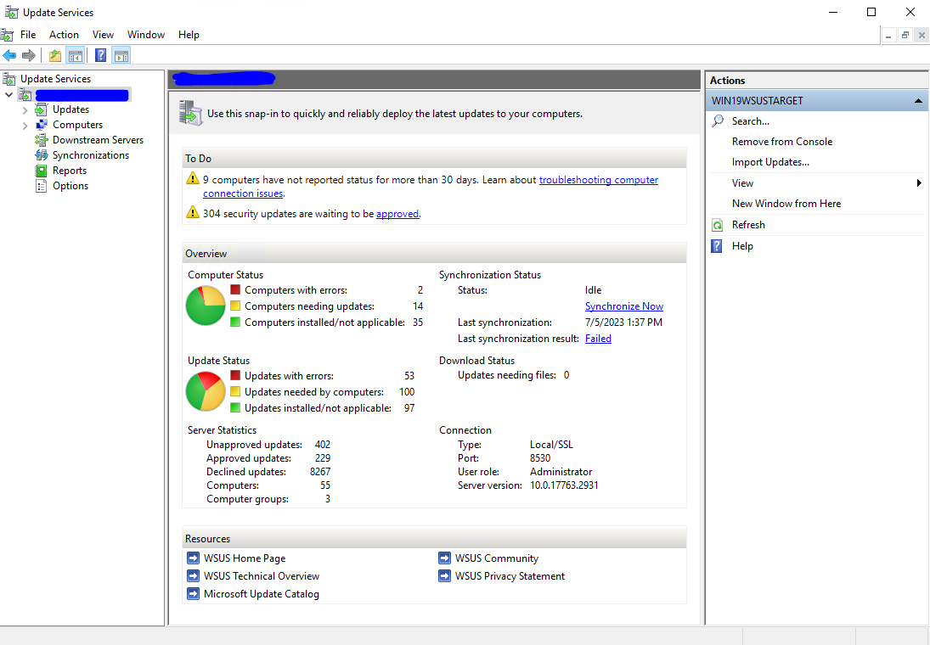

*By cliking “Synchronize Now” you have instruct WSUS to download ALL updates from Microsoft for all assigned Classifications. These are stored on WSUS DB. Approved updates are stored as well on WSUS content folder.*

* 1. Decline all updates on WSUS server

Next we need to “DECLINE” all updates on our WSUS Server.

From WSUS GUI we can select WSUS GUI 🡪 Update Services 🡪 “Name” of WSU Sserver 🡪 Updates 🡪 All Updates.

Then on Approval: select “Any except Declined” AND on Status: “Any” and click “Refresh”

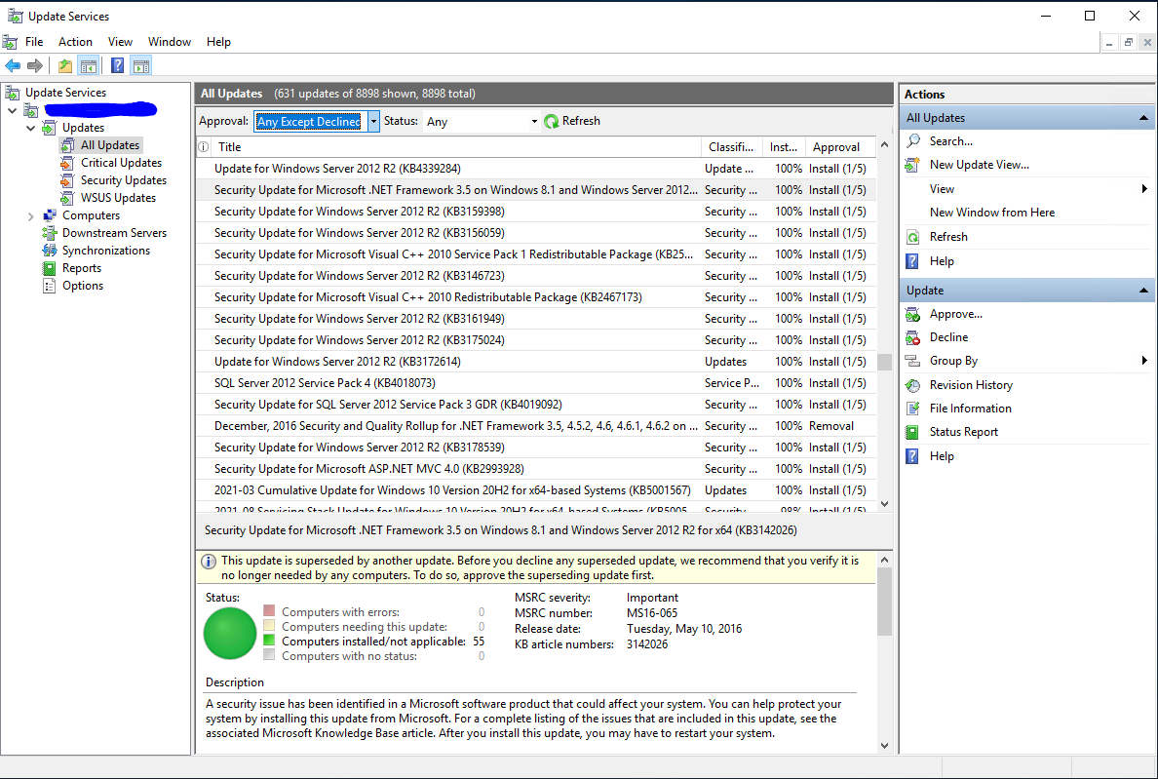

Then Select all (ctrl + a) and right click 🡪 Decline.

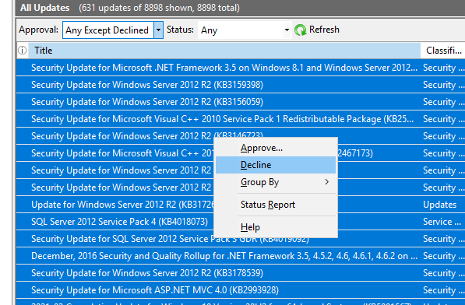

Alternatively you can run the script: “DeclineAll.ps1”

* 1. Delete WSUS content folder

Next we need to delete the WSUS content (To start WSUS content from scratch).

This step is very important because it reduces the size of the final package.

Navigate to the WSUS content path of your WSUS server (In my case is e:\WSUS\WsusContent) and delete everything inside.

The folder should be empty after deletion.

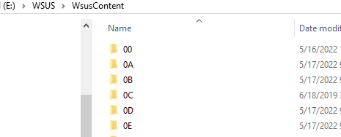

Alternatively you can run the script: “Delete_WSUS_content.ps1”

* 1. Approve all needed KBs

Approve all needed KBs.

From WSUS GUI we can select WSUS GUI 🡪 Update Services 🡪 “Name” of WSU Sserver 🡪 Updates 🡪 All Updates.

Then on Approval: select “Declined” AND on Status: “Any” and click “Refresh”

Wait for a while for the GUI to be populated.

On the right pane under Actions, click “Search”. Add the KB numbers and search, and then right click on the appropriate KB and “Approve”. Do for the rest of the KBs you want to add to your package

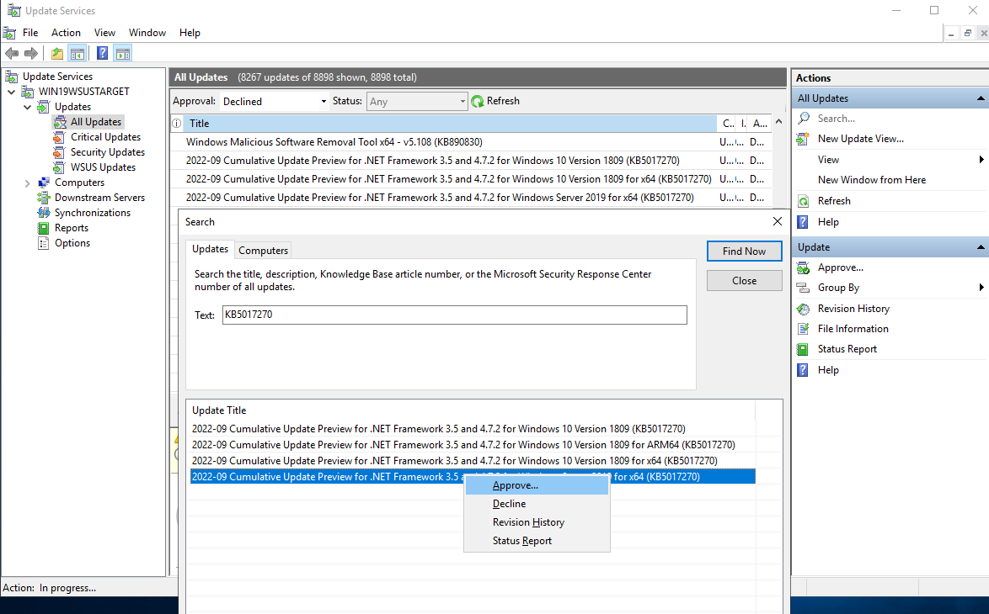

On WSUS GUI download and install all KBs needed.

Alternatively you can run the script: “Approve4Install.ps1”

On the same folder you run the script, you should have the files with the KBs you need for the appropriate group of servers (files: “GroupA.txt”, ”GroupB.txt”)

* 1. Create the Update Package for the internal WSUS system

From this point and on, WSUS content (with reduced size) along with the “meta” file are ready for collect and construct the Package.

The WSUS content folder can be just copied with the windows “copy” and “paste”, or other cmd tools like “robocopy”. This will be one of the parts we will hand in on our package.

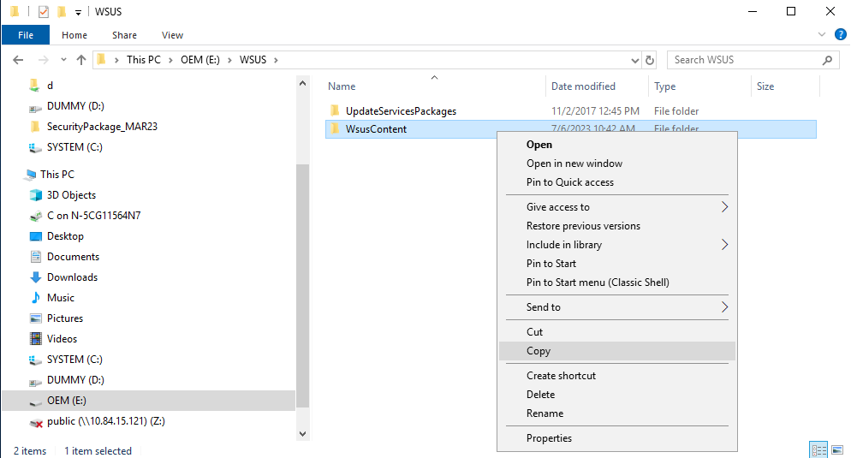

Next we need the “meta” data *WSUS-Export.xml.gz file*:

Open a cmd and run the following:

*C:\Program Files\Update Services\Tools\WsusUtil.exe export .\WSUS-Export.xml.gz .\WSUS-Export.log*

The “*WSUS-Export.xml.gz*” is the second file needed to be included in the hand in package.

1. Deployment package procedure on the Internal WSUS server

On the target site where the offline internal WSUS resides, we should need to follow the next steps to deploy the package:

* 1. Pass the new updates to WSUS content folder.

First you need to ADD the actual updates to WSUS server. The easiest way to do so is by using “Robocopy” command:

On the folder you have the “WSUS content folder” from the package you have just created you run:

*robocopy .\WsusContent E:WSUS\WsusContent /E*

The “*E:WSUS\WsusContent*” is the path of the internal WSUS on our example, and should be changed according to your configuration.

* 1. Pass meta data to WSUS DB

Then we need to pass the “meta” data. For this, we run the import process from the folder we have the “*WSUS-Export.xml.gz”*, and we run import:

C:\Program Files\Update Srvices\Tools\wsusutil.exe import .*WSUS-Export.xml.gz* .\WSUS-Import.log

Then we should approve the new Updates for installation. To do so we open the WSUS GUI:

From WSUS GUI we can select WSUS GUI 🡪 Update Services 🡪 “Name” of WSU Server 🡪 Updates 🡪 All Updates.

Then on Approval: select “Declined” AND on Status: “Any” and click “Refresh”

Wait for a while for the GUI to be populated.

On the right pane under Actions, click “Search”. Add the KB numbers and search, then, right click on the appropriate KB and “Approve”. Do for all KBs in your package.

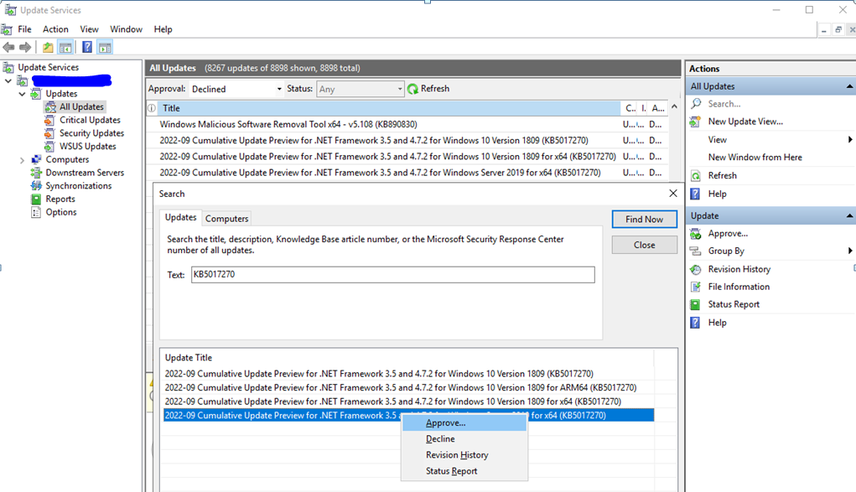

Alternately to approve the new Updates for installation we can run the script: “Approve4Install.ps1”

The updates should be ready for installation on all configured servers!

1. Improvements

A different procedure can be followed avoiding using WSUS external servers for creating a package of KBs to install on the internal WSUS.

For this procedure, we just download the KBs we need from “Microsoft Update Catalog site” from any computer connected to internet. Then we run the script provided “UpdateID.ps1” to extract the update ID. Next we transfer the downloaded “.msu” update to internal WSUS server and we are running the “DeployKB_WSUS.ps1” script. When asked we provide the “update ID” we previously extract.

A brief description of the steps for this procedure is the following:

* Go to Microsoft Update Catalog and download the appropriate KB.
* Run the script “UpdateID.ps1” and collect the KB ID.
* Then transfer the KB (the “.msu”) to the isolated system (with no connection to internet)
* Login to internal WSUS server.
* Create a folder c:\tmp and place there the kb (eg: windows10.0-kb5018419-x64_08f6e9eb4e8cb9f7af2b152e6dea624490a60b2d.msu) along with the script “DeployKB_WSUS.ps1”.
* Type the name - title of the KB as found on the Microsoft Update Catalog and the KB ID when asked from script. The KB will automatically install KB to WSUS server for providing to other connected servers.
* Finally you should “approve for install” the KB on the internal WSUS server.
* The update is ready to be installed on all approved servers.

1. Conclusion

The first method is more developed around the WSUS application of Microsoft and needs at least 2 WSUS servers, one connected to Internet and one on the isolates subsystem. This method has been tested providing update packages to customers for different Operating systems and many of functions needed are automated. All scripts referred on this document are included on the repository

An example of a full automated procedure (written in PowerShell) producing complete update packages can be found, on GitHub repository under name “AutoBuild_WSUS_UpdatePkg”. The S\W is significantly striped from extra functionality for easiness of reading and reference.

The second method, analyzed on improvements section, needed only one internal WSUS, is much faster, but it has been used only for few updates and little automation is created so far. Bear in mind that this method is based on the updates provided through Microsoft Update Catalog site, and only KBs able to be downloaded will work since the “.msu” is needed to be downloaded. As of now, KBs for upgrading Win10 kernel are not downloadable. This can be seen as a limitation of this procedure.

This procedure and software is provided “as is”, without warranty of any kind.

Feel free to contact me for any support, at a best effort basis.