# **Tasks**

**Learners have to develop a dashboard to support the answers to the following questions.**

**Objective Questions**:

1. What is the total no. of attributes present in the data?

* 16

1. Which columns have inconsistent or missing values, and what is the count of such values?

* There are 3 spelling mistakes in the sheet. Other than that there are no inconsistent or missing data.
* In the severity status it should be major instead of mayor.
* Unclassified spelling is wrong in severity.
* Unassigned spelling is wrong in Priority.

1. What is the average daily ticket volume over time?

* 53

1. What is the distribution of ticket categories (e.g., Login Access, System, Software)?

* I created a pivot table to find distribution of ticket categories with category as row and count of tickets as value.

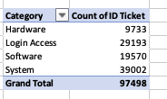

* Using the pivot table mapped a pie chart to visualise the distribution.

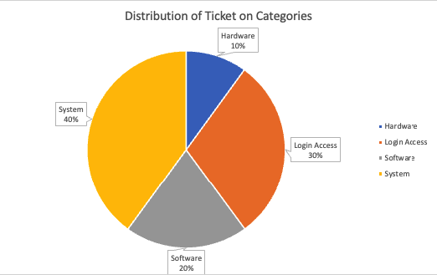

1. How many tickets has each agent handled?

* I created a pivot table for this with Agent Name as rows and Count of Tickets for each agent as value.
* Along with that utilized HLOOKUP to get the names of each agent.

|  |  |
| --- | --- |
| **Agent Name** | **Count of ID Ticket** |
| Aurelio Tanori | 2027 |
| Jesus Contreras | 2026 |
| Elena Velez | 2021 |
| Melinda | 2007 |
| Barbara Grijalva | 2003 |
| Willyberto Gonzales | 2000 |
| Galindo Guadalupe | 1991 |
| Barraza Alberto | 1988 |
| Guadalupe Torrico | 1987 |
| Alfonso Barraza | 1984 |
| Alberto Casillas | 1974 |
| Silvia Morales | 1974 |
| Mata Lucero | 1969 |
| JesusGrajeda | 1968 |
| Isela Leyva | 1968 |
| Lorena | 1966 |
| Aldo Carrillo | 1966 |
| Flores Sierra | 1963 |
| Parra Luna | 1963 |
| Leon Lourdes | 1961 |
| Marisol Piedrahita | 1960 |
| Guadalupe Villanueva | 1958 |
| Lopez Moran. | 1956 |
| Rosa Olguin | 1950 |
| Ramon Macias | 1949 |
| Velasquez Jose | 1949 |
| A. Trejo | 1949 |
| Nurio Zepeda | 1946 |
| Darwin E. | 1945 |
| Eva Cardenas | 1943 |
| EstuardoTorres | 1942 |
| Enrique Montiel | 1938 |
| Estuardo Ocaño | 1935 |
| Yomaira Agudelo | 1933 |
| Segura Garcia | 1931 |
| Jesus Pacheco | 1931 |
| Luis Arguello | 1929 |
| Diana Rojo | 1927 |
| Orci Carlos | 1926 |
| Eduardo Luna | 1920 |
| Alfredo Barreras | 1920 |
| Guadalupe Hernandez | 1915 |
| Luis Torres | 1913 |
| Sandra Lujan | 1906 |
| Javier D. | 1897 |
| Reyna Santacruz | 1897 |
| Miller Gaviria | 1892 |
| Armando Sierra | 1890 |
| Alberto Gastelum | 1889 |
| Griselda Galindo | 1856 |
| **Grand Total** | **97498** |

1. How can you extract the domain from the email addresses in the IT Agents sheet?

* I used the following formula: =MID(R5,FIND("@",R5)+1,LEN(R5)-FIND("@",R5)-4)

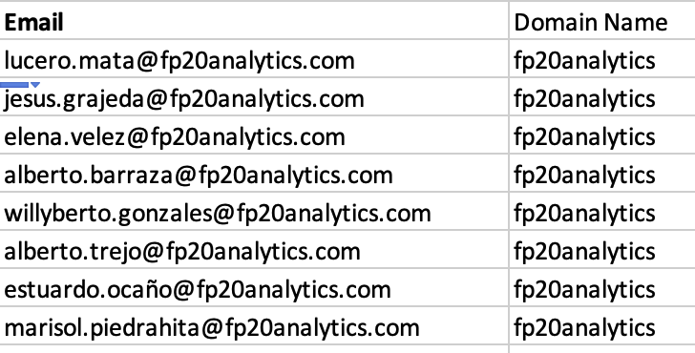

1. How can you find the full name of an agent given their Agent ID?

* I used VLOOKUP to find full name of the agent with there Agent ID.

=VLOOKUP(D2,IT_Agents[[#All],[Agent ID]:[Email Domain]],2,0)

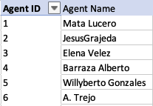

1. What is the count of each issue type (e.g., IT Error, IT Request)?

* I created a pivot table with issue type as row and count of ticket as value.



1. What is the daily average resolution time for tickets?

* I created a pivot table with date as row and average of resolution time (Days).

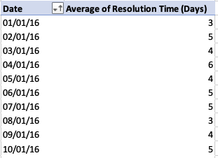

* The daily average resolution Time is 4.5 days.
* Utilized Average() and Round() functions.

1. How has the volume of tickets changed over time?

* The volume of IT tickets demonstrates a clear and robust trend of significant and continuous growth from 2016 to 2020. Starting at 13,051 tickets in 2016, the total volume more than doubled to 29,088 by 2020, with each subsequent year marking a substantial increase. Notably, 2020 experienced the most dramatic acceleration, with monthly ticket counts consistently exceeding 2,000 and reaching an all-time high of 2,609 in December. While there are some seasonal fluctuations with tendencies for higher activity in the first quarter, mid-year, and towards year-end, the overall pattern indicates an escalating demand for IT support with no significant periods of reduced volume.

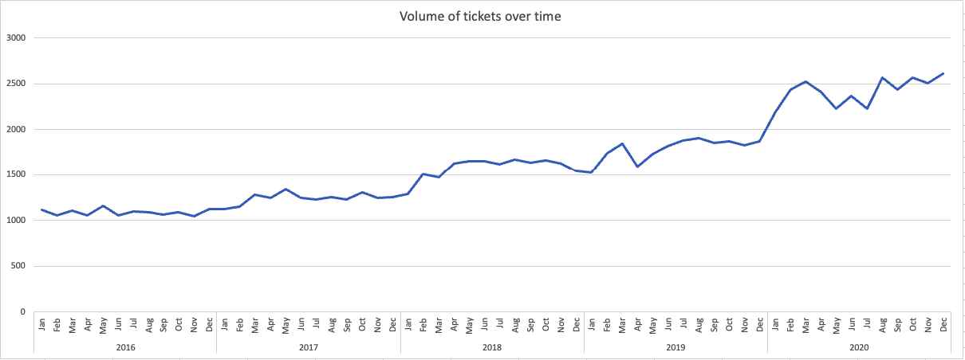

1. What is the average age of the IT agents?

* To calculate the age first I constructed the date using year,mont and day of birth of each agent and used datedif function
* Formula Used: =DATEDIF(DATE([@[Year of Birth]],[@[Month of Birth]],[@[Day of Birth]]),TODAY(),"Y")
* Then I used average() function to find the average age of agents and Round() to get floor value.
* Average Age of IT agents: 40 years old

1. Is there a correlation between the severity of issues and the resolution time?

* The correlation between severity and resolution time is : -0.040536.
* Use the following formula =CORREL(Tickets!M:M,Tickets!K:K).
* This value indicates a very weak negative correlation.This suggests that there is almost no linear relationship between how severe an issue is and how long it takes to resolve. A negative correlation would mean that as severity increases, resolution time tends to decrease, but in this case, the correlation is so close to zero that it suggests that severity has little to no impact on the resolution time.

1. How many categorical columns are there in the data? [Search about categorical and continuous data, and try to answer this question]

* Categorical data refers to data that can be divided into groups or categories, such as types, or labels. It does not have a numerical meaning that can be used for calculations. Continuous data, on the other hand, refers to numerical data that can take any value within a given range.
  + Request Category
  + Issue Type
  + Severity
  + Priority

**Subjective Question:**

1. If there is an investment, should it be used to hire more IT agents, improve training programs, or upgrade ticket management software?

Analysis: Perform a cost-benefit analysis using ticket resolution and satisfaction metrics.

* What is Cost-Benefit Analysis?
  + Cost-Benefit Analysis is a systematic process that organizations use to analyze decisions, projects, or policies. The core idea is to compare the total expected costs of an action with its total expected benefits. The goal is to determine if the benefits outweigh the costs, and by how much, to help make an informed decision on whether to proceed with a project or which option to choose among several alternatives.
  + By quantifying both costs and benefits ,this provides a structured framework for decision-making, aiming to maximize value or achieve goals most efficiently.

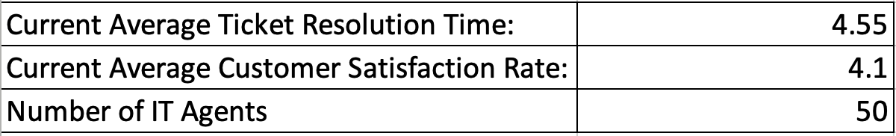

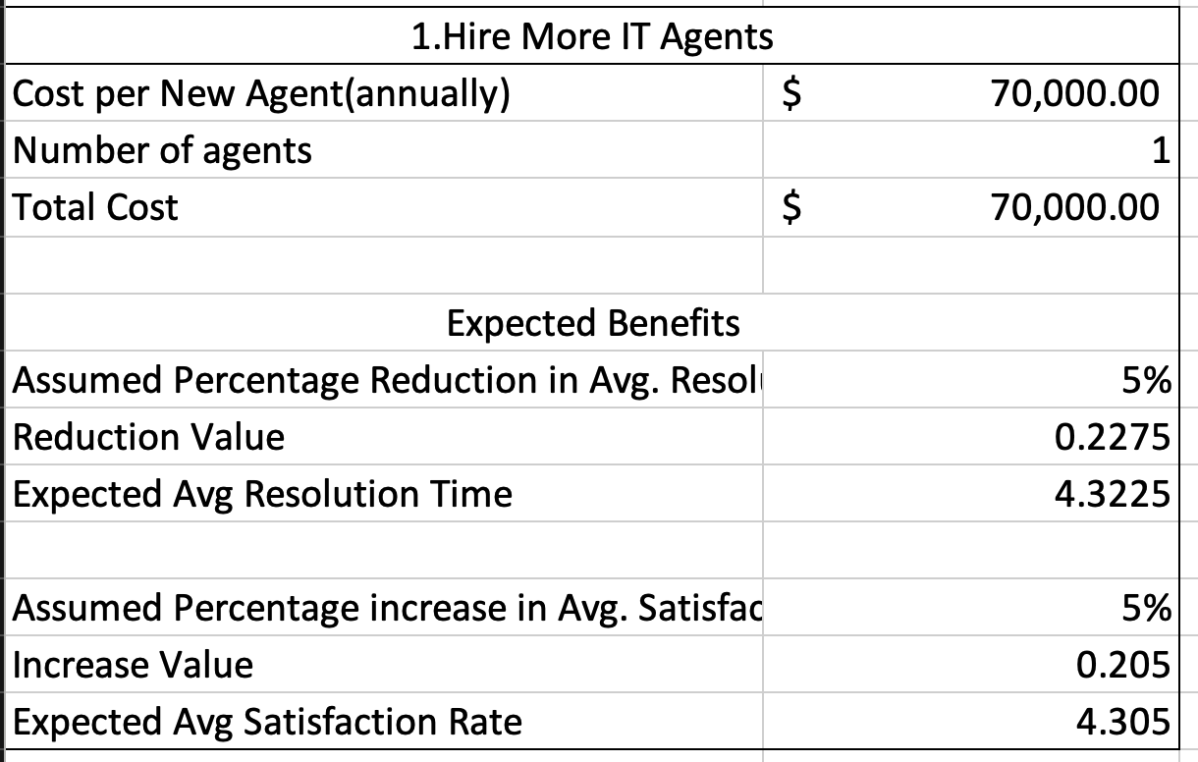

Scenario 1:Hiring More IT Agents:

* Benefits:
  + Adding staff directly enhances the speed of service and user happiness.This option increases capacity to handle existing demand but doesn't prevent issues from arising.
* Cost:
  + Salaries, Benefits and recruitement.
  + Time Consuming.
  + Re-occuring cost: Salary,Benefits,Infrastructure.

* Summary: This is primarily a capacity-scaling solution. It provides rapid improvements in service speed and user satisfaction but comes with significant, continuous financial outlay and does not address the root causes of ticket generation.

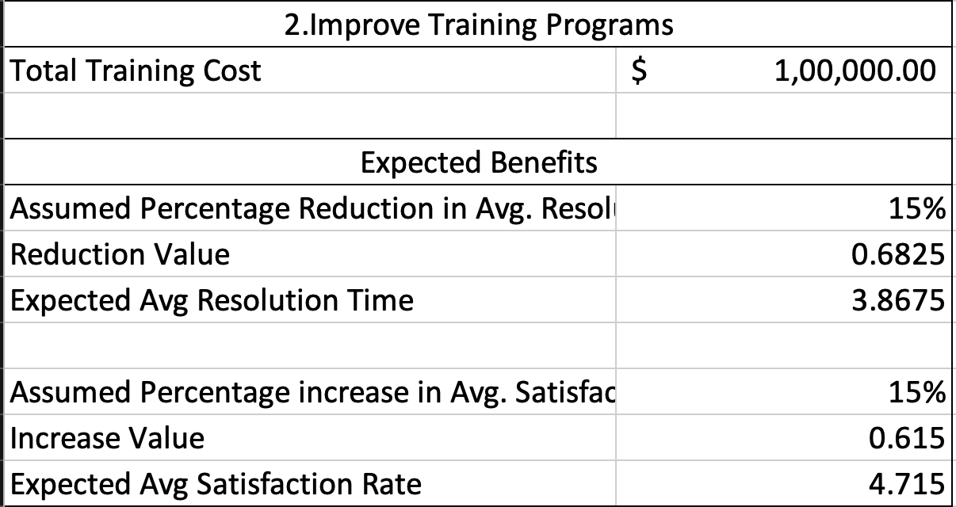

Scenario 2:Improved Training Programs:

* Benefits:
  + Enhancing agent skills directly leads to more efficient and higher-quality service. Better trained agents might resolve issues more comprehensively, reducing repeat contacts, or empowering users for self-service more effectively.
* Cost:
  + Cost of organising and training.
  + Training requires time to complete and for skills to be fully integrated into daily operations.
* Summary:
  + This scenario offers an excellent balance of benefits versus costs. It achieves significant improvements in efficiency and user satisfaction at a relatively moderate expense, while also contributing to a reduction in overall demand. It empowers the existing workforce.

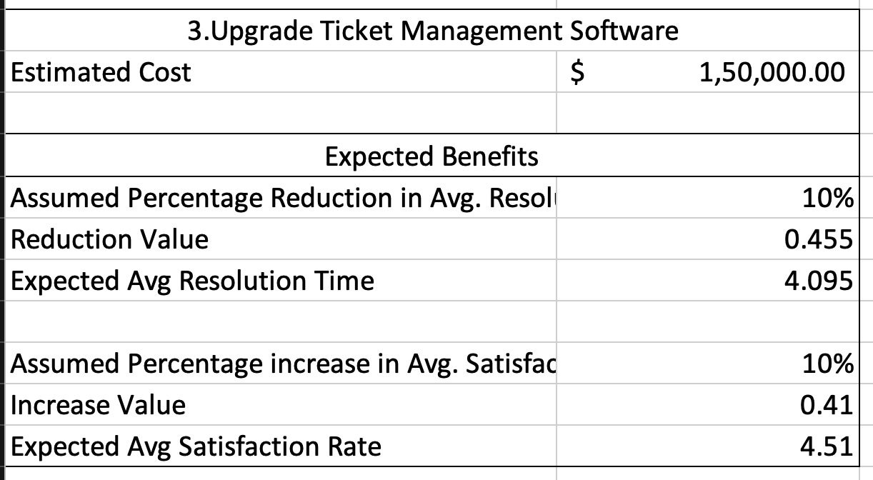

Scenario 3:Upgrading Ticket Management Software:

* Benefits:
  + A modern Ticket Management Software can introduce powerful features like advanced self-service portals, automation (e.g., AI chatbots, intelligent routing), and enhanced knowledge bases, which are key to preventing tickets from ever reaching an agent.
* Cost:
  + Cost of licensing,customization and implementation.
  + Training agents and customer with new software.
  + Scale software deployments are complex projects requiring extensive planning, development, testing, and user adoption phases.
* Summary:
  + This is a strategic, long-term investment. Its primary strength lies in proactively managing and reducing the demand for IT support, making operations more scalable and fundamentally efficient. However, it requires a substantial initial investment and a longer period to realize its full benefits.
* Conclusion:

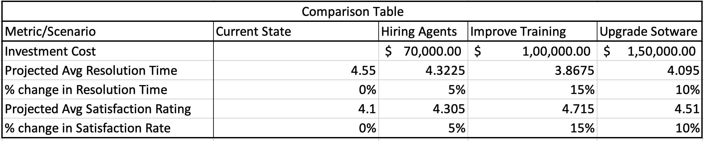

* + Based on the cost-benefit analysis derived from comparison table, and carefully weighing the projected impact, cost, and time-to-impact for each option: The most advantageous initial investment, offering the most efficient return on investment in the short-to-medium term, is to Improve Training Programs.
  + Why Improve training program is chosen?
    - It delivers high benefits in both Resolution Time Reduction and Satisfaction Rate Improvement two of the most critical customer-facing metrics – at a comparatively moderate financial cost.
    - Immediate impact can be observed within a reasonable time frame, allowing for relatively quick validation of the investment.
    - By enhancing the skills of existing IT agents, we not only improve their efficiency and service quality but also enable them to potentially resolve issues more completely, contributing moderately to reducing recurring tickets and overall demand. This is a more sustainable solution than simply adding more capacity.
* Recommendation for medium to long term:
  + While Training program is recommended for immediate focus, it's also crucial to acknowledge that it does not offer the same high potential for ticket volume reduction as a Ticket management Software upgrade. Given the observed year-over-year growth in IT ticket volume, a strategic investment in Upgrading Ticket Management Software should be planned for the medium to long term. This will be essential for achieving sustainable growth, significant automation, and shifting towards a more fundamentally proactive and scalable IT support model that genuinely reduces incoming demand.

1. Which agents need additional training based on their performance metrics?

Analysis: Identify agents with the lowest satisfaction ratings and longest resolution times.

Answer:

To identify which agents might need additional training, we have to analys their performance based on average ticket resolution time and customer satisfaction rates.

* Agents with lowest Average Satisfaction Ratings:
  + Alfonso Barraza (Agent ID: 19) - Average Satisfaction Rate 3.04
  + A. Trejo (Agent ID: 6) - Average Satisfaction Rate: 3.59
  + Sandra Lujan (Agent ID: 25) - Average Satisfaction Rate: 3.60
  + Nurio Zepeda (Agent ID: 28) - Average Satisfaction Rate: 3.61
  + Elena Velez (Agent ID: 3) - Average Satisfaction Rate: 3.62
* Agents with the longest Average Satisfaction Ratings:
  + Jesus Contreras (Agent ID: 39) - Average Resolution Time: 5.55 days
  + Estuardo Ocaño (Agent ID: 7) - Average Resolution Time: 5.52 days
  + Lorena (Agent ID: 22) - Average Resolution Time: 5.51 days
  + Ramon Macias (Agent ID: 50) - Average Resolution Time: 5.45 days
  + Mata Lucero (Agent ID: 1) - Average Resolution Time: 5.45 days

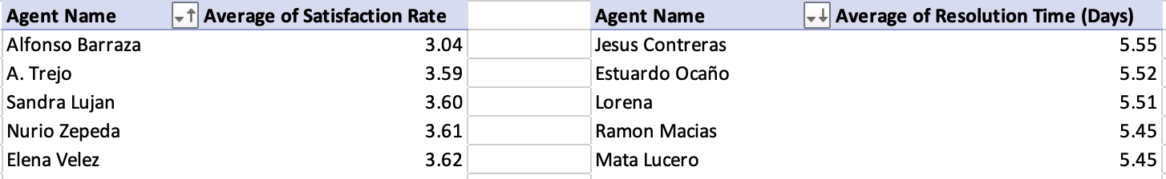

* Insight:
  + The analysis did not find any agents who were simultaneously in both the lowest satisfaction group and the longest resolution time group. This indicates that the performance challenges are distinct, allowing for more precise and effective training solutions.
* Recommendations:
  + Provide specialized training focused on customer service and communication skills.
  + Implement technical proficiency and process efficiency training. This should cover advanced troubleshooting for common issues, optimized use of diagnostic tools, efficient navigation of the ticket management system, and effective utilization of knowledge bases. Training here aims to boost their speed and accuracy in resolving technical problems.

1. Do certain categories of requests have longer resolution times?

Analysis: Analyze the resolution times by request category.

* The average resolution time for each request category

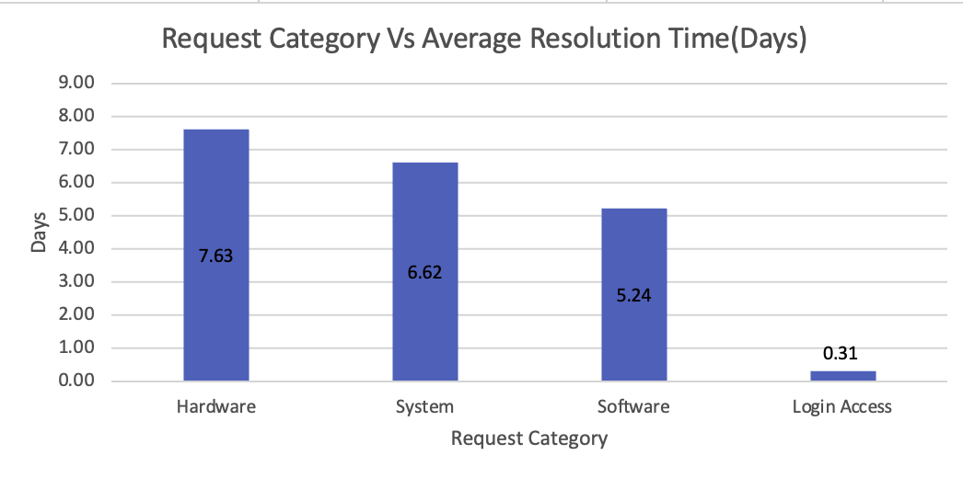

* Insights:
  + The analysis shows clear differences in resolution times by request category. Hardware issues take the longest at 7.63 days, followed closely by System issues at 6.62 days. Software requests are moderate at 5.24 days. In stark contrast, Login Access requests are resolved very quickly, averaging just 0.31 days. This indicates that complexity significantly impacts resolution time.
* Recommendations:
  + Learn from Login Access Success: Analyze the efficient processes for Login Access requests. Identify any automation or streamlined procedures that could be adapted to other, less complex issues in other categories.
  + Focus on Hardware and System: Prioritize efforts on Hardware and System categories due to their long resolution times. This includes specialized technical training, potentially assigning dedicated expert teams, and enhancing the knowledge base specifically for these complex issues.
  + 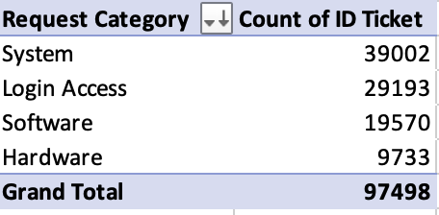
  + Investigate System Categories due to their high volume.

1. How effective are the current software tools in managing IT tickets?

Analysis: Evaluate performance metrics before and after the implementation of new tools.

Answer:

* Since there is no before and after data available that specifically tracks software tool implementations and corresponding performance metrics, we cannot directly evaluate the effectiveness of new tools by comparing past and present states. Instead, we will analyze the current effectiveness of ticket management system, which is supported by existing software tools, by examining the overall performance metrics reflected in the provided data. This approach allows us to understand how effectively the current tools, in conjunction with agents and processes, are facilitating IT support.
* Insights:

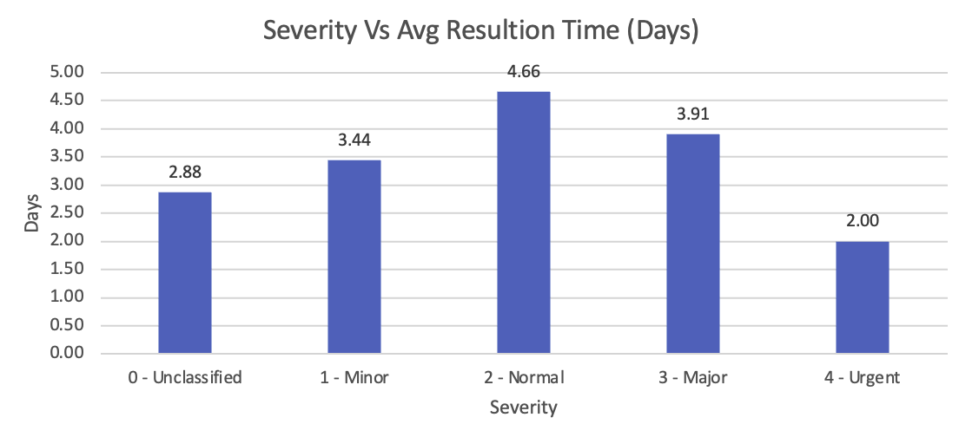

* + The ideal expectation is that as severity decreases, the average resolution time should increase. Ideally, an effective IT ticket management system (including its software) should ensure that higher severity issues are resolved in a shorter amount of time, as they have a greater impact on users or business operations.
  + This indicates a significant inefficiency.
    - Prioritization Logic Flaws: The software's prioritization rules might be misconfigured, or agents might not be adhering to them, leading to 'Normal' tickets being inadvertently neglected or de-prioritized beyond what's appropriate.
    - Initial Triage Issues: There could be a problem with how tickets are initially classified, where complex issues are mislabeled as 'Normal' but then take disproportionately long to resolve due to their true underlying complexity.

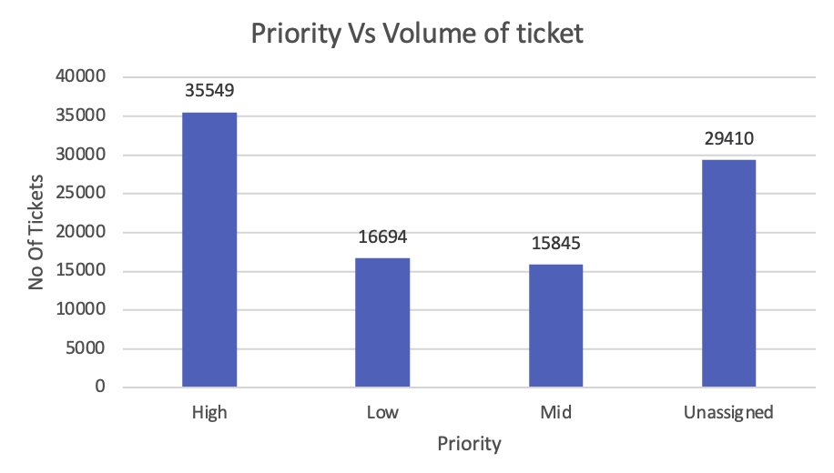

* + Having over 30% of tickets (29,410 tickets) with an Unassigned priority is a significant inefficiency. This means nearly a third of incoming IT requests lack clear direction, delaying resolution and making it impossible to prioritize effectively. It points to a critical flaw in how ticket management software is configured or used, as it's not ensuring that every ticket gets an immediate and proper priority.
* Recommendations:
  + Reconfigure Prioritization Logic.
  + Configure the ticket management software to mandate priority assignment at the point of ticket creation or initial logging. No ticket should be able to proceed without a defined priority.
  + Conduct a deep dive into the workflows for Hardware, System, and Software related tickets. Identify specific bottlenecks within the software's current processes that contribute to their long resolution times.
* In summary, while the current tools fall short, implementing a superior IT ticket management software would address these specific inefficiencies head-on, leading to faster resolution times, improved satisfaction rates, better utilization of resources, enhanced accountability, and a more effective IT support operation overall.
* The current software tools are effective in handling routine, simpler tasks, likely through good automation or streamlined processes. However, they demonstrate significant inefficiencies in managing ticket prioritization, ensuring complete data entry (like priority assignment), and facilitating the quicker resolution of more complex or even "normal" severity issues. These inefficiencies suggest that while the tools provide a framework, there are substantial opportunities for improvement through better configuration, enhanced workflow automation, agent training on proper usage and prioritization, and perhaps, evaluating additional features for more complex ticket management.

1. How has the performance of the IT support team changed over time (e.g., monthly or quarterly)?

Analysis: Trend analysis using time series charts.

* The performance of the IT support team has changed over time, as observed through quarterly trends in average resolution time and satisfaction rate.

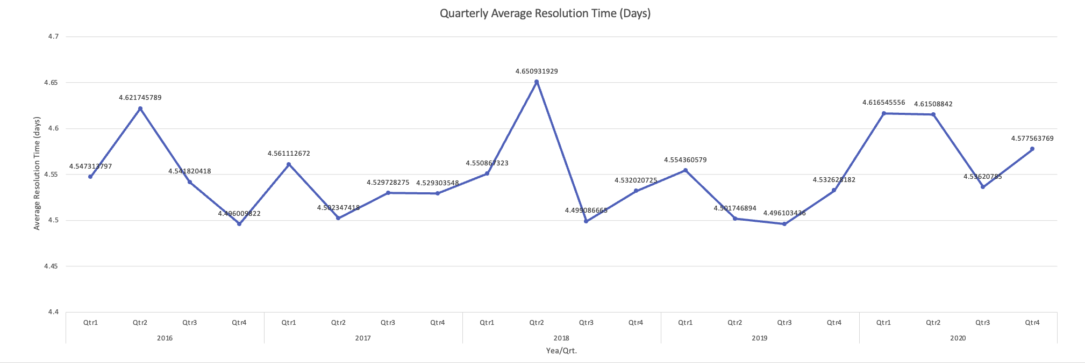

* + Quarterly Average Resolution Time (Days): As shown in the chart below, the average resolution time has displayed a general increasing trend across the quarters. This indicates that, on average, IT tickets have been taking progressively longer to resolve over the period.

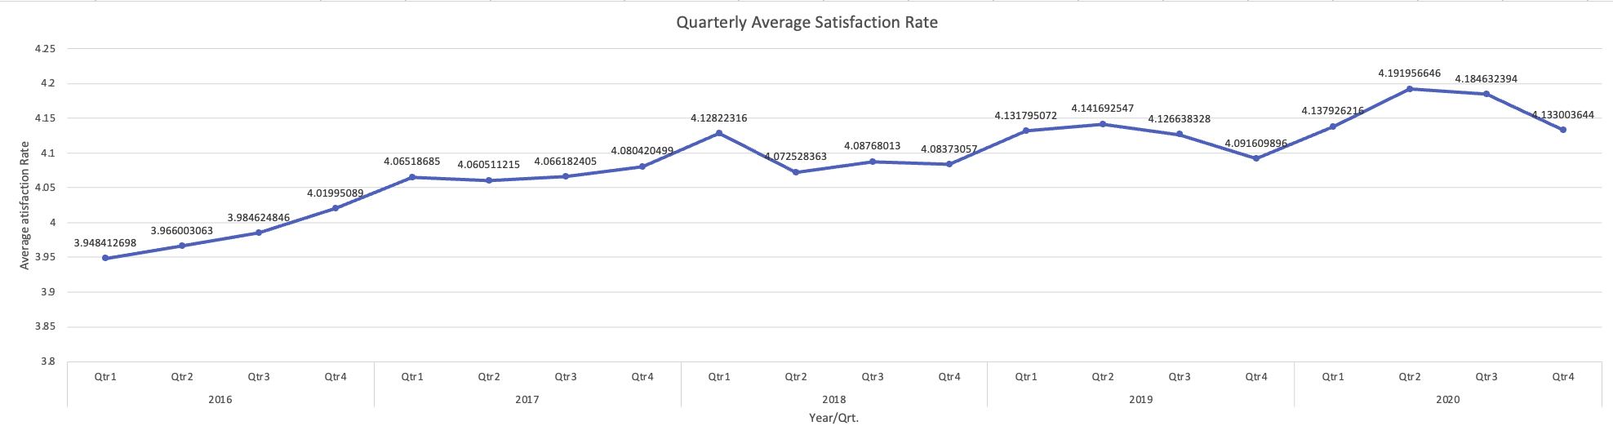

* + Quarterly Average Satisfaction Rate: The average satisfaction rate, as depicted in the chart below, has shown a slight overall upward trend throughout the quarters. While there are some minor fluctuations, the general direction points towards a gradual improvement in user satisfaction over time. This is a positive development, especially considering the increasing resolution times.
  + Despite the lengthening resolution times, customer satisfaction rates have remained remarkably stable and consistently high (hovering between 4.0 and 4.5 out of 5) throughout the entire period. This indicates that the team is successfully maintaining the quality of interaction and the effectiveness of their solutions from the customer's perspective, even if the speed of delivery is diminishing.
* Recommendations:
  + Conduct a deep dive to identify the specific factors contributing to the increasing average resolution time.
  + Leverage the insights from consistently high customer satisfaction.Analyze what aspects of the support interaction or solution delivery are driving satisfaction and ensure these are preserved or enhanced while streamlining for speed.
  + Based on the increasing trend in resolution times, forecast future demand and assess whether current staffing levels and agent skill sets are adequate.
* These quarterly trends provide a clear overview of the IT support team's performance evolution, highlighting both areas of improvement (satisfaction) and areas that may require further attention (resolution time).

1. If we invest more on tech (Hardware, software, etc), do you think it will improve the ticket resolution times and employee satisfaction?

Analysis: Use historical data to project potential improvements.

* Investing in hardware and software etc can significantly change ticket resolution time and satisfaction rates as it has a high ticket tickets in volume

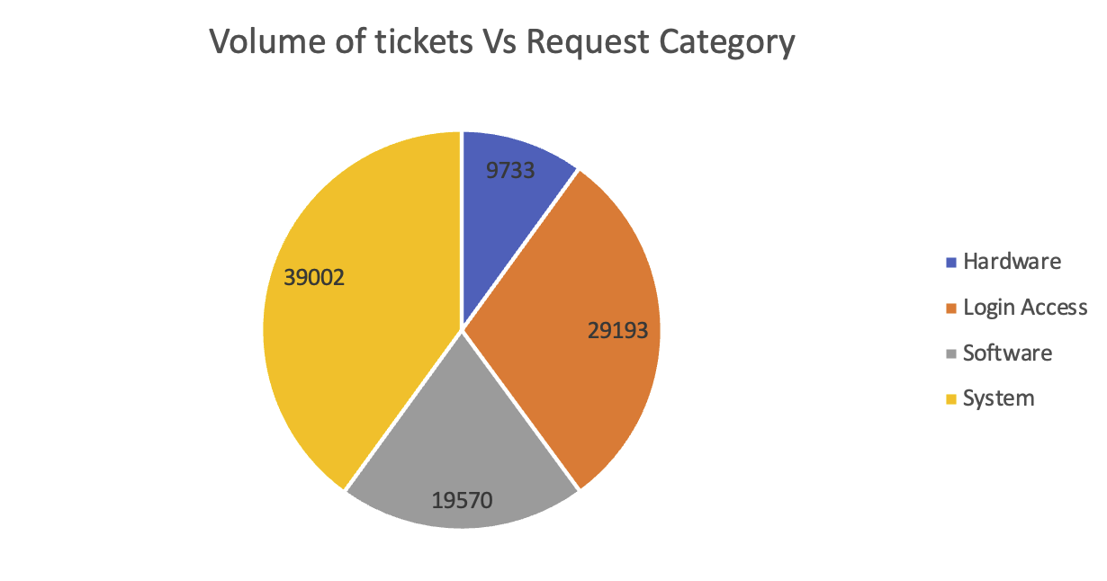

* Insights:
  + System (39,002 tickets) and Login Access (29,193 tickets) collectively account for the vast majority of IT requests, making them the largest sources of IT workload.
  + The sheer volume of tickets across all categories indicates a high demand for IT support, suggesting potential strain on resources and a constant flow of interruptions for employees.
  + Hardware has the lowest volume of tickets (9,733), suggesting it's not the most frequent type of problem users encounter.
* Recommendations:
  + Since System and Login Access are the highest volume categories, investment should primarily focus on automation and self-service solutions for these areas. For Login Access this means robust automated password resets and account unlock features. For System it points to proactive monitoring and automated initial diagnostics to reduce the sheer number of incoming tickets.
  + Given the high overall volume, assess if current IT staffing levels and skill sets are adequate. Investment in IT Ticket Management software with better routing and workload balancing capabilities can optimize existing resources and reduce technician burnout.

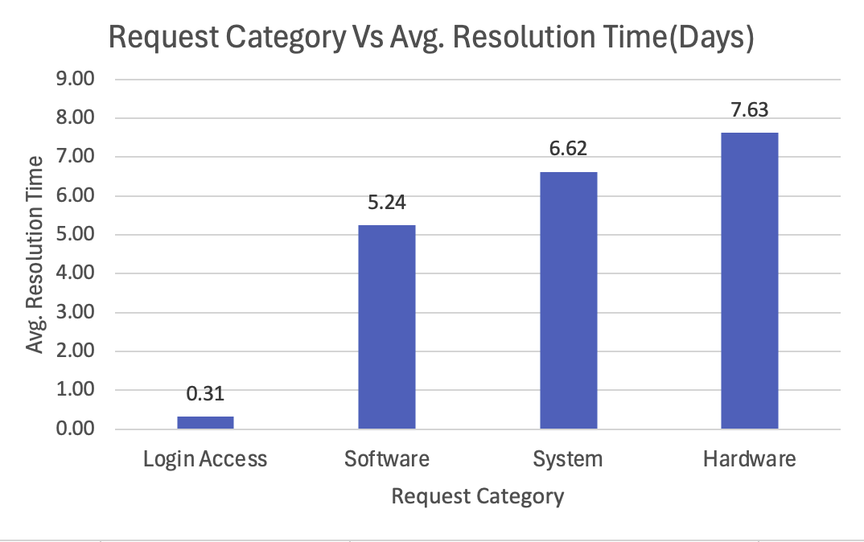

* Insights:
  + Login Access tickets are resolved remarkably quickly, averaging only 0.31 days (less than half a day).
  + Hardware tickets have the longest average resolution time at 7.63 days, indicating these issues take over a week to resolve on average.
  + Software (5.24 days) and System (6.62 days) fall in between, taking several days to resolve.
  + While Login Access has a very high volume, its resolution time is minimal. Conversely, Hardware has the lowest volume but the longest resolution time. System has the highest volume but a relatively long resolution time.
* Recommendations:
  + Given the already fast IT resolution of Login Access and its high volume, invest in user-facing self-service tools for password resets and account unlocks. This eliminates the need for IT intervention almost entirely, moving resolution time from fast to instant for the user.
  + Streamline Hardware Logistics: To address the extremely long Hardware resolution time, invest in better IT Asset Management systems, efficient spare parts inventory management, and potentially enhanced service level agreements with hardware vendors for quicker repairs or replacements.
  + For System and Software issues, invest in advanced remote diagnostic tools and a robust, easily searchable knowledge management system for IT staff. This will help technicians quickly identify root causes and access solutions, cutting down the multi-day resolution times.

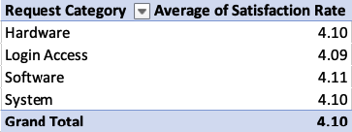

* Insights:
  + All categories show a remarkably similar and high average satisfaction rate, hovering around 4.10 out of a possible 5.0.
  + Despite significant differences in ticket volume and resolution times across categories, the satisfaction rates remain nearly identical.
  + Users might be generally satisfied with the outcome once the issue is resolved, even if the wait time is long, or they appreciate the effort of the IT team regardless of speed.
  + The satisfaction survey might be biased or not sensitive enough to capture granular differences in user experience.
* Recommendations:
  + Continue investing in IT staff training on customer service, empathy, and clear communication. The consistent high satisfaction suggests IT is doing well in terms of interaction, which should be maintained.
  + Consider conducting more granular user feedback surveys or focus groups to understand why satisfaction remains high despite varying resolution times. This can reveal specific aspects of IT service that are highly valued and should be further enhanced through training or specific tools.
* Conclusion: By making these targeted technology investments, the organization can expect significant improvements in overall ticket resolution times, a reduction in the total number of incidents, and a direct positive impact on employee satisfaction stemming from less downtime, quicker problem resolution, and a more efficient work environment. The existing high satisfaction provides a strong foundation upon which these improvements can build even greater trust and efficiency.

1. What are the key performance metrics for IT agents, and how can they be improved, do we need to fire any agents?

Analysis: Define and analyze metrics such as average handling time, satisfaction scores, and number of tickets resolved.

* Based on available data, the key performance metrics for IT agents are:
  + Average Satisfaction Rate: This metric reflects customer feedback on the service provided by an agent, indicating how satisfied users are with the resolution and interaction. A higher score is better.
  + Average Resolution Time (Days): This measures the average time an agent takes to resolve a ticket from its creation to closure. A lower number of days indicates greater efficiency.
  + Number of Tickets Resolved: This metric quantifies the volume of work an agent handles. A higher number indicates higher productivity, assuming quality is maintained.
  + Reopen Rate: No of Tickets Reopened or escalated.

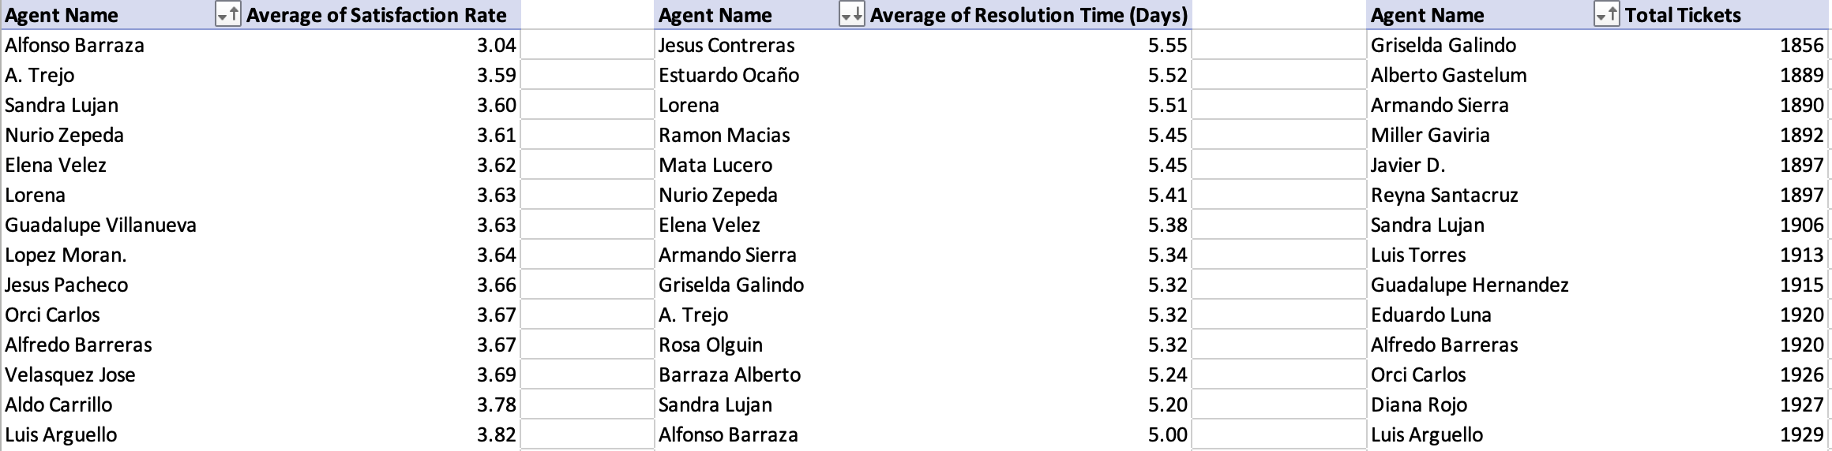

* Recommendations on how to improve these metrics:
* For low Satisfaction Rates:
  + Conduct feedbacks to encourage users to provide specific feedback and share this constructively with agents
  + Implement a process for agents to follow up after resolution to ensure user satisfaction.
  + Focus on communication skills, empathy, active listening, and setting clear expectations.
* For Long Resolution Times:
  + Targeted training on common or complex issues, especially in categories like Hardware and System which have longer resolution times overall.
  + Training on efficient workflows, use of diagnostic tools, and leveraging knowledge bases.
  + Ensure agents have quick access to necessary tools, documentation, and senior support for escalations.
  + Time Management, Training on prioritizing tasks and managing workload effectively.
* For Low Number of Tickets Resolved (if due to inefficiency):
  + Help agents organize their queues and handle multiple tasks efficiently.
  + Enable agents to fix problems thoroughly to prevent repeat issues that consume more time.
  + Performance Monitoring & Coaching, Regular one-on-one sessions with team leads to review metrics and provide personalized coaching.
* Do We Need to Fire Any Agents?
  + Based purely on the data provided, there is no immediate indication or justification to fire any agents.
* When Firing Might Be Considered (and why it's a last resort):
  + Metrics are consistently and significantly below team averages and agreed-upon standards, even after training and coaching.
  + If the agent shows no sustained improvement despite receiving targeted training, coaching, and being provided with the necessary tools and resources.
  + Due to under performance issues.
* The analysis highlights agents who need additional training and support, not necessarily dismissal. Focusing on improvement plans and targeted development is the first and most appropriate step. Based solely on these performance metrics, it is not appropriate to recommend firing any agents.
* In conclusion, the focus should be on empowering IT agents with better technology, streamlining their workflows, enhancing their skills, and providing consistent feedback. This proactive and supportive approach is much more likely to improve the key performance metrics and overall IT service quality than punitive measures like firing agents, especially given current positive satisfaction rates.

1. How do employee demographics (e.g., department, seniority) impact satisfaction and ticket outcomes?

Analysis: Segment analysis using filters and pivot tables.

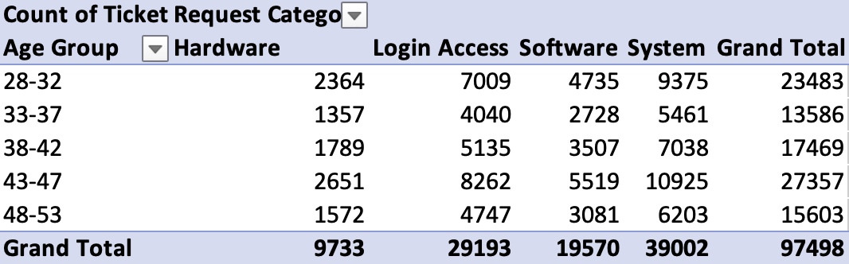

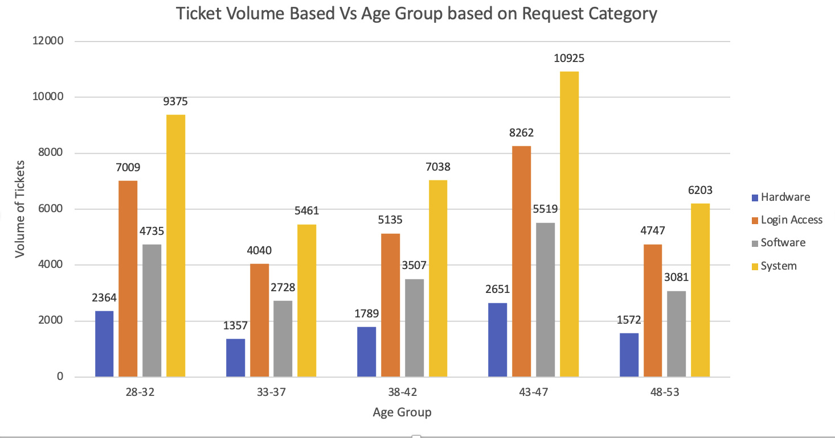

* Insights:
  + The 43-47 age group of IT agents resolves the highest number of tickets overall (27,357), followed by the 28-32 age group (23,483 tickets). This suggests these two age cohorts handle the largest share of the IT workload.
  + Across all agent age groups, System and Login Access remain the categories with the highest volume of tickets resolved, mirroring the overall distribution of incoming tickets. Agents are generally handling issues proportionate to their occurrence.
  + The 33-37 (13,586 tickets) and 48-53 (15,603 tickets) age groups of agents resolve significantly fewer tickets compared to the 28-32, 38-42, and 43-47 groups. This could indicate lower productivity, less capacity, or a different role (e.g., more specialized tasks not reflected in this volume, or higher-tier support with fewer but more complex tickets).
* Recommendations:
  + Invest in advanced Ticket Management tools with intelligent routing to ensure workload is distributed equitably and optimally across agent age groups, considering their capacity and expertise. Don't overload the 43-47 and 28-32 age groups, and investigate if the lower volume from 33-37 and 48-53 is intentional (specialization) or if they could handle more.
  + The high volume handled by 28-32 and 43-47 agents suggests they are highly active. Encourage them to document solutions in the knowledge base to enable junior or less experienced agents (potentially in other age groups) to handle more issues, thus improving overall team capacity.

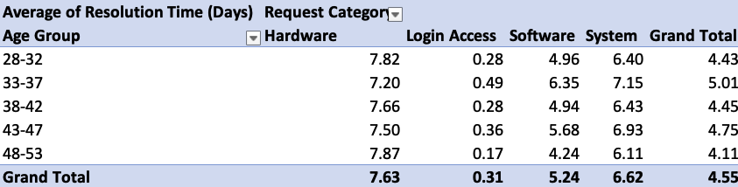

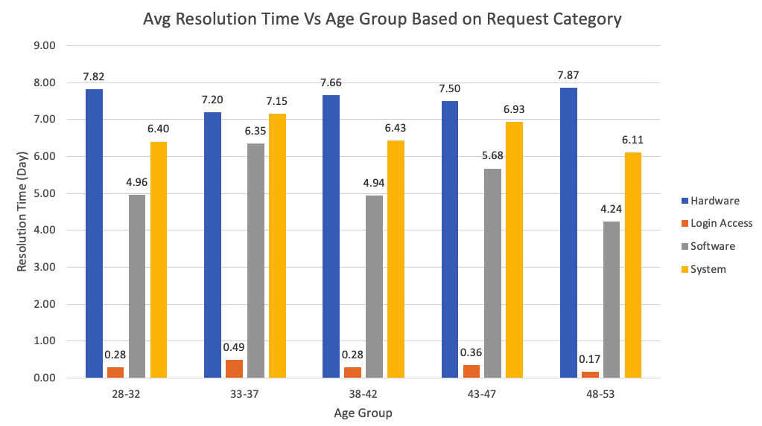

* Insights:
  + Hardware tickets have the longest resolution times for all agent age groups. This strongly indicates that the slowness is due to external factors or systemic process issues, not the specific agent's age or individual efficiency.
  + Login Access tickets are resolved quickly by all agent age groups, showcasing general IT efficiency in this area.
  + Age-Related Efficiency Discrepancies:
    - The 33-37 age group of agents has the longest average resolution times for System- 7.15 days and Software – 6.35 days.
    - The 48-53 age group of agents demonstrates the fastest average resolution times for System - 6.11 days and Software 4.24 days. This is a crucial insight – the most experienced agents (presumably, given their age) are resolving complex issues more quickly in these categories.
* Recommendations:

* + Focus training and development on the 33-37 age group of agents specifically for System and Software troubleshooting.
    - Deep-dive technical training on common issues in these categories.
    - Advanced diagnostic tool training.
    - Mentorship programs where they shadow faster-resolving senior agents
  + Utilize the expertise of the 48-53 age group agents. They are highly efficient in System and Software resolution. Encourage them to contribute to and refine the knowledge base. Establish them as mentors or subject matter experts for other agent groups. Consider assigning them more complex or high-priority tickets within their areas of expertise to maximize their efficiency.
  + As Hardware resolution is slow for all agent age groups, the focus remains on improving external processes, supply chains, and repair logistics rather than individual agent training.

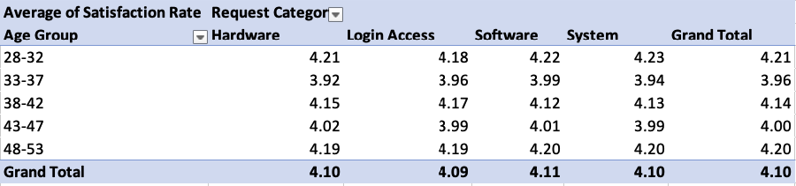

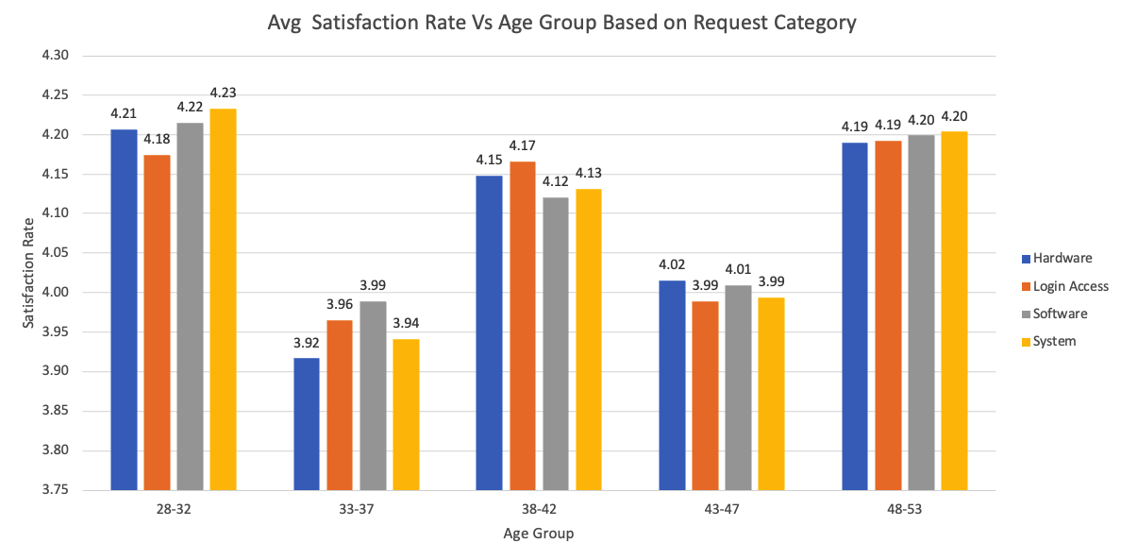

* Insights:
  + Customer satisfaction is consistently high around 4.00 to 4.20 for tickets handled by all IT agent age groups. This is a strong positive signal.
  + The 28-32 age group of agents achieves the highest average satisfaction rate 4.21.
  + The 33-37 and 43-47 age groups of agents show slightly lower overall satisfaction scores compared to others.
  + The 33-37 age group of agents, who have longer System and Software resolution times, also have a slightly lower satisfaction rate. This suggests that longer wait times, even if eventually resolved, can subtly impact satisfaction.
* Recommendations:
  + Understand what makes the 28-32 age group of agents so effective at achieving high satisfaction. Share these best practices across the team.
  + Since satisfaction is slightly lower for 33-37 and 43-47 groups, focus on refining their customer communication skills. This includes setting realistic expectations, proactive updates, empathetic listening, and ensuring clear post-resolution follow-up. While technical resolution is key, how the resolution is communicated matters.
  + Explicitly link the longer resolution times for 33-37 agents in System and Software to their satisfaction scores. Reducing those specific resolution times will likely automatically boost their satisfaction scores.
* Conclusion:
  + IT agent age significantly impacts ticket outcomes. While overall customer satisfaction is high, the 43-47 and 28-32 age groups handle the highest ticket volumes, while the 33-37 age group of agents experiences longer resolution times for System and Software issues, correlating with slightly lower satisfaction. Conversely, 48-53 year old agents are the most efficient in resolving these complex tickets. Hardware resolution is a systemic issue affecting all agent age groups.
  + In conclusion, strategic improvements should involve targeted training for the 33-37 age group, leveraging the expertise of 48-53 year old agents for mentorship and knowledge sharing, and implementing systemic process improvements for hardware. This data-driven approach will optimize IT operations, reduce resolution times, and maintain/enhance overall employee satisfaction.

1. Identify the trends for IT support operations based on ticket volumes and satisfaction, and mention the peak and stable times?

Analysis: Use pivot tables and charts to identify peak and off-peak hours.

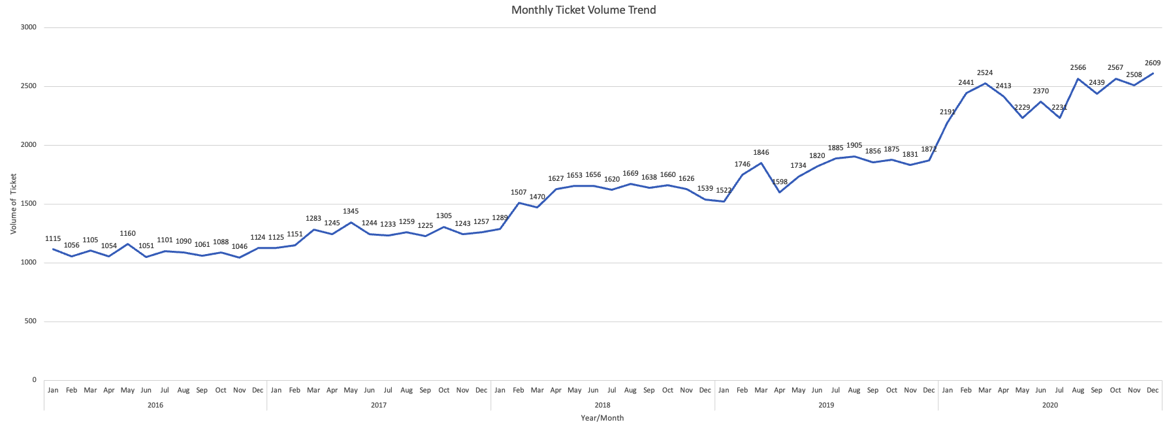

* Insights:
  + Ticket volumes consistently increased year-over-year, showing a significant rise in IT support needs.
  + Average satisfaction rates generally rose over time, indicating enhanced service quality despite increased workload.
* Ticket Volume Peaks:
  + Consistent Early-Year Surge: A recurring spike in demand observed from January through March/April each year.
  + Mid-to-Late Year Highs: Frequent periods of high volume in May-August and October-December.
  + Highest Peak: December 2020 saw the highest single-month ticket volume.
* Ticket Volume Off-Peak/Stable Times:
  + Relative Early-Year Dips: While an uptrend exists, January generally starts at a lower point within its quarterly surge.
  + Specific Monthly Lulls (Relative): Months like February and April (after the initial January spike) or some mid-year periods (e.g., June or July in some years, depending on the specific year's pattern) can show slightly lower activity compared to peak months within the same year. However, due to the overall growth, these "off-peak" periods in later years might still have higher volumes than "peak" periods in earlier years.
* Recommendations:
  + Plan for increased IT staff availability and resources from June to September to effectively manage the higher ticket volumes. This might involve managing vacation schedules, cross-training agents, or considering temporary support for these months.
  + In the months leading up to the mid-year peak months April-May, launch proactive IT health checks, push system updates, and re-emphasize self-service options to help mitigate the anticipated surge in tickets.
  + Utilize the lower volume months like January-February, November-December for intensive IT staff training, major system upgrades, documentation sprints, and strategic planning sessions. This allows for improvement initiatives without the pressure of high reactive demand.

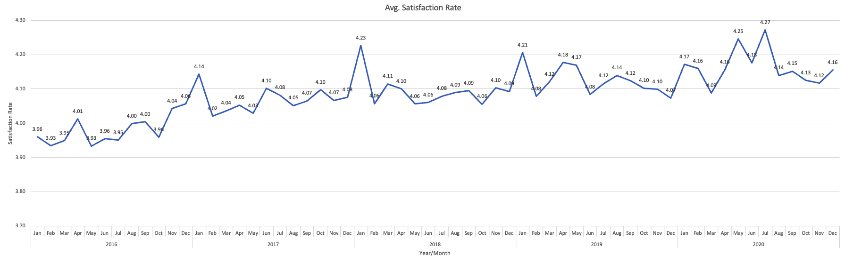

* Satisfaction Rate Patterns:
  + January Highs: Satisfaction often starts strong in January, frequently being the highest for the year.
  + Brief Mid-Q1 Dip: A slight dip in satisfaction typically follows the January peak (in February/March), coinciding with the rising early-year ticket volume.
  + Overall Resilience: Despite fluctuations and increasing demand, satisfaction generally recovers and remains at a high level.
* Recommendations:
  + The high and stable satisfaction rate is a testament to the IT team's effective service delivery. Continue to uphold current best practices for agent communication, professionalism, and problem resolution.
  + While satisfaction holds up during peaks, ensure that the IT team isn't experiencing burnout or excessive pressure. Continue to monitor agent well-being and satisfaction internally.
  + Share insights about the consistent high satisfaction across all months with the team, celebrating their ability to maintain quality even during busier periods.
* In conclusion, IT support operations exhibit a predictable annual cycle with a clear mid-year peak in ticket volume. Despite these seasonal surges, the IT team successfully maintains a high and stable level of customer satisfaction. Recommendations should focus on proactive planning to manage the mid-year peak in demand and strategically utilize off-peak months for continuous improvement initiatives.

1. What metrics should be included in the final dashboard to provide a comprehensive view of call center performance and guide investment decisions?

**Ensure that you put the slicers for choosing the priority wise and year in order to observe the dashboard since the management will be having a long discussion which can go for weeks.**

**Note: The dashboard would be more interactive and user-friendly, allowing management to explore data in detail and make informed decisions.**

* The final dashboard should include the following metrics to provide a comprehensive view of performance and guide investment decisions:
  + Average Resolution Time
  + Average Satisfaction Rating
  + Severity-based visualization
  + Performance trends
  + Volume of tickets handled
  + Performance of agents
* Additionally, the dashboard should include slicers for choosing the priority, category and year to make it more interactive and user-friendly for management discussions.



