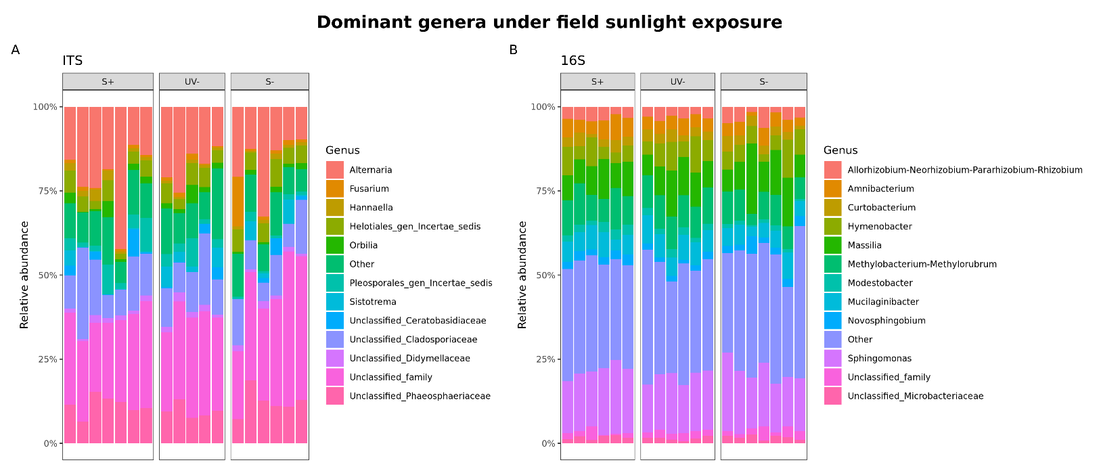
Figure S1. Relative abundance of dominant fungal and bacterial genus-level taxa in maize litter following field incubation under full sunlight (S+), reduced UV (UV−), or reduced UV and blue–green light (S−). (A) Fungal communities characterized using ITS sequencing (N = 18: S+, n = 7; UV−, n = 5; S−, n = 6). (B) Bacterial communities characterized using 16S rRNA gene sequencing (N = 19: S+, n = 6; UV−, n = 6; S−, n = 7). Each bar represents an individual litter sample. Colors identify the 12 most abundant genus-level categories based on mean relative abundance; all remaining taxa are combined as “Other.” Relative abundances were calculated from post-quality-control, prevalence-filtered, unrarefied counts.

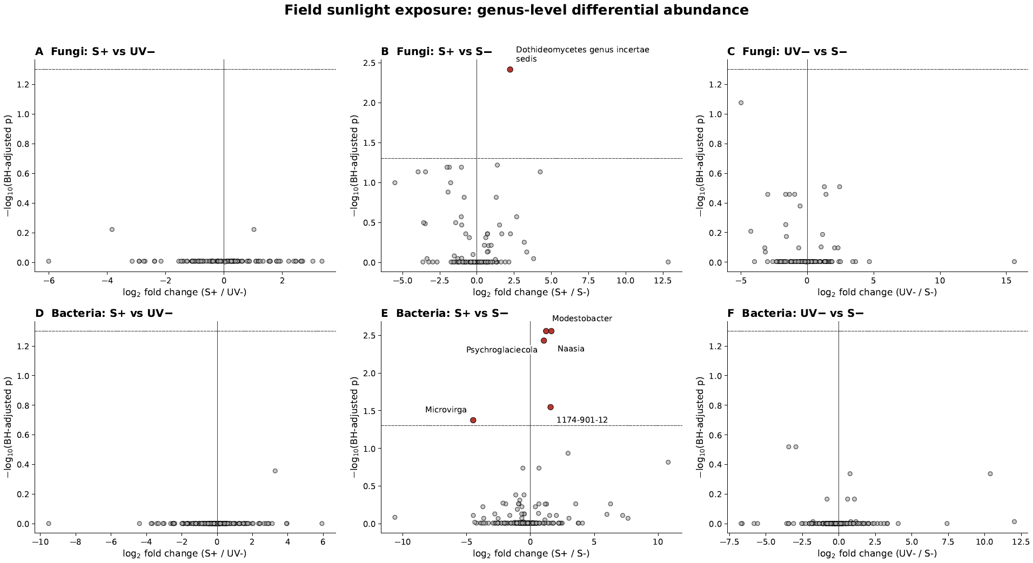
Figure S2. Differential abundance of fungal (A–C) and bacterial (D–F) genus-level categories in maize litter across field sunlight treatments. Columns show contrasts between full sunlight and reduced UV (S+ versus UV−; A and D), full sunlight and reduced UV and blue–green light (S+ versus S−; B and E), and reduced UV and reduced UV and blue–green light (UV− versus S−; C and F). Points represent all categories eligible for the marker-specific negative-binomial models: 119 fungal and 228 bacterial genus-level categories. Models were fitted to unrarefied counts and included field block as a fixed effect. Positive log₂ fold changes indicate greater abundance under the first treatment named in each contrast. The y-axis represents Benjamini–Hochberg-adjusted p-values. The horizontal dashed line indicates q = 0.05; significant categories are shown in red and labelled. Significant responses occurred only in the S+ versus S− contrast.

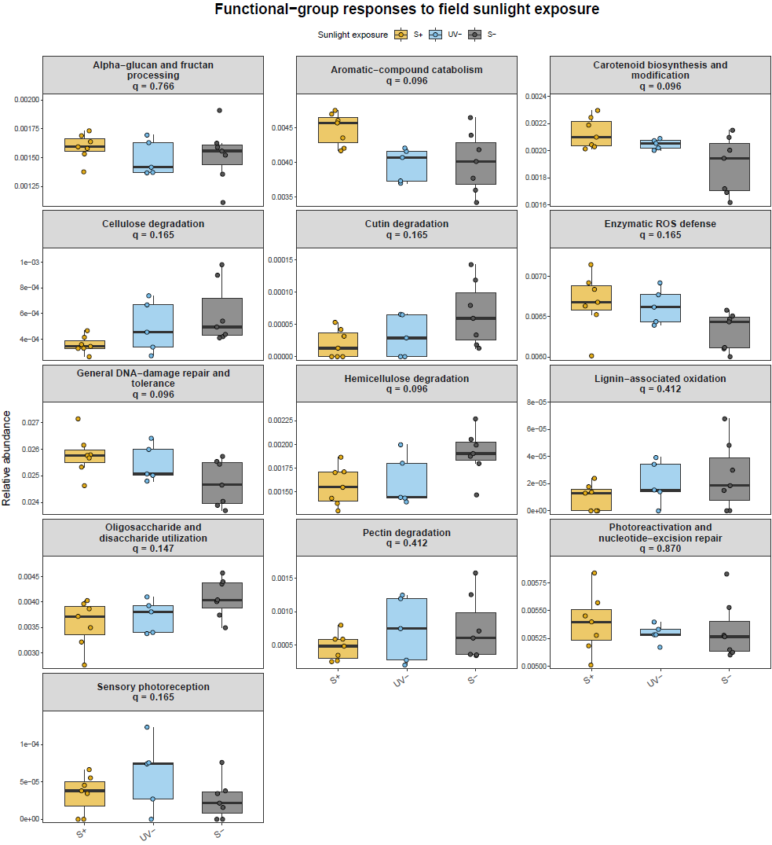
Figure S3. Relative abundances of 13 targeted functional groups in the maize-litter microbiome across field sunlight treatments. Treatments were full sunlight (S+, yellow), reduced UV (UV−, light blue), and reduced UV and blue–green (S−, dark grey; N = 19). Functional-group abundances were calculated by summing the total-sum-scaled relative abundances of the curated KEGG Orthology identifiers assigned to each group. Points represent individual samples; boxes show medians and interquartile ranges, with whiskers extending to 1.5 times the interquartile range. Treatment effects were evaluated using linear models that included field replicate as a fixed blocking factor. Values shown above each panel are Benjamini–Hochberg-adjusted omnibus p-values across the 13 functional groups. No individual functional group remained significant after correction for multiple testing (q ≥ 0.096).

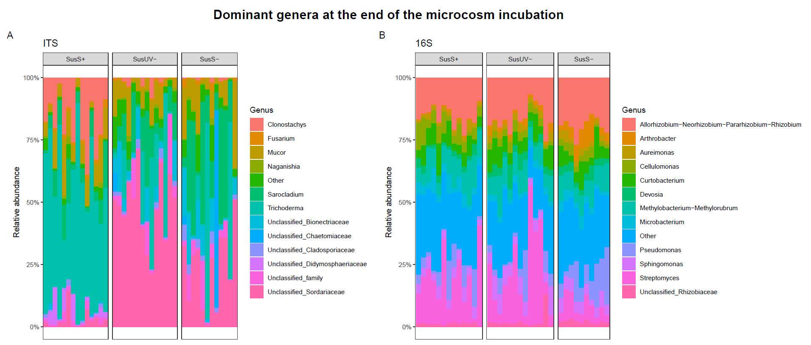
Figure S4. Genus-level composition of fungal (A) and bacterial (B) communities assembled on photochemically conditioned maize litter during the dark microcosm incubation. Stacked bars show the relative abundances of the 12 most abundant genus-level categories for (A) fungi (ITS; N = 40: SusS+, n = 14; SusUV−, n = 14; SusS−, n = 12) and (B) bacteria (16S rRNA gene; N = 36: SusS+, n = 13; SusUV−, n = 13; SusS−, n = 10). Substrates had previously been exposed in the field to full sunlight (SusS+), reduced UV (SusUV−), or reduced UV and blue–green light (SusS−). Each vertical bar represents one microcosm, and categories outside the 12 most abundant for each marker are combined as “Other.” Relative abundances were calculated from unrarefied genus-level counts after marker-specific quality control and ASV prevalence filtering.

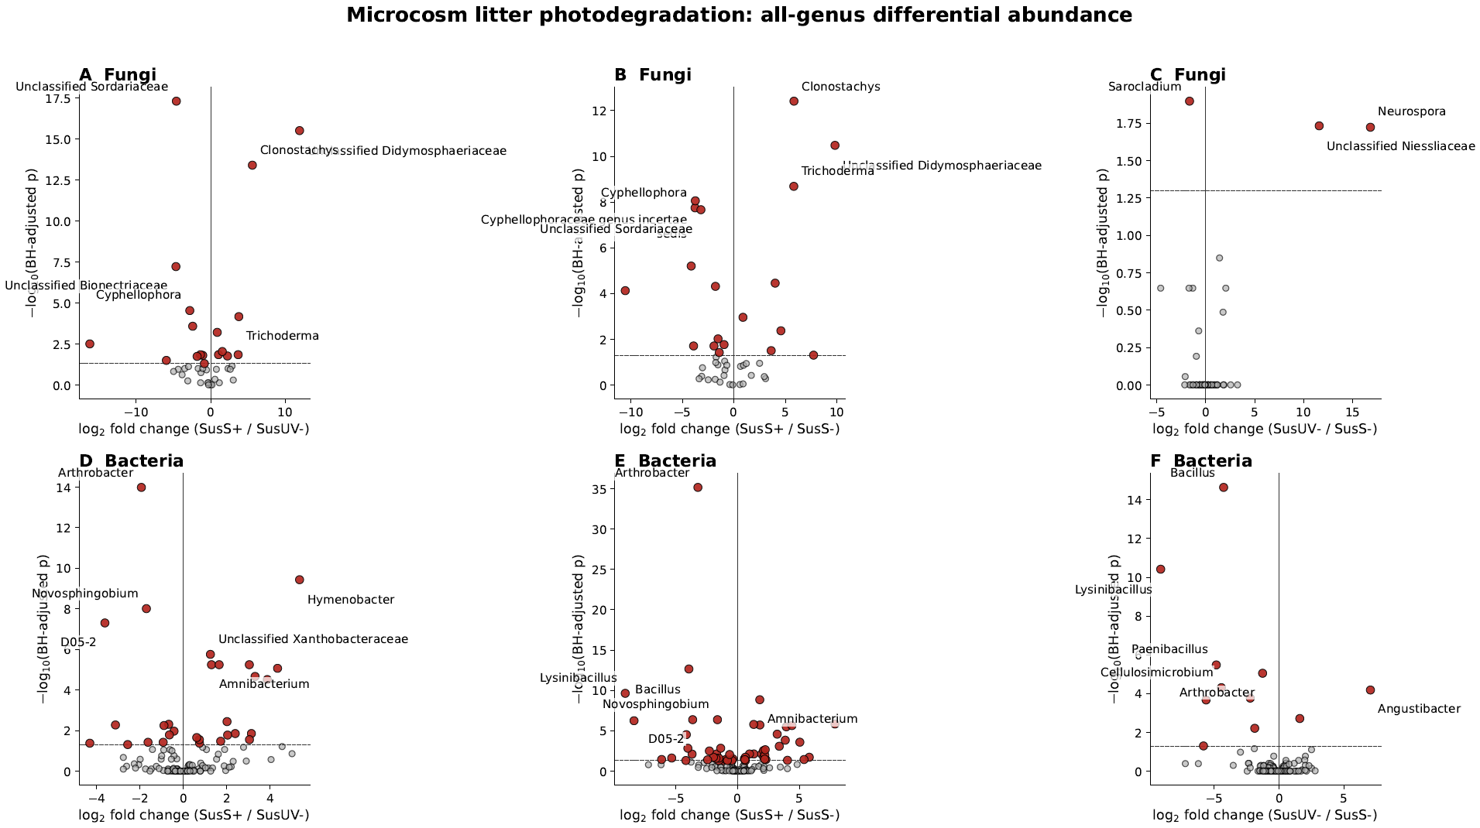
Figure S5. Genus-level differential abundance of fungal and bacterial communities assembled on photochemically conditioned maize litter during dark microcosm incubation. Volcano plots show all eligible fungal (ITS; top row) and bacterial (16S rRNA gene; bottom row) genera for the pairwise contrasts between full-sunlight litter (SusS+), reduced-UV litter (SusUV−), and litter exposed to reduced UV and blue–green light (SusS−). Differential abundance was evaluated using negative-binomial models fitted to unrarefied genus-level counts, including inoculum origin as a blocking factor. Positive log₂ fold changes indicate enrichment in the first treatment named in each contrast, whereas negative values indicate enrichment in the second. Genera with Benjamini–Hochberg-adjusted p-values below 0.05 are highlighted and labelled; nonsignificant genera are shown in grey. Horizontal dashed lines indicate the adjusted-p-value significance threshold (p_adj = 0.05).

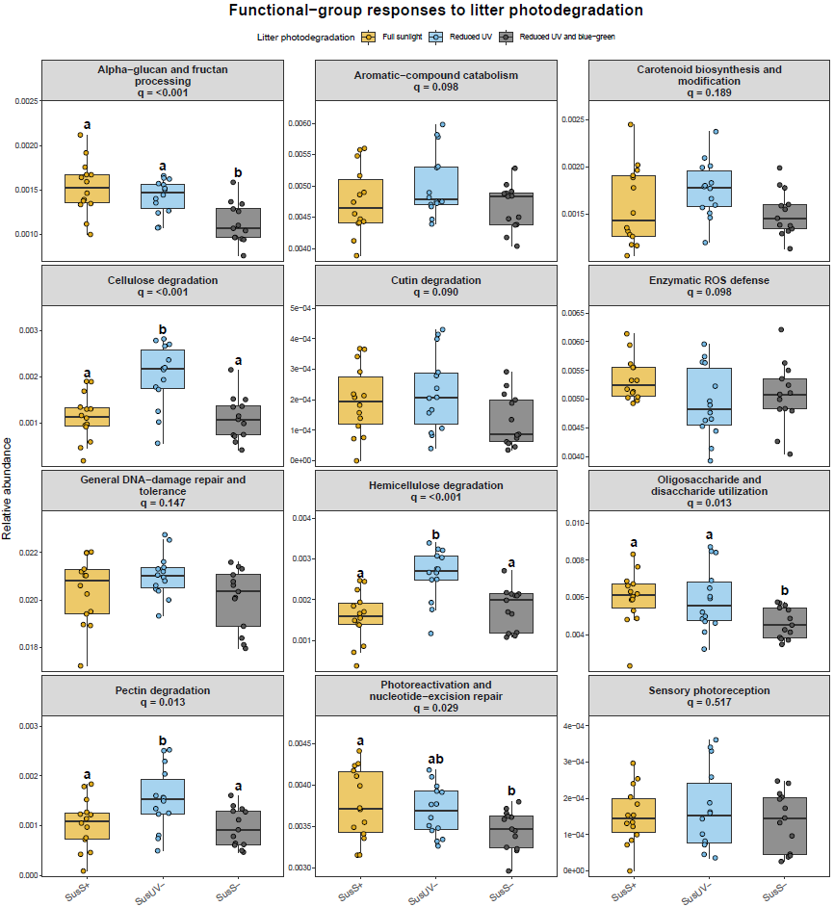
Figure S6. Relative abundances of targeted microbial functional groups at the end of the incubation across the three photodegradation treatments of litter used as substrates in the dark microcosm incubation. Boxplots show functional-group relative abundances in microbiomes assembled on litter pre-exposed to full sunlight (SusS+, yellow), reduced UV (SusUV−, light blue), or reduced UV and BG light (SusS−, dark grey). Points represent individual microcosms. Treatment effects were evaluated using linear mixed-effects models with substrate treatment and replicate as fixed effects and inoculum as a random intercept. Reported q-values are Benjamini–Hochberg-adjusted omnibus p-values across the 12 analyzable functional groups. For groups with q < 0.05, different letters indicate significant Tukey-adjusted pairwise differences among substrate treatments.

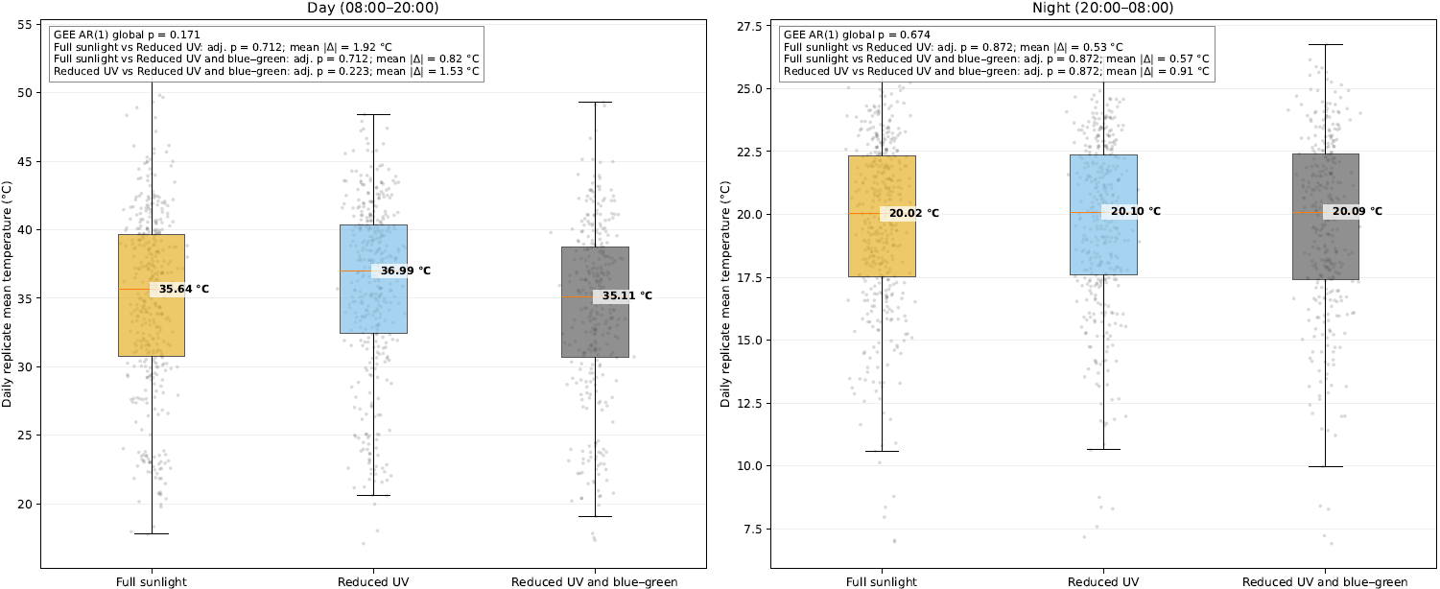
Figure S7. Daytime and nighttime temperatures inside maize-litter boxes across sunlight treatments. Boxplots show replicate-level daily mean temperatures under full sunlight (gold), reduced UV (light blue), and reduced UV and blue–green light (dark grey). Daytime and nighttime were defined as 08:00–20:00 and 20:00–08:00, respectively. Points represent replicate-day means. Treatment effects were evaluated using repeated-measures Gaussian generalized estimating equations with an AR(1) temporal correlation structure. Global and Benjamini–Hochberg-adjusted pairwise p-values are shown. No significant differences were detected among treatments.

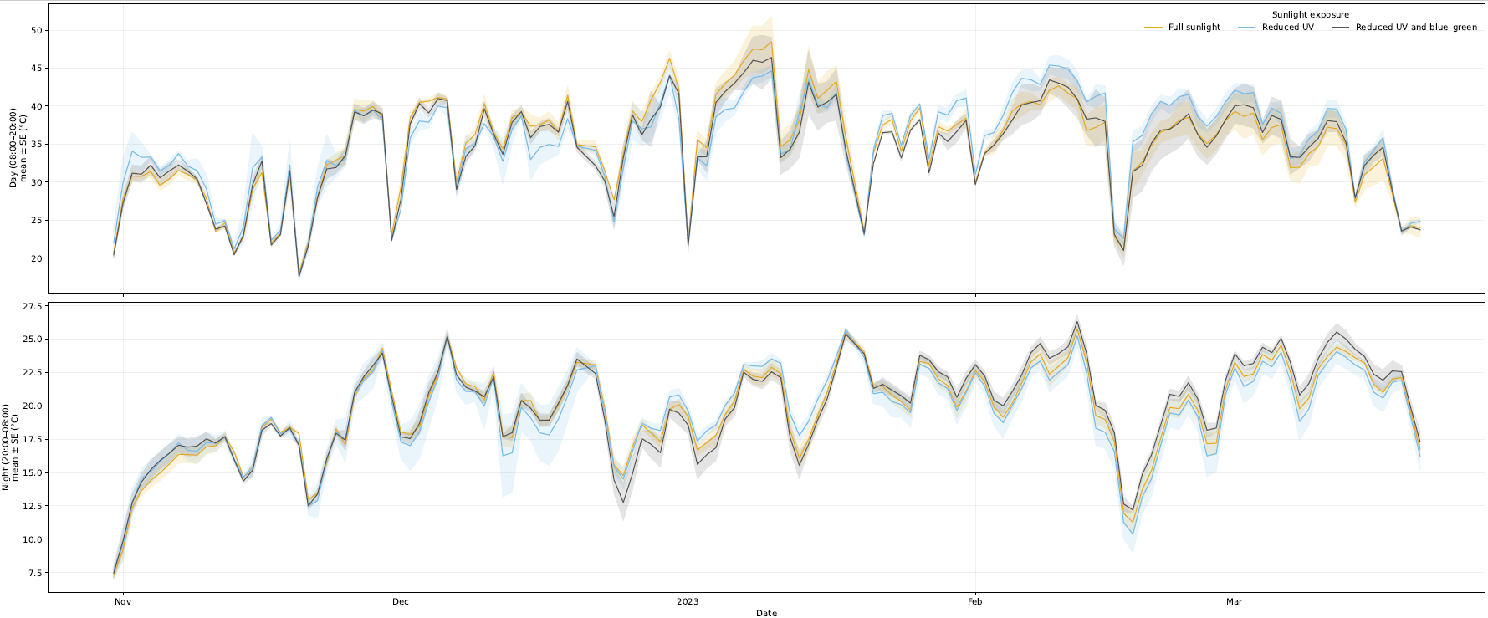
Figure S8. Temporal variation in daytime and nighttime temperatures inside maize-litter boxes across sunlight treatments. Lines show daily treatment means under full sunlight (gold), reduced UV (light blue), and reduced UV and blue–green light (dark grey), separately for daytime (08:00–20:00) and nighttime (20:00–08:00). Shaded regions represent the standard error of the mean.

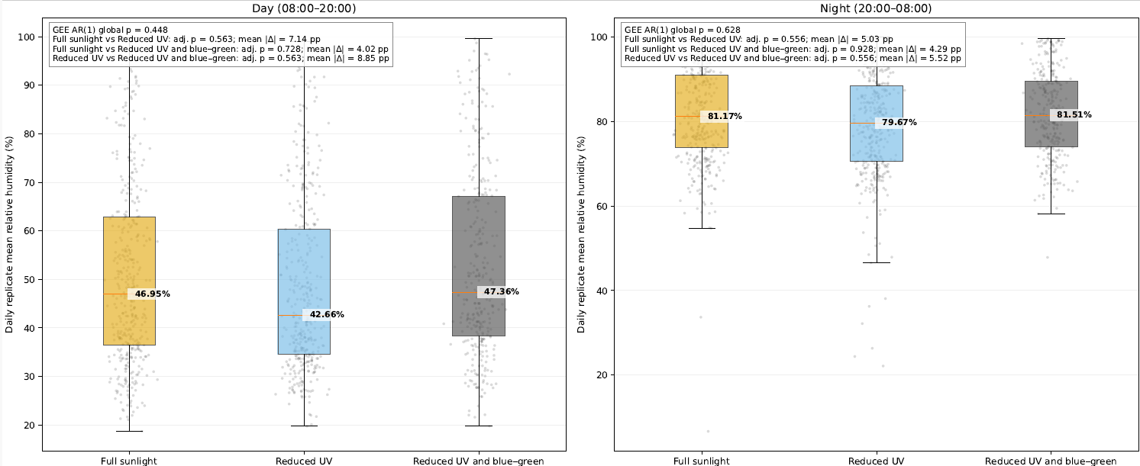

Figure S9. Daytime and nighttime relative humidity inside maize-litter boxes across sunlight treatments. Boxplots show replicate-level daily mean relative humidity under full sunlight (gold), reduced UV (light blue), and reduced UV and blue–green light (dark grey). Points represent replicate-day means. Treatment effects were evaluated using repeated-measures Gaussian generalized estimating equations with an AR(1) temporal correlation structure. Global and Benjamini–Hochberg-adjusted pairwise p-values are shown. No significant differences were detected among treatments.

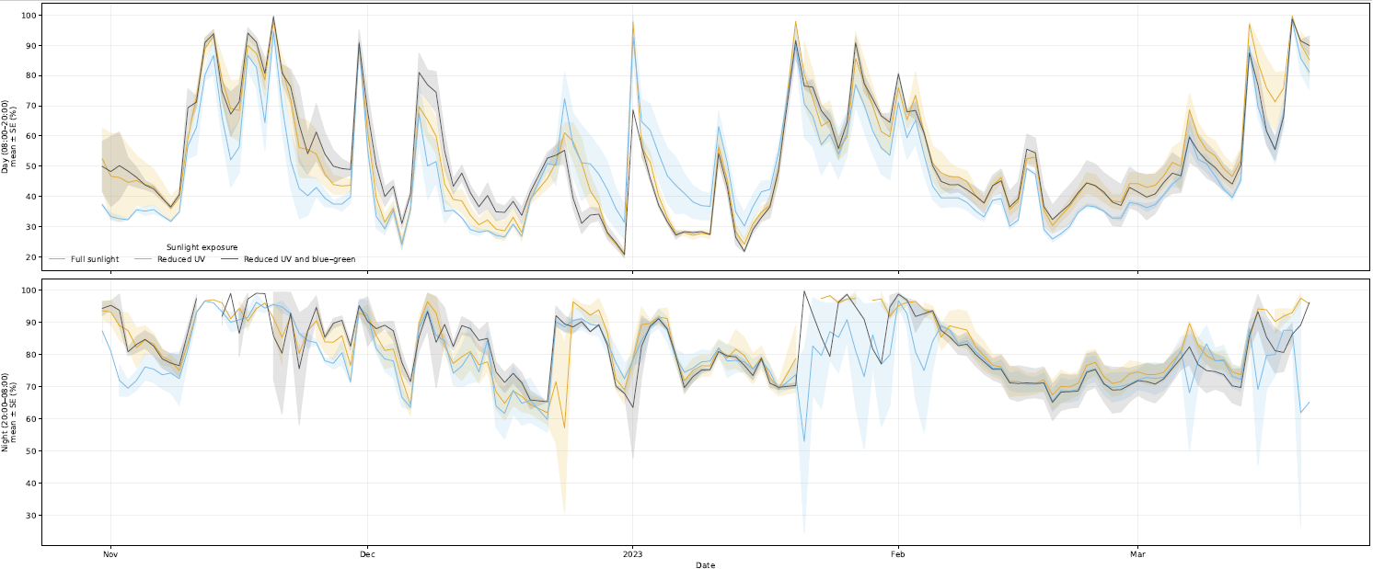
Figure S10. Temporal variation in daytime and nighttime relative humidity inside maize-litter bags across sunlight treatments. Lines show daily treatment means under full sunlight (gold), reduced UV (light blue), and reduced UV and blue–green light (dark grey), separately for daytime (08:00–20:00) and nighttime (20:00–08:00). Shaded regions represent the standard error of the mean.

