Report

Xie Zejian

2021/1/18

# Construction of two trading strategies.

## Simplified BARRA model:

1. Data Reading
2. Standardization:
3. Data Training:

## Optimized Long-short Portfolio:

1. Construct the time windows for map.
2. Combine step 1-7 to a function.

# Cumulative wealth series.

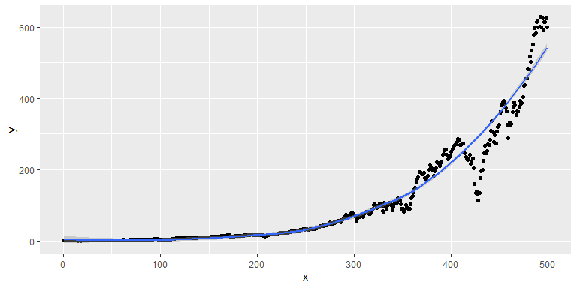

cumulative wealth series of r1

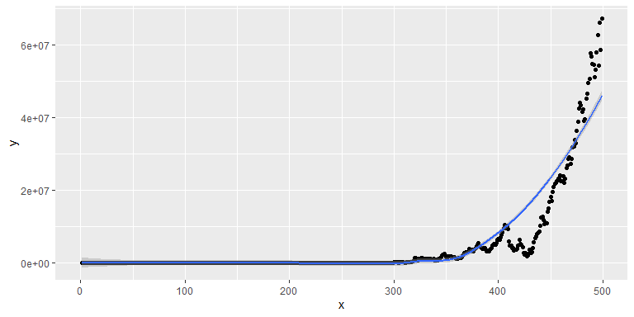

cumulative wealth series of r3

# Compare performance measures

* Based on return criterion, strategies 3 is better with Annualized Alpha 0.52(much more than 0.10);
* Based on risk criterion, strategies 1 has better performance with so low maximal drawdown(60%), beta(0.59) and acceptable sys volatility(0.19) relatively.
* Based on risk-return tradeoff criterion, strategies 3 is better with much higher sharpe ratio and almost same information ratio.

# Choice

When we examine the risk of our total portfolios, we should use total volatility instead of beta as the right measure of risk. Mean and alpha lack the dimension of risk. Sharpe ratio is the best choice apparently. I prefer strategies 3 with higher annual sharpe ratio 0.98.

# Improvement advises

Add or change more factors to improve goodness of fit and decrease alpha.(Try the best to explain return by beta)