STATISTICAL ANALYSIS REPORT

# A/B Test Analysis: Maximum Bidding vs Average Bidding

**Variable Analyzed: Purchase**

Analysis Date: August 21, 2025 16:40:02  
Total Sample Size: 80 observations  
Significance Level: α = 0.05

**❌ NO SIGNIFICANT DIFFERENCE**

# 📋 EXECUTIVE SUMMARY

**KEY FINDING:** No statistically significant difference between Maximum Bidding and Average Bidding (p=0.3493).

## 📊 Key Performance Metrics

|  |  |  |
| --- | --- | --- |
| **Metric** | **Maximum Bidding** | **Average Bidding** |
| Sample Size | 40 | 40 |
| Mean | 550.894 | **582.106** |
| Std Deviation | 134.108 | 161.153 |
| Median | 531.206 | 551.356 |
| Min Value | 267.029 | 311.630 |
| Max Value | 801.795 | 889.910 |

## 📈 Visual Analysis

The following charts provide visual insights into the data distribution and comparison:

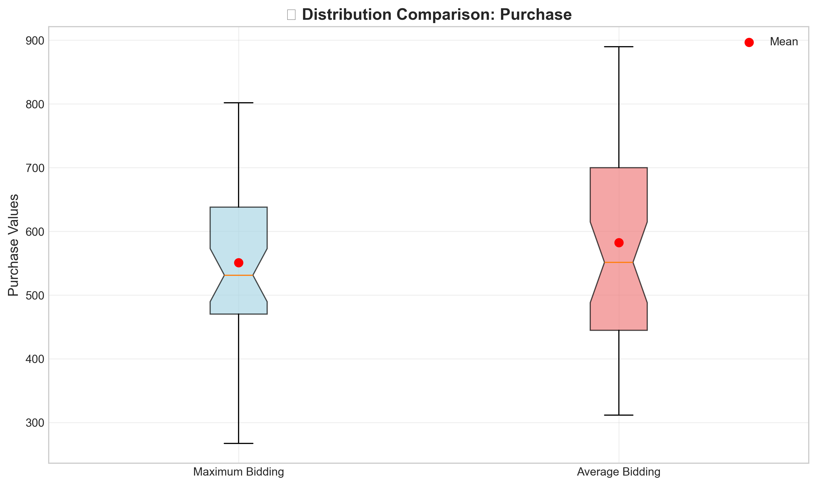

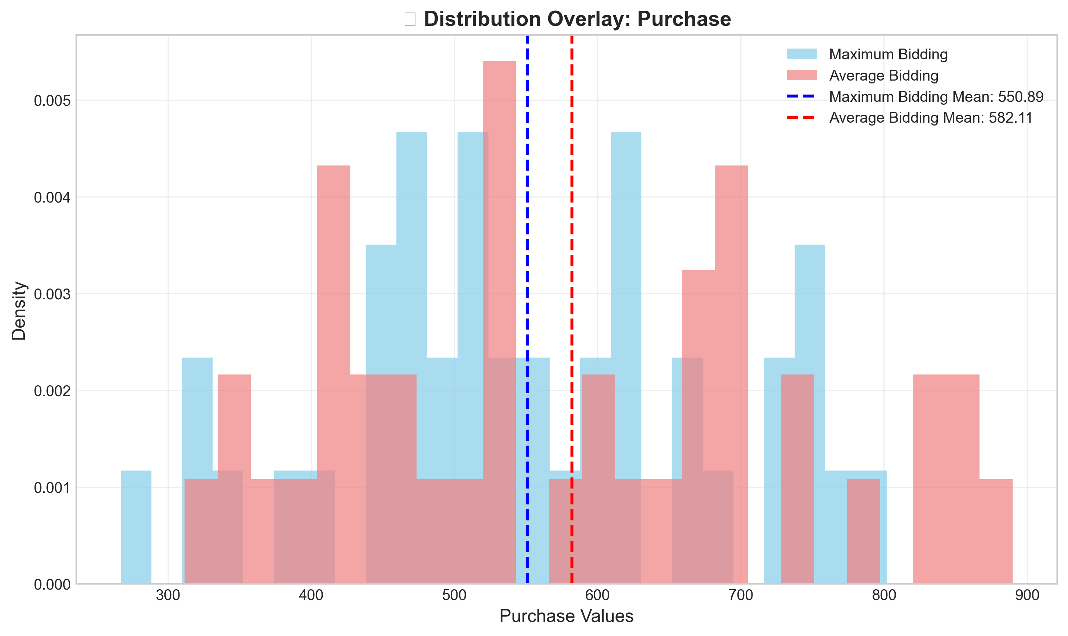

Normal distribution assessment (Q-Q Plots):

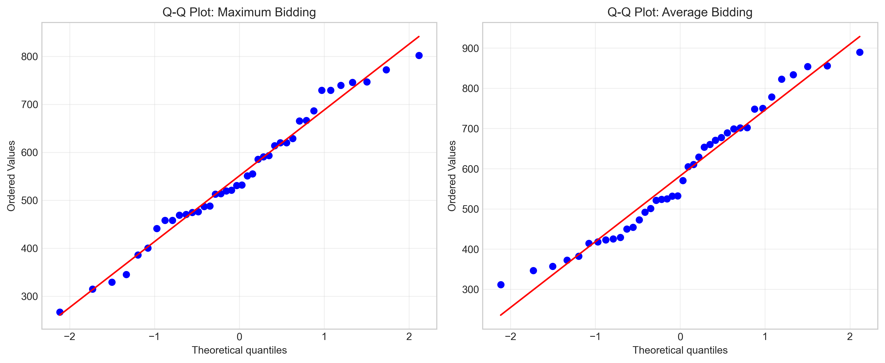

## ✅ Statistical Assumptions Check

|  |  |  |
| --- | --- | --- |
| **Assumption** | **Result** | **Impact** |
| Normality (Group 1) | **✅ Satisfied** | Parametric test OK |
| Normality (Group 2) | **✅ Satisfied** | Parametric test OK |
| Variance Homogeneity | **✅ Satisfied** | Equal variances OK |

# 🧪 Statistical Test Results

|  |  |
| --- | --- |
| **Statistical Measure** | **Value** |
| Test Method | Independent Samples T-Test (equal variances) |
| Test Statistic | 0.9416 |
| P-value | 0.349326 |
| Significance Level (α) | 0.05 |
| Effect Size | 5.67% |
| Cohen's d | 0.2105 |
| Statistical Significance | **NO ❌** |
| Practical Significance | YES ✅ |

# 💼 Business Impact & Recommendations

**PRIMARY RECOMMENDATION: 🔄 CONTINUE with MAXIMUM BIDDING**

**JUSTIFICATION:** No statistically significant difference detected

**RISK ASSESSMENT:** LOW RISK - No significant difference detected. Current approach can continue safely.

# 📝 Detailed Statistical Analysis

Complete statistical output from the analysis:

================================================================================

COMPLETE HYPOTHESIS TESTING: Maximum Bidding vs Average Bidding

Variable: Purchase

================================================================================

📊 SAMPLE INFORMATION:

Maximum Bidding: 40 observations

Average Bidding: 40 observations

Total: 80 observations

🔍 STEP 1: ASSUMPTION TESTING

------------------------------------------------------------

============================================================

NORMALITY TEST: Maximum Bidding - Purchase

============================================================

📊 Sample Size: 40

🎯 Alpha Level: 0.05

📋 HYPOTHESIS DEFINITION:

H₀: Data comes from a normal distribution

H₁: Data does NOT come from a normal distribution

🧪 TEST RESULTS:

Test Statistic: 0.977269

P-value: 0.589107

📊 DECISION:

✅ H₀ CANNOT BE REJECTED (p=0.589107 ≥ α=0.05)

📈 Normal distribution assumption is SATISFIED

🎯 Parametric test can be used

============================================================

NORMALITY TEST: Average Bidding - Purchase

============================================================

📊 Sample Size: 40

🎯 Alpha Level: 0.05

📋 HYPOTHESIS DEFINITION:

H₀: Data comes from a normal distribution

H₁: Data does NOT come from a normal distribution

🧪 TEST RESULTS:

Test Statistic: 0.958945

P-value: 0.154134

📊 DECISION:

✅ H₀ CANNOT BE REJECTED (p=0.154134 ≥ α=0.05)

📈 Normal distribution assumption is SATISFIED

🎯 Parametric test can be used

======================================================================

VARIANCE HOMOGENEITY TEST: Maximum Bidding vs Average Bidding

======================================================================

📊 Group 1 Sample Size: 40

📊 Group 2 Sample Size: 40

🎯 Alpha Level: 0.05

📋 HYPOTHESIS DEFINITION:

H₀: Variances are homogeneous (σ₁² = σ₂²)

H₁: Variances are NOT homogeneous (σ₁² ≠ σ₂²)

📈 DESCRIPTIVE STATISTICS:

Group 1 - Mean: 550.8941, Std: 134.1082, Variance: 17985.0096

Group 2 - Mean: 582.1061, Std: 161.1525, Variance: 25970.1326

Variance Ratio (Var1/Var2): 0.6925

🧪 TEST RESULTS:

Test Statistic (Levene): 2.639269

P-value: 0.108286

📊 DECISION:

✅ H₀ CANNOT BE REJECTED (p=0.108286 ≥ α=0.05)

📈 Variance homogeneity assumption is SATISFIED

🎯 Can use equal_var=True in t-test

🧪 STEP 2: TEST SELECTION

------------------------------------------------------------

Maximum Bidding normality: ✅ NORMAL

Average Bidding normality: ✅ NORMAL

Variance homogeneity: ✅ HOMOGENEOUS

🎯 SELECTED TEST: Independent Samples T-Test (equal variances)

📋 MAIN HYPOTHESIS DEFINITION:

H₀: There is NO significant difference between Maximum Bidding and Average Bidding

H₁: There IS a significant difference between Maximum Bidding and Average Bidding

Significance Level (α): 0.05

If p-value < significance level (α), then H₀ CANNOT be REJECTED!

📈 DESCRIPTIVE STATISTICS:

Maximum Bidding:

Mean: 550.8941, Std: 134.1082, Median: 531.2063

Average Bidding:

Mean: 582.1061, Std: 161.1525, Median: 551.3557

Difference (Group2 - Group1): 31.2120

Percentage Change: 5.67%

Cohen's d (Effect Size): 0.2105

🧪 TEST RESULTS:

T-statistic: 0.941558

P-value: 0.349326

📊 STATISTICAL DECISION:

✅ H₀ CANNOT BE REJECTED (p=0.349326 ≥ α=0.05)

📊 There is NO statistically significant difference

🔄 Both groups perform similarly

📏 EFFECT SIZE INTERPRETATION:

Cohen's d = 0.2105 → Small effect

💼 BUSINESS RECOMMENDATION:

==================================================

🔄 CONTINUE with MAXIMUM BIDDING

📋 Reason: No statistically significant difference detected

# 📎 Appendix

## Technical Details

Analysis Parameters:  
 • Variable: Purchase  
 • Significance Level: α = 0.05  
 • Test Type: Independent Samples T-Test (equal variances)  
 • Sample Sizes: Maximum Bidding (n=40), Average Bidding (n=40)  
  
 Software Information:  
 • Analysis performed using Python statistical libraries  
 • Report generated on 2025-08-21 at 16:40:03  
 • Methodology follows standard statistical testing procedures