TECHCORP ANALYTICS

# CUSTOMER ANALYTICS REPORT

**RFM Segmentation & Customer Lifetime Value Analysis**

Analysis Period: Q4 2024 Analysis  
Report Generated: August 23, 2024 at 11:24  
Total Customers Analyzed: 5,878  
Customer Segments Identified: 10

**💎 14.1% Champions | 💰 Avg CLTV: ₺3,053 | 👥 5,878 Total Customers**

# 📋 EXECUTIVE SUMMARY

**KEY FINDINGS:**  
• Customer base consists of 5,878 active customers across 10 distinct segments  
• 14.1% of customers are in the 'champions' segment (largest group)  
• 34.0% of customers are high-value (Champions + Loyal Customers)  
• Average customer lifetime value: ₺3,053  
• Revenue concentration: Top 20% customers likely drive majority of revenue

## 📊 Key Performance Indicators

|  |  |  |  |
| --- | --- | --- | --- |
| Metric | Value | Metric | Value |
| Total Customers | 5,878 | Champions % | 14.1% |
| Avg Monetary Value | ₺3,019 | Avg CLTV | ₺3,053 |
| Avg Frequency | 6.3 | At Risk % | 12.8% |
| Avg Recency (days) | 202 | Hibernating % | 26.0% |

## 📈 Visual Analysis

Customer segment distribution and value analysis:

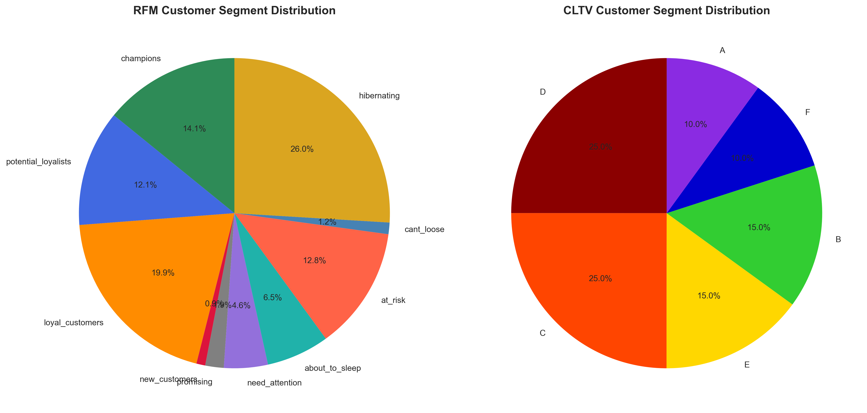

RFM metrics comparison across customer segments:

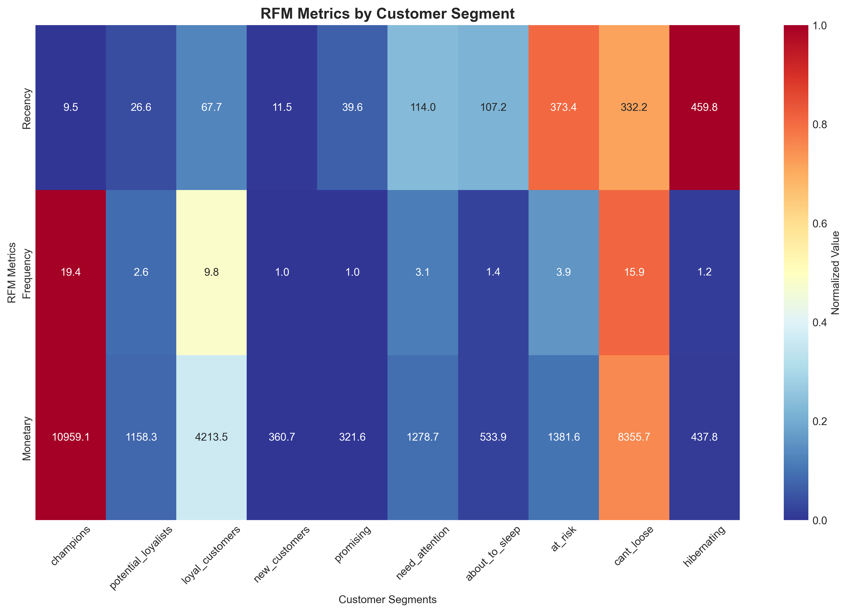

Customer Lifetime Value progression over different time periods:

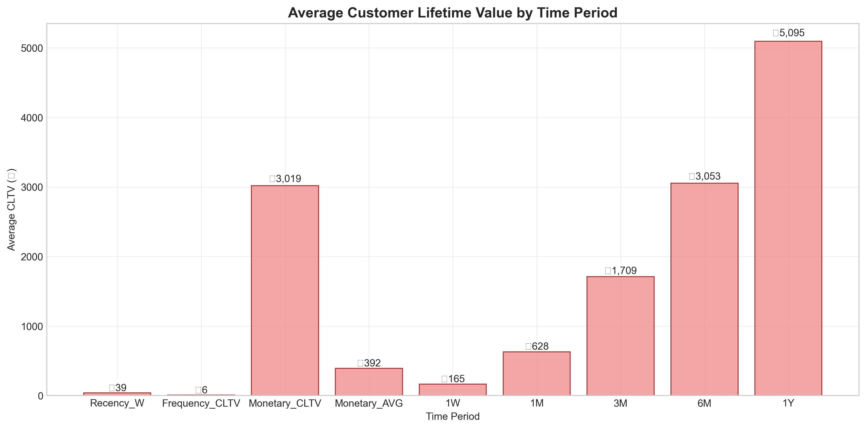

# 🎯 RFM SEGMENTATION ANALYSIS

## Customer Segment Breakdown

|  |  |  |  |  |  |
| --- | --- | --- | --- | --- | --- |
| Segment | Count | Percentage | Avg Recency | Avg Frequency | Avg Monetary |
| Champions | 830 | 14.1% | 9 days | 19.4 | ₺10,959 |
| Potential Loyalists | 711 | 12.1% | 27 days | 2.6 | ₺1,158 |
| Loyal Customers | 1,167 | 19.9% | 68 days | 9.8 | ₺4,214 |
| New Customers | 54 | 0.9% | 12 days | 1.0 | ₺361 |
| Promising | 113 | 1.9% | 40 days | 1.0 | ₺322 |
| Need Attention | 268 | 4.6% | 114 days | 3.1 | ₺1,279 |
| About To Sleep | 384 | 6.5% | 107 days | 1.4 | ₺534 |
| At Risk | 754 | 12.8% | 373 days | 3.9 | ₺1,382 |
| Cant Loose | 71 | 1.2% | 332 days | 15.9 | ₺8,356 |
| Hibernating | 1,526 | 26.0% | 460 days | 1.2 | ₺438 |

## Segment Characteristics & Actions

**💎 Your best customers:** 830 customers (14.1%) - Reward them, ask for referrals, upsell premium products

**🔵 Consistent customers:** 1,167 customers (19.9%) - Nurture relationship, recommend new products

**🟡 Recent customers:** 711 customers (12.1%) - Offer membership, increase engagement

**🆕 Brand new customers:** 54 customers (0.9%) - Onboard properly, provide excellent service

**⭐ Promising new customers:** 113 customers (1.9%) - Increase frequency, build loyalty

**⚠️ Declining customers:** 268 customers (4.6%) - Win them back with targeted campaigns

**😴 Becoming inactive:** 384 customers (6.5%) - Reactivate with special offers

**🚨 Important but at risk:** 754 customers (12.8%) - Immediate attention needed, prevent churn

**💰 High value but inactive:** 71 customers (1.2%) - Aggressive reactivation campaigns

**💤 Lowest engagement:** 1,526 customers (26.0%) - Minimal investment, basic retention

# 💰 CUSTOMER LIFETIME VALUE ANALYSIS

## CLTV Summary Statistics

|  |  |  |  |  |  |  |  |  |
| --- | --- | --- | --- | --- | --- | --- | --- | --- |
| CLTV Recency_W | CLTV Frequency_CLTV | CLTV Monetary_CLTV | CLTV Monetary_AVG | CLTV 1W | CLTV 1M | CLTV 3M | CLTV 6M | CLTV 1Y |
| Average | ₺6 | ₺3,019 | ₺392 | ₺165 | ₺628 | ₺1,709 | ₺3,053 | ₺5,095 |
| Median | ₺3 | ₺899 | ₺285 | ₺52 | ₺197 | ₺533 | ₺947 | ₺1,577 |
| Max | ₺398 | ₺608,822 | ₺84,236 | ₺32,264 | ₺121,151 | ₺320,390 | ₺558,009 | ₺907,984 |
| Min | ₺1 | ₺3 | ₺3 | ₺0 | ₺0 | ₺0 | ₺0 | ₺0 |
| Std Dev | ₺13 | ₺14,738 | ₺1,215 | ₺774 | ₺2,954 | ₺8,061 | ₺14,427 | ₺24,128 |

## CLTV Segment Analysis

|  |  |  |  |
| --- | --- | --- | --- |
| Segment | Customer Count | Avg CLTV_6M | Percentage |
| Segment D | 1,469 | ₺393 | 25.0% |
| Segment C | 1,469 | ₺1,795 | 25.0% |
| Segment E | 882 | ₺13 | 15.0% |
| Segment B | 882 | ₺4,246 | 15.0% |
| Segment F | 588 | ₺1 | 10.0% |
| Segment A | 588 | ₺18,666 | 10.0% |

## 👑 High-Value Customer Analysis

### Top 10 Customers by Monetary Value (RFM)

|  |  |  |  |  |  |
| --- | --- | --- | --- | --- | --- |
| Rank | Customer ID | Monetary Value | Frequency | Recency (days) | Segment |
| 1 | **18102** | **₺608,822** | **145** | **2** | **Champions** |
| 2 | **14646** | **₺528,603** | **152** | **3** | **Champions** |
| 3 | **14156** | **₺313,946** | **156** | **11** | **Champions** |
| 4 | **14911** | **₺295,973** | **398** | **2** | **Champions** |
| 5 | **17450** | **₺246,973** | **51** | **9** | **Champions** |
| 6 | **13694** | **₺196,483** | **143** | **5** | **Champions** |
| 7 | **17511** | **₺175,604** | **60** | **4** | **Champions** |
| 8 | 16446 | ₺168,472 | 2 | 2 | Potential Loyalists |
| 9 | **16684** | **₺147,143** | **55** | **5** | **Champions** |
| 10 | 12415 | ₺144,458 | 28 | 25 | Loyal Customers |

### Top 10 Customers by CLTV

|  |  |  |  |
| --- | --- | --- | --- |
| Rank | Customer ID | CLTV_6M | CLTV Segment |
| 1 | 16446 | ₺558,009 | Segment A |
| 2 | 18102 | ₺471,260 | Segment A |
| 3 | 14646 | ₺409,805 | Segment A |
| 4 | 17450 | ₺302,771 | Segment A |
| 5 | 14096 | ₺244,081 | Segment A |
| 6 | 14156 | ₺239,423 | Segment A |
| 7 | 14911 | ₺227,629 | Segment A |
| 8 | 16000 | ₺156,448 | Segment A |
| 9 | 13694 | ₺152,582 | Segment A |
| 10 | 12415 | ₺151,541 | Segment A |

# 💼 BUSINESS RECOMMENDATIONS & ACTION PLAN

## 🎯 Priority Actions

🏆 Focus on 830 Champions: Implement VIP program and referral incentives

🔄 Reactivate 71 Can't Lose customers: High-value but inactive customers need immediate attention

⚠️ Prevent churn of 754 At-Risk customers: Implement retention campaigns

📈 Nurture 711 Potential Loyalists: Convert to loyal customers

💰 Optimize for high CLTV: Focus marketing spend on segments with CLTV > ₺27,999

## 💰 Revenue Optimization Opportunities

**Revenue Impact Analysis:**  
• Current high-value customers (830 Champions) represent significant revenue concentration  
• Estimated annual revenue potential from optimization: ₺18,591,306  
• Cross-selling opportunities exist within Loyal Customers segment  
• Retention of At-Risk customers could prevent ₺1,041,726 revenue loss

## 📅 Implementation Timeline

|  |  |  |
| --- | --- | --- |
| Phase | Timeline | Key Activities |
| Phase 1 - Immediate | 0-30 days | Champion recognition program, At-risk customer outreach |
| Phase 2 - Short term | 1-3 months | Loyalty program launch, Personalization implementation |
| Phase 3 - Medium term | 3-6 months | Advanced segmentation, Predictive analytics |
| Phase 4 - Long term | 6-12 months | Full automation, Advanced CLTV optimization |

# 📎 APPENDIX

## Methodology

RFM Analysis:  
 • Recency: Days since last purchase (lower is better)  
 • Frequency: Number of purchases (higher is better)   
 • Monetary: Total purchase value (higher is better)  
 • Customers scored 1-5 on each dimension, combined into segments  
  
 CLTV Analysis:  
 • Utilizes BG-NBD model for purchase prediction  
 • Gamma-Gamma model for monetary value prediction  
 • Predictions calculated for multiple time horizons  
 • Segments created based on CLTV quintiles  
  
 Analysis Period: Q4 2024 Analysis  
 Total Customers: 5,878  
 Data Processing: Removed cancelled orders, handled missing values  
 Currency: ₺