DESKTOP-GGS8TLK\SQLEXPRESS
PIZZA SALES SQL QUERIES
A. KPI's
1. TOTAL revenue
- # we used (cast ... AS FLOAT) to convert text in number .00
FROM pizza_sales

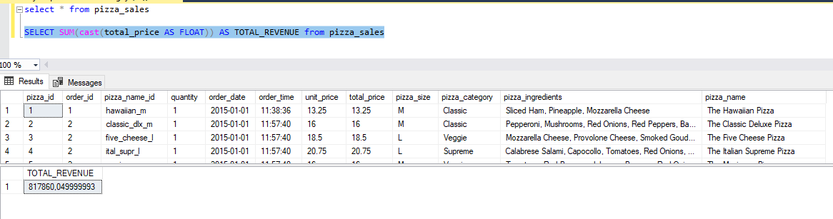

2.AVG_Order_Value
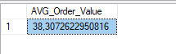

3. Total_Pizza_Sold
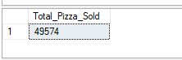

4. Total_ORDERS
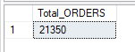

5.Avg_Pizza_Per_order
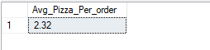

B. Daily trend for ToTal Orders
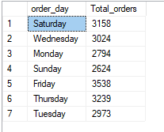

C. Montly Trend fo Orders
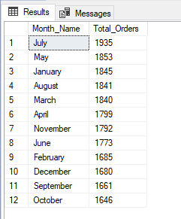

D. % of Sales by Pizza category
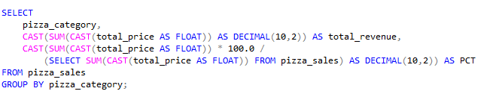
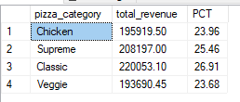
E. % of Sales by Pizza Size
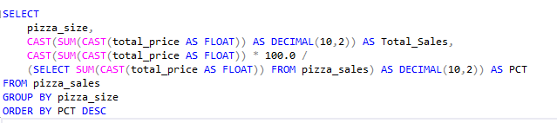
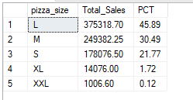
F. Total Pizzas Sold by Pizza Category
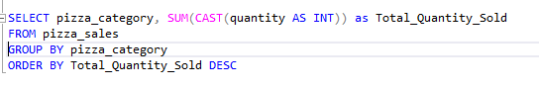
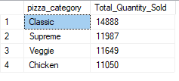

G. TOP 5 Pizzas by Revenue
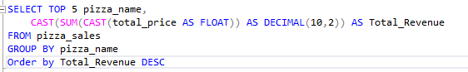
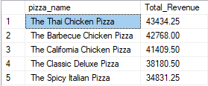

H. Bottom 5 Pizzas by Revenue
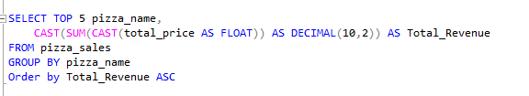
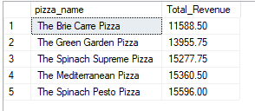

I. Top 5 Pizzas by Quantity
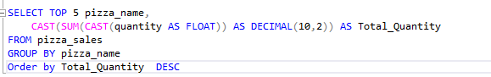
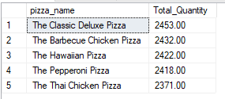

J. Bottom 5 Pizzas by Quantity
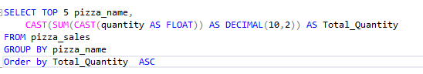
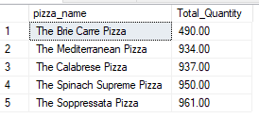

K. Top 5 Pizzas by Total Orders
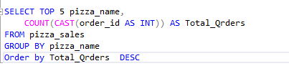
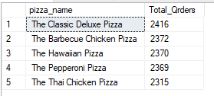

L. Borrom 5 Pizzas by Total Orders
