The number of stocks: 323

Dimensions:

**1. Sectors**

  1.1 Categories: Energy, Industrials...

**2. Market Cap**

  2.1 Categories: 1st quintile, 2nd quintile..,

**3. Price to book**

  3.1 Categories: 1st quintile, 2nd quintile..,

**4. Countries**

  4.1 Categories: Spain, Italy...

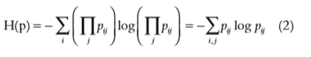

 The process to obtain Pij:

1.  I calculate the volatility of the returns.

2.  I classify stocks within dimensions and categories.

3.    For each category, I calculate the sum of (stock volatility/ number of stocks in the category). And then I use this number as Pij.

For example, in dimension ***Sectors*** and category ***Energy***, there are 11 stocks. Then I calculate ∑(stock volatility / 11) = Pij

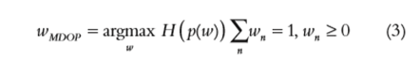

  When we have   H(p), we maximize the function looking for the weights