CURRICULUM VITAE (MAY 2017)

FEDERICO AGUSTÍN CACCIA

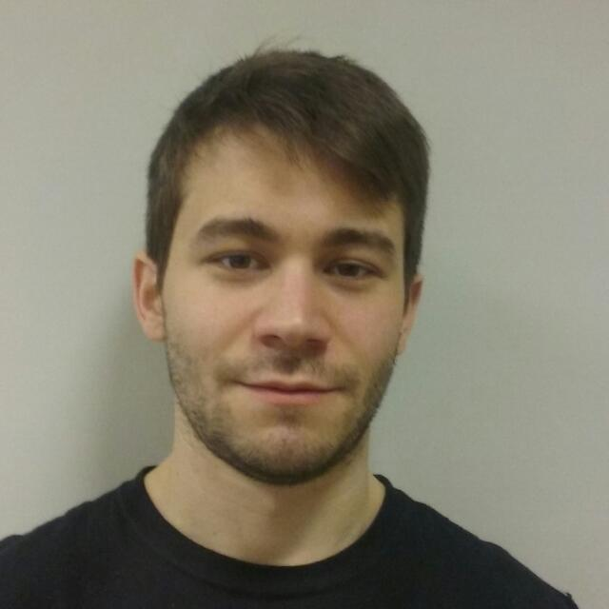
Personal data:

- Name: Federico Agustín Caccia
- D.N.I.: 34297997
- Age: 28
- Date of birth: 08 – 02 – 1989
- Nacionality: Argentina
- Civil status: Single
- Work Adress: Centro Atómico Bariloche, Av. Bustillo 9500, San Carlos de Bariloche (CPA: R8402AGP), Río Negro, Argentina.
- Work telephone: +54 294 4445900 – int 5891
- Peronal telephone: +54 3476 623177
- E-mails: cacciaf@cab.cnea.gov.ar / federicoagustincaccia@gmail.com

Education:

- Master degree in engineering, Instituto Balseiro, Universidad Nacional de Cuyo, Argentina
Tesis topic: “Multiscale coupling of fluid dynamics calculations“
Director: Dr. Enzo Dari
Period: 08/2014 - present
- Nuclear engineer, Instituto Balseiro, Universidad Nacional de Cuyo, Argentina.
Tesis topic: “Conceptual design of a fast nuclear reactor”, doi: 10.13140/RG.2.2.24599.57762
Director: Dr. Eduardo Villarino
Period: 07/2011 – 06/2014
- Student in civil engineer, Universidad Nacional de Rosario, Facultad de Ciencias Exactas, Ingeniería y Agrimensura, Argentina
Approbed subjects: 14
Period: 03/2009 – 06/2011

Professional experience:

- Nuclear engineer at Computational Mechanics Department, Centro Atómico Bariloche, San Carlos de Bariloche, Argentina
Topic: Computational fluid dynamics in research reactors
Period: 11/2014 – present
Director: Dr. Enzo Dari
Co-Director: Dr. Mariano Cantero
References: Dr. Enzo Dari: darie@cab.cnea.gov.ar / Dr. Mariano Cantero: mcantero@cab.cnea.gov.ar

- Passant at SIC-TEC, Mendoza, Argentina
Topic: Building load validation and calculation using OpenFOAM
Period: 07/2014
References: Ing. Tano Eduardo, tano@sictec.com.ar

- Supervised profesional practice at Nuclear Engineer Division, INVAP S.E, San Carlos de Bariloche, Argentina
Topic: Neutronic calculations using cell and core codes
Period: 07/2013 – 06/2014
References: Dr. Villarino Eduardo, men@invap.com.ar

Teaching experience:

- Auxiliar teaching ad-honorem
Subject: Matemática 2A (Mathematics 2A), Instituto Balseiro, Universidad Nacional de Cuyo, Argentina.
Period: 01/2016 – 03/2016
References: Dr. Javier Fernandez: jfernand@cab.cnea.gov.ar
- Auxiliar teaching ad-honorem
Subject: Métodos Numéricos (Numerical methods), Instituto Balseiro, Universidad Nacional de Cuyo, Argentina.
Period: 03/2016 – 06/2016
References: Dr. Enzo Dari: darie@cab.cnea.gov.ar

Languages:

- Spanish: native speaker
- English: fluent comprehension, reading, speaking, and written
- French: basic comprehension and reading. A1 international certificate, 2015.

Grants and fellowships:

- Professional perfectioning grant A1, 2014 – present, Comisión Nacional de Energía Atómica, Argentina
- Summer School Grant, January 2017, Latin American Summer School in Computational Neuroscience, Valparaíso, Chile.
- Fellowship, 2011 – 2014, Instituto Balseiro, Comisión Nacional de Energía Atómica, Universidad Nacional de Cuyo, Argentina

Specialization courses:

Courses taken during Masters:
- “Introducción al procesamiento distribuido” (Introduction to Distributed Processing) – Professor: Dari, E. PhD, 60 hs, Instituto Balseiro, Universidad Nacional de Cuyo, Argentina.
- “Introducción al cómputo en placas gráficas” (Introduction to computing with GPU) – Professor: Colavecchia, F. PhD, 64 hs, Instituto Balseiro, Universidad Nacional de Cuyo, Argentina.
- “Redes neuronales” (Neural networks) – Professor: Mato, G. PhD, 128 hs, Instituto Balseiro, Universidad Nacional de Cuyo, Argentina.
- “Método de elementos finitos” (Finite elements method) – Professor: Dari, E. PhD, 120 hs, Instituto Balseiro, Universidad Nacional de Cuyo, Argentina.
- “Métodos numéricos en mecánica de fluidos” (Numerical methods in fluid mechanics) – Professor: Teruel, F. PhD, 80 hs, Instituto Balseiro, Universidad Nacional de Cuyo, Argentina.
- “Modelado de sistemas termohidráulicos en reactores mediante códigos de planta” (Modeling of thermohydraulic systems in reactors using plant codes) – Professor: Zanocco, P. PhD, 80 hs, Instituto Balseiro, Universidad Nacional de Cuyo, Argentina.
- “Cálculo y análisis de reactores” (Reactor analysis and calculation) – Professor: Lopasso, E. PhD, 80 hs, Instituto Balseiro, Universidad Nacional de Cuyo, Argentina.

Other courses:
- “Filosofía” (Philosophy) – Professor: Cerolini, P., 120 hs, Facultad de Psicología, Universidad Nacional de Rosario.
- “Desarrollos psicológicos contemporáneos” (Contemporary psychological developments) – Professor: Olcese, M., 120 hs, Facultad de Psicología, Universidad Nacional de Rosario.
- “Psicología” (Psychology) – Professor: Gentile, A., 120 hs, Facultad de Psicología, Universidad Nacional de Rosario.
- “Lingüística” (Linguistics) – Professor: Cisneros, L., 120 hs, Facultad de Psicología, Universidad Nacional de Rosario.
- “Epistemología” (Epistemology) – Professor: Capelletti, A. 120 hs, Facultad de Psicología, Universidad Nacional de Rosario.
- “Trabajo de campo: área laboral” (Field work: work area) – 120 hs, Facultad de Psicología, Universidad Nacional de Rosario.

Reports Comisión Nacional de Energía Atómica

- Rechiman, L.; Cantero, M.; Dari, E.; Caccia, F.; Chacoma, A. 2015. “Análisis hidrodinámico del Segundo Sistema de Parada del reactor RA10” (“Hydrodynamic analysis of the Second Shutdown System of RA10 reactor”). Technical Report CNEA IN-ATN40MC- 03/2015, Bariloche, Argentina

Publications in internationals journals:

- Rechiman, L.; Cantero, M. ; Caccia, F.; Chacoma, A. and Dari, E. 2017. “Three-dimensional hydrodynamic modeling of the sencod shutdown system of an experimental nuclear reactor”, Nuclear Engineering and Design, vol. 319, pp 163-175.

Presentations at congresses with publication in acts:

- Caccia, F. and Dari. E. “Acoplamiento multiescala en cálculos fluidodinámicos” (“Multiscale coupling in fluiddynamic calculations”). XXll Congress on Numerical Methods and its Applications, 7-11 November 2016, Córdoba, Argentina.
- Rechiman, L.; Chacoma, A.; Caccia, F.; Dari E. and Cantero, M. “Validación del modelo multiescala del segundo sistema de parada del reactor nuclear experimental RA-10” (“Validation of the multiscale model of the second shutdown system of the experimental RA-10 reactor”). XXll Congress on Numerical Methods and its Applications, 7-11 November 2016, Córdoba, Argentina.

Conferences and courses attended:

- “Evolution of neural computation”, 6-17 February 2017, Centro Atómico Bariloche, San Carlos de Bariloche, Argentina.
- “Latin American Summer School in Computational Neuroscience”, Project title: “Sensory adaptation without plasticity in the V1 visual cortex”, 9-27 January 2017, Valparaíso, Chile.
- “Computational Neuroscience: new trends and challenges for the 2030”, 18 January 2017, Instituto de Sistemas Complejos de Valparaíso, Valparaíso, Chile.
- “Machine learning”, 21-23 November 2016, Centro Atómico Bariloche, San Carlos de Bariloche, Argentina.
- “Plasma processing of radioactive wastes: process engineering, flue gas and solid wastes”, organized by the Nuclear Material Department, the National Program of Radioactive Waste Management and the International Atomic Energy Agency, September 2015, Centro Atómico Bariloche, San Carlos de Bariloche, Argentina.

Federico Agustín Caccia

