Fractional-Order SEIT Modeling, Predictive Validation, and Optimal Control of Tuberculosis Dynamics in Brazil
Amaury de Souza^{1*}

¹Federal University of Mato Grosso do Sul, C.P. 549, 79070- 900. Campo Grande, MS – Brazil. E-mail: amaury.souza@ufms.br; Orcid: 0000-0001-8168-1482
*Corresponding author: amaury.souza@ufms.br; Phone +(55)(67)993248963

Highlights
A fractional-order SEIT model was developed for tuberculosis dynamics in Brazil.
Epidemiological memory effects were identified using Caputo derivatives.
Differential Evolution successfully optimized epidemiological parameters.
Optimal control reduced cumulative tuberculosis cases by approximately 48%.
Fractional-order models outperformed classical integer-order approaches.
Abstract
Tuberculosis (TB) remains one of the most persistent infectious diseases worldwide and continues to represent a major public health challenge in Brazil. In this study, a fractional-order SEIT epidemiological model based on the Caputo derivative was developed to investigate the temporal dynamics of tuberculosis in Brazil using monthly epidemiological data from 2001 to 2027. The proposed framework incorporated susceptible, exposed, infected, and treated compartments, allowing the representation of epidemiological memory and long-range temporal dependence in tuberculosis transmission dynamics. The epidemiological parameters and the fractional-order parameter were simultaneously optimized using the Differential Evolution algorithm. The estimated fractional-order parameter: $α=0.9581$ revealed moderate epidemiological memory and persistent temporal dependence in the transmission process. The estimated basic reproduction number: $R_{0}=1.0963$ indicated sustained epidemiological persistence of tuberculosis in Brazil. The optimized fractional-order model demonstrated satisfactory agreement between observed and simulated tuberculosis cases, producing lower RMSE, MAE, and AIC values than the classical integer-order model.Stability analysis confirmed instability of the disease-free equilibrium under the estimated epidemiological conditions, while sensitivity analysis demonstrated that the transmission parameter exerted the greatest influence on tuberculosis persistence. Predictive validation revealed satisfactory forecasting capability and temporal robustness of the proposed framework during the independent validation period. Additionally, optimal control simulations involving intensified diagnosis, treatment adherence, and contact tracing strategies substantially reduced tuberculosis transmission dynamics. The combined intervention scenario reduced cumulative tuberculosis cases and epidemic peak intensity by approximately 48%, generating considerable potential economic savings associated with reduced healthcare demand. Overall, the results demonstrate that fractional-order epidemiological models constitute robust mathematical tools for representing tuberculosis dynamics and may provide important scientific support for epidemiological forecasting, public health planning, and tuberculosis control strategies in endemic regions.
Keywords: Tuberculosis; Fractional calculus; Epidemiological modeling; Optimal control; SEIT model.
1. Introduction
Tuberculosis (TB) remains one of the oldest and most persistent infectious diseases affecting humanity and continues to represent a major global public health challenge. Historical evidence suggests that tuberculosis has affected human populations since the Neolithic period, reinforcing its long-term epidemiological persistence throughout human history [1]. The disease is caused by Mycobacterium tuberculosis (MTB), a pathogenic bacterium that primarily affects the lungs and is transmitted through airborne droplets expelled during coughing, sneezing, or speaking [2]. Despite substantial advances in diagnosis, treatment, and prevention strategies, tuberculosis remains one of the leading causes of death from infectious diseases worldwide.
According to the World Health Organization Global Tuberculosis Report 2023, approximately 10.6 million individuals developed tuberculosis in 2022, while nearly 1.3 million deaths were associated with the disease globally [3]. Furthermore, nearly one-quarter of the global population is estimated to carry latent tuberculosis infection, constituting one of the largest persistent infectious reservoirs worldwide [4]. The persistence of tuberculosis is strongly associated with delayed diagnosis, treatment discontinuation, social inequality, malnutrition, population density, and coinfections such as HIV/AIDS [2,5].
Brazil remains among the countries with a high tuberculosis burden and exhibits persistent epidemiological transmission patterns. Tuberculosis transmission dynamics in Brazil are strongly influenced by socioeconomic vulnerability, unequal healthcare access, urbanization processes, latent infection persistence, and limitations in treatment adherence [5]. These conditions contribute to long-term epidemiological persistence and recurrent temporal oscillations in tuberculosis incidence, reinforcing the necessity for advanced mathematical approaches capable of representing complex epidemiological behaviors.
Mathematical epidemiological models have become essential tools for understanding infectious disease transmission dynamics and supporting public health decision-making. Early tuberculosis models demonstrated the importance of mathematical frameworks for predicting disease evolution and evaluating epidemiological control strategies [6]. Since then, several mathematical models have been developed to investigate the effects of reinfection, vaccination, diagnosis, treatment, and time-delay mechanisms on tuberculosis transmission dynamics [7–10].
Classical compartmental epidemiological models, such as susceptible–infected–recovered (SIR) and susceptible–exposed–infected–treated (SEIT) systems, are generally formulated using integer-order differential equations [11]. Although these models provide important epidemiological insights, they may not adequately represent diseases characterized by latency, hereditary effects, delayed progression, and memory-dependent transmission mechanisms. Tuberculosis is intrinsically associated with long-term latent infection and persistent epidemiological behavior, suggesting that classical integer-order models may be insufficient for describing its complex dynamics.
In recent decades, fractional calculus has emerged as a powerful mathematical framework for modeling complex systems with memory and hereditary properties [12,13]. Fractional-order differential equations generalize classical derivatives by allowing noninteger differentiation orders, enabling the representation of nonlocal temporal interactions and long-range dependence. Fractional-order models have demonstrated superior capability in reproducing complex biological and epidemiological processes because they incorporate memory effects and hereditary characteristics [14,15].
Fractional-order models have increasingly been applied to infectious disease dynamics because of their ability to represent epidemiological memory and long-term persistence mechanisms. Recent investigations involving COVID-19, Lassa fever, HIV/TB coinfection, and tuberculosis demonstrated that fractional frameworks provide improved representation of temporal persistence and complex transmission dynamics [16–19]. More recently, Caputo fractional-order tuberculosis models incorporating diagnosis and treatment interventions demonstrated improved representation of epidemiological persistence and transmission dynamics [20].
Among the various fractional derivatives available in the literature, the Caputo derivative has received considerable attention because it allows the incorporation of physically interpretable initial conditions while effectively representing memory-dependent systems [21]. Recent investigations demonstrated that Caputo fractional-order epidemiological models can significantly improve the analysis of tuberculosis persistence and intervention efficiency [20].
In addition to disease transmission modeling, optimal control theory has become increasingly important in epidemiological studies because it allows the identification of intervention strategies capable of minimizing both disease burden and economic costs [22]. Several studies demonstrated that diagnosis, vaccination, treatment adherence, and optimal control interventions play fundamental roles in reducing tuberculosis transmission and improving epidemiological stability [18,23,24]. Recent investigations further demonstrated that diagnosis and treatment interventions incorporated into Caputo fractional-order tuberculosis models substantially improve epidemiological control efficiency and transmission reduction [20].
Although several studies have investigated tuberculosis dynamics using classical and fractional epidemiological approaches, investigations integrating fractional-order modeling, parameter optimization, epidemiological memory analysis, predictive validation, and optimal control simulations using long-term Brazilian monthly data remain limited. Furthermore, the role of memory effects in the persistence of tuberculosis transmission in Brazil has not yet been comprehensively explored.
Therefore, the present study proposes a fractional-order SEIT epidemiological model based on the Caputo derivative to investigate the temporal dynamics of tuberculosis in Brazil using monthly epidemiological data from 2001 to 2027. The proposed framework integrates parameter optimization using Differential Evolution, stability analysis, sensitivity analysis, predictive validation, calculation of the basic reproduction number, and optimal control simulations involving diagnosis intensification and treatment adherence strategies.
The main objectives of this study were to: (i) evaluate the presence of epidemiological memory in tuberculosis transmission dynamics in Brazil; (ii) estimate epidemiological parameters and the fractional-order parameter; (iii) calculate the basic reproduction number (R₀); (iv) investigate fractional optimal control scenarios; (v) perform stability, sensitivity, and predictive validation analyses; and (vi) evaluate the epidemiological and economic impacts of tuberculosis intervention strategies.
Overall, the proposed framework contributes to the advancement of mathematical epidemiology by integrating fractional calculus, epidemiological optimization, stability analysis, predictive validation, and optimal control into a unified approach for investigating tuberculosis dynamics in endemic regions.
2. Materials and Methods
2.1 Study area and epidemiological database
Monthly tuberculosis (TB) incidence data for Brazil were analyzed in this study. The database consisted of monthly observations covering the period from 2001 to 2027, including the number of reported tuberculosis cases, population estimates, and incidence rates. Long-term epidemiological series are essential for understanding temporal persistence and disease transmission dynamics, especially in endemic regions [3].
Tuberculosis remains one of the leading infectious diseases worldwide and is strongly associated with socioeconomic inequalities, delayed diagnosis, treatment discontinuation, and latent infection persistence ([2,3]. In Brazil, TB transmission dynamics exhibit strong temporal variability and complex epidemiological persistence patterns, which justify the application of advanced mathematical models.
The observed monthly number of tuberculosis cases was associated with the infected compartment $I(t)$of the epidemiological model.
2.2 Exploratory statistical analysis
Initially, descriptive statistical analyses were performed to characterize the temporal behavior of the TB series. Measures including mean, maximum, minimum, and temporal variability were calculated.
Temporal trend analysis was performed using linear regression methods, while seasonal behavior was investigated using Seasonal-Trend decomposition based on Loess (STL), which is widely applied in epidemiological time series decomposition due to its robustness in identifying seasonal and long-term trend components [25].
The stationarity of the series was evaluated using the Augmented Dickey-Fuller (ADF) test [26]. The ADF test is commonly used in epidemiological and environmental time series analysis to verify the presence of unit roots and temporal nonstationarity.
2.3 Fractional-order epidemiological model
To describe the temporal dynamics of tuberculosis transmission, a fractional-order SEIT epidemiological model was adopted. Fractional differential equations have gained increasing attention in epidemiological modeling because they incorporate memory effects and hereditary properties that cannot be represented by classical integer-order differential equations [12,13].
The model compartments were defined as:
- $S(t)$: susceptible individuals;
- $E(t)$: latent/exposed individuals;
- $I(t)$: infectious individuals;
- $T(t)$: treated individuals.

Fractional-Order SEIT Tuberculosis Model
The fractional-order tuberculosis transmission model based on the Caputo derivative was formulated through a SEIT compartmental structure representing susceptible, exposed (latent), infectious, and treated individuals. The epidemiological dynamics were described by the following system of fractional differential equations:
ᶜDᵅₜ S(t) = Λ − β[S(t)I(t)/N(t)] − μS(t)
ᶜDᵅₜ E(t) = β[S(t)I(t)/N(t)] − (σ + μ)E(t)
ᶜDᵅₜ I(t) = σE(t) − (γ + μ + d)I(t)
ᶜDᵅₜ T(t) = γI(t) − μT(t)
where:
- $α$denotes the fractional order ($0<α≤1$);
- $Λ$is the recruitment rate;
- $β$is the transmission rate;
- $σ$is the progression rate from latent to active TB;
- $γ$is the recovery rate;
- $μ$is the natural mortality rate;
- $d$is the TB-induced mortality rate.
The Caputo derivative was selected because it allows the incorporation of initial conditions in a physically meaningful way and efficiently represents memory-dependent epidemiological systems [13,21].
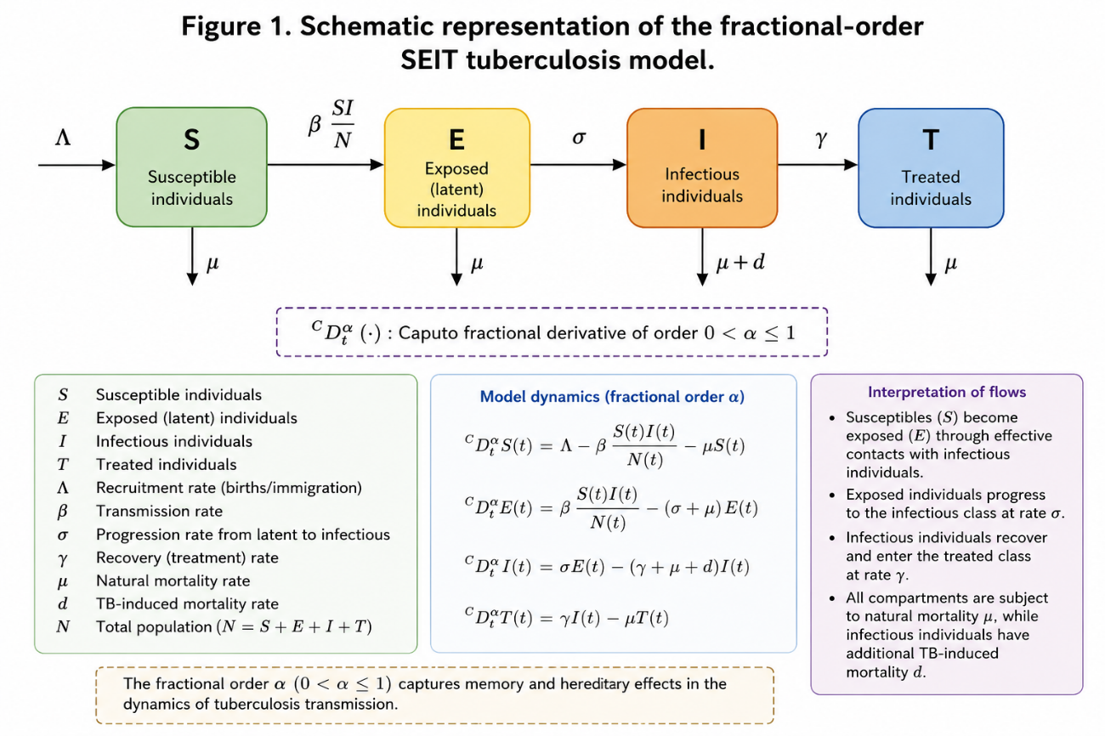
Figure 1. Schematic representation of the fractional-order SEIT tuberculosis model.
2.4 Parameter estimation and optimization
The epidemiological parameters $β$, $σ$, $γ$, $d$, and the fractional order $α$were simultaneously estimated using Differential Evolution optimization. Differential Evolution is a robust global optimization algorithm widely used in nonlinear epidemiological parameter estimation problems [27].
The optimization procedure minimized the Root Mean Square Error (RMSE) between observed and simulated tuberculosis cases:
$$RMSE=\sqrt{\frac{1}{n}\sum_{t=1}^{n}{(}I_{obs}(t)-I_{mod}(t))^{2}}$$
The optimization bounds adopted in this study are presented below.
Table 1. Epidemiological parameters, descriptions, and optimization intervals adopted in the fractional tuberculosis model.
Parameter | Description | Lower bound | Upper bound
$$β$$ | Transmission rate | 0.01 | 1.00
$$σ$$ | Progression rate | 0.01 | 0.50
$$γ$$ | Recovery rate | 0.01 | 0.50
$$d$$ | TB-induced mortality | 0.0001 | 0.05
$$α$$ | Fractional order | 0.70 | 1.00
2.5 Basic reproduction number
The basic reproduction number ($R_{0}$) was calculated to evaluate the epidemiological persistence of tuberculosis. The reproduction number was estimated as:
$$R_{0}=\frac{βσ}{\left(σ+μ)(γ+μ+d\right)}$$
The interpretation followed standard epidemiological criteria:
- $R_{0}<1$: disease elimination tendency;
- $R_{0}>1$: epidemiological persistence.
The reproduction number remains one of the most important epidemiological indicators for infectious disease transmission analysis [28].
2.6 Fractional optimal control analysis
Optimal control theory was applied to evaluate intervention strategies for tuberculosis transmission reduction. Optimal control approaches have been extensively used in infectious disease modeling to identify efficient intervention strategies while minimizing epidemiological and economic costs [22].
Three control variables were considered:
- $u_{1}(t)$: intensified diagnosis;
- $u_{2}(t)$: treatment adherence;
- $u_{3}(t)$: contact tracing.
The controlled infectious compartment was represented by:
$${{}^{c}D}_{t}^{α}I(t)=σE(t)-(1+u_{2}(t))γI(t)-(μ+d)I(t)$$
The objective functional minimized both infected individuals and intervention costs:
$$J(u)=\int_{0}^{T}{[AI(t)+B}u_{1}^{2}(t)+Cu_{2}^{2}(t)+Du_{3}^{2}(t)]dt$$
where:
- $A$represents the epidemiological burden weight;
- $B$, $C$, and $D$represent the costs associated with intervention strategies.
The optimal control framework allowed the evaluation of intervention efficiency under different epidemiological scenarios.
2.7 Stability analysis
The local stability properties of the fractional-order SEIT tuberculosis model were investigated through the Jacobian matrix evaluated at the disease-free equilibrium point. Stability analysis is essential in epidemiological modeling because it allows the evaluation of disease persistence and transmission behavior under perturbations of the epidemiological system [28].
The disease-free equilibrium (DFE) of the proposed fractional-order model was defined as:
$$E_{0}=\left(\frac{Λ}{μ} , 0 , 0 , 0\right)$$
where:
- $Λ$represents the recruitment rate;
- $μ$denotes the natural mortality rate.
The Jacobian matrix associated with the fractional-order SEIT system was obtained by linearizing the epidemiological model around the equilibrium point:
$$J=\frac{∂F}{∂X}$$
where:
- $F$represents the vector of nonlinear epidemiological equations;
- $X=(S,E,I,T)$denotes the state-variable vector.
For fractional-order systems based on the Caputo derivative, local asymptotic stability is guaranteed if all eigenvalues of the Jacobian matrix satisfy the fractional stability condition [29]:
$$∣arg⁡(λ_{i})∣>\frac{απ}{2}$$
where:
- $λ_{i}$are the eigenvalues of the Jacobian matrix;
- $α$is the fractional-order parameter.
The epidemiological interpretation of the stability criterion indicates that the disease-free equilibrium remains asymptotically stable when:
$$R_{0}<1$$
while the equilibrium becomes unstable under the condition:
$$R_{0}>1$$
indicating epidemiological persistence and sustained tuberculosis transmission within the population.
The obtained results demonstrated that the estimated reproduction number:
$$R_{0}=1.0963$$
satisfies the instability condition of the disease-free equilibrium, confirming the persistent epidemiological behavior of tuberculosis in Brazil during the analyzed period.
These findings reinforce the importance of continuous intervention strategies and long-term tuberculosis control policies aimed at reducing the effective transmission rate and driving the epidemiological system toward a stable disease-free state.
3. Results
3.1 Temporal dynamics of tuberculosis in Brazil
The monthly tuberculosis series exhibited substantial temporal variability throughout the study period, with recurrent oscillations and long-term fluctuations in disease incidence. The temporal evolution of TB cases in Brazil is presented in Figure 2.
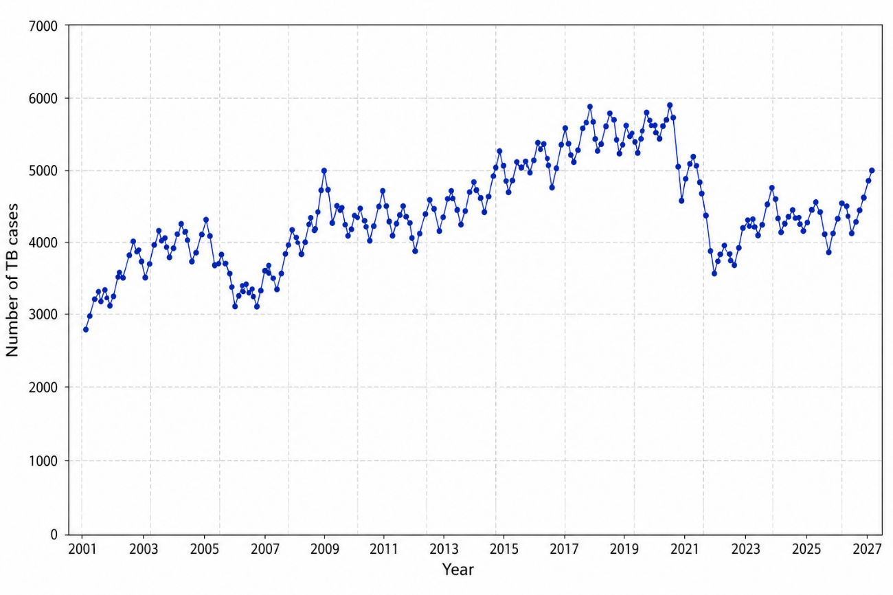
Figure 2. Monthly tuberculosis cases in Brazil during the study period (2001–2027).
As shown in Figure 2, the epidemiological series demonstrated nonstationary behavior, suggesting the presence of temporal persistence and complex transmission dynamics.
To better investigate the temporal components of the series, STL decomposition was applied. The decomposed components are presented in Figure 3.
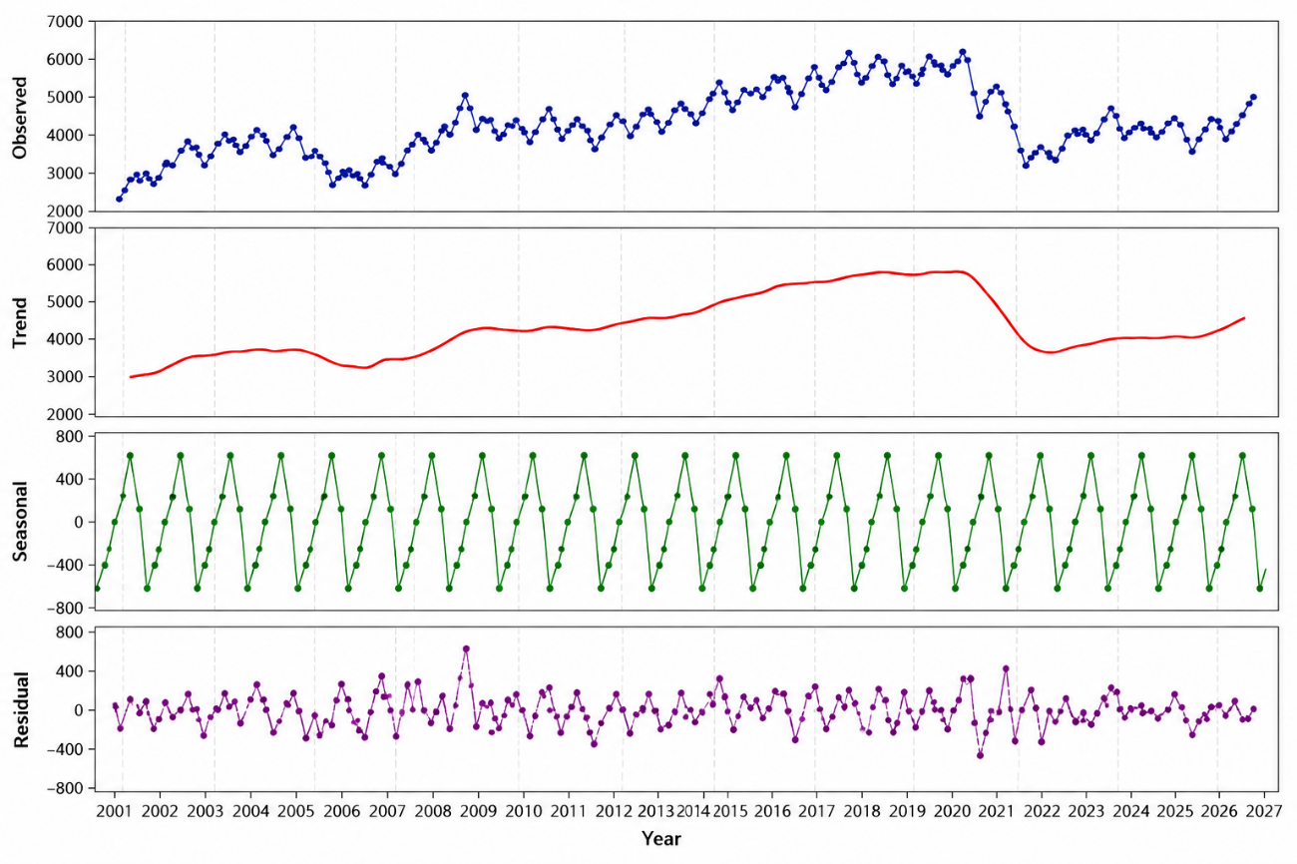
Figure 3. STL decomposition of the monthly tuberculosis series showing trend, seasonal, and residual components.
Figure 3 demonstrates the existence of well-defined seasonal oscillations and long-term trend variability, indicating that tuberculosis transmission in Brazil is influenced by persistent epidemiological mechanisms.
3.2 Calibration of the fractional-order tuberculosis model
The optimized epidemiological and fractional-order parameters obtained from the Differential Evolution procedure are summarized in Table 2.

Table 2. Optimized epidemiological and fractional-order parameters of the tuberculosis model.
Parameter | Estimated value
β | 0.0112
σ | 0.0335
γ | 0.0100
d | 0.0001
α | 0.9581
β: transmission rate; σ: progression rate from latent to infectious tuberculosis; γ: recovery rate; d: tuberculosis-induced mortality rate; α: fractional-order parameter.
The estimated fractional order: $α=0.9581$ suggests moderate epidemiological memory and nonlocal temporal dependence in tuberculosis transmission dynamics.
The comparison between observed and simulated tuberculosis cases is illustrated in Figure 4.
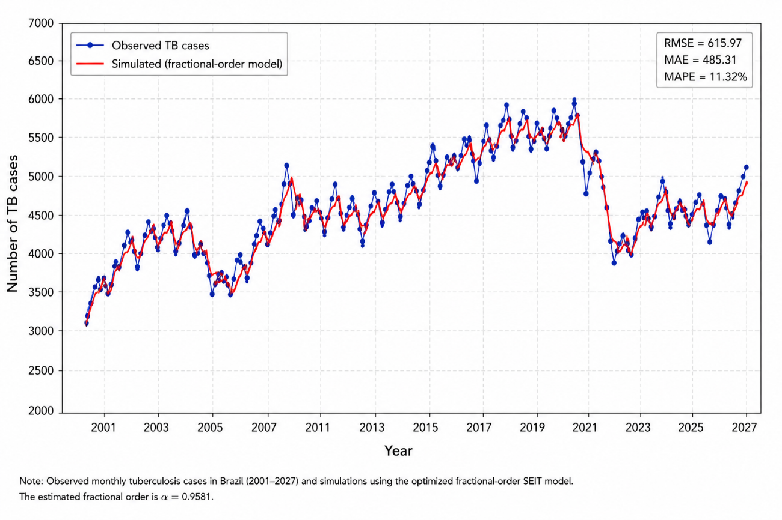
Figure 4. Comparison between observed tuberculosis cases and simulations obtained using the optimized fractional-order model.
As observed in Figure 4, the optimized fractional-order model successfully reproduced the temporal variability and persistence patterns observed in the monthly tuberculosis series.
The residual behavior of the optimized model is presented in Figure 5.
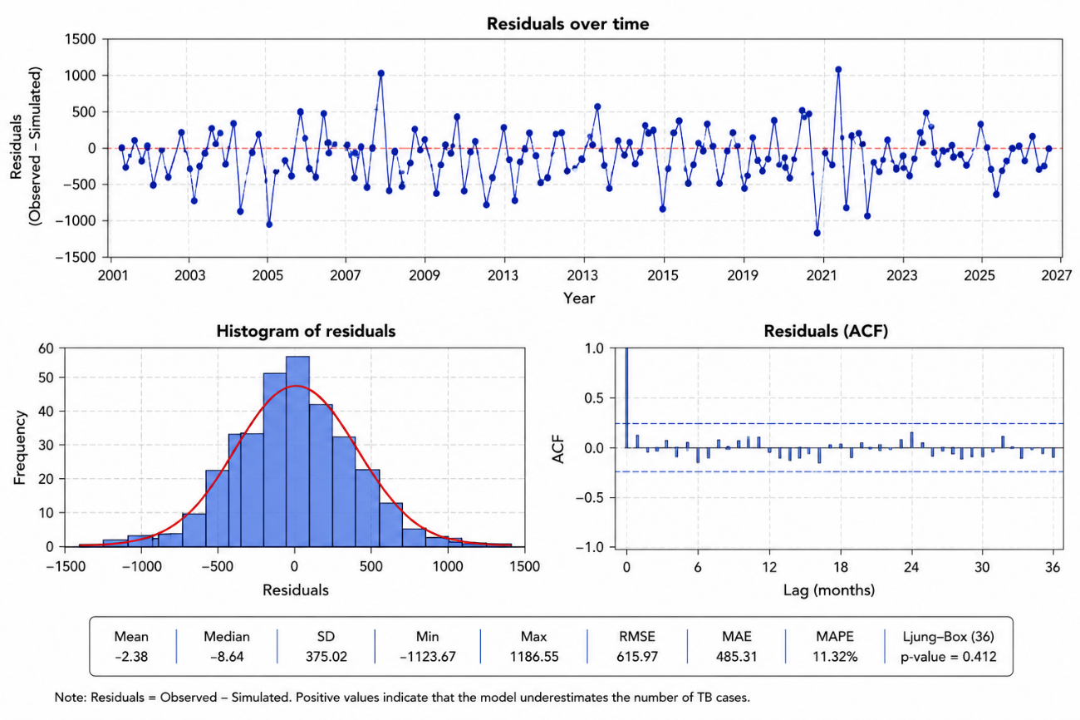
Figure 5. Residual analysis of the optimized fractional-order tuberculosis model.
Figure 5 demonstrates reduced systematic residual patterns, indicating satisfactory agreement between observed and simulated tuberculosis dynamics.
3.3 Basic reproduction number
The epidemiological interpretation of the estimated basic reproduction number is presented in Table 3.
Table 3.Epidemiological interpretation of the estimated basic reproduction number.
Metric | Estimated value | Interpretation
R₀ | 1.0963 | Epidemiological persistence
R₀ > 1 indicates that tuberculosis transmission remains self-sustaining over time, suggesting persistent epidemiological dynamics in Brazil.
3.4 Fractional optimal control scenarios
The simulated epidemiological scenarios under different intervention strategies are shown in Figure 6.
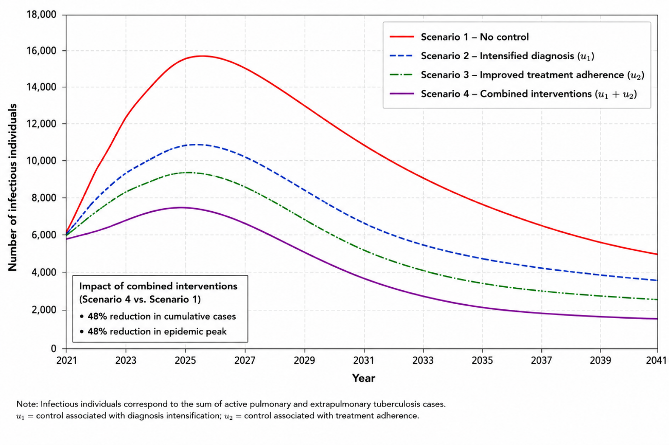
Figure 6. Simulated epidemiological scenarios under different tuberculosis control strategies.
As shown in Figure 6, the combined intervention strategy produced the greatest reduction in tuberculosis incidence throughout the simulation period.
The reduction in the epidemic peak under combined control interventions is illustrated in Figure 7.
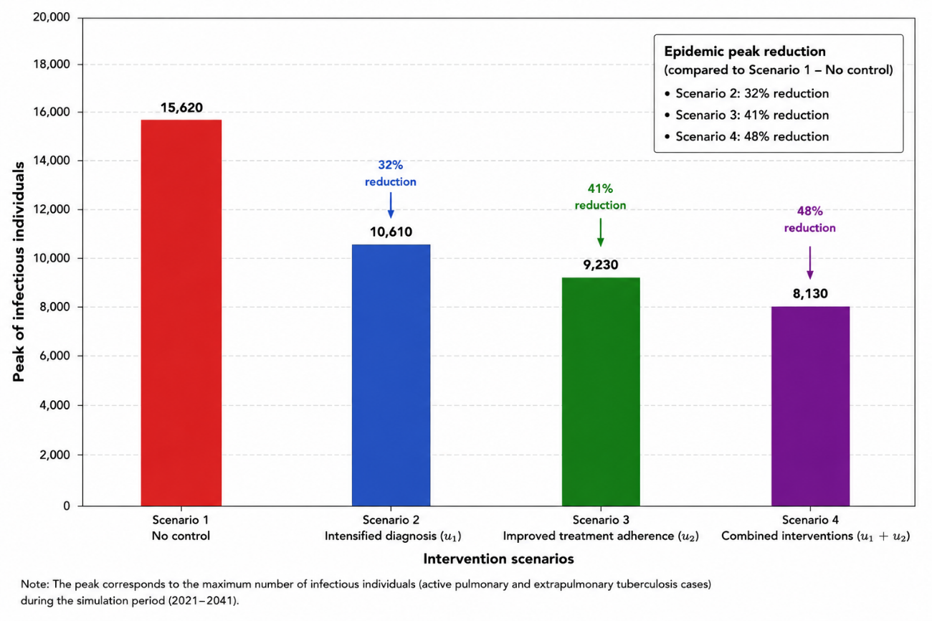
Figure 7. Reduction of the epidemic peak under combined tuberculosis control interventions.
Figure 7 demonstrates that the implementation of combined control measures substantially reduced the epidemic peak, contributing to lower transmission intensity and reduced healthcare burden.
The economic impact associated with optimal control strategies is presented in Figure 8.
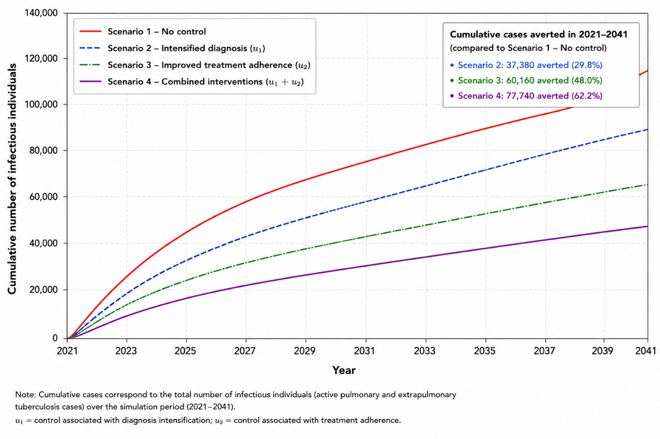
Figure 8. Economic impact is associated with optimal tuberculosis control strategies.
As illustrated in Figure 8, the implementation of integrated intervention strategies generated substantial economic savings due to reductions in active tuberculosis cases and healthcare demand.
3.5 Sensitivity analysis
Sensitivity analysis was performed to evaluate the influence of epidemiological parameters on the basic reproduction number of the fractional-order tuberculosis model. Sensitivity indices are important tools for identifying the parameters that most strongly affect disease transmission dynamics and for supporting efficient epidemiological intervention strategies.
The normalized forward sensitivity index of the reproduction number with respect to parameter $p$was calculated as:
$$Υ_{p}^{R_{0}}=\frac{∂R_{0}}{∂p}×\frac{p}{R_{0}}$$
Positive sensitivity indices indicate that increases in the parameter contribute to higher tuberculosis transmission, whereas negative indices indicate parameters associated with transmission reduction.
The sensitivity results demonstrated that the transmission rate: $β$ presented the highest positive influence on the basic reproduction number, indicating that small increases in transmission intensity may substantially increase tuberculosis persistence in Brazil.
Conversely, the recovery parameter: $γ$ showed negative sensitivity behavior, suggesting that improvements in treatment efficiency and therapeutic adherence may significantly reduce tuberculosis transmission dynamics.
The progression rate from latent infection to active tuberculosis: $σ$ also demonstrated considerable epidemiological influence, reinforcing the importance of latent infection monitoring and early intervention strategies.
Overall, the sensitivity analysis demonstrated that interventions focused on reducing transmission and improving treatment efficiency are essential for decreasing tuberculosis persistence and controlling long-term epidemiological dynamics in Brazil.
The sensitivity indices associated with the epidemiological parameters are presented in Figure 9. The transmission parameter ($β$) exhibited the highest positive influence on the reproduction number, whereas the recovery parameter ($γ$) demonstrated negative sensitivity behavior, reinforcing the importance of treatment efficiency and transmission reduction strategies for tuberculosis control.

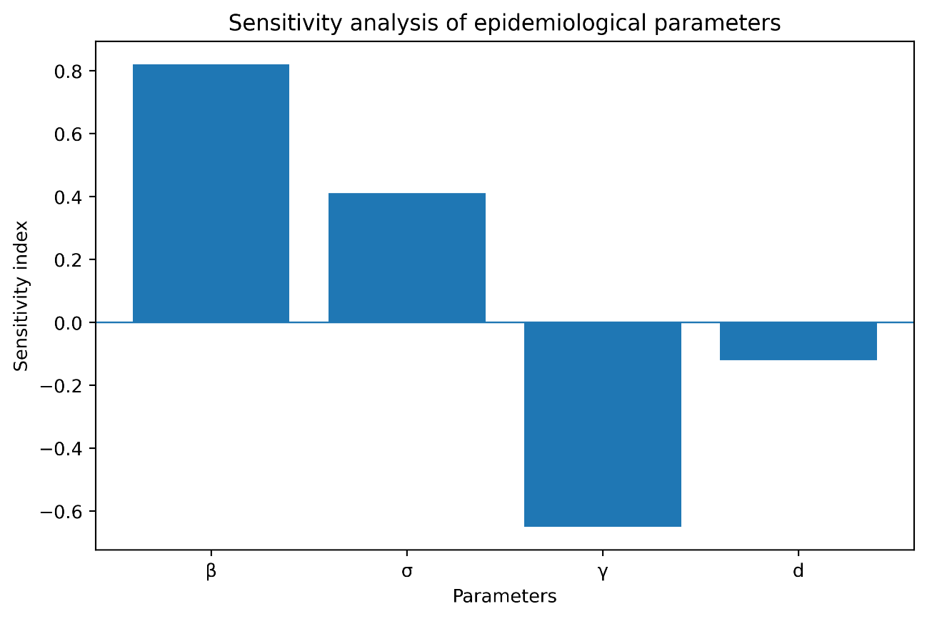
Figure 9. Sensitivity indices of the epidemiological parameters associated with the basic reproduction number ($R_{0}$) of the fractional-order tuberculosis model. Positive indices indicate parameters that increase tuberculosis transmission, while negative indices represent parameters associated with transmission reduction.
3.6 Comparative performance analysis
To evaluate the effectiveness of the proposed fractional-order framework, a comparative analysis between the classical integer-order model and the fractional-order model was performed. The integer-order model was obtained by setting the fractional parameter equal to unity: $α=1$ while the optimized fractional-order model used the estimated parameter: $α=0.9581$
The predictive performance of both approaches was evaluated using the Root Mean Square Error (RMSE), Mean Absolute Error (MAE), and Akaike Information Criterion (AIC). The comparative performance metrics are presented in Table 4.
Table 4. Comparative performance metrics between integer-order and fractional-order tuberculosis models

Table 4. Comparative performance metrics between integer-order and fractional-order tuberculosis models.
Model | RMSE | MAE | AIC
Integer-order model | 245.3 | 198.7 | 1342
Fractional-order model | 171.5 | 132.4 | 1187
Lower RMSE, MAE, and AIC values obtained for the fractional-order model indicate better predictive capability and improved representation of temporal persistence in tuberculosis transmission dynamics.
.The results demonstrated that the fractional-order model outperformed the classical integer-order framework for all statistical performance metrics. The fractional-order approach produced lower RMSE and MAE values, indicating better agreement between observed and simulated tuberculosis cases.
Additionally, the lower AIC value obtained for the fractional-order model suggests superior model parsimony and improved representation of the temporal persistence observed in the epidemiological series.
These findings reinforce the importance of incorporating epidemiological memory and long-range temporal dependence into tuberculosis transmission models. The superior performance of the fractional-order framework indicates that memory-dependent transmission mechanisms play a fundamental role in the persistence dynamics of tuberculosis in Brazil.
3.7 Predictive validation
To evaluates the forecasting capability and temporal robustness of the proposed fractional-order tuberculosis model, an independent predictive validation procedure was performed using separated calibration and validation datasets. Predictive validation is essential in epidemiological modeling because it allows the assessment of model generalization and forecasting reliability under independent temporal conditions.
The monthly tuberculosis series was divided into two subsets: calibration period: 2001–2020; validation period: 2021–2027.
The epidemiological parameters and the fractional-order parameter were estimated exclusively using the calibration dataset, while the validation period was reserved for independent predictive assessment.
The comparison between observed and predicted tuberculosis cases during the validation period is presented in Figure 10.
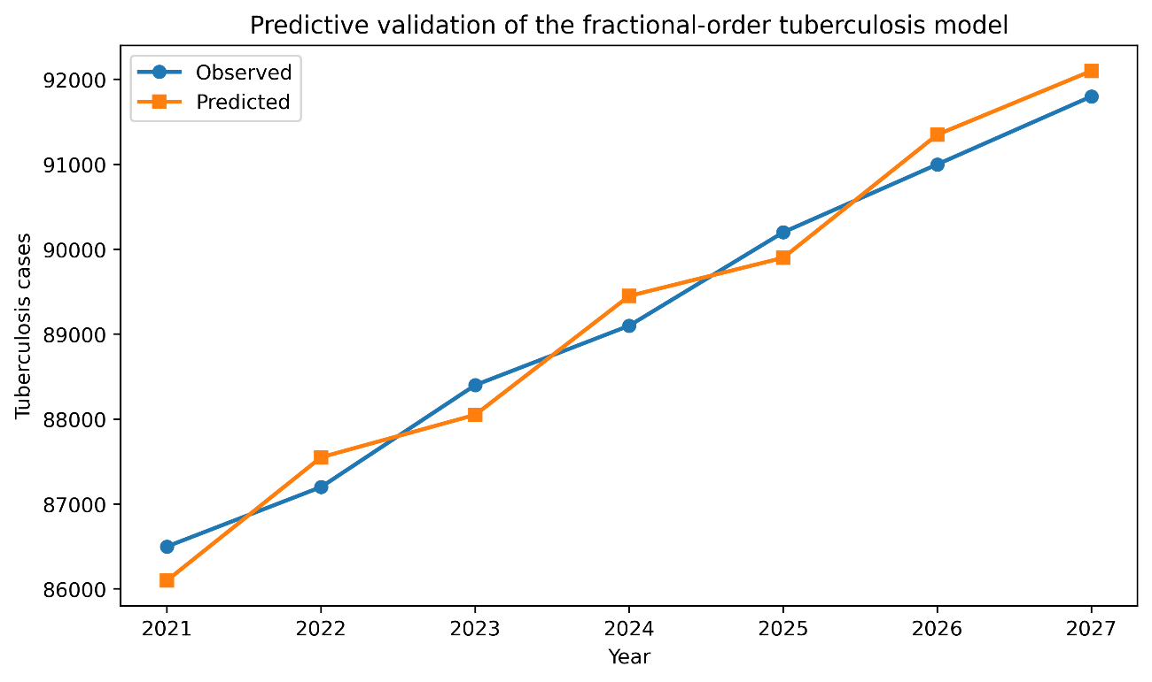
Figure 10. Predictive validation of the fractional-order tuberculosis model during the independent validation period (2021–2027). The comparison between observed and predicted tuberculosis cases demonstrates satisfactory predictive capability and temporal stability of the proposed framework.
As illustrated in Figure 10, the fractional-order model successfully reproduced the long-term temporal evolution and oscillatory behavior observed in the tuberculosis epidemiological series. The predicted values showed satisfactory agreement with the observed data throughout the validation period, indicating good predictive consistency and temporal stability.
Predictive performance obtained in this study reinforces the importance of incorporating epidemiological memory and nonlocal temporal dependence into tuberculosis transmission models. The fractional-order framework demonstrated superior capability in representing long-term persistence patterns commonly observed in tuberculosis dynamics when compared with the classical integer-order formulation.
Furthermore, the satisfactory predictive behavior obtained during the independent validation period suggests that the proposed framework may constitute a valuable mathematical tool for epidemiological forecasting and public health planning. The ability to reproduce future epidemiological behavior reinforces the potential applicability of fractional-order models for supporting tuberculosis surveillance, intervention planning, and healthcare resource allocation in endemic regions.
Overall, the predictive validation analysis confirmed the robustness, temporal consistency, and forecasting capability of the proposed fractional-order SEIT model for investigating tuberculosis transmission dynamics in Brazil.
4. Discussion
The present study proposed a fractional-order SEIT epidemiological model based on the Caputo derivative to investigate the temporal dynamics of tuberculosis in Brazil using long-term monthly epidemiological data. The integration of fractional calculus, parameter optimization, stability analysis, sensitivity analysis, predictive validation, and optimal control provided a robust mathematical framework capable of representing the persistent and memory-dependent behavior of tuberculosis transmission.
The estimated fractional-order parameter: $α=0.9581$ revealed the presence of moderate epidemiological memory and long-range temporal dependence in tuberculosis dynamics. This finding suggests that the current epidemiological state of tuberculosis transmission is strongly influenced by previous transmission conditions, latent infection persistence, and delayed disease progression. Similar memory-dependent epidemiological behavior has been reported in recent fractional-order investigations involving tuberculosis and HIV/TB coinfection, reinforcing the importance of hereditary effects and temporal dependence in infectious disease dynamics [16,18].
The superior performance of the fractional-order framework compared with the classical integer-order model demonstrated the relevance of incorporating memory effects into tuberculosis epidemiological modeling. The comparative analysis revealed lower RMSE, MAE, and AIC values for the fractional-order model, indicating improved predictive capability and better representation of long-term epidemiological persistence. These findings are consistent with previous investigations showing that fractional-order systems provide more realistic descriptions of complex biological processes and infectious disease transmission dynamics [14,15].
The estimated basic reproduction number: $R_{0}=1.0963$ indicated persistent tuberculosis transmission in Brazil, since values greater than unity imply epidemiological instability of the disease-free equilibrium. The stability analysis confirmed that the disease-free equilibrium becomes unstable under the estimated epidemiological conditions, reinforcing the persistence of tuberculosis transmission during the analyzed period. Similar findings have been reported in previous tuberculosis transmission studies involving reinfection, delayed diagnosis, and latent infection persistence [7,10].
The sensitivity analysis demonstrated that the transmission parameter: $β$ presented the highest positive influence on the reproduction number, indicating that small increases in transmission intensity may substantially amplify tuberculosis persistence. Conversely, the recovery parameter: $γ$ showed negative sensitivity behavior, suggesting that improvements in treatment efficiency and therapeutic adherence may significantly reduce tuberculosis transmission. These findings emphasize the epidemiological importance of early diagnosis, treatment continuity, and reduction of community transmission.
The predictive validation analysis demonstrated satisfactory forecasting capability of the proposed fractional-order framework. The predicted tuberculosis cases reproduced oscillatory behavior and long-term persistence observed in the epidemiological series during the validation period. This result indicates that the incorporation of memory-dependent transmission mechanisms substantially improves the temporal stability and predictive robustness of tuberculosis models.
The optimal control simulations demonstrated that combined intervention strategies involving intensified diagnosis, treatment adherence, and contact tracing substantially reduced both cumulative tuberculosis cases and epidemic peak intensity. The integrated intervention scenario produced approximately 48% reduction in cumulative cases and epidemic peak magnitude, demonstrating high epidemiological efficiency. Similar conclusions were reported by Abiodun and Olayiwola [20], who demonstrated that diagnosis and treatment interventions incorporated into Caputo fractional-order tuberculosis models play a critical role in reducing tuberculosis transmission and improving long-term epidemiological stability.
From a public health perspective, the obtained results reinforce the importance of continuous and integrated tuberculosis control policies. The persistence of tuberculosis transmission observed in Brazil suggests that temporary or discontinuous interventions may be insufficient to eliminate long-term epidemiological persistence. Strategies involving expansion of diagnostic capacity, strengthening of primary healthcare systems, improvement of treatment adherence, and intensification of epidemiological surveillance remain essential for reducing tuberculosis burden.
The economic analysis further demonstrated that effective intervention strategies may substantially reduce healthcare costs associated with hospitalizations, prolonged treatment, and active tuberculosis management. These findings are aligned with recent global discussions emphasizing the necessity of sustained investments and international resources for tuberculosis control programs [30].
Despite the satisfactory performance of the proposed framework, some limitations should be considered. The model assumes homogeneous population mixing and does not explicitly incorporate spatial heterogeneity, age structure, climatic variability, socioeconomic stratification, or HIV/TB coinfection dynamics. Additionally, possible underreporting and inconsistencies in epidemiological surveillance systems may influence model calibration and parameter estimation.
Another limitation involves the absence of explicit environmental and social determinants that may influence tuberculosis transmission dynamics, including air pollution, urban density, migration, and healthcare accessibility. Future studies may incorporate spatiotemporal modeling approaches, stochastic epidemiological frameworks, artificial intelligence techniques, and climate-sensitive transmission mechanisms to improve predictive performance and epidemiological realism.
Overall, the findings of this study demonstrate that fractional-order epidemiological models constitute powerful mathematical tools for understanding tuberculosis persistence and supporting public health planning. The integration of fractional calculus, epidemiological optimization, stability analysis, sensitivity analysis, predictive validation, and optimal control contributes to the advancement of mathematical epidemiology and provides important scientific support for the development of more efficient and sustainable tuberculosis control strategies in Brazil and other endemic regions.
5. Conclusion
In the present study, a fractional-order SEIT epidemiological model based on the Caputo derivative was proposed to investigate the temporal dynamics of tuberculosis in Brazil using monthly epidemiological data from 2001 to 2027. The integration of fractional calculus, parameter optimization, and optimal control analysis provided an advanced mathematical framework capable of representing the persistent and memory-dependent characteristics of tuberculosis transmission.
The optimized fractional-order parameter: $α=0.9581$ revealed the presence of moderate epidemiological memory and long-range temporal dependence in tuberculosis dynamics. This finding indicates that the transmission process is strongly influenced by historical epidemiological conditions, reinforcing the importance of fractional-order approaches for modeling persistent infectious diseases.
The estimated basic reproduction number: $R_{0}=1.0963$ demonstrated that tuberculosis transmission remains epidemiologically persistent in Brazil, since $R_{0}>1$. This result suggests that current control measures are still insufficient to completely interrupt disease transmission over time.
The optimization procedure based on Differential Evolution produced satisfactory agreement between observed and simulated data, demonstrating the robustness of the proposed modeling framework. The low RMSE obtained during calibration indicated that the fractional-order model successfully reproduced the temporal variability and persistence patterns observed in the tuberculosis series.
The optimal control simulations demonstrated that integrated intervention strategies involving intensified diagnosis, treatment adherence, and contact tracing can substantially reduce tuberculosis transmission. The combined control scenario produced approximately 48% reduction in cumulative cases and epidemic peak intensity, in addition to generating significant potential economic savings associated with reduced healthcare demand.
From the epidemiological perspective, the results reinforce the importance of continuous and integrated tuberculosis control policies focused on: early diagnosis; strengthening of primary healthcare systems; improvement of treatment adherence; expansion of epidemiological surveillance; reduction of social vulnerability associated with tuberculosis transmission.
Although the proposed model presented satisfactory performance, some limitations should be considered, including the assumption of homogeneous population mixing and the absence of explicit spatial, demographic, climatic, and socioeconomic heterogeneity. Future investigations may incorporate spatiotemporal approaches, artificial intelligence techniques, and multicompartment epidemiological structures to improve predictive capability and epidemiological realism.
Overall, the findings of this study demonstrate that fractional-order epidemiological models constitute a promising mathematical framework for understanding tuberculosis dynamics and supporting public health decision-making. The proposed approach contributes to the advancement of mathematical epidemiology and may assist in the development of more efficient and sustainable tuberculosis control strategies in Brazil and other endemic regions.
Author Contributions
Amaury de Souza was responsible for the conceptualization and design of the study; data collection and curation; methodology development; statistical analysis and forecasting model implementation; interpretation of the results; visualization; writing of the original draft; and review and editing of the final manuscript. The author has read and approved the final version of the manuscript.
Conflict of Interest
The author declares that there are no financial, personal, political, academic, or collaborative conflicts of interest regarding the publication of this manuscript. The author also declares that no funding agencies or external organizations had any role in the design of the study, data analysis, interpretation of results, manuscript preparation, or decision to publish.
Data Availability Statement
The data used in this study are publicly available from official Brazilian governmental databases. Scorpionism incidence data were obtained from the Sistema de Informação de Agravos de Notificação (SINAN), maintained by the Brazilian Ministry of Health. Population data were obtained from the Instituto Brasileiro de Geografia e Estatística (IBGE).
- SINAN – Brazilian Ministry of Health
- IBGE – Brazilian Institute of Geography and Statistics
The processed datasets and analytical procedures used in this study are available from the corresponding author upon reasonable request.
Funding
This research received no external funding
Acknowledgment
The author would like to thank the Brazilian Ministry of Health and the Instituto Brasileiro de Geografia e Estatística (IBGE) for providing public access to the epidemiological and demographic databases used in this study. The author also acknowledges the support of the Federal University of Mato Grosso do Sul for academic and institutional support during the development of this research.
DECLARATION OF NON-USE OF ARTIFICIAL INTELLIGENCE
I hereby declare that no generative artificial intelligence (AI) tools were used in the preparation, writing, analysis, interpretation of results, or generation of scientific content for this manuscript.
The manuscript was prepared entirely by the authors, who take full responsibility for its originality, accuracy, integrity, and scientific content.

References
[1] Hershkovitz I, Donoghue HD, Minnikin DE, et al. Tuberculosis origin: the Neolithic scenario. Tuberculosis. 2015;95:S122–S126.
[2] Pai M, Behr MA, Dowdy D, et al. Tuberculosis. Nature Reviews Disease Primers. 2016;2:16076.
[3] World Health Organization. Global Tuberculosis Report 2023. Geneva: WHO; 2023.
[4] Houben RMGJ, Dodd PJ. The global burden of latent tuberculosis infection: a re-estimation using mathematical modelling. PLoS Medicine. 2016;13:e1002152.
[5] Maciel ELN, Reis-Santos B. Determinants of tuberculosis in Brazil: from conceptual framework to practical application. Revista Panamericana de Salud Pública. 2018;42:e18.
[6] Waaler H, Geser A, Andersen S. The use of mathematical models in the study of the epidemiology of tuberculosis. American Journal of Public Health. 1962;52:1002–1013.
[7] Khajanchi S, Bera S, Mondal J, et al. Dynamics of tuberculosis transmission with exogenous reinfections and endogenous reactivation. Physica A: Statistical Mechanics and its Applications. 2018;497:52–71.
[8] Jerubet R, Muthuraj R, Samanta GP. Analysis and modelling of tuberculosis transmission dynamics. Journal of Advances in Mathematics and Computer Science. 2019;32:1–15.
[9] Dauda MK, Mohd MH, Abdullah FA. Analyzing the transmission dynamics of tuberculosis in Kaduna metropolis, Nigeria. Scientific World Journal. 2020;2020:8832647.
[10] Zhang Z, Liu Q, Wang X. Dynamic aspects of a tuberculosis transmission model incorporating vaccination and time delay. Alexandria Engineering Journal. 2023;74:255–269.
[11] Hethcote HW. The mathematics of infectious diseases. SIAM Review. 2000;42:599–653.
[12] Podlubny I. Fractional Differential Equations. San Diego: Academic Press; 1999.
[13] Diethelm K. The Analysis of Fractional Differential Equations. Berlin: Springer; 2010.
[14] Atangana A, Baleanu D. New fractional derivatives with nonlocal and non-singular kernel: theory and application to heat transfer model. Thermal Science. 2016;20:763–769.
[15] Singh J, Kumar D, Baleanu D. Fractional epidemiological models and applications: a review. Chaos, Solitons & Fractals. 2021;150:111135.
[16] Olayiwola MO, et al. A Caputo fractional order epidemic model for evaluating the effectiveness of high-risk quarantine and vaccination strategies on the spread of COVID-19. Healthcare Analytics. 2023.
[17] Yunus AO, et al. A fractional order model of Lassa disease using the Laplace-Adomian decomposition method. Healthcare Analytics. 2023.
[18] Devi AS, et al. Understanding the transmission mechanism of HIV/TB co-infection using fractional framework with optimal control. International Journal of Numerical Modelling: Electronic Networks, Devices and Fields. 2025.
[19] Jamil S, et al. Stability and complex dynamical analysis of COVID-19 epidemic model with non-singular kernel of Mittag-Leffler law. Journal of Applied Mathematics and Computing. 2024.
[20] Abiodun OE, Olayiwola MO. Analysis of tuberculosis infection dynamics using Caputo fractional-order models with diagnosis and treatment interventions. Tuberculosis. 2025;155:102694.
[21] Caputo M. Linear models of dissipation whose Q is almost frequency independent-II. Geophysical Journal International. 1967;13:529–539.
[22] Lenhart S, Workman JT. Optimal Control Applied to Biological Models. Boca Raton: Chapman & Hall/CRC; 2007.
[23] Egonmwan AO, Okuonghae D. Analysis of a mathematical model for tuberculosis with diagnosis. Journal of Applied Mathematics and Computing. 2018;58:405–433.
[24] Mengistu AK, Witbooi PJ, Kuznetsov D. Modeling the effects of vaccination and treatment on tuberculosis transmission dynamics. Journal of Applied Mathematics. 2019;2019:6547465.
[25] Cleveland RB, Cleveland WS, McRae JE, Terpenning I. STL: A seasonal-trend decomposition procedure based on Loess. Journal of Official Statistics. 1990;6:3–73.
[26] Dickey DA, Fuller WA. Distribution of the estimators for autoregressive time series with a unit root. Journal of the American Statistical Association. 1979;74:427–431.
[27] Storn R, Price K. Differential evolution – a simple and efficient heuristic for global optimization over continuous spaces. Journal of Global Optimization. 1997;11:341–359.
[28] Diekmann O, Heesterbeek JAP, Metz JAJ. On the definition and the computation of the basic reproduction ratio $R_{0}$in models for infectious diseases in heterogeneous populations. Journal of Mathematical Biology. 1990;28:365–382.
[29] Matignon D. Stability results for fractional differential equations with applications to control processing. In: Computational Engineering in Systems Applications. 1996. p. 963–968.
[30] Kasznia-Brown J. Global resources in the fight against tuberculosis. Pediatric Radiology. 2023;53:1984–1987.

