fix err when we delete file (with the name that exists?) and it tries to delete file with id 0

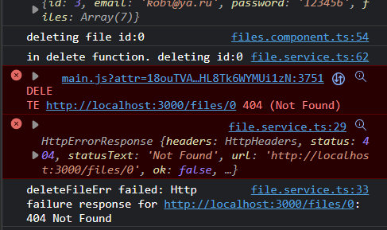

it happens when I upload and then remove the file immediately.