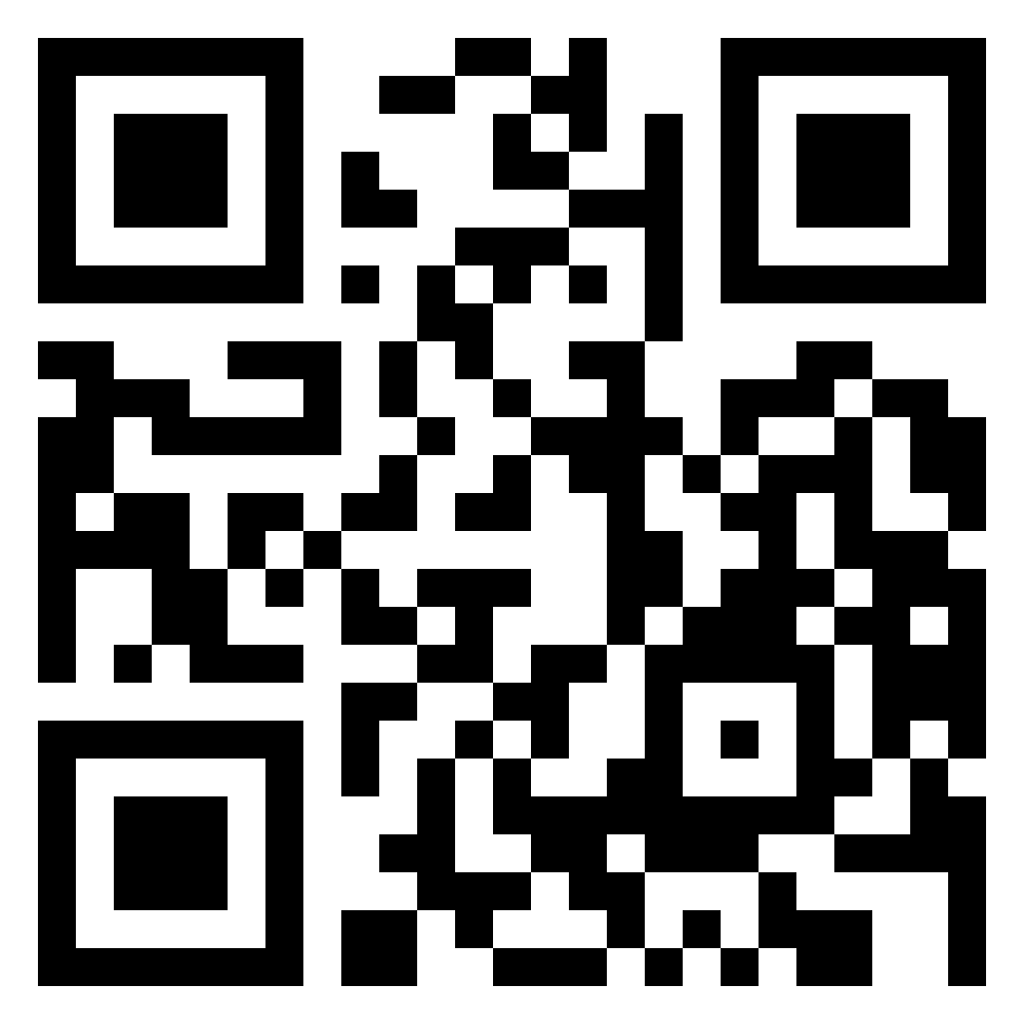TupoyUgolCamPoseForWall

MainEntrance2LeftColumnCamPoseForWall

1FloorStairs1CamPoseForWall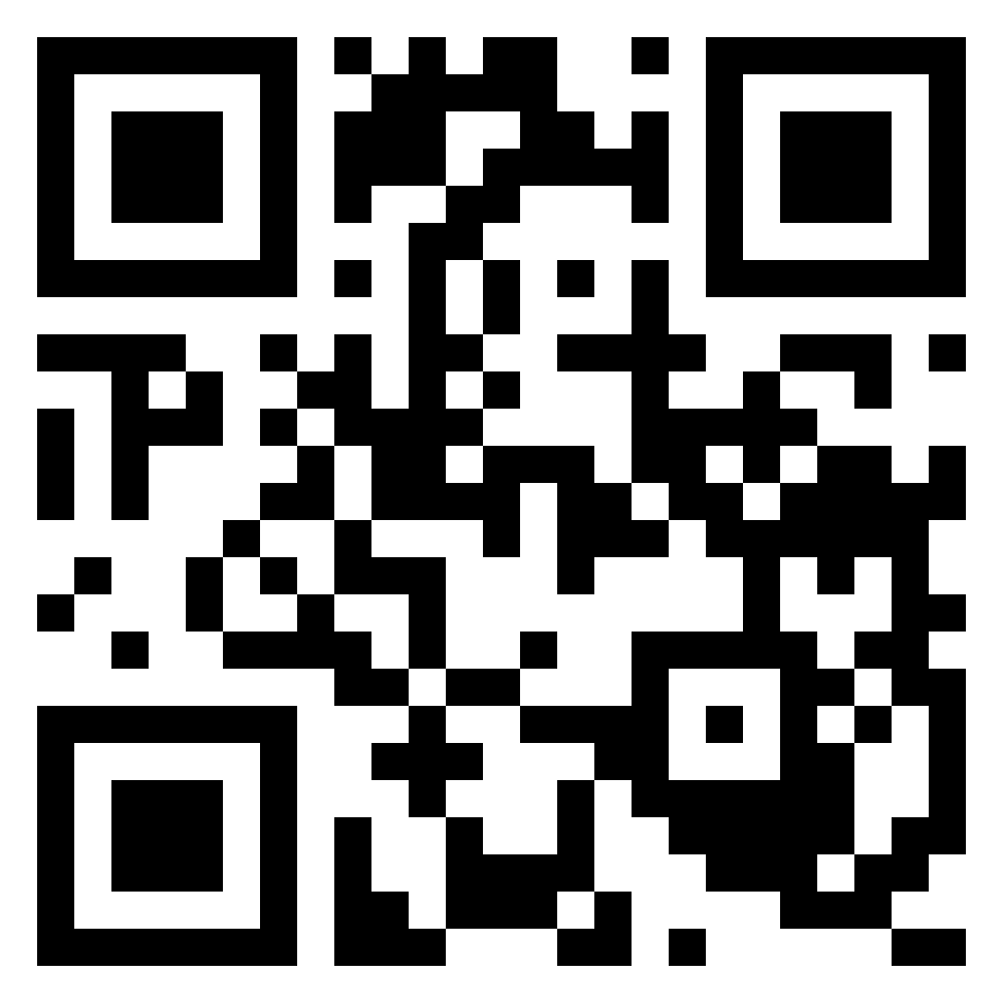

4FloorStairs1CamPoseForWall