1. Add dataset to the image area and add the mesh resampling node at the end of the workflow. Start the project and wait for it to complete.

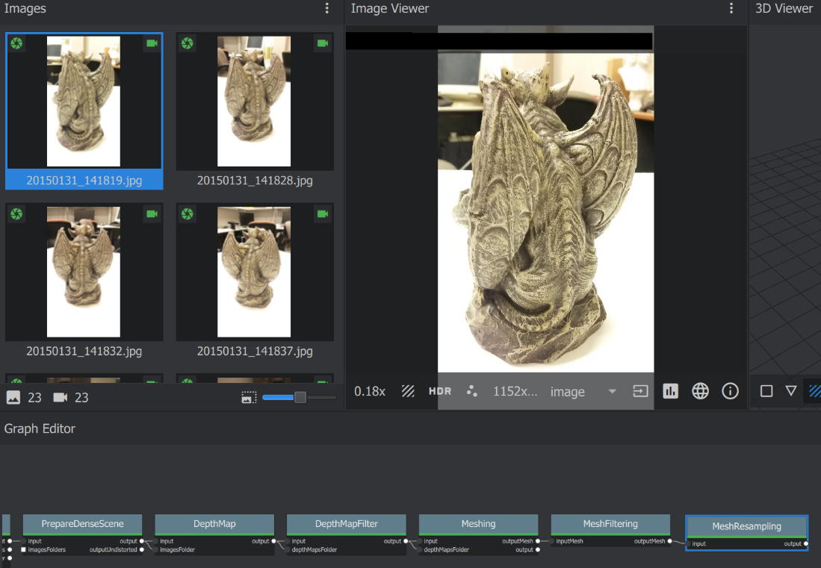

2. From the meshroomCache folder of the project

Get the 2 files, cameras.sfm from the structureFromMotion folder, and the mesh.obj from the meshResampling folder.

3. Run the Start.py file and open the 2 files

3.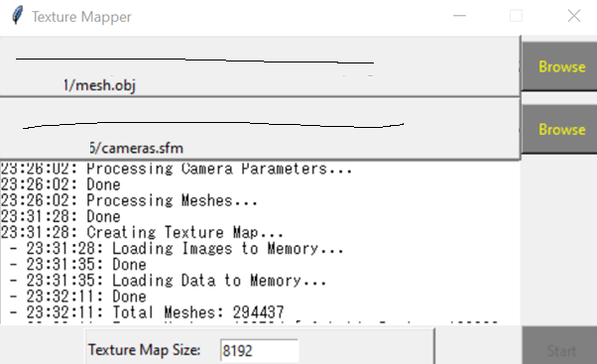

4. Press start and wait for the process to complete

5. The output texture is saved as texture.png in the root directory of the python project

Possible Crashes:

1. Out of memory errors

Reduce max_p and max_p2 in the groupMesh function

