# Catalogue transactions without using web interface

## Context

This document explains how to perform different transactions with the FGP-Geotnetwork 3.6 catalogue without using the web interface. More in detail, this document will explain how to :

1. Upload metadata
2. Submit publication request
3. Approve publication request
4. Validate publication process

## Useful queries

Here is a list of queries used to perform specific actions

## Extracting workspace

This following request extracts all workspace information. It allows users to have workspace ID (eg. 7) based on workspace name (e.g. FGP-Support) .

|  |  |
| --- | --- |
| Type | GET |
| URL | https://gcgeo.gc.ca/geonetwork/srv/api/groups |
| Password protected | No |
| Output (JSON) | {  . . . .          "id": 7,          "description": "FGP-Support / PGF-Support",          "name": "FGP-Support",          "label": {              "fre": "PGF-Support",              "eng": "FGP-Support"} |

## Extracting user

This following request extracts all user information. It allows users to have user ID (eg. 69) based on user username (e.g. fgp_guest) .

|  |  |
| --- | --- |
| Type | GET |
| URL | https://gcgeo.gc.ca/geonetwork/srv/api/users |
| Password protected | Yes |
| Output (JSON) | {          "id": 69,          . . . .          "username": "fgp_guest",          "name": "GUEST"      } |

## Extracting metadata from catalogue

There are various ways to extract metadata from catalogue. However, to be able to have information about metadata update date, user can utilize this query.

|  |  |
| --- | --- |
| Type | POST |
| URL | https://maps.canada.ca/geonetwork/srv/csw |
| Password protected | NO |
| Body/Payload (raw XML) | <csw:GetRecords xmlns:csw="http://www.opengis.net/cat/csw/2.0.2"      xmlns:gmd="http://www.isotc211.org/2005/gmd" service="CSW" version="2.0.2"      resultType="results_with_summary" startPosition='1' maxRecords='10'>      <csw:Query typeNames="gmd:MD_Metadata">      <csw:Constraint version="1.1.0">        <Filter xmlns="http://www.opengis.net/ogc" xmlns:gml="http://www.opengis.net/gml">          <PropertyIsEqualTo>            <PropertyName>dc:identifier</PropertyName>            <Literal>UUID</Literal>          </PropertyIsEqualTo>        </Filter>      </csw:Constraint>      </csw:Query>  </csw:GetRecords> |
| Output | . . . .             <geonet:info xmlns:gmd="http://www.isotc211.org/2005/gmd" xmlns:gml="http://www.opengis.net/gml/3.2" xmlns:gfc="http://www.isotc211.org/2005/gfc" xmlns:gts="http://www.isotc211.org/2005/gts" xmlns:gss="http://www.isotc211.org/2005/gss" xmlns:xlink="http://www.w3.org/1999/xlink" xmlns:gmx="http://www.isotc211.org/2005/gmx" xmlns:gsr="http://www.isotc211.org/2005/gsr" xmlns:gco="http://www.isotc211.org/2005/gco" xmlns:gmi="http://www.isotc211.org/2005/gmi" xmlns:srv="http://www.isotc211.org/2005/srv">                  <id>21001</id>                  <schema>iso19139.nap</schema>                  <createDate>2020-04-24T19:39:12</createDate>                  <changeDate>2020-09-10T12:50:19</changeDate>                  <isTemplate>n</isTemplate>                  <title />  . . . . |

## XSRF TOKEN

For some POST queries, an XSRF token is required. Basically, first query will fail and you need to extract XSRF Token for the output and use it for your next queries. As long as the app stay open, the token will stay alive. <https://geonetwork-opensource.org/manuals/trunk/en/customizing-application/misc.html#example-of-csrf-call-using-curl>

## Uploading metadata

This following section shows how to replace actions performed by a user to upload metadata in the web interface by one query.

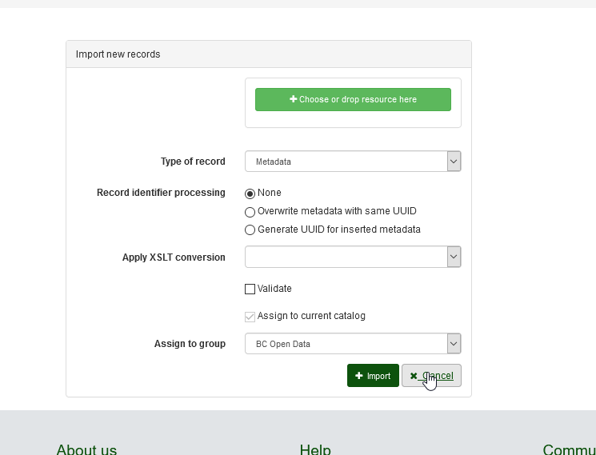 (<https://gcgeo.gc.ca/geonetwork/srv/eng/catalog.edit#/import>)

|  |  |
| --- | --- |
| Type | Post |
| URL | https://gcgeo.gc.ca/geonetwork/srv/api/records |
| Password protected | Yes |
| XSRF Token required | Yes |
| Body/Payload (raw text) | -----------------------------132797856227398911421313208406  Content-Disposition: form-data; name="language"  eng  -----------------------------132797856227398911421313208406  Content-Disposition: form-data; name="metadataType"  METADATA  -----------------------------132797856227398911421313208406  Content-Disposition: form-data; name="uuidProcessing"  Same as **Record identifier processing**  Possible values 🡪 NOTHING/OVERWRITE/GENERATEUUID  OVERWRITE  -----------------------------132797856227398911421313208406  Content-Disposition: form-data; name="transformWith"  Same as **Validate**  Possible values 🡪on/<leave it blank>  -----------------------------132797856227398911421313208406  Content-Disposition: form-data; name="rejectIfInvalid"  on  -----------------------------132797856227398911421313208406  Content-Disposition: form-data; name="group"  812588  -----------------------------132797856227398911421313208406  Metadata data content  (Copy/Paste) XML content here  Content-Disposition: form-data; name="file"; filename="myfile.xml"  Content-Type: text/xml  <?xml version="1.0" encoding="UTF-8"?>  <MD_Metadata > … </MD_Metadata>  -----------------------------132797856227398911421313208406-- |

## Submiting publication request

This following section shows how to replace actions performed by a user to publish metadata in the web interface by chaining 4 queries.

## Query #1- Initiating publication

This first query replaces the publish action performed in the web interface.

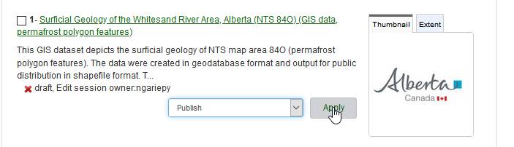

|  |  |
| --- | --- |
| Type | Get |
| Url | https://gcgeo.gc.ca/geonetwork/srv/canada/workflow/publish/eng |
| Password protected | Yes |
| Parameters | Uuid=UUID to be published |
| Output (HTML) | . . . .                 </div>                      <div id="error-info" class="col-md-12   alert alert-warning" style="display:none;">&nbsp;</div>                      <input type="hidden" name="id" id="id" value="821533">                          <input type="hidden" name="requestType" id="requestType" value="P">  . . . . |

This number is the publication id , you need to keep it for 3 next queries

## Query #2- Selecting workspaces

This second query replaces the action of selecting workspaces where the user wants the dataset to be published.

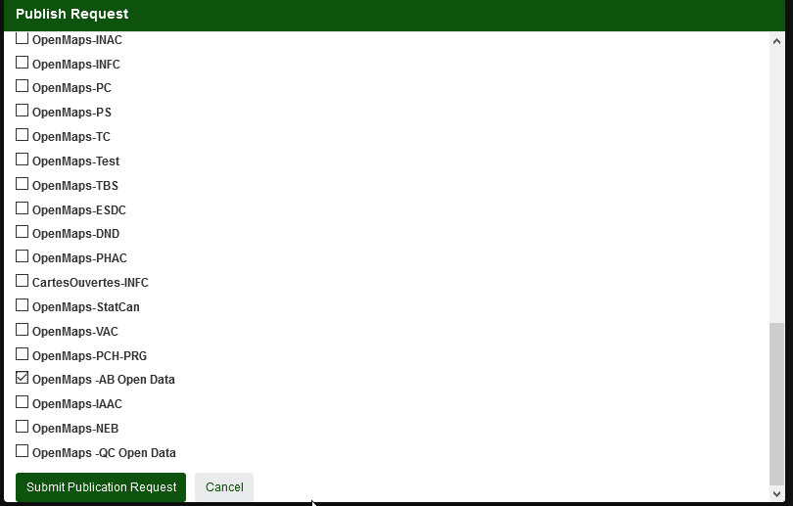

|  |  |
| --- | --- |
| Type | Post |
| url | https://gcgeo.gc.ca/geonetwork/srv/canada/workflow/publish/eng |
| Password protected | Yes |
| XSRF Token required | Yes |
| Body/Payload (form data) | |  |  | | --- | --- | | showLicencse | y | | _0 | true | | _72 | on | | Id | 821533 | | requestType | P |   In this payload, some values change:  *The Id (821533) is the publication extracted from the query #1 return. This value needs to be updated for each query.  * _0 means FGP internal and _72 means OpenMaps-AB Open Data. _72 must be replaced by the L2 workspace by the publication. To know the id, user must use the workspace query. |
| Output | The output is an HTML output without any interesting information. |

## Query #3- Accepting Terms and Conditions

This third query replaces the acceptation of Terms and Conditions window.

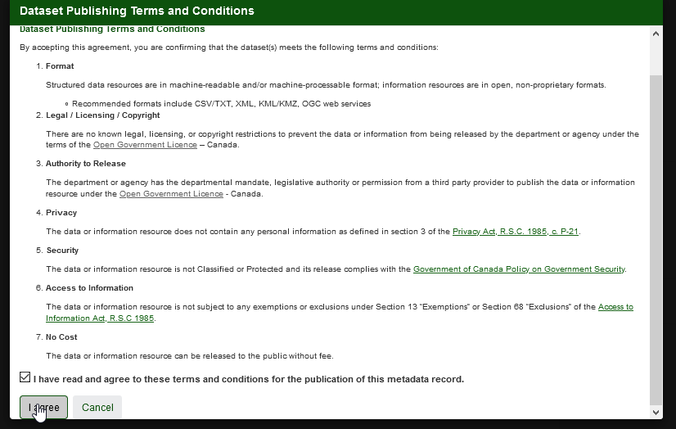

|  |  |
| --- | --- |
| url | https://gcgeo.gc.ca/geonetwork/srv/canada/workflow/publish/eng |
| Password protected | Yes |
| XSRF Token required | Yes |
| Body/Payload (form data) | |  |  | | --- | --- | | _0 | on | | _72 | on | | Id | 821533 | | requestType | P | | mode | license | | license_agreement_check | on |   In this payload, some values will change:  *The Id (821533) is the publication extracted from the query #1 return. This value needs to be updated for each query.  * _0 means FGP internal and _72 means OpenMaps-AB Open Data. _72 must be replaced by the L2 workspace by the publication. To know the id, user must use the workspace query. |
| Output | The output is an HTML output without any interesting information |

## Query 4: Selecting the approval and publication request submission

This fourth query replaces the action of selection content reviewer and submission

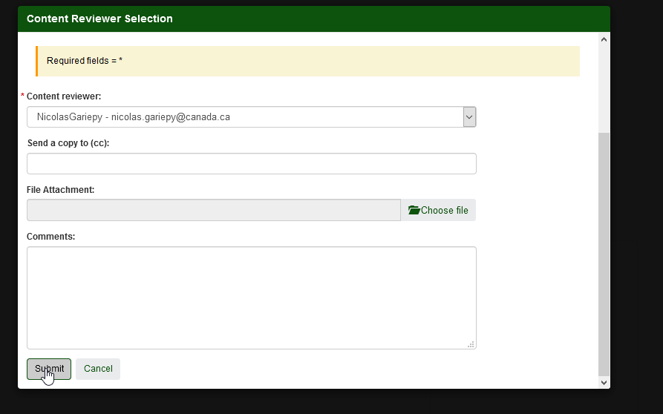

|  |  |
| --- | --- |
| Type | Post |
| url | https://test.gcgeo.gc.ca/geonetwork/srv/canada/workflow/submit/eng |
| Password protected | Yes |
| XSRF Token required | Yes |
| Body/Payload (form data) | |  |  | | --- | --- | | id | 821533 | | requestType | P | | validateBothLanguages | true | | _0 | on | | _72 | on | | contentReviewer | 68 | | additionalMailCC | &attachFile | | comments_request | Your comments |   In this payload, some values will change:  *The Id (821533) is the publication extracted from the query #1 return. This value needs to be updated for each query.  * _0 means FGP internal and _72 means OpenMaps-AB Open Data. _72 must be replaced by the L2 workspace by the publication. To know the id, user must use the workspace query.  *68 as contentReviewer is the ID of the user that need to approve the publication. To know the id, user must use the user query.  * Users can add some comments in comments_request parameter |

## Approving publication request

To be able to approve publication you to perform 2 queries

## Query #1- Identifying publication requests

The following query replaces this web interface

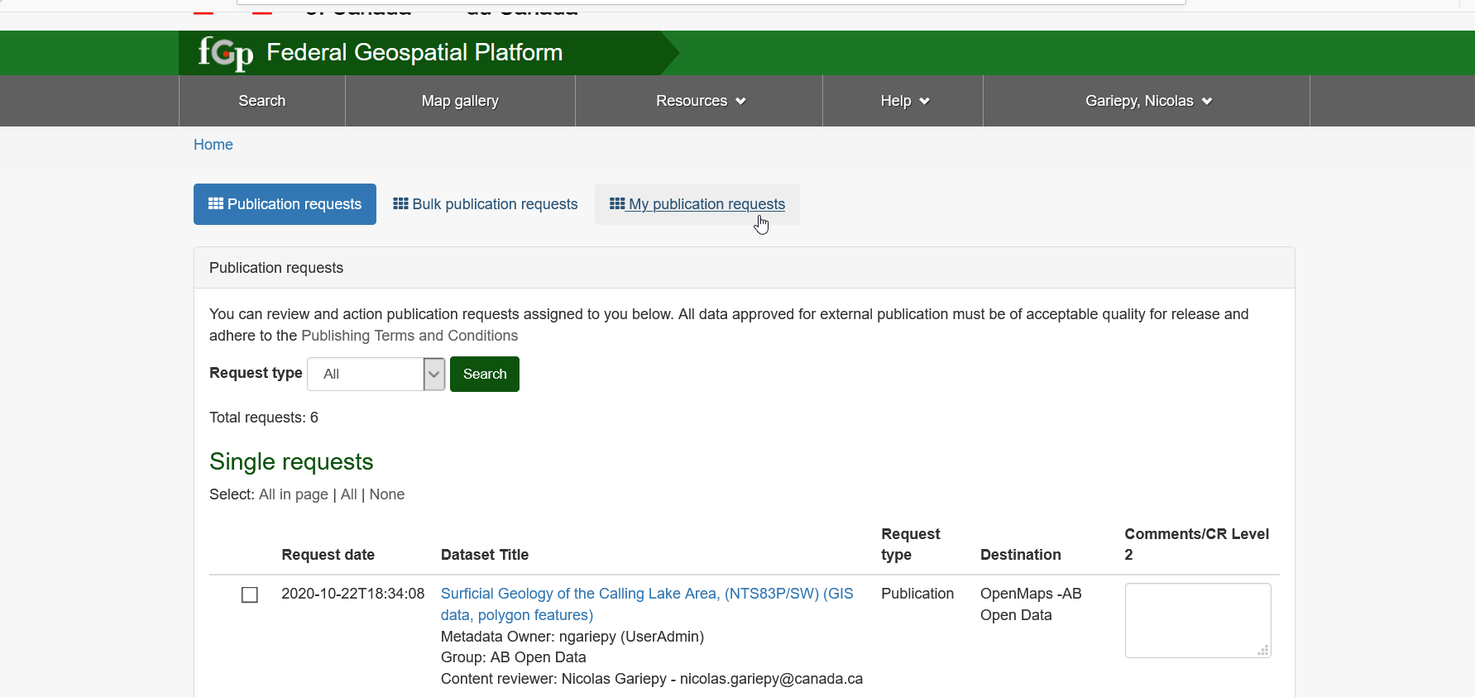

(<https://gcgeo.gc.ca/geonetwork/srv/eng/admin.console#/workflow>)

|  |  |
| --- | --- |
| Type | Get |
| URL | https://gcgeo.gc.ca/geonetwork/srv/canada/workflow/list/eng |
| Password protected | Yes |
| Output | The query will give you publication request available for logged in user . Make sure after to select appropriate id. This following example shows publication in internal and external workspace request for UUID 9f1dd2e7-649c-43c7-a873-5dc6754074ca. Note: To be able to publish in external workspace, a publication at L1 must be done at the same time.  {                  "id": 863525,                  "uuid": "9f1dd2e7-649c-43c7-a873-5dc6754074ca",                   . . . .                  "contentReviewerLevel1": {                      "id": 3288,                      . . . .                  },  . . . .                  "group": {                      . . . .                      "reviewLevel": 1,                      . . . .                  }  }  Group.reviewlevel:1 means that the publication 863525 is for internal workspace. The content reviewer for level 1 is 3288.              {                  "id": 863528,                  "uuid": "9f1dd2e7-649c-43c7-a873-5dc6754074ca",  . . . .                  "contentReviewerLevel1": {                      "id": 3288,  . . . . },  . . . .                  “processDateLevel1": **null**,                   . . .                  "group": {  . . . .                      "reviewLevel": 2,  . . . .                          }                  }  Group.reviewlevel:2 means that the publication 863528 is for external workspace. The processDateLevel1 set to NULL means that a publication level one is required for this publication before publishing it at level 2. Same as the first request the content reviewer for level 1 (contentReviewerLevel1) is 3288.              {                  "id": 863528,                  "uuid": "9f1dd2e7-649c-43c7-a873-5dc6754074ca ",                   . . . .                    "contentReviewerLevel2": {                      "id": 3288,}                    "processDateLevel1": "2020-10-23T09:17:04",  . . . .                  "group": {                      "reviewLevel": 2,  . . . . }  }  Group.reviewlevel:2 means that the publication 863528 is for external workspace. The processDateLevel1 set to "2020-10-23T09:17:04", means that a publication level one is approved for this external publication. The user can now publication at level 2 with appropriate content reviewer for level 2. (contentReviewerLevel2). |

## Query #2- Approving publication request

This request will replace actions performed in the following page

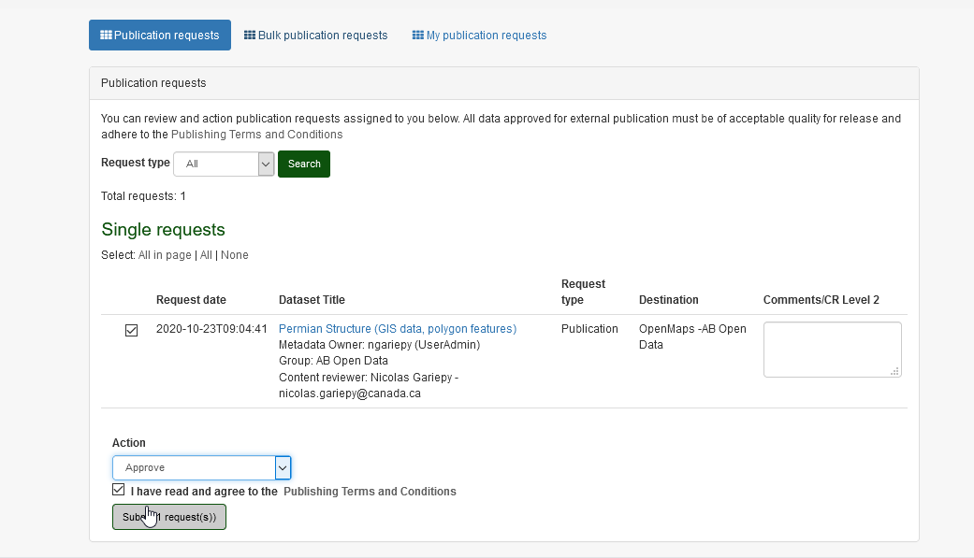

(<https://gcgeo.gc.ca/geonetwork/srv/eng/admin.console#/workflow> )

|  |  |
| --- | --- |
| Type | POST |
| URL | https://geonetwork/srv/canada/workflow/process/eng |
| Password protected | Yes |
| XSRF Token required | Yes |
| Body/payload (JSON) | There are two types of payload to send t in this post request  Level 1 approval  {"type":"approve","requests":[{"id":863525,"comments":"Your comments","cr":"3288"}]}  In this 863525 is the publication request to be approved, 3288 is the content reviewer for level 1  Level 2 approval  {"type":"approve","requests":[{"id":863528,"comments":"","cr":""}]}  In this 863528 is the publication request to approve at level 2.  Note: As mentioned earlier, L1 approval is required to approve L2. |

## Validate publication

The best way to validate if the publication worked well is to look at the metadata update date. To do it, refers to section 2.c of this document.