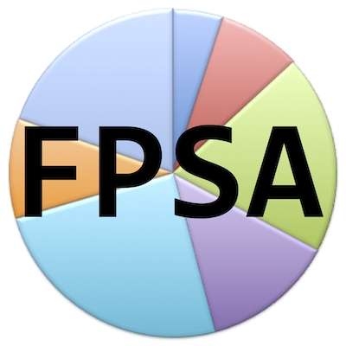

Federal Party SA (FPSA) Fundraising

This confirms Dr/Mr/Mrs/Ms …......................................... (ID no: ............................................) has permission to do fundraising for FPSA. His/her name can be confirmed on the website of FPSA at:
https://federalpartysa.github.io/DiP/Fundraisers.html.
For enquiries contact Marquard Pienaar at:
Tel: +27(0)824477125
Email: federalpartysa@gmail.com
DiP Website: https://federalpartysa.github.io

Signature
M.D. Pienaar
Head of FPSA

