Auscultation: BN report

author 1, author 2

Today: Tue Sep 1 15:03:51 2020  
Current release: rel. 1.5

## Notes

## Tables

Prior and posterior probability values.

## # A tibble: 4 x 7  
## ID CHF Pneumonia ILD_IPF ILD_CTD ILD_other LungScars  
## <chr> <dbl> <dbl> <dbl> <dbl> <dbl> <dbl>  
## 1 Init_prob 0.0131 0.943 0.0196 0.00656 0.00327 0.0147  
## 2 Final_prob 0.00898 0.951 0.0151 0.00514 0.00252 0.0176  
## 3 ratioPostPre 0.687 1.01 0.772 0.784 0.772 1.20   
## 4 ratioPrePost 1.46 0.992 1.29 1.28 1.29 0.834

BF values

## # A tibble: 3 x 7  
## ID CHF Pneumonia ILD_IPF ILD_CTD ILD_other LungScars  
## <chr> <dbl> <dbl> <dbl> <dbl> <dbl> <dbl>  
## 1 iniOdds 0.0132 16.5 0.0200 0.00661 0.00328 0.0149  
## 2 finOdds 0.00906 19.3 0.0154 0.00517 0.00253 0.0179  
## 3 BFval 0.684 1.17 0.769 0.782 0.772 1.20

## Figures

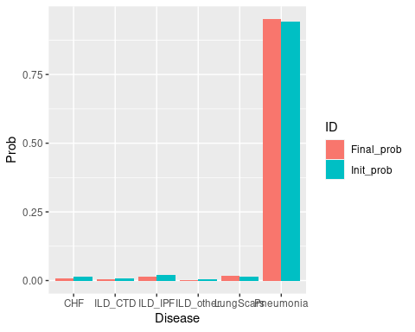

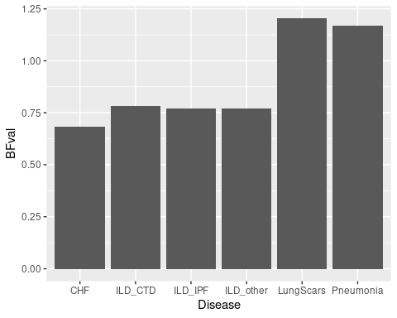

## Informed nodes (evidence)

Here below the evidence entered into the Bayesian Network and selected parameters values.

Sensitivity and specificiy values:

## $EE_AuscVC_Basal  
## speci sensi   
## 0.73 0.78   
##   
## $EE_AuscVC_Lateral  
## speci sensi   
## 0.73 0.78   
##   
## $EE_AuscVC_Higher  
## speci sensi   
## 0.73 0.78   
##   
## $EE_AuscVC_Sym_same_lev  
## speci sensi   
## 0.73 0.78

Evidence:

## Age_above60 = YES  
## EE_AuscVC_Basal = YES  
## EE_AuscVC_Sym_same_lev = Unilateral

# Effect size: informed evidences

In this section the leave-one-out effect (Loo) and the switch-one-state (Sos) effect are evaluated for every node for which evidence is provided.

Here below calculations of posterior probability ratios and BF are performed for all the provided evidences under such reference state (crackles), given that the reference state is not “lack of any evidence” but presence of crackles: this is the reference-context also considered in subsequent sections.

Prior and posterior probability values, crackles as initial state, original provided evidence:

## CHF Pneumonia ILD_IPF ILD_CTD ILD_other LungScars  
## Init_prob 0.007470921 0.9589247 0.01119394 0.003803712 0.001865657 0.01674104  
## Final_prob 0.008977277 0.9506244 0.01513234 0.005141983 0.002522057 0.01760196  
## ratioPostPre 1.201629231 0.9913441 1.35183288 1.351832885 1.351832885 1.05142558  
## ratioPrePost 0.832203457 1.0087315 0.73973641 0.739736406 0.739736406 0.95108967

BF values, crackles as initial reference, original provided evidence:

## CHF Pneumonia ILD_IPF ILD_CTD ILD_other LungScars  
## iniOdds 0.007527155 23.3455445 0.01132067 0.003818236 0.001869144 0.01702608  
## finOdds 0.009058598 19.2529105 0.01536485 0.005168560 0.002528434 0.01791734  
## BFval 1.203455709 0.8246931 1.35723874 1.353651354 1.352722471 1.05234699

## Informed evidences: Loo

Below the node removed from evidences is printed and the implied tables are shown.

--------------------------------------------------------------------------------  
Deleted evidence: Age_above60   
  
 CHF Pneumonia ILD_IPF ILD_CTD ILD_other LungScars  
Init_prob 0.008977277 0.9506244 0.01513234 0.005141983 0.002522057 0.01760196  
Final_prob 0.007470921 0.9589247 0.01119394 0.003803712 0.001865657 0.01674104  
ratioPostPre 0.832203457 1.0087315 0.73973641 0.739736406 0.739736406 0.95108967  
ratioPrePost 1.201629231 0.9913441 1.35183288 1.351832885 1.351832885 1.05142558  
  
 CHF Pneumonia ILD_IPF ILD_CTD ILD_other LungScars  
iniOdds 0.009058598 19.252910 0.01536485 0.005168560 0.002528434 0.01791734  
finOdds 0.007527155 23.345545 0.01132067 0.003818236 0.001869144 0.01702608  
BFval 0.830940426 1.212572 0.73679005 0.738742659 0.739249936 0.95025691

## Informed evidences: Sos

Here each node in the evidence switches its state to another one which is not equal to the collected evidence.

--------------------------------------------------------------------------------  
Node "Age_above60" switched state to "NO"  
  
   
  
 CHF Pneumonia ILD_IPF ILD_CTD ILD_other LungScars  
Init_prob 0.008977277 0.9506244 0.015132341 0.005141983 0.0025220568 0.01760196  
Final_prob 0.004470430 0.9754581 0.003349101 0.001138028 0.0005581835 0.01502619  
ratioPostPre 0.497971723 1.0261236 0.221320766 0.221320766 0.2213207657 0.85366581  
ratioPrePost 2.008146154 0.9745415 4.518328846 4.518328846 4.5183288458 1.17141859  
  
 CHF Pneumonia ILD_IPF ILD_CTD ILD_other LungScars  
iniOdds 0.009058598 19.252910 0.015364847 0.005168560 0.0025284336 0.01791734  
finOdds 0.004490504 39.746582 0.003360355 0.001139324 0.0005584953 0.01525542  
BFval 0.495717363 2.064445 0.218704127 0.220433598 0.2208858771 0.85143342