Auscultation: BN report

author 1, author 2

Today: Tue Sep 1 09:46:32 2020  
Current release: rel. 1.5

## Notes

## Tables

Prior and posterior probability values.

## # A tibble: 4 x 7  
## ID CHF Pneumonia ILD_IPF ILD_CTD ILD_other LungScars  
## <chr> <dbl> <dbl> <dbl> <dbl> <dbl> <dbl>  
## 1 Init_prob 0.0131 0.943 0.0196 0.00656 0.00327 0.0147  
## 2 Final_prob 0.00894 0.947 0.0199 0.00410 0.00251 0.0175  
## 3 ratioPostPre 0.684 1.00 1.02 0.624 0.770 1.20   
## 4 ratioPrePost 1.46 0.996 0.984 1.60 1.30 0.837

BF values

## # A tibble: 3 x 7  
## ID CHF Pneumonia ILD_IPF ILD_CTD ILD_other LungScars  
## <chr> <dbl> <dbl> <dbl> <dbl> <dbl> <dbl>  
## 1 iniOdds 0.0132 16.5 0.0200 0.00661 0.00328 0.0149  
## 2 finOdds 0.00902 17.9 0.0203 0.00411 0.00252 0.0178  
## 3 BFval 0.681 1.08 1.02 0.623 0.769 1.20

## Figures

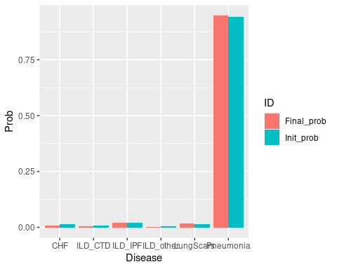

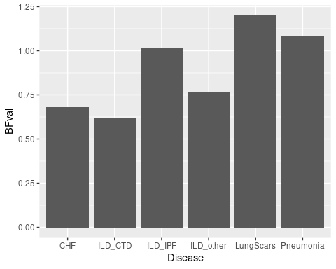

## Informed nodes (evidence)

Here below the evidence entered into the Bayesian Network and selected parameters values.

Sensitivity and specificiy values:

## $EE_AuscVC_Basal  
## speci sensi   
## 0.73 0.78   
##   
## $EE_AuscVC_Lateral  
## speci sensi   
## 0.73 0.78   
##   
## $EE_AuscVC_Higher  
## speci sensi   
## 0.73 0.78   
##   
## $EE_AuscVC_Sym_same_lev  
## speci sensi   
## 0.73 0.78

Evidence:

## Age_above60 = YES  
## EE_AuscVC_Basal = YES  
## EE_AuscVC_Sym_same_lev = Unilateral  
## Sex = Male