**Olist E-commerce Full-Stack Marketing Analytics with Product Segmentation**

# Project Overview

This comprehensive end-to-end marketing analytics project illustrates my ability to design, implement, and deploy a full-stack data solution transforming raw e-commerce data into business-critical recommendations. The focus is on product performance segmentation within a simulated online retail platform, culminating in an interactive dashboard that delivers actionable insights to stakeholders.

# 1. Introduction: What Is Olist?

Olist is a Brazilian company that empowers small and medium-sized retailers to list and sell their products across major online marketplaces, including Amazon, Mercado Libre, and Magalu. Rather than managing individual accounts on each platform, sellers register through Olist, which:

* Connects their product listings to multiple marketplaces automatically
* Manages logistics, customer service, and order fulfillment
* Helps businesses increase visibility, improve sales efficiency, and scale operations

Olist serves as a commercial enabler, bridging independent sellers and large marketplaces through a unified infrastructure that simplifies digital commerce.

# 2. Database Schema Design and Implementation

To replicate a real-world analytics ecosystem, the raw CSV data provided by Olist was transformed into a normalized relational database schema. The schema was modeled using **QuickDB** (an ERD tool) and implemented in **PostgreSQL**, enabling robust data governance and complex querying.

Key motivations for using a relational database included:

* **Referential integrity** (e.g., foreign keys linking orders to valid customers, products, and sellers)
* **Query efficiency** for multi-table joins and aggregations
* **Replicability** of e-commerce transactional architecture

This structured approach ensured clean, validated, and scalable storage to support all downstream analytics.

**Entity Relationship Diagram (ERD):**  
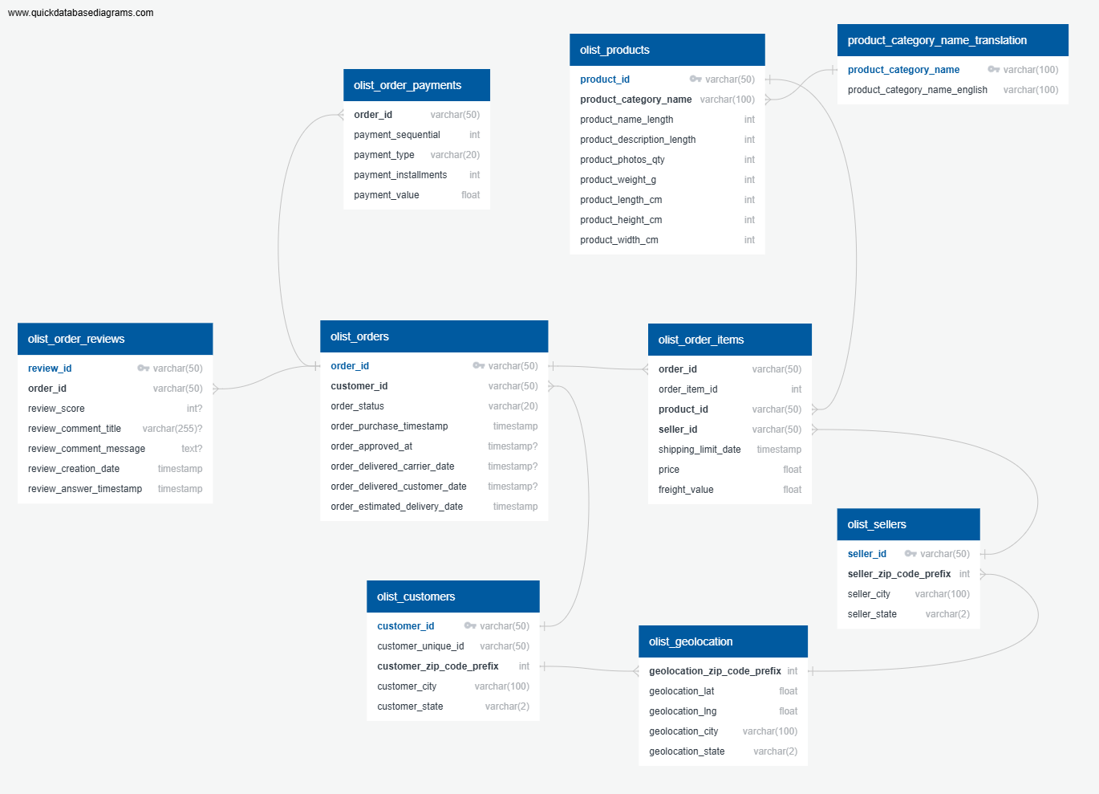

# 3. Data Extraction and Processing (Python + SQL)

Once the database was established, the next step was data validation and processing. Using **psycopg2** and **SQLAlchemy**, data was extracted from PostgreSQL and transformed using Python and Pandas. Key processing steps included:

* Multi-table joins (orders, reviews, products, sellers)
* Calculating KPIs such as sales volume, revenue, review scores, and delivery times
* Creating derived features (e.g., product performance scores, satisfaction indexes)

The resulting DataFrame served as the cleaned dataset for the segmentation pipeline.

# 4. Product Segmentation Analysis

## 4.1 **Feature Selection and KPI Aggregation**

To enable meaningful product clustering, KPIs were aggregated at the product_category_name level:

| **Feature** |  | **Description** |
| --- | --- | --- |
| total_sales_volume |  | Total units sold per category |
| total_revenue |  | Total revenue per category |
| avg_review_score |  | Average review rating (1 to 5) |
| avg_delivery_delay |  | Mean delay in delivery (days) |

These metrics capture both commercial and operational performance.

## 4.2 Data Cleaning and Transformation

To prepare for modeling:

* **Log Transformation** was applied to skewed features (revenue, sales)
* **Outlier Removal** excluded the top 5% values (95th percentile)
* **Standardization** used z-score scaling to normalize all variables

## 4.3 Dimensionality Reduction (PCA)

To reduce dimensionality and improve cluster visualization, **Principal Component Analysis (PCA)** was used. The first two principal components captured most of the dataset’s variance and were used to plot and interpret cluster formations.

## 4.4 Optimal Clustering with Elbow Method

The **Elbow Method** was applied to determine the optimal number of clusters (k), examining inertia across different values of k. A clear inflection point at **k = 4** suggested the best balance between simplicity and explanatory power.

## 4.5 K-Means Clustering and Labeling

Using **K-Means**, product categories were grouped into four strategic clusters:

| **Segment** | **Strategic Meaning** |
| --- | --- |
| Top Sellers | High sales and revenue; prioritize inventory and logistics |
| Reliable Performers | Moderate sales, excellent reviews; enhance exposure |
| Niche Favorites | Low sales, high reviews; target loyal customer bases with promotions |
| Underperformers | Low across KPIs; investigate issues in pricing, fulfillment, or quality |

# 5. Dashboard Design and Insights

## 5.1 Dashboard Purpose

A dashboard was developed using **Streamlit** and **Plotly** to bridge technical insights with executive decision-making. It enables stakeholders to:

* Select a product cluster via dropdown
* View KPIs for each cluster
* Explore top-selling categories
* Download filtered datasets as CSV

## 5.2 Technical Stack

| **Component** | **Purpose** |
| --- | --- |
| Python | Data extraction, transformation, clustering |
| PostgreSQL (Docker) | Structured data backend |
| Streamlit | Dashboard UI and logic |
| Plotly | Interactive visualizations |
| Docker | Environment reproducibility and portability |
| QuickDB | Schema modeling and ERD visualization |

## 5.3 Strategic Use of Clusters

Each cluster comes with embedded business recommendations, enabling marketing, product, and logistics teams to take targeted actions immediately.

## 5.4 Deliverables

* Relational database in PostgreSQL
* Python notebooks for preprocessing, clustering, and modeling
* Streamlit dashboard with cluster exploration tools
* CSV download functionality for segment-specific insights
* Dockerized deployment instructions

# 6. Conclusion and Future Directions

This project showcases the full lifecycle of a data-driven marketing analytics solution from structured database design and data transformation to clustering-based product segmentation and interactive dashboard deployment. Through the use of PostgreSQL, Python, and Streamlit, we translated raw e-commerce data into strategic insights that support product positioning and business decision-making.

Looking ahead, this system provides a solid foundation for expanding into deeper, business-critical analyses. Planned next steps include:

* **Customer Lifetime Value (LTV/CLV)** modeling to support strategic targeting
* **Churn prediction** to proactively retain high-risk customers
* **Customer Acquisition Cost (CAC)** estimation per channel or campaign
* **Sentiment analysis** from reviews to inform product and service improvements
* **Target segment identification** using behavioral clustering

To further elevate the system, we aim to integrate advanced capabilities such as:

* **A/B testing frameworks** for experimentation and campaign evaluation
* **Customer personas** combining behavioral and demographic clustering
* **Revenue forecasting** using time-series models like SARIMA and LSTM
* **Inventory optimization** based on sales velocity and demand predictions

These enhancements will transform the project into a comprehensive marketing intelligence platform positioned to drive smarter decisions in acquisition, retention, and operational efficiency.