

Computer Networks

Lab 1 Report

Federico António Campos Barrezueta - up200503891@edu.fe.up.pt
João Gonçalo Pedro Amorim Dias - up202307583@edu.fe.up.pt

Table of Contents
Data link layer: 3
Frame synchronization process : 3
Retransmission : 4
Robustness to errors and error control: 4
Application Layer : 6
Control Packets : 6
File integrity : 6
Code organization : 7
Interface and layer independency : 7
Protocol Efficiency : 8
Annex : 11
test_protocol terminal output: 11

Data link layer:
Implemented in link_layer.c / link_layer.h for both transmitter and receiver, depending on the role defined in link_layer.h . The specified protocol is implemented via llopen(), llwrite(), llread(), llclose() which can be used by the application layer to establish coomunication and send information. The data link will use the open(), write(), read() and close() of the serial port to send information and supervision frames.

Frame synchronization process :
Frame synchronization process is done through the FLAG byte state machine present in link_layer.c. Every frame starts and ends with FLAG.
The receiver reads one byte at a time and only goes throught the different states when it receives the expected bytes.

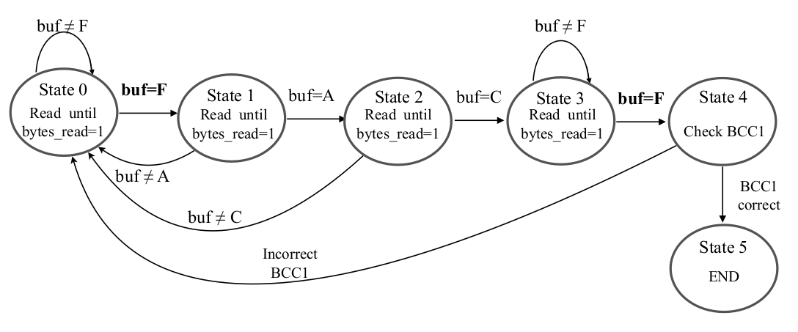

- Resync at garbage bytes : this guarantees that any unexpected byte sends the state machine to START (State 0) or FLAG_RCV (state 1)
- FLAG inside data can’t be interpreted as frame delimiter : as byte-stuffing is implemented by replacing 0x7E → 0x7D 0x5E and 0x7D→ 0x5D before transmission is ever made. Then llread() does the byte-destuffing so the real 0x7E (~) function as frame delimiters.

Retransmission :
Retransmission mechanism is assured in llwrite() vis the SIGALARM (sigaction.c) based timer combined with a REJ fast-path.
- Whhen the alarm fires, alarmHandler sets alarmEnabled = FALSE and increments alarmCount. This repeats until numTransmissions is reached (3 by default)
- When a REJ is received inside the state-machine alarmEnabled =FALSE triggers an immediate retransmit on next iteration. Cancelling the alarm and clearing alarmEnabled causes a retransmit on the same iteration.
Not implemented :
- Lost REJ /lost RR : if the ACK is corrupted (cable), the transmitter never sees it and must wait for the timeout rather than getting the immediate REJ.
- BCC1 errors : if the header is corrupted , the receiver state machine resets to START with no REJ sent, having to trigger the timeout to restart the communication procedure
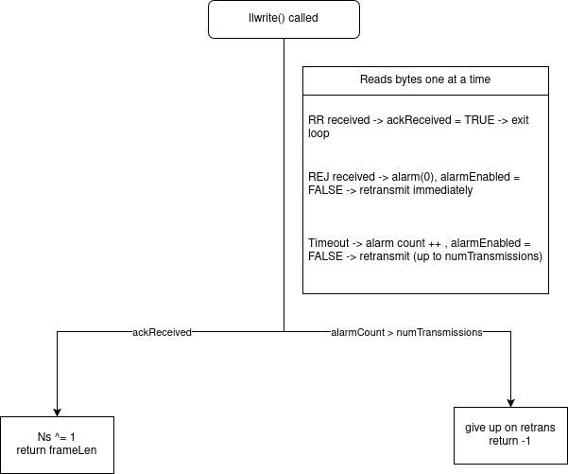

Robustness to errors and error control:
In the link_layer.c two independent CRC fields protect each I frame :
- BCC 1 = A XOR C detects any single byte corruption in the header, this is done inside the state machine.
- BCC2 = XOR of all data bytes, is checked after the closing FLAG, and detects any odd number of bit flips across the payload.
BCC2 cannot detect even numbers of errors in the same bit position across different bytes (cancelled out in XOR). A CRC-16 would be more suitable for this.

Corruption | Detected by | Response | Retransmit trigger
Header (A,C,BCC1) | State machine rejects frame | Silent drop, REJ sent | Transmit timeout (3s)
Data / BCC2 | BCC2 check fails | REJ sent | Immediate retransmit
ACK/REJ itself corrupted | Transmitter never sees RR/REJ | No response received | Transmit timeout (3s)

Duplicate frame detection : after a retransmission the receiver might get the same frame twice. This is handled by the receivedNs :
if (receivedNs != expectedNs)
{
printf("Duplicate frame (Ns=%d), discarding\n", receivedNs);
return 0;
}

Here the RR is still sent , so the transmitter knows the previous frame was already acknowledged and can continue. Without this mechanism , a lost RR would result in the same data being written to the file twice.
The protocol is robust to detectable errors :
- any frame with a bad BCC2 is rejected and retransmitted up to numTransmissions before connection gives up
- robust to duplicate frames via the mod-2 sequence number
- is is less robust to header errors : these can cause a drop with no REJ , so recovery relies on timeout, which penalizes efficiency at high BER

Application Layer :

Control Packets :
Control packets implemented use the TLV structure (Type – Length – Value) :
| C | T1 | L1 | V1 … | T2 | L2 | V2 |
- C = 0x02 → Start
- C = 0x03 → End
Two TLV fields are always present :
- T = 0x00 , L = 4 → file size (4 bytes,big-endian)
- T = 0x01 , L = N → file name (N bytes)
These assure :
- Framing of the transfer : the receiver only opens the ouput file on START and closes at END. Data packets arriving before START are discarded.
- File size known in advance : the receiver extracts expectedSize from the START packet , which could be used to check the integrity at the end
- Output filename negotiated by the transmitter : the receiver uses the filename from START packet unless overriden by a CLI argument . This way the receiver doesn’t need prior info of what file is being sent
- START and END carry the same TLV fields : this allows the receiver to cross-check the file size and name on END
Limitations : The END packet is not verified against the START packet → the receiver accepts END unconditionally , corrupted END packets what pass whtough BCC2 would terminate the transfer. This is very unlikely because every packet goest throught the DLL error detection.

File integrity :
The following mechanisms protect file integrity :
- BCC2 (XOR of all data bytes) detects corruption in every data packet payload : a corrupted data packet triggers REJ and retransmission this way bad data is not written to the file
- Stop and Wait ordering : frames are delivered strictly in sequence , so bytes are always writeen in the correct order
- START packet carries the expected file size
Limitations :
- expectedSize is never verififed, the receiver stores the file size from START but never compares it against how many bytes were actually written to the file. Transmitted aborted midway files would not be detected.
- No end-to-end checksum – BCC2 protects each DLL frame individually, but there is no whole file hash(MD5, CRC32, etc) exchanged in the control packets. If the reassembly logic had a bug , the file could be corrupted.
- END packet not verififed agains START : the end packet carreies out thje same TLV fiels but are never read or compared

Code organization :

Interface and layer independency :

- Int llopen(LinkLayer params) → establish connection
- int llwrite(const unsigned char *buf, int bufSize) → sends one packet
- int llread(unsigned char *packet) → receives one packet
- int llclose() → terminates the connection
This interfaces enforces :
- Complete layer independence : application_layer.c has zero knowledge of frames, flags, byte_stuffing, BCC, or sequence numbers. It only calls these 4 functions (above). All DLLs internal params (fd,Ns,expectedNs, oldtio) are static in link_layer.c, invisible to the layer above.
- llwrite()/llread() are payload only – the application layer passes raw packet bytes and gets raw packet bytes back. Framing is entirely the DLLs responsibility. The aplication layer neverr touches 0X7E or escape sequences..
- Roel and connection parameters are passed once : llopen takes LinkLayer struct with a serial port, baudrate, role, timeout and retru count. After that ,llwrite/llread/llclose take no configuration – the DLL manages all state internally.
- Return values signal errors cleanly - -1 on failure >0(bytes writeen / read) on success.The application layer checks them.

Protocol Efficiency :
The test_protocol.c implements an automated full test procedure by doing the following :
- forks cable , transmitter and receiver subprocesses , configures the cable via pipe commands (ber , prop) times each transfer with CLOCK_MONOTONIC and quits everything via quit.
- Sweeps a 5 x 5 matrix of BER values and propagation delays each repeated 3 times and averaged.
- Computes both measured S = (file bits / elapsed) / C and theoretical S = (1 – FER) / (1 + 2a) and writes them both to efficiency_results.csv

Plotting the valus on the CSV gave the following plots

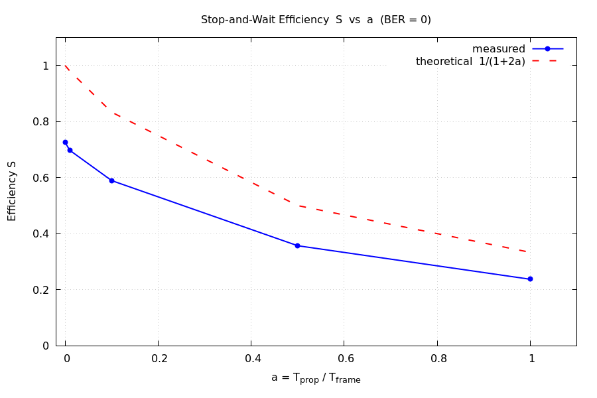Figure 1: Efficiency vs Non Error (BER = 0)

The figure shown above shows the validation plot , this isolates the effect of propagation delay, by removing errors entirely.Both curves decrease as a grows confirming the behavior of Stop and Wait : the larger the propagation delay relative to frame the more time the transmitter spends waiting for an ACK. The practical value sits below the 1 / (1+2a) with a constant vertical gap. The formula models ideal behavior with no overhead while the real implementation must include :
- Connection setup and teardown (SET/UA , DISC/UA)
- Application layer control packets (START / END)
- 300ms head start given to the receiver in this test.

For the combined effect of errors and propagation delays , the figure below shows :

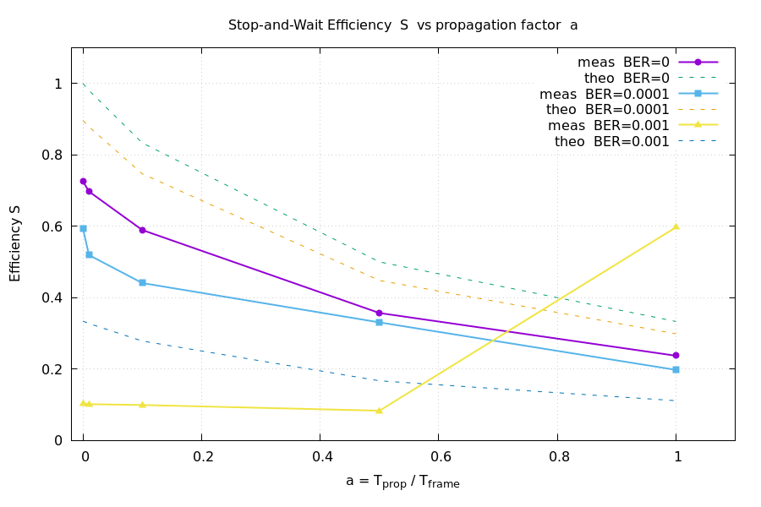Figure 2: Combined effect of errors and propagation delay on the efficiency S
From the plot above we can conclude the following for each of the three observations :
- BER = 0 and BER 0.0001 are close together : at very low error rates , the REJ fast path recovers quickly enough that the efficiency is barely affected. The protocol is robust to sporadic errors.
- BER = 0.0001 drops sharply : at this error rate FER ~66% (2 in 3 frames requires retransmission) and measured S collapses to ~0.10 for small a. The protocol here is spending most of its time retransmitting
- BER = 0.001 shows anomalous rise at a= 1.0 which is impossible. Probable cause is a measurement error due to an artifact , at high BER combined with the large propagation delay , the 3 second timeout dominates each retransmission cycle . With only 3 runs averaged one run got few errors by chance and this inflates significantly. More repeats are needed to eliminate this.
In every case S measured is below theoretical and the gap gets bigger as BER increases. This is consistent with the implementation flaw that makes the header errors timeout , taking always the slowest path , instead of trigerring immediate REJ.

Annex :

test_protocol terminal output:

=== Stop-and-Wait Efficiency Test ===
File : penguin.gif (10968 bytes)
Baud rate : 9600 bps
T_frame : 0.1427 s (137 bytes × 10 bits)
Runs/config: 3

Waiting for cable to initialise (socat setup ~2 s)...
Cable ready.

── BER=0.0000 prop= 0 µs a=0.000 FER≈0.00000 ──
[timeout] killing pid 12068
run 1: 12.008 s → S = 0.7611
run 2: 12.909 s → S = 0.7081
run 3: 12.908 s → S = 0.7081
→ S_avg=0.7258 S_theo=1.0000

── BER=0.0000 prop= 1427 µs a=0.010 FER≈0.00000 ──
run 1: 13.109 s → S = 0.6972
run 2: 13.109 s → S = 0.6972
run 3: 13.110 s → S = 0.6972
→ S_avg=0.6972 S_theo=0.9804

── BER=0.0000 prop= 14271 µs a=0.100 FER≈0.00000 ──
run 1: 15.510 s → S = 0.5893
run 2: 15.510 s → S = 0.5893
run 3: 15.511 s → S = 0.5893
→ S_avg=0.5893 S_theo=0.8333

── BER=0.0000 prop= 71354 µs a=0.500 FER≈0.00000 ──
run 1: 25.617 s → S = 0.3568
run 2: 25.617 s → S = 0.3568
run 3: 25.617 s → S = 0.3568
→ S_avg=0.3568 S_theo=0.5000

── BER=0.0000 prop=142708 µs a=1.000 FER≈0.00000 ──
run 1: 38.524 s → S = 0.2373
run 2: 38.525 s → S = 0.2373
run 3: 38.526 s → S = 0.2372
→ S_avg=0.2372 S_theo=0.3333

── BER=0.0001 prop= 0 µs a=0.000 FER≈0.10381 ──
run 1: 13.909 s → S = 0.6571
run 2: 15.209 s → S = 0.6009
run 3: 17.511 s → S = 0.5219
→ S_avg=0.5933 S_theo=0.8962

── BER=0.0001 prop= 1427 µs a=0.010 FER≈0.10381 ──
run 1: 20.714 s → S = 0.4412
run 2: 20.113 s → S = 0.4544
run 3: 13.809 s → S = 0.6619
→ S_avg=0.5192 S_theo=0.8786

── BER=0.0001 prop= 14271 µs a=0.100 FER≈0.10381 ──
run 1: 19.613 s → S = 0.4660
run 2: 24.017 s → S = 0.3806
run 3: 19.211 s → S = 0.4758
→ S_avg=0.4408 S_theo=0.7468

── BER=0.0001 prop= 71354 µs a=0.500 FER≈0.10381 ──
run 1: 27.919 s → S = 0.3274
run 2: 27.619 s → S = 0.3309
run 3: 27.418 s → S = 0.3334
→ S_avg=0.3306 S_theo=0.4481

── BER=0.0001 prop=142708 µs a=1.000 FER≈0.10381 ──
run 1: 46.330 s → S = 0.1973
run 2: 44.628 s → S = 0.2048
run 3: 48.033 s → S = 0.1903
→ S_avg=0.1975 S_theo=0.2987

── BER=0.0010 prop= 0 µs a=0.000 FER≈0.66598 ──
[timeout] killing pid 14906
run 1: 79.255 s → S = 0.1153
run 2: 111.575 s → S = 0.0819
run 3: 79.351 s → S = 0.1152
→ S_avg=0.1041 S_theo=0.3340

── BER=0.0010 prop= 1427 µs a=0.010 FER≈0.66598 ──
run 1: 86.157 s → S = 0.1061
run 2: 97.862 s → S = 0.0934
run 3: 86.757 s → S = 0.1054
→ S_avg=0.1016 S_theo=0.3275

── BER=0.0010 prop= 14271 µs a=0.100 FER≈0.66598 ──
run 1: 95.765 s → S = 0.0954
run 2: 94.362 s → S = 0.0969
run 3: 86.758 s → S = 0.1054
→ S_avg=0.0992 S_theo=0.2784

── BER=0.0010 prop= 71354 µs a=0.500 FER≈0.66598 ──
run 1: 115.775 s → S = 0.0789
[timeout] killing pid 17634
[timeout] killing pid 17633
Transfer failed (ret=-1)
run 2: FAILED
run 3: 104.567 s → S = 0.0874
→ S_avg=0.0832 S_theo=0.1670

── BER=0.0010 prop=142708 µs a=1.000 FER≈0.66598 ──
[timeout] killing pid 18342
[timeout] killing pid 18341
Transfer failed (ret=-1)
run 1: FAILED
[timeout] killing pid 18722
run 2: 15.310 s → S = 0.5970
[timeout] killing pid 18850
[timeout] killing pid 18849
Transfer failed (ret=-1)
run 3: FAILED
→ S_avg=0.5970 S_theo=0.1113

── BER=0.0050 prop= 0 µs a=0.000 FER≈0.99589 ──
[timeout] killing pid 19230
run 1: 16.011 s → S = 0.5709
[timeout] killing pid 19327
run 2: 14.611 s → S = 0.6256
[timeout] killing pid 19453
run 3: 15.211 s → S = 0.6009
→ S_avg=0.5991 S_theo=0.0041

── BER=0.0050 prop= 1427 µs a=0.010 FER≈0.99589 ──
[timeout] killing pid 19580
run 1: 19.914 s → S = 0.4590
[timeout] killing pid 19717
run 2: 21.714 s → S = 0.4209
[timeout] killing pid 19856
run 3: 13.609 s → S = 0.6716
→ S_avg=0.5172 S_theo=0.0040

── BER=0.0050 prop= 14271 µs a=0.100 FER≈0.99589 ──
[timeout] killing pid 19978
run 1: 16.610 s → S = 0.5503
[timeout] killing pid 20109
run 2: 22.416 s → S = 0.4077
[timeout] killing pid 20252
run 3: 14.110 s → S = 0.6478
→ S_avg=0.5353 S_theo=0.0034

── BER=0.0050 prop= 71354 µs a=0.500 FER≈0.99589 ──
[timeout] killing pid 20374
run 1: 16.310 s → S = 0.5604
[timeout] killing pid 20472
run 2: 18.713 s → S = 0.4884
[timeout] killing pid 20608
run 3: 30.320 s → S = 0.3015
→ S_avg=0.4501 S_theo=0.0021

── BER=0.0050 prop=142708 µs a=1.000 FER≈0.99589 ──
[timeout] killing pid 20771
run 1: 12.708 s → S = 0.7192
[timeout] killing pid 20889
run 2: 12.009 s → S = 0.7611
[timeout] killing pid 20976
run 3: 26.818 s → S = 0.3408
→ S_avg=0.6071 S_theo=0.0014

── BER=0.0100 prop= 0 µs a=0.000 FER≈0.99998 ──
[timeout] killing pid 21128
run 1: 12.608 s → S = 0.7249
[timeout] killing pid 21249
run 2: 12.109 s → S = 0.7548
[timeout] killing pid 21366
run 3: 12.008 s → S = 0.7611
→ S_avg=0.7470 S_theo=0.0000

── BER=0.0100 prop= 1427 µs a=0.010 FER≈0.99998 ──
[timeout] killing pid 21485
run 1: 12.008 s → S = 0.7612
[timeout] killing pid 21615
run 2: 18.613 s → S = 0.4911
[timeout] killing pid 21749
run 3: 12.208 s → S = 0.7487
→ S_avg=0.6670 S_theo=0.0000

── BER=0.0100 prop= 14271 µs a=0.100 FER≈0.99998 ──
[timeout] killing pid 21870
run 1: 12.308 s → S = 0.7426
[timeout] killing pid 21991
run 2: 23.016 s → S = 0.3971
[timeout] killing pid 22134
run 3: 15.911 s → S = 0.5745
→ S_avg=0.5714 S_theo=0.0000

── BER=0.0100 prop= 71354 µs a=0.500 FER≈0.99998 ──
[timeout] killing pid 22261
run 1: 12.508 s → S = 0.7307
[timeout] killing pid 22379
run 2: 12.008 s → S = 0.7611
[timeout] killing pid 22496
run 3: 19.612 s → S = 0.4660
→ S_avg=0.6526 S_theo=0.0000

── BER=0.0100 prop=142708 µs a=1.000 FER≈0.99998 ──
[timeout] killing pid 22633
run 1: 12.008 s → S = 0.7612
[timeout] killing pid 22750
run 2: 12.008 s → S = 0.7612
[timeout] killing pid 22867
run 3: 12.009 s → S = 0.7611
→ S_avg=0.7612 S_theo=0.0000

Results saved to efficiency_results.csv

