Schio, [DD/MM/’YY]
Messrs.
[COMPANY NAME]
[Address]
[Zip] [City], [Region]
[Country]
To the attn. of Mr./Ms. [Full Name]

OFFER NO...: [NNN/YY]

[INVENTORY]
- [INVENTORY DESCRIPTION] -
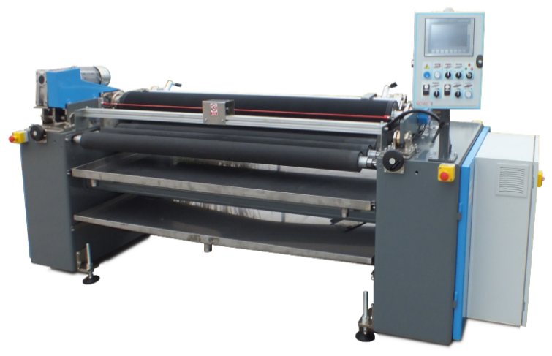
Max working width 130 cm
Operational modes:
- Printing roller in reverse (enamelling, printing, coating)
- Printing roller in synchro (back-coating, pattern & design printing) - optional
Machine composed of:
- main frame with solid steel side shoulders and stiffening crossbeams,
- adjustable levelling feet, minimum working height from floor 900 mm.
- main rubberized counter-roller, diameter 200 mm., rubber oils and solvents resistant, hardness 25 ShA, max eccentricity +/- 1/100 mm., driven,
- A/C gearmotor 0,37 Kw, inverter controlled, to drive the rubberized counter roller mounted on the counter-roller axle,
- no. 6 driven transport rubberized rollers, hardness 25 ShA, step 140 mm.
- A/C gearmotor 0,25 Kw., inverter controlled, with chain and sprocket gears to drive the transport rollers.
- air mandrel holder with pneumatic lifting and lowering by means of two pistons,
- A/C gearmotor 0,37 Kw., inverter controlled, to drive the air-mandrel. With toothed belt and pulleys,
- No. 1 doctor blade holder complete one composite made doctor blade, with manual adjustment of scraping pressure,
- stainless steel wastewater collection trays at the sides and under the counter-roller, with central drain,
- movable stainless steel washing tray for the engraved sleeve, the sleeve can be washed on the machine without the need to be taken out,
- motorized micrometric adjustment of coating thickness (clearance), with independent adjustment LH and RH sides and digital display on control panel; this setting is achieved by the vertical positioning of the engraved sleeve by electric jacks,
- mechanical parts for the electronic auto-positioning of the engraved printing roller (anti-drip device) in order to avoid excess delivery (overcoating) of enamel at the entry edge,
- electronic adjustment of working speed from 0,5 to 6 mt./min.
- electronic adjustment of engraved roller speed from 0,5 to 38 mt./min.
- Control panel with digital touch screen 8", fitted on the main cabinet, to check and set all the machine functions, fitted on RH side; list of available functions: line speed, printing roller speed, working thickness, anti-drip device settings, error messages and fault warnings,
- main electrical cabinet with electro-mechanical devices, inverters, router for remote assistance, protection IP55,
- set of machine accessories and instruction & maintenance manual,

Accessories included:
- No. 1 AIR MANDREL WW1300 for one engraved rubber sleeve
- No. 1 RUBBER POSITIVE SLEEVE WW1300 for reverse rotation.
Engraving code: 10C - for coating and enamelling
Total Price at EXW - loaded: GLASSTINTER 1300 EUR 44.000,-

TECHNICAL SPECIFICATIONS
Nominal width : 1.300 mm.
Max working width : 1.300 mm.
Mechanical speed : 0-38 meters/min.
Pneumatic system feeding : compressed air 6 bar
Pneumatic controls : on the machine control panel
Electrical protection : IP54 – CE norms
Voltage : 400V 3ph+N / 50Hz
Installed electrical power : about 2,5 Kw
Color : RAL 5010 - blue

NORMS
The machine will comply with below CE directives:
2006/42/CE (Machines directive)
2014/30/UE (EMC)
2014/35/UE (Low tension)

MAIN EXCLUSIONS
- Brickworks or any type of work for building, carpentry or other, for the installation of the machines.
- Transport and lifting means necessary to unload and install the machines,
- Compressed-air and all feeding system (tubes, valves, junctions, etc.) from the supply to the connection points of the machines,
- Electrical supply (wires, cable passes, terminals etc.) from the main el. line up to the main control panel,
- Supporting brackets for the pipelines and electrical ducts to the line main el. panel,
- Drain pipes from the machine connection points to the drain system,
- Air compressor, fumes depurator and filters,
- Raw materials,
- Anything else not clearly specified herein.

TERMS & CONDITIONS
Offer validity: 60 days
Payment: 30% down payment by T/t transfer at the order
60% before loading
10% after start-up
Bank details: Unicredit Banca, Via Palladio #4, 36070 Trissino VI
ACCOUNT NO: 000105397238
SWIFT CODE: UNCRITM1N56
IBAN CODE: IT 11 T 02008 60810 000105397238
Erection & start-up: Included in the price, at buyer’s charge hotel, food for one technician
Delivery terms: EXW - loaded
Delivery time: 8 - 10 weeks from down payment receipt + transit time
Packing: Included, in wooden crate
Shipment: By truck
Guarantee: 12 months
HS code: 8451.8010.00

Looking forward to receiving your reply, we thank you for your kind attention and remain
yours faithfully,
RMD Srls
M. Bauce

