DE:TMP:11:MINI:TOP
-

BOTTOM OVERLAY
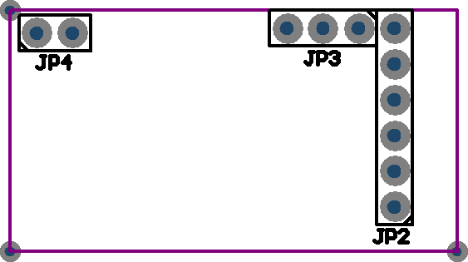

TOP OVERLAY
