PFP:TMP:555:DOFF
Modulo Temporizador 555 / Salida Relay 10A / Alimentación 12VDC / Pulso al Encendido / Tiempo Ajustable

Componentes
Description |  | N | N x40 | N x100 | N x200 | Costo Unitario [US$] | Costo * N [US$] | ARLEX | LAYER
1N4148 SMD | D1, D2 | 2 | 80 | 200 | 400 | 0.0201 |  | DL4148 | Bottom
Resistencia 1206; 1Kohm | R5, R8 | 2 | 80 | 200 | 400 | 0.00678 |  | PR1206-1K | Bottom
Resistencia 1206; 330Kohm | R7 | 1 | 40 | 100 | 200 | 0.00678 |  | PR1206-330K | Bottom
MMBTA13 | Q1 | 1 | 40 | 100 | 200 | 0.1278 |  |  | Bottom
Capacitor Electrolitico 1000uF; 16V; 10mm x 16mm | C3 | 1 | 40 | 100 | 200 | 0.11094 |  | 1000X16GR | Top
Cgrid Header 9x1 | JP1 | 0.25 | 10 | 25 | 50 | 0.1734 |  | TP1X40 | Top
Relay 6V; 1 Inversor | K1 | 1 | 40 | 100 | 200 | 0.6174 |  |  | Top
Zener 5.6V | D3 | 1 | 40 | 100 | 200 | 0.6174 |  |  | Top
Preset 1 vuelta 10Kohm / Ajuste Vertical / Cuerpo Desnudo | R1 | 1 | 40 | 100 | 200 | 0.1182 |  | VR085-10K | Top
Total Materiales 1 unidad: |  |  |  |  |  |  | 0

Bottom Layer
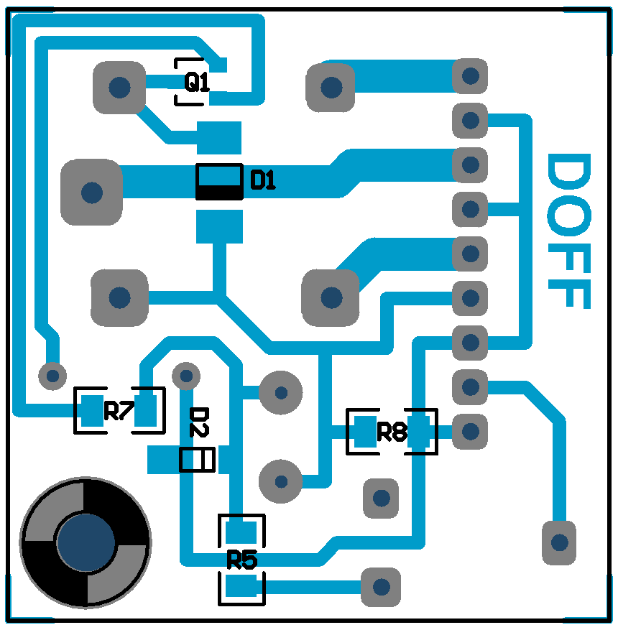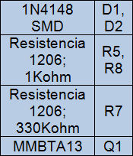

Top Layer
