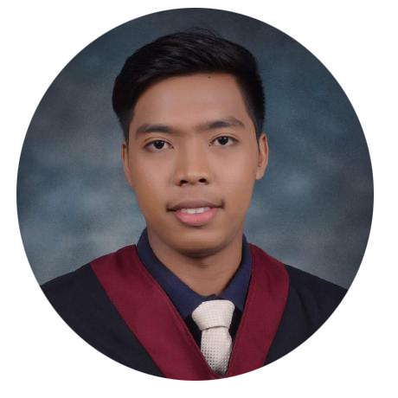

**WEB DEVELOPER**

**FEDERICO K. FLORES JR.**

**PROFILE & OBJECTIVE EDUCATION**

**Bachelor of Science in Information Technology**

Trimex Colleges

Tertiary Level

Trojan Building, Poblacion, City of Biñan Laguna

Hi, I'm a web developer who is

passionate about web development and

willing to discover or learn new things in

my field and also I love to work with a

talented team.

An Enthuastic and Passionate Problem **KEY SKILLS**

* **HTML**
* **CSS**
* **JAVASCRIPT**
* **GIT (VERSION CONTROL)**
* **PHP**
* **LARAVEL**
* **BOOTSTRAP**
* **JQUERY**

Solver Looking for suitable Job that will

help to utilize my skills and be part of

Digital Growing industry.

**CONTACT**

 [federicokakilalaflores@gmail.com](mailto:federicokakilalaflores@gmail.com) **WORK EXPERIENCE**

**MELKO OUTSOURCING SOLUTION INC.**

**(FIRST WORLD E-COMM)**

October 2020 – March 2021

Web Developer



+63 9976540115



Brgy. Malaban Biñan, Laguna



<https://federicokakilalaflores.github>.

io/portfolio/

**PROJECTS & PORTFOLIO**

**REFERENCES** <https://federicokakilalaflores.github.io/portfolio/>

<https://github.com/federicokakilalaflores>

Available upon request.