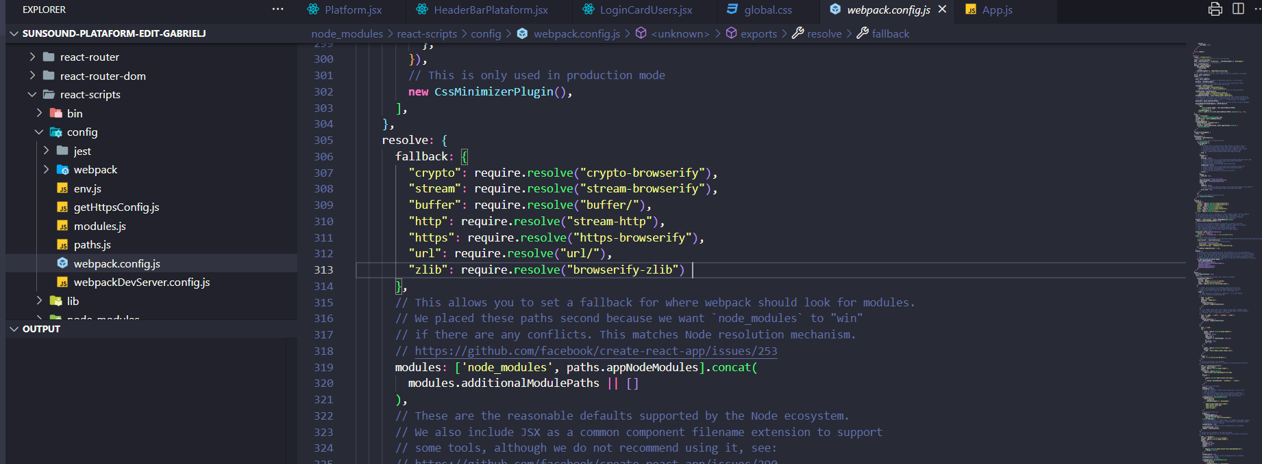  
copiar y pegar esto en la línea 305  
proyect\node_modules\react-scripts\config\webpack.config.js  
  
fallback: {

"crypto": require.resolve("crypto-browserify"),

"stream": require.resolve("stream-browserify"),

"buffer": require.resolve("buffer/"),

"http": require.resolve("stream-http"),

"https": require.resolve("https-browserify"),

"url": require.resolve("url/"),

"zlib": require.resolve("browserify-zlib")

},