Contents

1 Introduction 1

1.1 Backgroud 1

1.2 Business Problem 1

2 Data 1

**3** **Methodology** 2

**4** **Results** 4

**5** **Discussion** 5

**6** **Conclusion** 5

# Introduction

## Backgroud

Toronto is one of the most desirable place to live in Canada. The strong economy based on modern infrastructures and remarkable research centres and the proximity with many nature facilities attracts many young couples that want to build in the city the roots for their families.

*ChildrenAtHome* is a start-up with base in Toronto that organizes activities for children and teenagers and provides services such as baby-sitting and homework tutoring. The major pillars of the company are:

* A child who can stay in his own house is much more relaxed, therefore babysitters and tutors are sent directly to the clients’ homes

Parents sometimes have uninspected needs and it is difficult for them to organize how to look after their children. That is why *ChildrenAtHome* assures to offer solutions with just 60 minutes notice.

## Business Problem

*ChildrenAtHome* plans to open a new office in Toronto but is not sure in which area of the city.

The aim is to settle in an area where many potential clients live, in order to let the tutors easily reach them and fulfil the “one hour notice”.

# Data

We suppose that many families with children live in the nearby of elementary and high schools.

Therefore, using Foursquare location data, we will retrieve the information about elementary and high schools in Toronto.

For the geographical coordinates of the neighbourhoods of Toronto we will use:

* the following Wikipedia table, containing the postal codes of Toronto: <https://en.wikipedia.org/wiki/List_of_postal_codes_of_Canada:_M>
* the following database offered by Coursera, containing the geospatial information of Toronto: <http://cocl.us/Geospatial_data>.

We will cluster Toronto neighbourhoods accordingly to the concentration of schools.

We will suggest *ChildrenAtHome* to settle the new office in the neighbourhoods where there is a higher concentration of schools.

1. **Methodology**

Using the information from the Wikipedia page and the Coursera database described above, I created the main master data, which has the following fields: *Postcode*, *Borough*, *Neighborhood*, *Latitude*, *Longitude*. Here below the first five rows of the table:

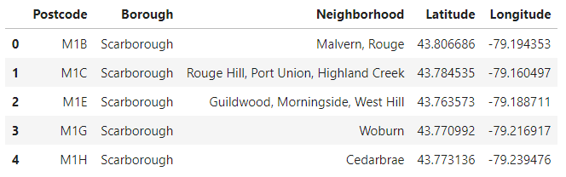

I used python *Folium* library to visualize geographic details of Toronto and its boroughs and I created a map of Toronto with neighbourhoods superimposed on top. I used latitude and longitude values to get the visual as below:

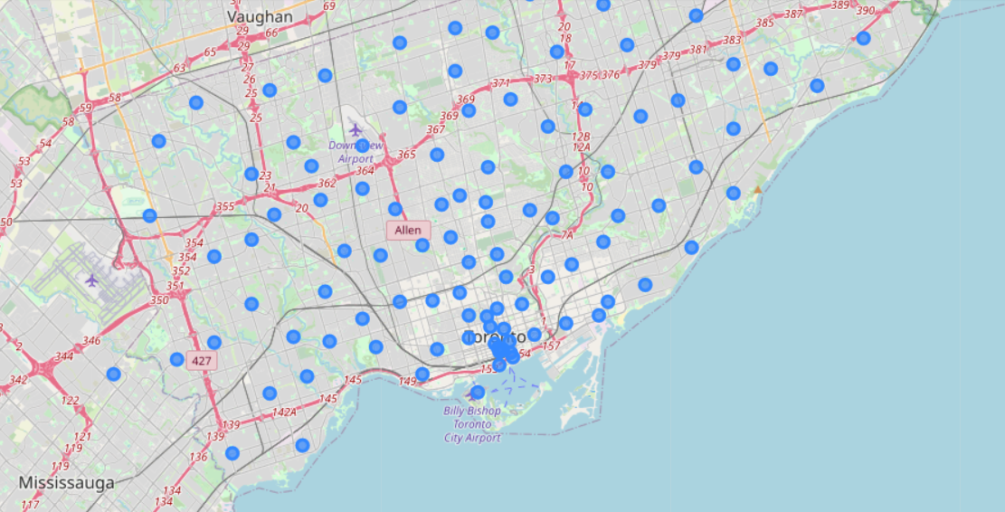

I utilized the Foursquare API to explore the city and identify the list of schools in the city. This is possible using the CategoryId field in the Foursquare url. In particular I used the following CategoryId:

* Elementary School: 4f4533804b9074f6e4fb0105
* High School: 4bf58dd8d48988d13d941735
* Middle School: 4f4533814b9074f6e4fb0106
* Preschool: 52e81612bcbc57f1066b7a45
* Nursery School: 4f4533814b9074f6e4fb0107

Using the retrieved data I built a table as follows:

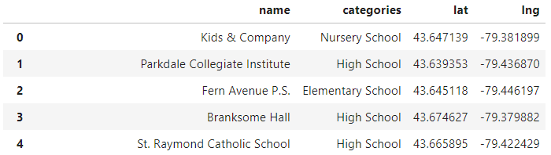

I performed the query making a loop through all neighbourhoods and built the following table, which has 1545 rows:

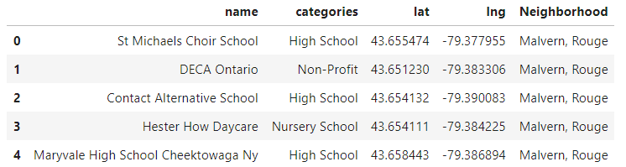

The distribution of schools is:

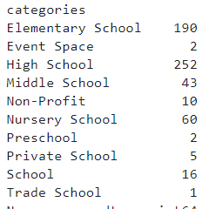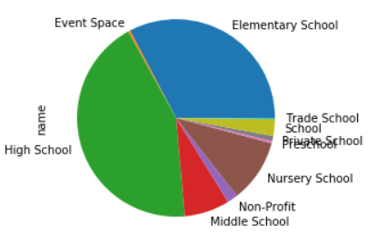

Here below the map with the distribution of school around Toronto (red). In black it is marked the coordinates considering the average of all schools retrieved:

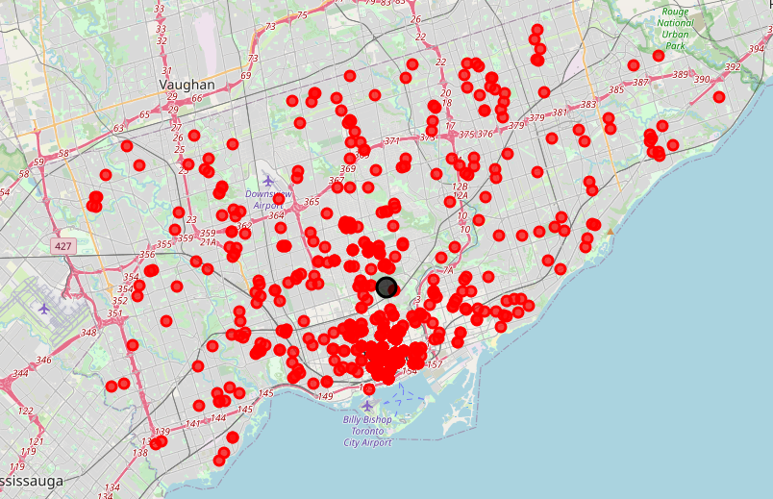

Below is the list of 10 top neighbourhoods with the number of schools in their area:

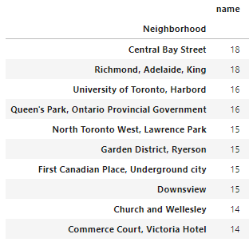

1. **Results**

The data retrived from the analysis show that the school are highly concentrated in a downtown area. If we restrict the analysis to the top 5 neighborhoods and calculate the mean of the coordinates of the schools, we found out that the following adress: 151 Bloor St W, Toronto

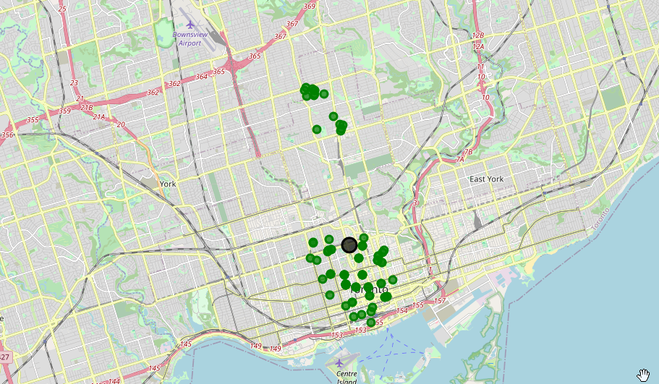

1. **Discussion**

As I mentioned before, Toronto is a big city with a high population density in a narrow area. Schools are distributed all over the city but with a higher concetration in downtow, expecially in neighborhoods.

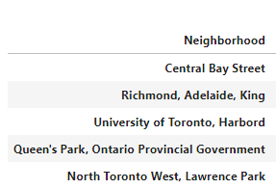

It is reasonable to decide to place the new site of *ChildrenAtHome* in an area that can be easily reached by those neighborhoos

1. **Conclusion**

As a result, we suggest *ChildrenAtHome* to find a building available in the neighbourhood of address 151 Bloor St W, Toronto.