Search:

. Audio & Video1

2. Iframe

1)Audio & Video

First Audio:

To play an audio file in HTML, use the <audio> element:

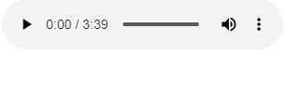

The audio source is put inside source tag which Is put inside audio tag

Audio Attributes:

- The controls attribute adds audio controls, like play, pause, and volume.

To start an audio file automatically, use the autoplay attribute.-

-Add muted after autoplay to let your audio file start playing automatically (but muted).

Second Video:

The HTML <video> element is used to show a video on a web page.



*Ps. As audio attributes is video attributes.*

Video Attributes:

- The controls attribute adds video controls, like play, pause, and volume.

To start a video file automatically, use the autoplay attribute.-

-Add muted after autoplay to let your video file start playing automatically (but muted).

Iframe(2

An HTML iframe is used to display a web page within a web page.

Iframe Attributes:

src attribute defines the URL of the page to embed-

-Always include a title attribute

The height and width attributes specify the size of the iframe-