Proposition of Organisation – Insurance Model

The proposed subject for this mini-project is an insurance company model, organizing its customers, subscribed policies and claims. The company proposes insurance for various types of property (types of vehicles, houses or others) as well as life insurance depending on the occupation of the subscribing customer.
The database is composed of 6 tables::
- Customers: ID, first name, last name, birth date, gender and contact details (address, phone, email).
- Policies: Policy ID, description, price and duration of the policy until renewal (in months). There are 2 specifications of this table:
  - Life insurance policies: occupation code and respective danger indicator.
  - Property insurance policies: property code, age and value of property.
- Subscribed policies (customers_policies): customers_policys_ID, subscription start and end dates, bonus for long periods without claims and other details, customer and policy keys.
- Complaints / claims: claim ID, customers_policys_ID, .description, requested indemnification amount, status (e.g pending, refused, accepted), and description of the result (e.g "Customer was fully indemnified"), claim and settlement dates.

Entity–relationship model (DSD)
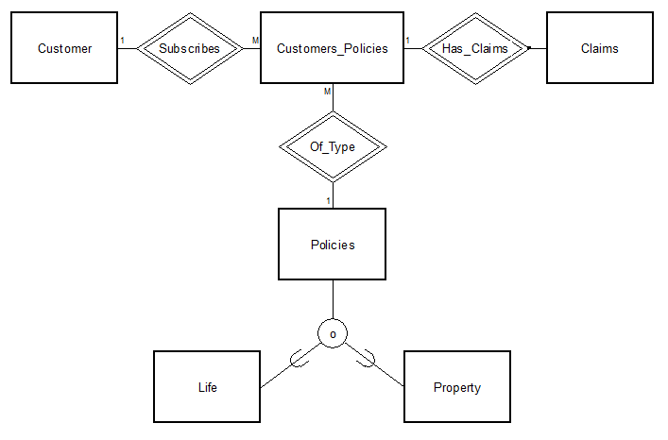
Data Structure Diagram (DSD)
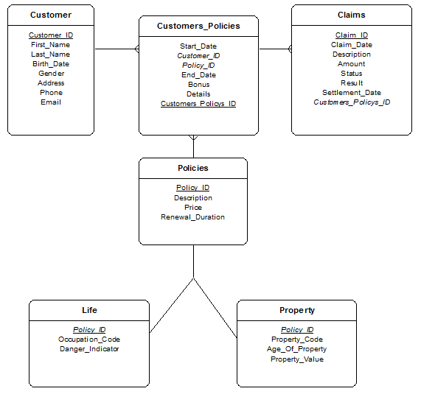

SQL Script
--
-- Target: Oracle
-- Syntax: sqlplus user@tnsnames_entry/password @filename.sql
--
-- Date : Apr 04 2013 15:07
-- Script Generated by Database Design Studio 2.21.3
--

--
-- Create Table : 'Customer'
-- Customer_ID :
-- First_Name :
-- Last_Name :
-- Birth_Date :
-- Gender :
-- Address :
-- Phone :
-- Email :
--
CREATE TABLE Customer (
Customer_ID NUMBER(38) NOT NULL,
First_Name VARCHAR2(20) NOT NULL,
Last_Name VARCHAR2(20) NOT NULL,
Birth_Date DATE NOT NULL,
Gender NUMBER(1) NOT NULL,
Address VARCHAR2(100) NOT NULL,
Phone VARCHAR2(20) NOT NULL,
Email VARCHAR2(100) NOT NULL,
CONSTRAINT pk_Customer PRIMARY KEY (Customer_ID))
/

--
-- Create Table : 'Policies'
-- Policy_ID :
-- Description :
-- Price :
-- Renewal_Duration :
--
CREATE TABLE Policies (
Policy_ID NUMBER(38) NOT NULL,
Description CLOB NOT NULL,
Price NUMBER(38) NOT NULL,
Renewal_Duration NUMBER(38) NOT NULL,
CONSTRAINT pk_Policies PRIMARY KEY (Policy_ID))
/

--
-- Create Table : 'Customers_Policies'
-- Customers_Policys_ID :
-- Customer_ID : (references Customer.Customer_ID)
-- Policy_ID : (references Policies.Policy_ID)
-- Start_Date :
-- End_Date :
-- Bonus :
-- Details :
--
CREATE TABLE Customers_Policies (
Customers_Policys_ID NUMBER(38) NOT NULL,
Customer_ID NUMBER(38) NOT NULL,
Policy_ID NUMBER(38) NOT NULL,
Start_Date DATE NOT NULL,
End_Date DATE NOT NULL,
Bonus FLOAT NOT NULL,
Details CLOB,
CONSTRAINT pk_Customers_Policies PRIMARY KEY (Customers_Policys_ID),
CONSTRAINT fk_Customers_Policies FOREIGN KEY (Customer_ID)
REFERENCES Customer (Customer_ID)
ON DELETE CASCADE,
CONSTRAINT fk_Customers_Policies2 FOREIGN KEY (Policy_ID)
REFERENCES Policies (Policy_ID)
ON DELETE CASCADE)
/

--
-- Create Table : 'Life'
-- Policy_ID : (references Policies.Policy_ID)
-- Occupation_Code :
-- Danger_Indicator :
--
CREATE TABLE Life (
Policy_ID NUMBER(38) NOT NULL,
Occupation_Code NUMBER(38) NOT NULL,
Danger_Indicator FLOAT NOT NULL,
CONSTRAINT pk_Life PRIMARY KEY (Policy_ID),
CONSTRAINT fk_Life FOREIGN KEY (Policy_ID)
REFERENCES Policies (Policy_ID))
/

--
-- Create Table : 'Property'
-- Policy_ID : (references Policies.Policy_ID)
-- Property_Code :
-- Age_Of_Property :
-- Property_Value :
--
CREATE TABLE Property (
Policy_ID NUMBER(38) NOT NULL,
Property_Code NUMBER(1) NOT NULL,
Age_Of_Property NUMBER(38) NOT NULL,
Property_Value NUMBER(38) NOT NULL,
CONSTRAINT pk_Property PRIMARY KEY (Policy_ID),
CONSTRAINT fk_Property FOREIGN KEY (Policy_ID)
REFERENCES Policies (Policy_ID))
/

--
-- Create Table : 'Claims'
-- Claim_ID :
-- Customers_Policys_ID : (references Customers_Policies.Customers_Policys_ID)
-- Claim_Date :
-- Description :
-- Amount :
-- Status :
-- Result :
-- Settlement_Date :
--
CREATE TABLE Claims (
Claim_ID NUMBER(38) NOT NULL,
Customers_Policys_ID NUMBER(38) NOT NULL,
Claim_Date DATE NOT NULL,
Description CLOB NOT NULL,
Amount NUMBER(38) NOT NULL,
Status NUMBER(1),
Result CLOB,
Settlement_Date DATE,
CONSTRAINT pk_Claims PRIMARY KEY (Claim_ID),
CONSTRAINT fk_Claims FOREIGN KEY (Customers_Policys_ID)
REFERENCES Customers_Policies (Customers_Policys_ID)
ON DELETE CASCADE)
/

--
-- Permissions for: 'public'
--
GRANT ALL ON Customer TO public
/
GRANT ALL ON Policies TO public
/
GRANT ALL ON Customers_Policies TO public
/
GRANT ALL ON Life TO public
/
GRANT ALL ON Property TO public
/
GRANT ALL ON Claims TO public
/

exit;
Queries

Customers
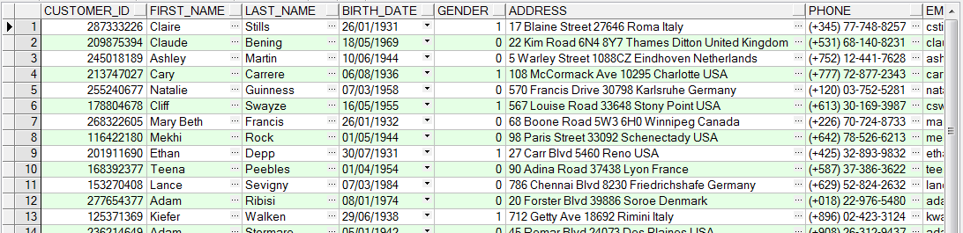

Policies
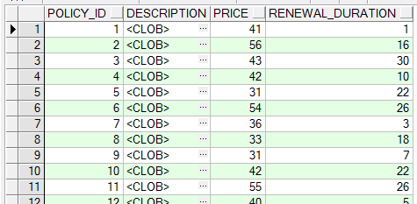

Property
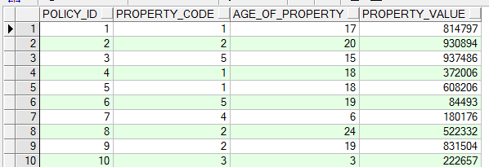

Life
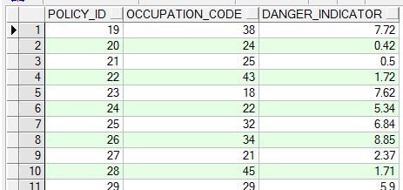

Customers_Policies
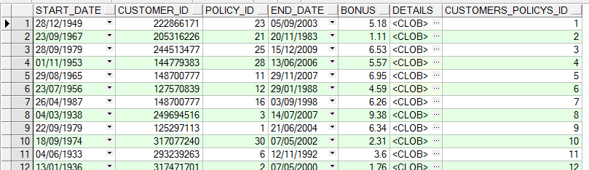

Claims
