

**Algebraic Dynamic Parametric Renderer**

User manual

26.04.2017

Version 2.4

© Dmitriy Fedoriaka

**Table of contents**

1.Introduction 3

2. Main algorithm 4

3. Main features 5

3.1. Main window 5

3.2. Generator 5

3.3. Color map 6

3.4. Navigation 6

3.5. Saving picture 6

4. Editing movie 7

5. Settings 8

6. CUDA Support 9

7. System requirements 10

8. Credits 11

1.Introduction

Purpose of **Aldyparen** is to render some specific fractal-like images by given parameters and save them as images or as a video.

2. Main algorithm

Program is based on theory of function of complex variable. For each pixel of image, it puts in accordance some point of complex plane. Then it builds a sequence, which depends on this point. Then, analyzing convergence or divergence of this sequence, it determines color of pixel.

Let’s consider complex number *c* and function $f=f(c,x)$*, $f:C×C→C$.* Let’s build a sequence: $z_{0}$ is given, then $z_{i+1} = f(c,z_{i}).$ Then let’s determine “infinity” – positive real number $A$*.* Let $n$ be such minimal index*,* such as $|z_{n}|>A$*.* Then, define $m = min(n,N),$ where $N$ is given number of evaluated elements. If for all elements $|z_{n}|≤A$*,* let be $m=N$.

Thus, for set $\left\{c, f,z_{0},N\right\}$ we have determined an integer $X∈\overline{0,N}.$

Then for each pixel let’s take corresponding complex number $c$, evaluate $X$ and paint this pixel in $X^{th}$ color from given color map.

For example, if we take $f=z^{2}+c$ and $z_{0}=0$ and sufficiently big $N$ (more than 20), pixels with $X=N$ will display Mandelbrot’s set.

Further, the function $f(c,x)$ will be referred to as “generator”

3. Main features

# 3.1. Main window

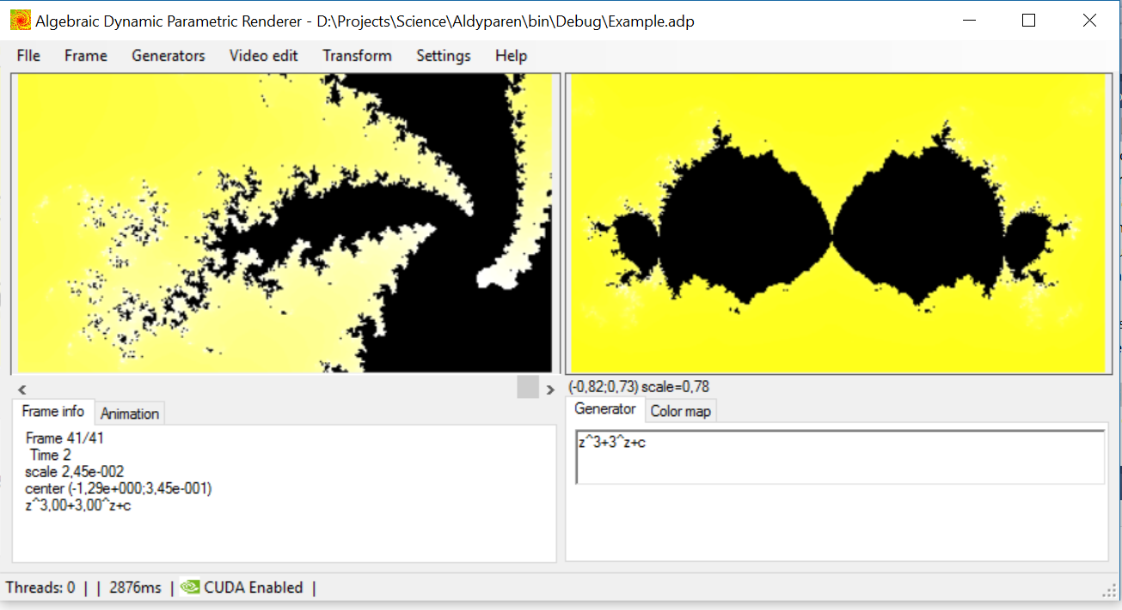

*Work frame*

*Movie*

Main window of the program contains two parts. On the left there is **Movie area** in which you can see any frame of the project. Use scrollbar under this area to switch between frames. On the right there is **Work frame**, which you can modify and transform.

Under movie area there is **Frame info** tab, which contains all information about selected frame, and **Animation** tab.

Under work frame there is **Generator** tab and **Color map** tab.

On the top of main window there is main menu.

# 3.2. Generator

In text field in **Generator**tab you can enter “generator” as function of variables “c” and “z”. It can contain:

* Arithmetic operators (“+”, “-”, “*”, “/”);
* Power operator (“^”);
* Braces (“(”, “)”);
* Real numbers;
* Symbols “i” (imaginary one), “pi” (3.141592…), “e” (2.71828…);
* Functions exp, log, sqrt;
* Trigonometric functions: sin, cos, tg, ctg;
* Hyperbolic trigonometric functions: sh, ch, th, cth;
* Complex-numeric functions: re, im, abs, arg.
* Unary minus.

Note that all functions are functions of complex variable.

If generator is incorrect, you will see message below text area.

# 3.3. Color map

To change specific color in color map, select its number in box in **Color map** tab, then click on colored square at right and choose color.

You can set gradient for range of colors in color map. Choose left and right borders of range in two boxes below box with number of color, then press “Gradient” button.

If you check “Geo” box, gradient will be built using three key colors: red, yellow and green.

Press “Random” to fill color map with random colors.

# 3.4. Navigation

You can navigate on picture inn right frame in real time. You can move, rotate and scale it.

To move, press left mouse button when cursor is upon frame, then drag mouse, holding button.

To scale, use mouse wheel. If you hold Shift, scaling will be faster.

To rotate, use mouse wheel holding Ctrl.

# 3.5. Saving picture

You can save picture from right frame as BMP or JPG file in high resolution. Set size of picture in **Photo Settings** box, then press **Make Photo**. By default, it will be saved in Output directory.

You may specify destination, checking **“Select destination”** option.

4. Editing movie

Movie consists of frames. You can append key frames and middle frames will be added automatically. Rendering of whole movie will be carried out when you choose **File – Make Video**.

To append the work frame to the movie, use **Video edit — Append**. To replace last frame with frame from right, use **Video edit — Replace**.

To add frame as key frame and some frames before it as animation (animation will be smooth and cool) set **Animation Length** (in **Animation** tab) in frames, then click **Video Edit –** **Make Animation!**

You also can delete any frame. To do this, choose the frame using scrollbar under movie area and select **Video Edit – Remove Selected Frame**.

5. Settings

If you click **Settings – Settings…**, you will see following window:

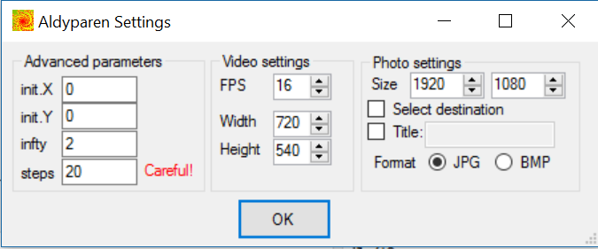

In **Advanced parameters** section you can define parameters of sequence:

* **init** – z0;
* **infty** – A;
* **steps** – N.

In **Video settings** section you can specify frame size of video and frame frequency (FPS, frames per second).

In **Photo settings** section you can specify size of photos; their format (BMP or JPG); whether ask you about destination or save them in **Output** folder.

6. CUDA Support

Program supports CUDA. It is used to accelerate rendering using graphics processing unit(GPU) on your PC. To use it you must have NVIDIA GPU on your PC and have CUDA installed (download link: <https://developer.nvidia.com/cuda-downloads>).

By default, the option is disabled and all images are rendered on CPU. To enable it use Settings — CUDA Settings —Use CUDA. If you can see your GPU properties, then CUDA is enabled successfully. Also, you can see status of CUDA (Enabled/Disabled) in status line in bottom of main window.

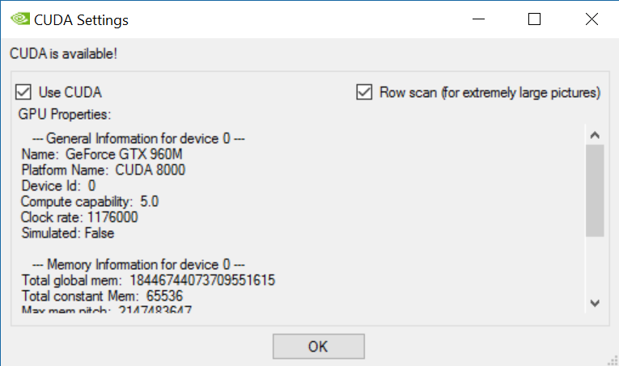

If there was error in CUDA routine, program will not allow you use CUDA until you restart application. Errors can appear if you want render too big images or use too complex generators. Limits depends on your system.

There is **Row scan** option. If it is enabled, the single task for GPU will be not the whole frame, but one row of it. It is enabled by default. It is recommended to use for big pictures and complex generators, though it is a bit slower.

7. System requirements

* Microsoft Windows 7,8,10.
* .NET Framework 4.5 (<https://www.microsoft.com/net/download>).
* For CUDA: NVIDIA GPU and installed CUDA.

8. Credits

Author — Dmitriy Fedoriaka, e-mail [fedimser@yandex.ru](mailto:fedimser@yandex.ru).

Web site of program <http://fedimser.github.io/aldyparen>.