**SOFTWARE VERIFICATION, VALIDATION AND TESTING**

TESTING DOCUMENTATION

Comtrade.com testing

Prepared by:

**Feđa Pandžić**

**Vedran Kilalić**

**Sanjin Kurtalija**

Proposed to:

**Samed Jukić, Assist. Prof. Dr.**

**Aldin Kovačević, Teaching Assistant**

Date of submission: 22/1/2023

TABLE OF CONTENTS

Contents

1. Introduction 3

1.1. About the Project 3

2. Test Plan 3

2.1. Scope 3

2.2. Testing Environment and Tools 3

3. Test Execution 3

Test Case 1 3

Test Case 2 4

Test Case 3 5

Test Case 4 6

Test Case 5 6

Test Case 6 7

Test Case 7 8

Test Case 8 9

Test Case 9 9

Test Case 10 10

Test Case 11 11

Test Case 12 11

Test Case 13 12

Test Case 14 12

Test Case 15 13

4. Conclusion 14

9.1. Testing Summary 14

9.2. Final Thoughts 14

# 1. Introduction

## 1.1. About the Project

The website we have decided to test is comtrade.com . Comtrade.com is the home page of the Comtrade organization. You can find information about the organization and its companies as well as possible job openings.

# 2. Test Plan

## 2.1. Scope

We plan to test as many functionalities as possible, from visiting parts of the website to applying for a job. We will not be sending the application as to not clog up the websites database with dummy data.

## 2.2. Testing Environment and Tools

We will use Intellij and/or Eclipse IDE and will be creating a Maven project to easily import all the needed dependencies.

# 3. Test Execution

## Test Case 1

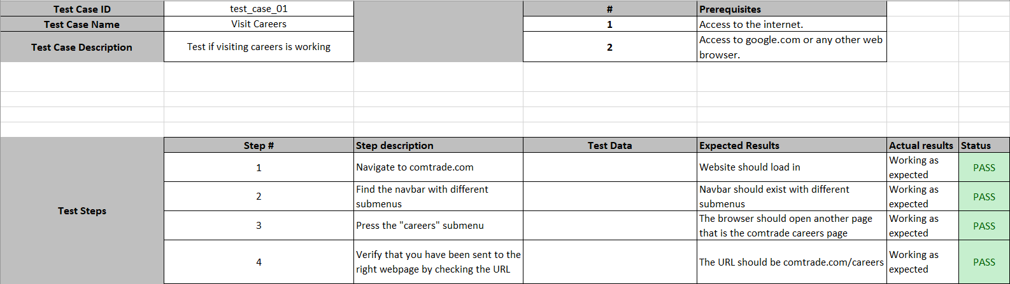

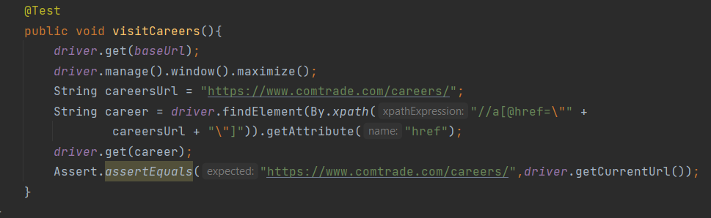

## Test Case 2

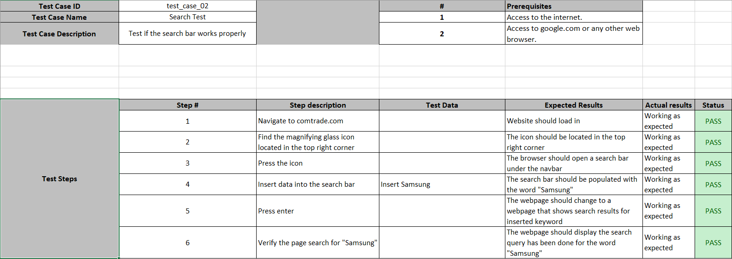

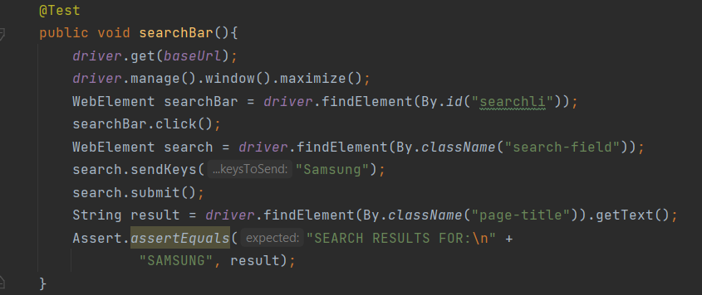

## Test Case 3

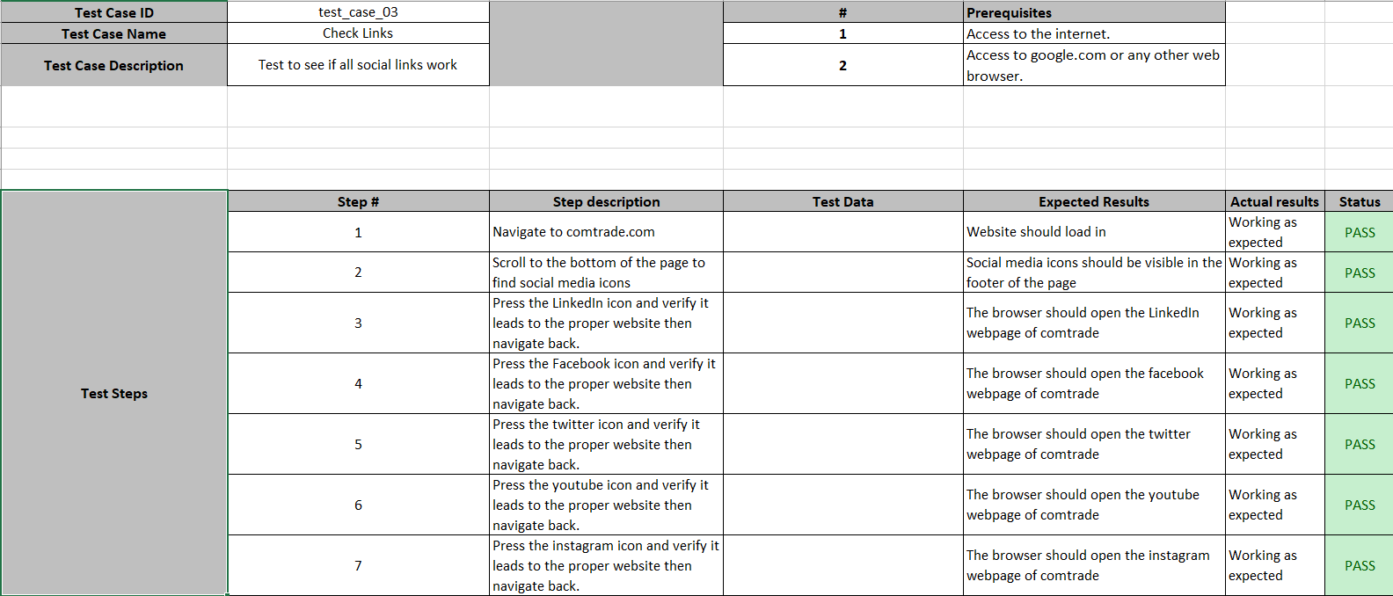

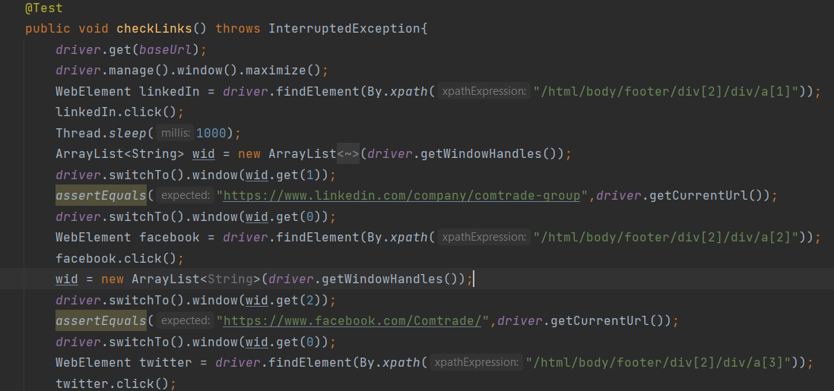

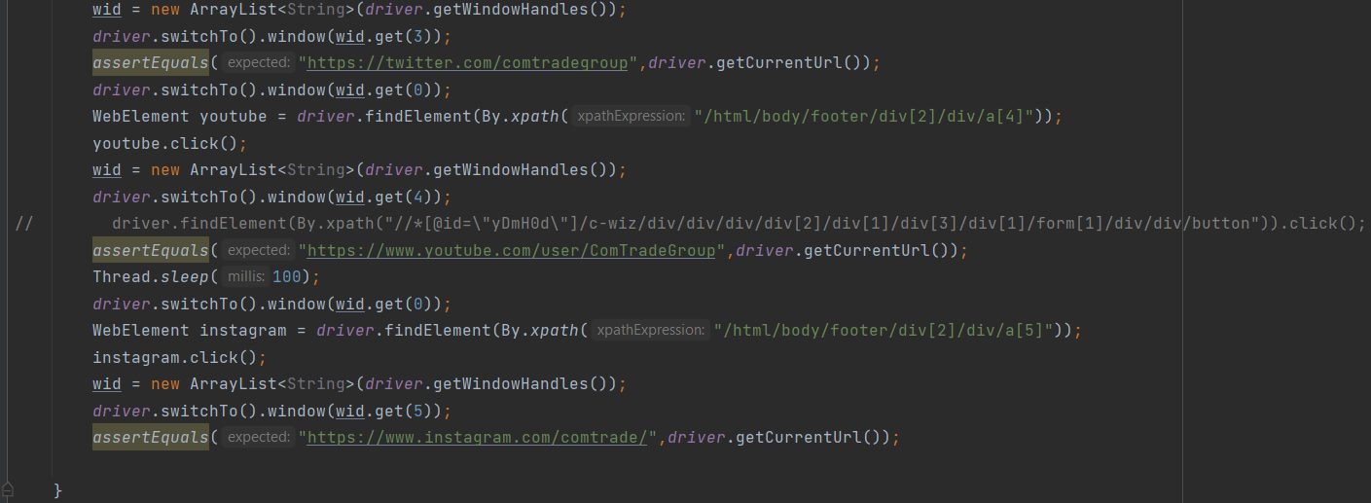

## Test Case 4

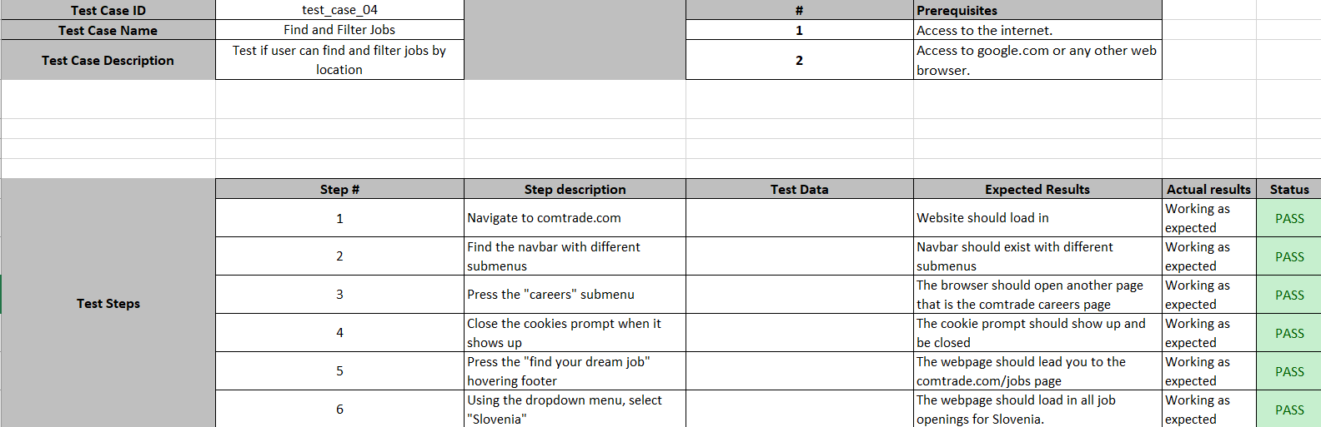

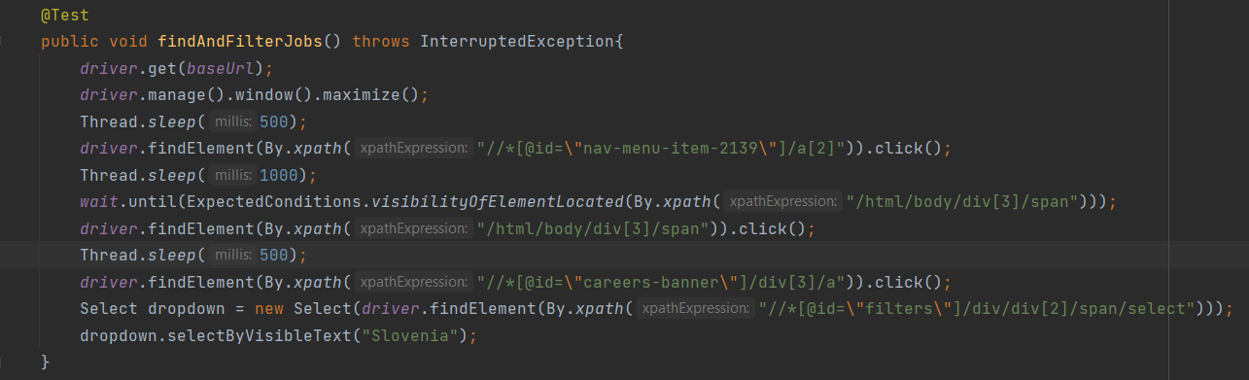

## Test Case 5

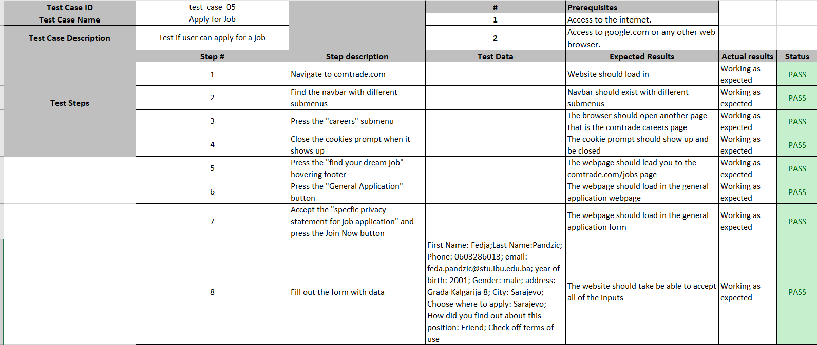

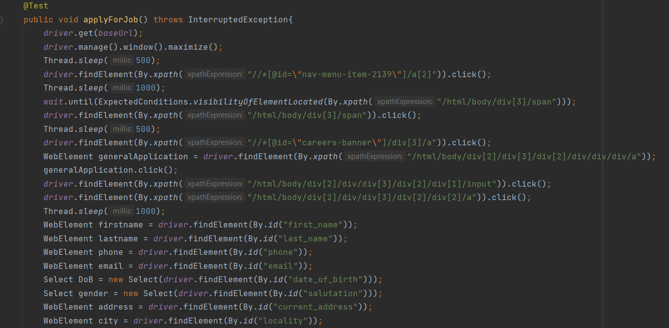

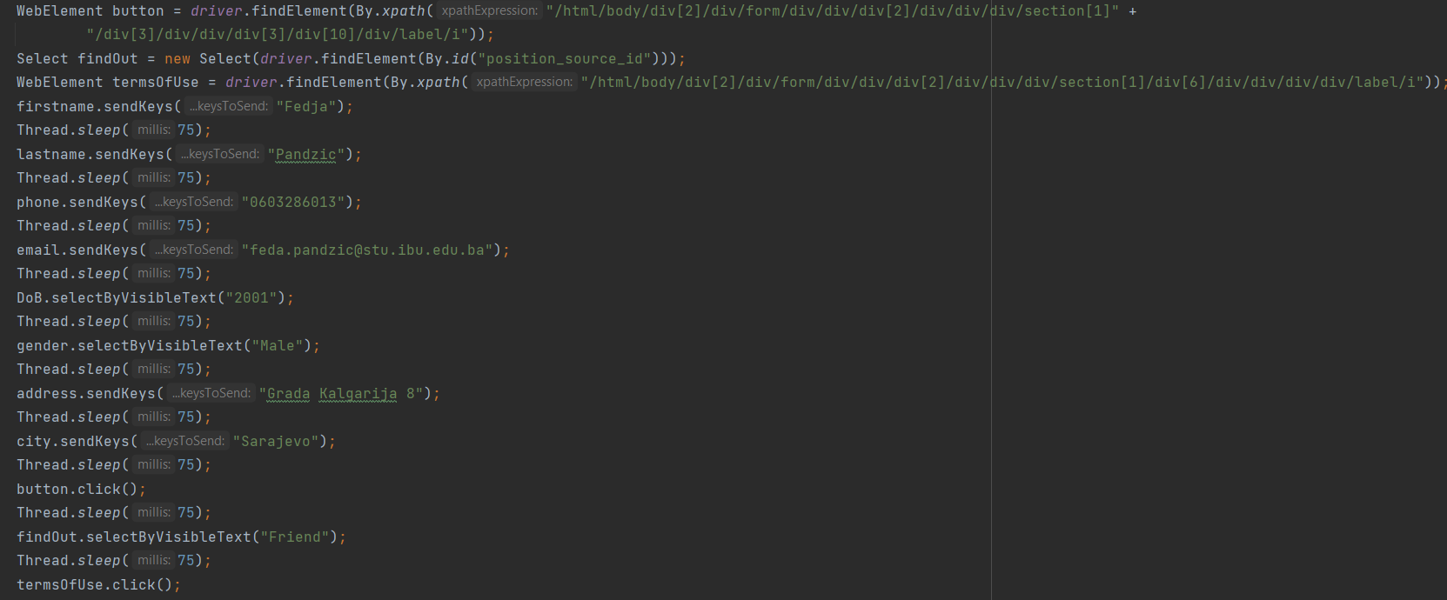

## Test Case 6

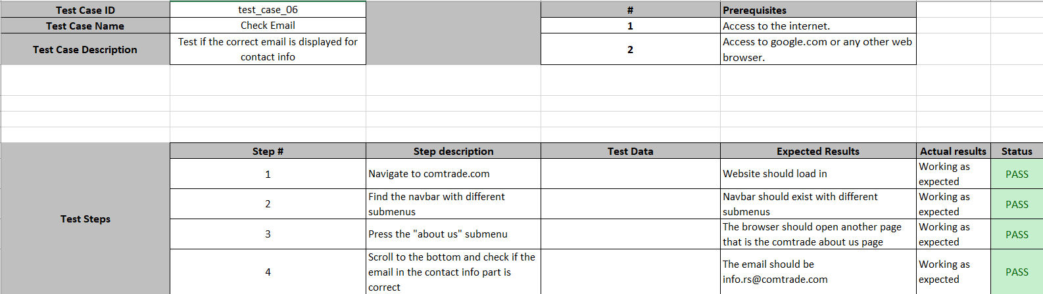

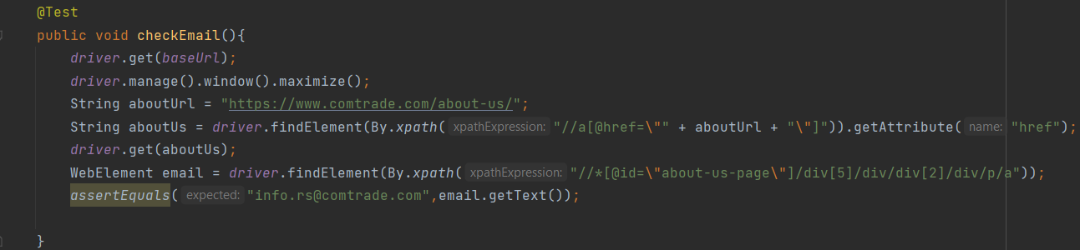

## Test Case 7

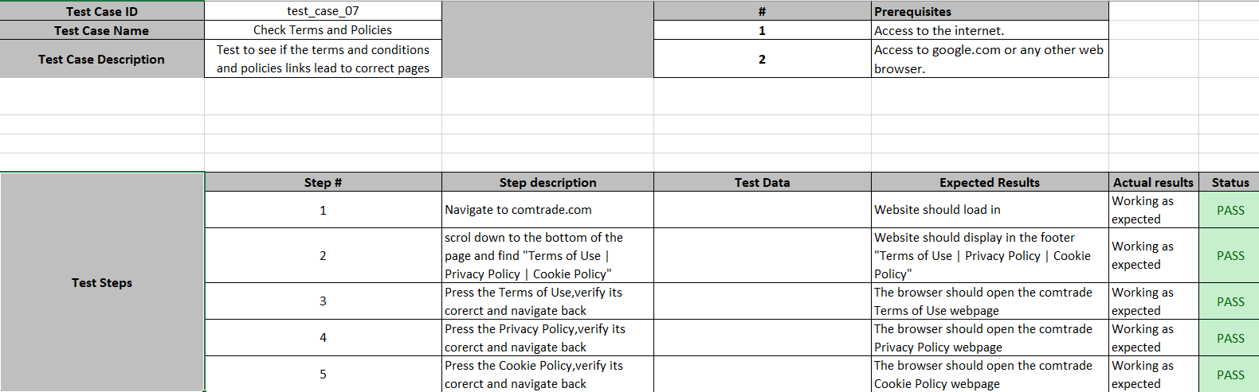

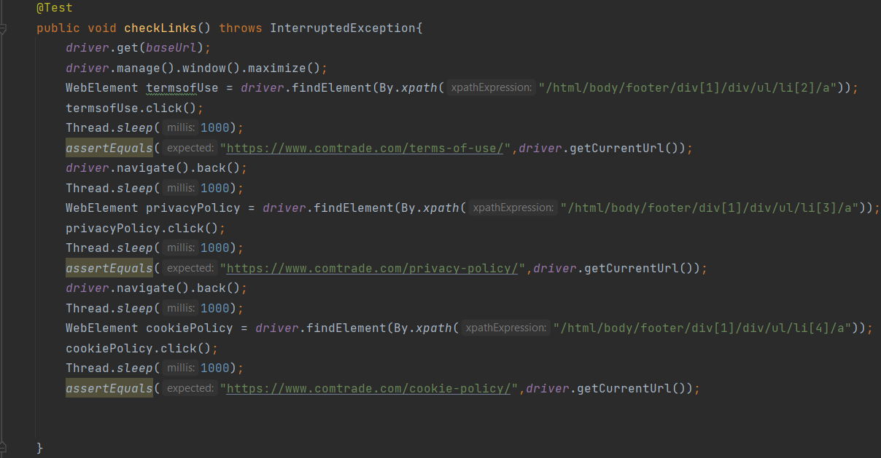

## Test Case 8

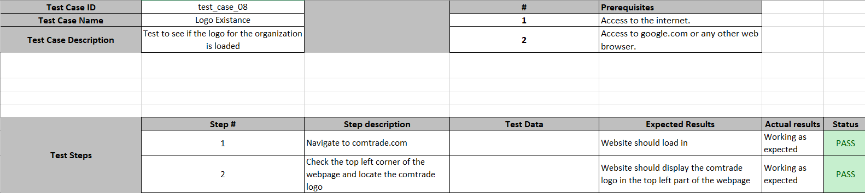

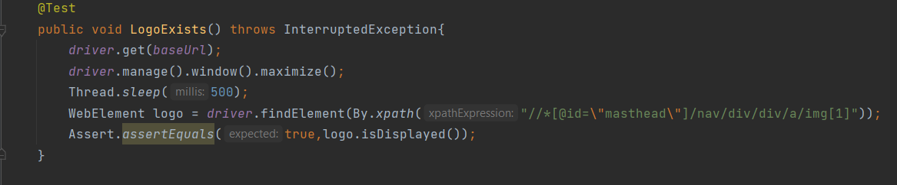

## Test Case 9

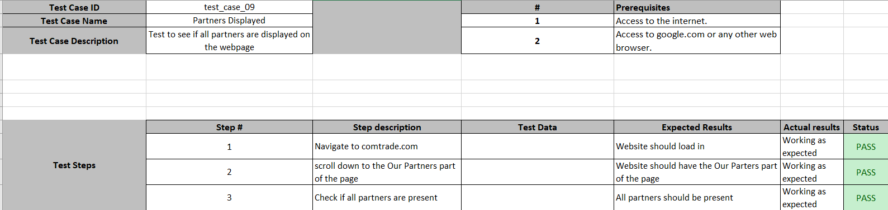

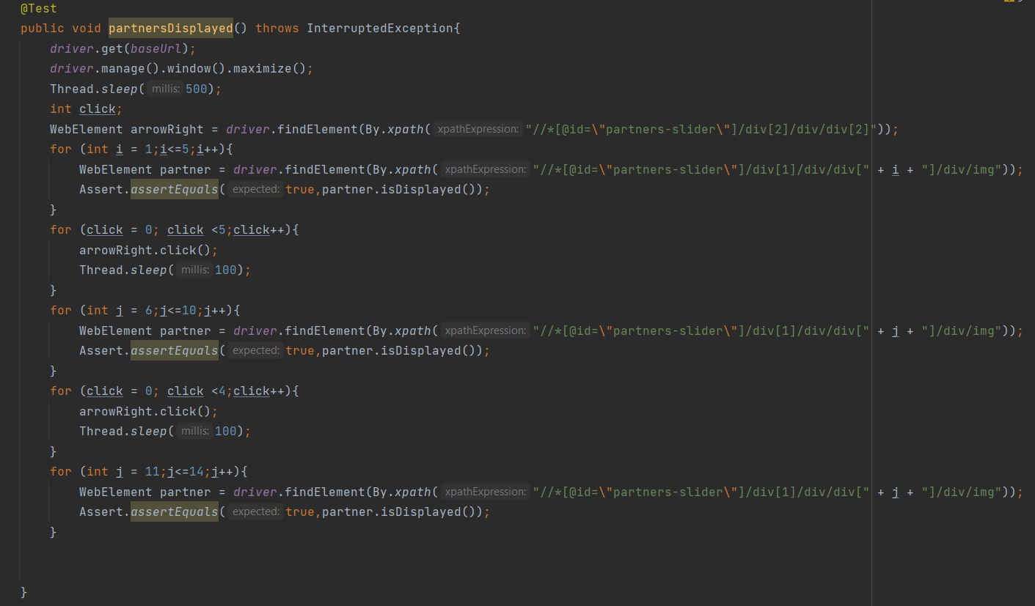

## Test Case 10

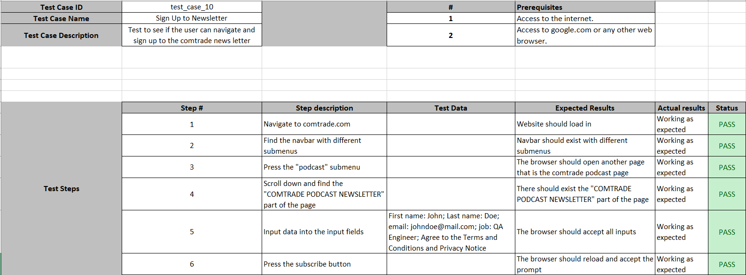

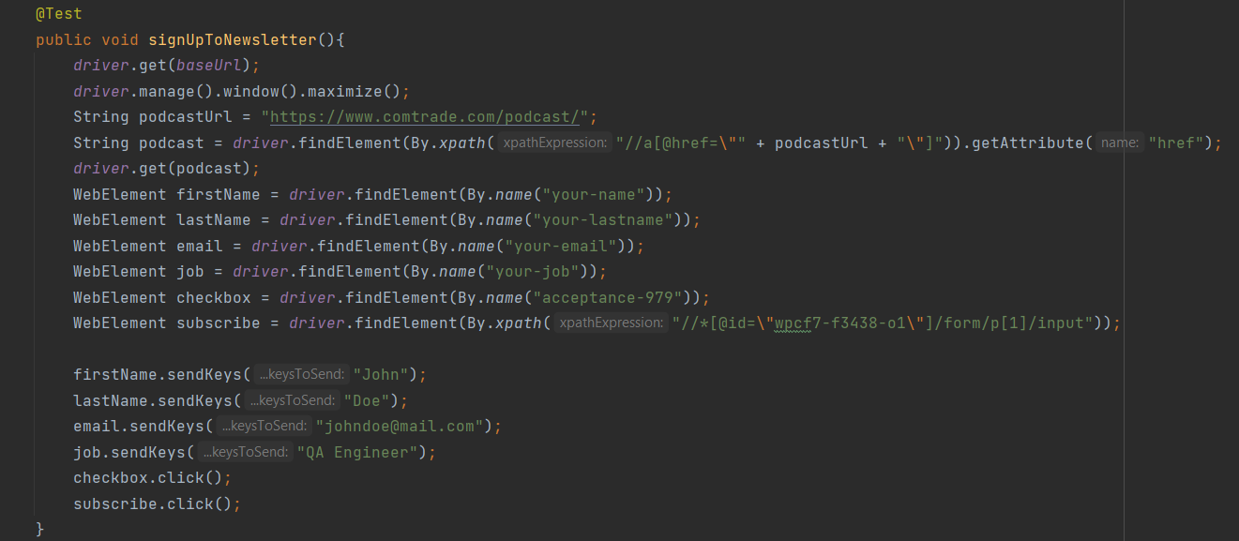

## Test Case 11

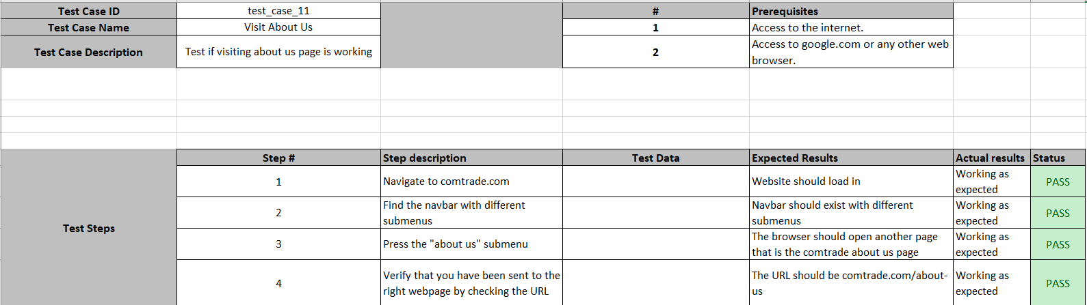

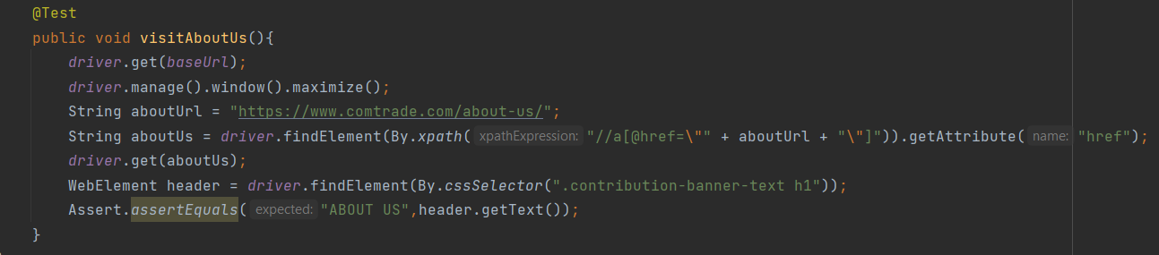

## Test Case 12

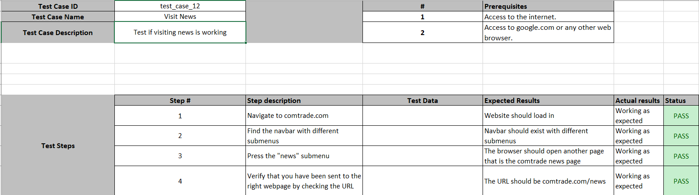

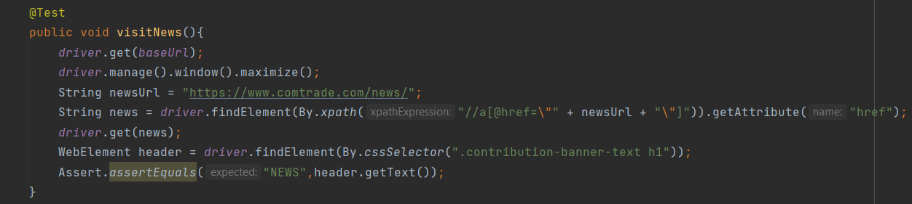

## Test Case 13

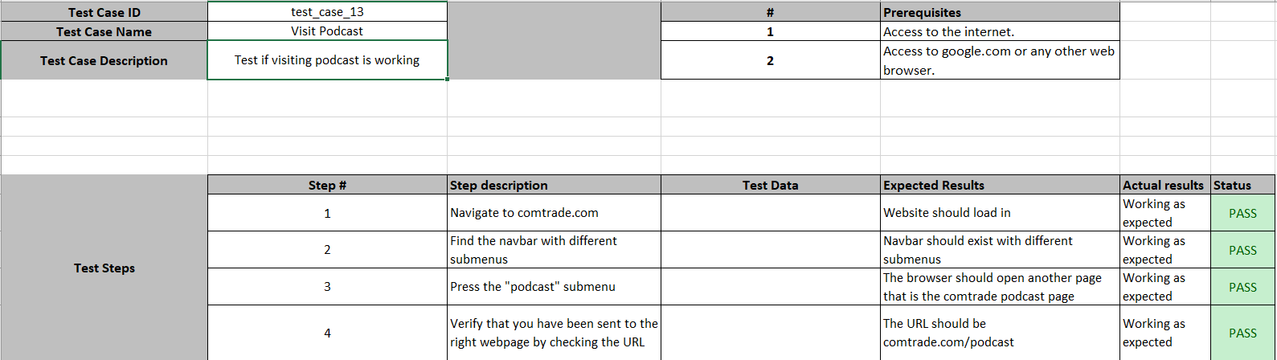

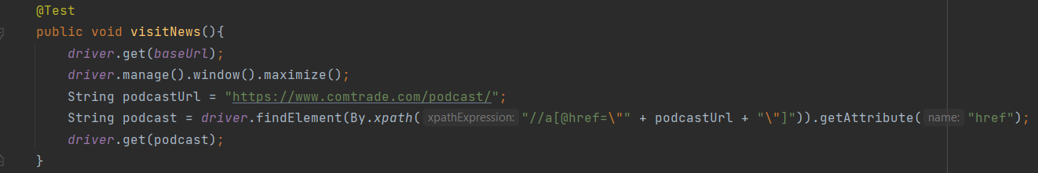

## Test Case 14

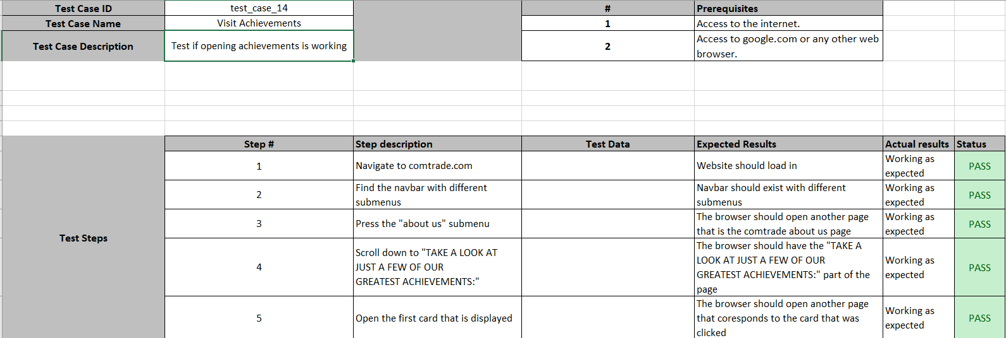

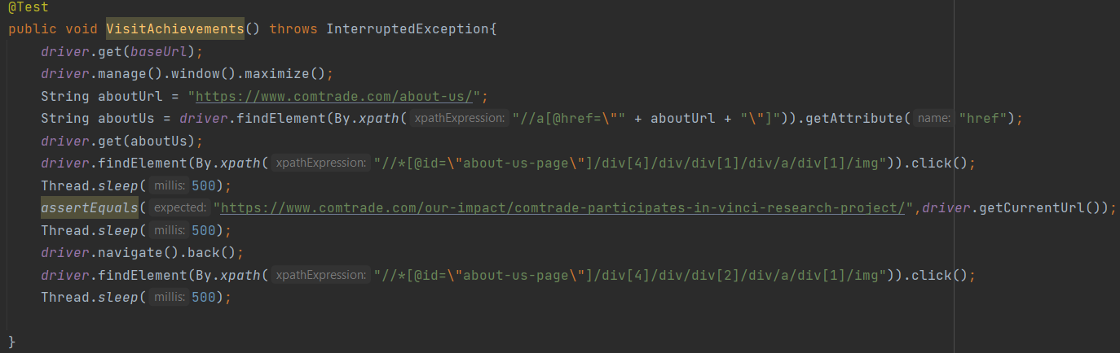

## Test Case 15

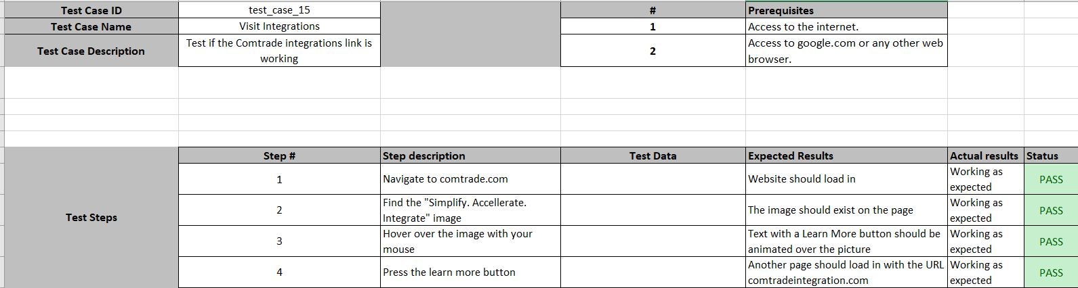

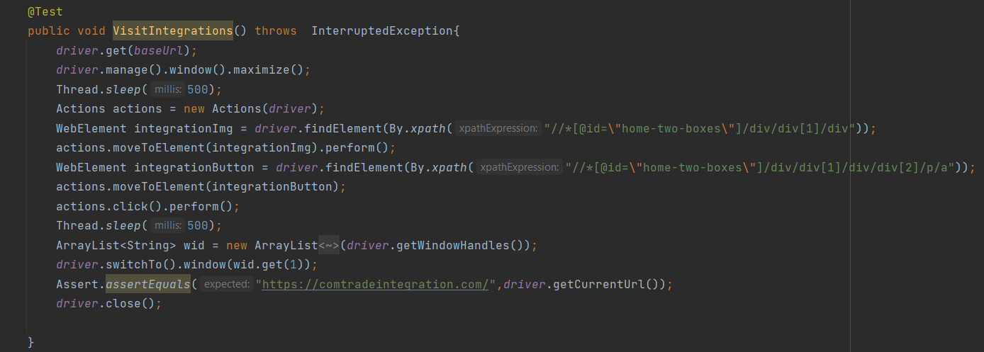

# 4. Conclusion

## 9.1. Testing Summary

|  |  |  |  |
| --- | --- | --- | --- |
| **Testing Tool** | **Total Tests** | **Passed Tests** | **Failed Tests** |
| By using maven we imported the selenium, testNG, junit and junit-jupiter dependencies to use for our testing purposes | 15 | # of passing tests:  15 | # of failing tests:  0 |

## 9.2. Final Thoughts

Our final thoughts on this project is that the website we have tested has shown great implementation of their functionalities. All 15 of our tests have passed which shows how bug free this website is.