High Level Design and API Specification
USB COMM Support for TRACE and DEBUG

Scope: | Description of the high level design for USB communication support.
Audience: | TRK Developers and TraceCore developers.
Owner: | Ravi Kurupati
Location: | Austin
Name: | USB_Comm_Design_API_Spec

Change History
Issue | Date | Handled by | Comments
0.1 | 6/18/07 | Ravi Kurupati | Initial version.
0.2 | 10/9/07 | Ravi Kurupati | Updated based on the initial version of OST protocol, removed the phonet routing information.
0.3 | 10/24/07 | Ravi Kurupati | Updated after reviewing the latest version of OST protocol, also updated with comments from Hannu.

Copyright © Nokia Corporation 2026. All rights reserved.

We welcome and consider all comments and suggestions. Please send them to:

C++ Tools
701, Brazos Street, Suite 1000, Austin, TX 78701
USA

http://www.nokia.com

Copyright © Nokia. This material, including documentation and any related computer programs, is protected by copyright controlled by Nokia. All rights are reserved. Copying, including reproducing, storing, adapting or translating, any or all of this material requires the prior written consent of Nokia. This material also contains confidential information, which may not be disclosed to others without the prior written consent of Nokia.

The content of this documentation may be changed without prior notice.
TABLE OF CONTENTS

1 About this document 4
1.1 Text conventions 4
1.2 References 4
2 About this design 5
2.1 Goals 5
2.2 Features 5
2.3 Limitations 5
2.4 Open Issues 6
2.5 Future considerations 6
3 System architecture for common usb channel 7
3.1 Long Term Solution 7
3.2 Short Term Solution 9
4 Message routing and API 11
4.1 Message Routing 11
4.2 API 12

About this document
This document is a design and API specification for USB communication support for both TRK and TraceCore. It describes the changes and enhancements required for providing a common communication channel which can be used for multiple tools like TRK and TraceCore. It also includes the API description for using the USB communication channel. The main driver for these two requirements is to be able to use run mode debugging and tracing via the USB communication port. The goal is to provide a connectivity option which will be seamless for the user when using both TRK and TraceCore.
This document doesn’t describe the changes required to either TRK or TraceCore for using the new USB communication API. This document also doesn’t describe the changes required in Carbide on the host side.

Text conventions
This specification uses the following text conventions:
- File names, and path names appear in Courier.
- Names of source files, software programs or software components appear in Courier.
- URLs appear in Courier.

References
# | Location and Name | Description
 | Ser_Comms_USB_Subsystem_Architectural_Description.doc | This document describes the USB communications sub system architecture in Symbian.
 | USBManager_Component_Design.doc | This document describes the USB manager component in Symbian.
 | USB_ACM_Component_Design.doc | This document describes the ECACM component in C32.

About this design
Currently tracing is provided in Nokia terminals via Musti. This requires a special connection called XTI which is only available on the wing boards or either through a flash adapter. To use tracing, the user needs to go through setting up Musti and get the required special hardware. Although the special hardware is required for fast tracing, say in case of complete system trace, it would be nice to have a simple connectivity option via USB for user side trace.
TRK already has USB connectivity support. It uses the USB as a serial port via ECACM. The goal of this design is to provide a common USB communications channel for both TraceCore and TRK. This would require TRK and TraceCore to be modified to use the new API described later in this document.

Goals
Design goals include:
- Common USB communication API for both TRK and TraceCore.
- Ability to use this USB channel simultaneously by multiple tools like TRK and TraceCore..
- Support for OST routing.
- End User Impact – The design must have minimal impact in the usage of TRK and TraceCore. For TraceCore, this might not be an issue since USB support is being provided for the first time to the users.
- Performance – Communication speed of this USB channel should be good enough to do both run mode debugging and tracing at the same time. Users shouldn’t see noticeable difference in either debugging speed or tracing speed.

Features
- Common USB communication channel.
- API for the common USB channel.

Limitations
Some of the currently identified limitations are listed below. All the possible limitations haven’t been identified with the common USB communication channel.
- Configuration of the common USB communications port will be possible only from one client. It won’t be possible to reconfigure the port if it’s already configured.
- Speed of the USB channel will be limited by the speed provided by the ECACM channel for the first implementation.
- Currently the design addresses the needs of TRK and TraceCore, but the design is done keeping mind of the needs of other tools like memory analysis or memory leak tools.

Open Issues
- OST protocol is not completely defined yet, if there are any major changes in the OST protocol header, then it would require some changes to the OST router.
- The performance impact for trace when using USB via ECACM is unknown at this point, the bandwidth requirements are not clear.
- Its not clear whether USB 2.0 speeds are possible through the ECACM channel.

Future considerations
- Consider support for more clients other than trace and debug applications.

System architecture for common usb channel
This section describes the intended architecture of the common USB communication subsystem. It describes both the long term and short term solutions.

Long Term Solution
The ideal solution for providing a common USB communication channel is to define a new personality layer and provide a new USB class controller so that the communication can happen on an end point that is dedicated for this purpose. Also the configurability of this end point can be controlled by the new USB class controller which will make it easier to provide the necessary support for debug and trace communication. It will also make it easier to extend the support for providing better user experience.
For example: if we have a new personality layer, then we can provide a new option to the user like “Debug/Trace port” or something like that, when the user connects the USB cable between the phone and the PC.
Also with the new class controller, we don’t have to work around the limitations of the existing class controllers if there are any.
As already mentioned, this solution introduces a new USB class controller specifically for debug/trace communication. This USB class controller will interact with the USB manager to define and control the new class which will essentially be mapped to an end point in the USB physical device driver. The actual communication API will be provided in a separate library, for now, this library is called debug/trace service DLL. The main functionality of this DLL is to provide the API to both run mode debug and trace clients to access the USB channel. It also provides the routing of the messages between these two clients.
The schematic shows all the intended architecture for this solution.
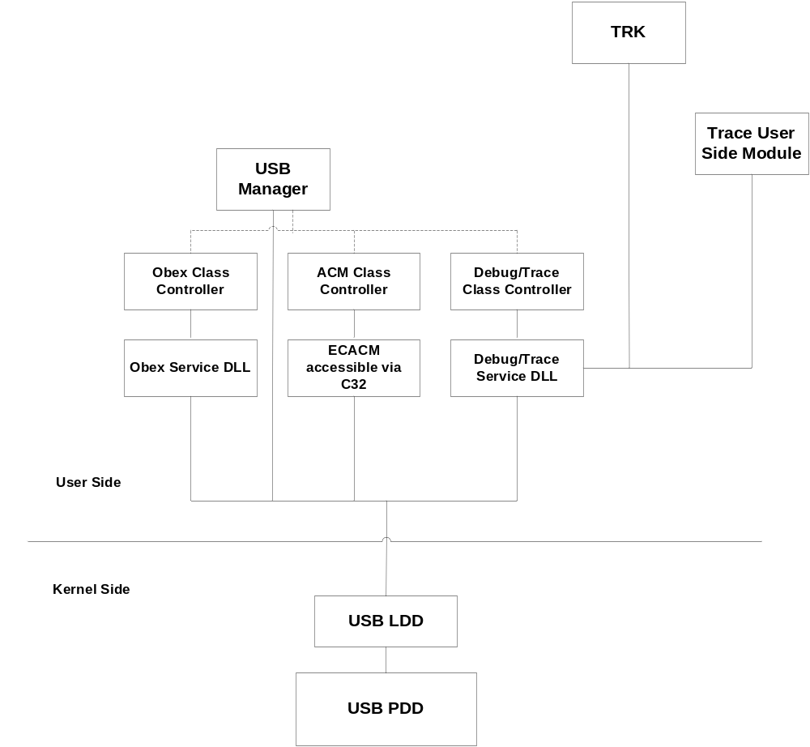
The main draw back of this approach is that it requires quite a few modifications to other S60 components to provide better user experience when using USB. For example, we would need to modify USB watcher and USB notification UI to show the new class name and appropriately invoke the right functionality based on the user selection. It would also take quite a bit of time in convincing all the associated parties involved in agreeing to the changes to all the necessary S60 components .

Short Term Solution
TRK already has USB connectivity support. It uses the ECACM service provided via C32 to use the USB channel. The idea for the short term solution is to make use of this service provided as part of C32 since it’s already proven to work with TRK. Also it wouldn’t require changes in some of the S60 components that the long term solution requires. Although ECACM service is a serial port based communication on top of USB, higher baud rates are available through this port and hence the performance should be good enough to use the ECACM port for both trace and run mode debugging at the same time. However it’s not clear whether ECACM service can provide as much speed as the USB channel provides, for ex: if USB 2.0 is available on the target, I am not sure if ECACM channel can provide USB 2.0 speed.
The plan is to provide the communication API for debug/trace through the Debug/Trace service DLL. Debug/Trace Comms server will handle the message routing and the ACM channel. Standard Symbian IPC mechanism will be used to manage the sessions between different clients.
The schematic below shows the architecture diagram for the short term solution.
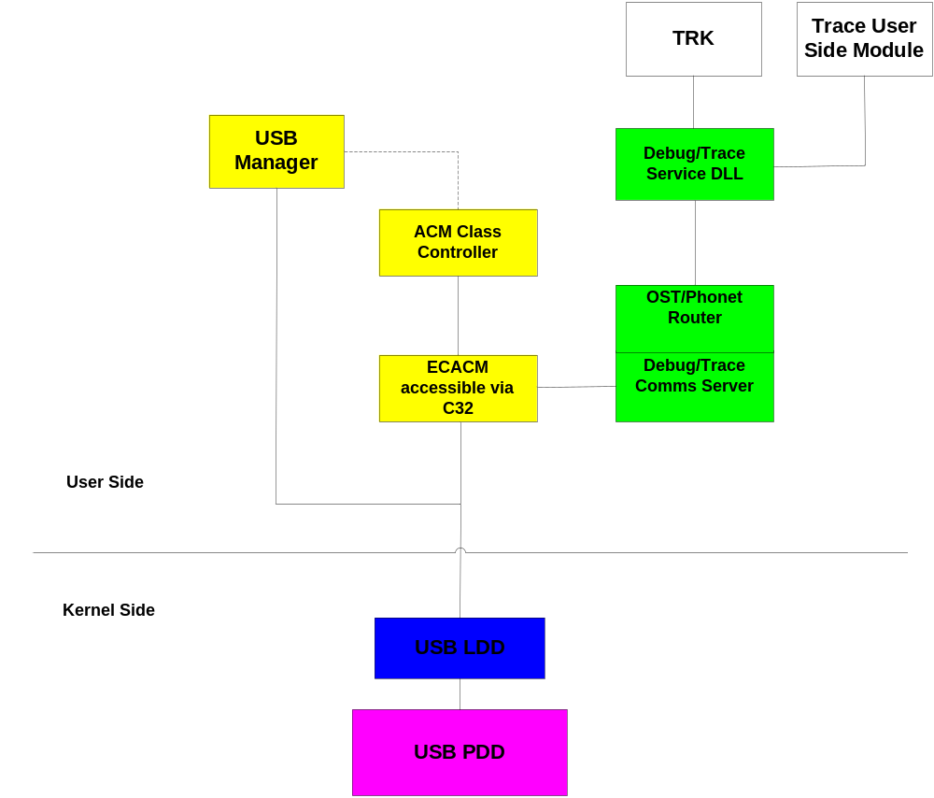
As already mentioned, the main advantage of the solution is that we can provide the solution to the end users relatively soon compared to the long term solution. As seen in the schematic, the Dbg/trace service DLL provides the API functionality for using the common USB communication channel. The server provides the routing of the messages among various clients of the API. This routing depends upon the debug/trace protocol that is being currently defined.
Another advantage of this solution is that it can be extended to become the long term solution just by replacing the usage of ECACM service with our own USB class. Potentially the functionality of reading and writing from the ACM could be in a separate library, but for now, we will keep it in the server itself. It could easily be separated out into a separate library.

Message routing and API
This section describes the message routing scheme based on the OST protocol. This describes the USB communication API provided by this DLL for both run mode debugging and tracing.

Message Routing
The main functionality of the debug/trace service library is to send and receive different messages from both TRK and TraceCore. When receiving messages, the service library should send the message to the right client. In order to route the messages to the right client, the message ids embedded in the data will be used.
The table below shows the current message structure as defined in the OST protocol.
The OST protocol is not finalized. The current OST router is based on this structure. Unless there are major changes in the header structure, the impact on the OST router implementation should be minimal.
VERSION: The version info is internal to the OST router and will be managed by the OST router. For the initial implementation, the version info is just a place holder and the OST router doesn’t have to do anything right now. For future versions, we need to always make sure that the backwards compatibility is retained.
PROTOCOL: The protocol field is the important field as this is the field that will be used for routing. As defined in the OST protocol specification, 0 -127 numbers are at the discretion of the OST router. For now, the protocol id assignments from the OST specification are given below:
ID | TYPE
0x00 | OST System Protocol
0x01 | OST Trace Activation Protocol
0x02 | OST ASCII Trace Protocol
0x03 | OST Simple Application Trace Protocol
0x04 | OST Extensible Trace Protocol
0x05 | Symbian Trace
0x90 | TRK protocol
0x91 | TraceCore

LENGTH: The length field is the key as it determines the end of each message. Right now the only way for the OST router to determine the end of the message is by using the length field.
The details of message routing itself will be hidden from the users of this library. The only thing that's important to know here is that the protocol id is the key to route the messages. The message routing itself will happen in the Debug/Trace comms server and will be hidden from the users of Debug/Trace USB comms API. Also the clients of this API can only read and write their own messages. The individual clients can choose to either get the header in the message or strip off the header.
Different queues will be maintained for a particular client. Each client can register its protocol id or ids and based on the protocol ids, messages will be stored in the appropriate queue. When the client tries to read the message, it will come from the queue if there are any for that particular client.

API
This is a first draft of the API for using the common USB channel. This is just a draft so that all the interested parties can review if it’s going to work for their purpose or not. This API is open for changes at this moment. Also the class names are just placeholders for now, if we come up with better names for API classes, we will change them accordingly.
The core of the API will be defined in RDbgTrcComm class. This will be very similar to RComm class to make it more like a standard when we adopt the common USB channel as the port for all developer tools’ related communication. There will be other helper classes provided to the clients if there is a necessity for other functionality that's not covered in this class. The underlying implementation details for the implementation of the API are not covered in this document.

The main API calls are:
API | Description
Connect | Establishes a session with the comms server. Also starts the server if necessary
Disconnect | Closes the session with the comms server
GetAcmConfig | Gets the configuration of the port, more details in the description of the function
SetAcmConfig | Sets the configuration of the port.
Open | Opens the common USB channel for use by one of the clients
Close | Closes the connection
RegisterProtocolId | Registers the protocol ID for the client
RegisterProtocolIds | Registers set of protocol IDs for the client
UnRegisterProtocolId | Unregisters the protocol ID for the client, essentially stops queuing up the messages with this protocol id.
UnRegisterProtocolIds | Unregister set of protocol IDs for the client, essentially stops queuing up the messages with this protocol ids.
ReadMessage | Reads the message with or without the header.
ReadCancel | Cancels the last read
WriteMessage | Writes the data passed through the descriptor, if the header is included by the client, then the message will be written directly to the USB port. If not, the USB router will add the header before writing the message. If the USB router has to add the header, the assumption is that the client has registered only one protocol id.
WriteCancel | Cancels the last write from this client, needs to be investigated whether its needed or not, more details in the description

Currently these are the minimum API calls required to be implemented, so that both TRK and TraceCore can use this API to access the common USB channel.
Connect:
TInt Connect ()
Creates a session with the comms server for subsequent calls. Also starts the comms server if necessary i.e. if its not already started.
Return Value: Returns KErrNone if successful, otherwise system wide error code.

Disconnect:
TInt Disconnect ()
Closes the session with the comms server. Checks to see if the port is still open or not. If the port is still open, then it will return an error (KErrInUse).
Return Value: Returns KErrNone if successful, otherwise system wide error code.

GetAcmConfig:
TInt GetAcmConfig(TDes8& aConfig)
Gets the configuration for the common USB/ACM channel. This is to get various parameters like port number and baud rate. Rest all the configuration options are pretty much standard and don’t change at all like stop bits, flow control etc. The port number is also fixed for the most part except it could be 0 or 1 depending on the number of ACM ports available. The actual structure that should be used to fill up the descriptor is defined below.

class TAcmConfigV01
{
public:
TUint iPortNumber;
TInt iBaudRate;
};
typedef TPckgBuf< TAcmConfigV01> TAcmConfig;
Right now these are the only fields that the client needs to specify to configure the ACM port. Rest all the settings are fixed and don’t change. If there are other fields identified that need to be configured by the client, we can add them to this structure.
More details on each field in the structure are given in the API header files.
Parameters: aConfig – Descriptor containing the configuration information
Return Value: Returns KErrNone if successful, otherwise system wide error code.

SetAcmConfig:
TInt SetAcmConfig(TDesC8& aConfig)
Sets the configuration for the common USB channel. This is to specify parameters like port number and baud rate. The actual structure that needs to be used to fill up the descriptor is defined above.
Parameters: aConfig – Descriptor containing the configuration information
Return Value: Returns KErrNone if successful, otherwise system wide error code.

Open:
TInt Open()
Sends a request to the comms server for opening up the communication port. As long as the port number is set correctly in the ACM configuration, this call will always be successful. As you can see, the very first open called by any of the clients will actually open the ACM port on the C32 side. Subsequent calls to Open will not reopen the port. Infact they will just return KErrNone if the port is already successfully open by another client. But this detail is hidden from the API itself.
Parameters: None
Return Value: KErrNone if successful, otherwise system wide error code.

Close:
void Close()
Closes the common USB channel for the requesting client. This will essentially terminates the session with the server. Here also, the actual ACM port itself will not be closed unless there are no other clients holding onto the port.
Parameters: None
Return Value: None

RegisterProtocolID:
TInt RegisterProtocolID(const TOstProtIds aId)
Registers the protocol ID for the particular client. This is the key to receiving messages. Any messages that come through the common USB channel will be queued up for this client once the client registers it’s protocol id. Without the registering the protocol id id, any of the read calls will always fail.
Parameters: aId – protocol id for the particular client
Return Value: Returns KErrNone if successful, otherwise system wide error code.

RegisterProtocolIDs:
TInt RegisterProtocolIDs(const TOstProtIds* aIds, const TUint aNumberofIds)
Registers the set of protocol IDs for the particular client.
Parameters: aIds – protocol ids for the particular client
aNumberofIds – number of ids
Return Value: Returns KErrNone if successful, otherwise system wide error code.

UnRegisterProtocolID:
TInt UnRegisterProtocolID(const TOstProtIds aId)
Unregisters the protocol ID for the particular client. Essentially this will stop queuing up the messages for the particular client. Any of the messages in the queue will be discarded as well. If there are any pending reads for the particular client, then this function will fail.
Parameters: aId – protocol id for the particular client
Return Value: Returns KErrNone if successful, otherwise system wide error code.

UnRegisterProtocolIDs:
TInt UnRegisterProtocolID(const TOstProtIds* aId, const TUint aNumberofIds)
Unregisters the set of protocol IDs for the particular client.
Parameters: aIds – protocol ids for the particular client
aNumberofIds – number of ids
Return Value: Returns KErrNone if successful, otherwise system wide error code.

ReadMessage:
void ReadMessage(TRequestStatus& aStatus, TDes8& aDes, TBool aNeedHeader)
Reads a message if there is one already in the queue, otherwise queues up the read request. This request will be completed when the message comes from the USB channel with the registered protocol id. As mentioned before, only complete messages will be delivered, i.e. no partial messages will be delivered. The OST header will be included if aNeedHeader is true.
Parameters: aStatus – status object containing the return value.
aDes – buffer to read the data into
aNeedHeader – flag to specify whether the header needs to be included or not.
Return Value: None

ReadCancel:
TInt ReadCancel()
Cancels the last read if there is one pending..
Parameters: None.
Return Value: Returns KErrNone if successful, if not sytem wide error code.

WriteMessage:
void WriteMessage(TRequestStatus& aStatus, TDesC8& aDes, TBool aHasHeader)
Writes a message to the common USB channel. The length of the message will be taken from the descriptor length itself.
Parameters: aStatus – status object containing the return value.
aDes – buffer to read the data into
aHasHeader – flag to specify whether the header is included or not.
Return Value: None.

WriteCancel:
TInt WriteCancel()
Cancels the last write if there is one pending. This needs to be investigated further as this increases further complexity and see if we need for the first version of the API. Essentially we would have to maintain separate queues for writes as well if we have to provide support for this.
Parameters: None.
Return Value: Returns KErrNone if successful, if not, system wide error code.

