S60 3.0
Using TRK v2.5 on S60 Devices

Team name | Author

Change history:

Version | Date | Status | Comments
1.0 | 15.03.2006 | Approved

Table of contents:

1. Purpose of this document 4
1.1 Scope 4
1.2 References 4
2. Requirements 5
3. Build instructions 6
4. Connectivity options 7
4.1 Bluetooth 7
4.2 USB 8
5. Using TRK from the CodeWarrior IDE 11
6. Known issues 12

Purpose of this document
This document describes how to use Nokia’s Target Resident Kernel (TRK) on S60 devices using various connection methods. The connections methods that are possible in Symbian are Serial, USB, Bluetooth, and IrDA.

Scope
The scope of the document is to explain the usage of TRK only. The document does not cover the TRK implementation details, nor does it cover the usage of CodeWarrior (CW) development tools in general. There is a small section which explains how to set up a remote connection in CW in order to use TRK.

References
- CodeWarrior for Symbian OS | Targeting manual for all CodeWarrior for Symbian OS products. Delivered with CodeWarrior.
- CodeWarrior IDE User’s Guide | CodeWarrior IDE manual. Delivered with CodeWarrior.

Requirements
- PC with CodeWarrior for Symbian OS v3.1 Professional or OEM edition, or a later version.
- Symbian Environment installer.
- Bluetooth device on the PC (if using a Bluetooth connection).
- USB cable if using a USB connection (USB DKU2 cable for Nokia S60 phones).

NOTE: If an older version of CodeWarrior is used, it is not possible to use TRK on Symbian OS 9.x.

Build instructions
If TRK is already included in the build, this step can be ignored.
For all environments (S60 3.x, 4.0) based on EKA2, TRK can be built from the bld.inf file which is located under the s60\trk\group folder.
If the S60 environment is based on EKA1 (all pre-S60 3.0 devices are based on EKA1), the ASSP target must be added to \TRK\group\bld.inf. The ASSP target should be added to the first line under the PRJ_PLATFORMS in the bld.inf file.
Here is an example:
Before:
#ifdef EKA2
PRJ_PLATFORMS
DEFAULT
#else
PRJ_PLATFORMS
ARMI ARM4 THUMB
MCGA MCOT MINT MISA
#endif

After:
#ifdef EKA2
PRJ_PLATFORMS
DEFAULT
#else
PRJ_PLATFORMS
ARMI ARM4 THUMB
MOMAP16XX
#endif

The default trk.ini uses Bluetooth as the connection. This can be changed from the connection settings of the TRK running on the phone. This procedure is explained in the next section.
TRK is built by following these steps:
- Generate makefiles.
- Open a Command Prompt window.
- Type: bldmake bldfiles from the group folder.
- Press Enter.
- Cleanup any obsolete files
- In the Command Prompt window, type: abld reallyclean.
- Press Enter.
- Build the TRK binaries.
- In the Command Prompt window, type: abld build.
- Press Enter.

If the environment uses rofsbuild, the TRK driver (Trkkerneldriver.ldd) needs to be added to romfiles.txt or a similar file that lists all the files that go into the ROFS image.

Connectivity options
TRK supports connectivity through the serial port service in C32. In other words, any connectivity method that supports serial port service through C32 can be used with TRK. The connectivity options that function correctly are Serial, USB, Bluetooth and IR.

Bluetooth
On the target side (i.e. on the phone), as soon as TRK is started, the prompt Searching for devices appears, as well as a list of all Bluetooth devices. The Bluetooth device that relates to the PC should be selected. If the connection setting has previously been something else than BT, the setting can be changed from Options → Settings.
On the host side, a PC with a Bluetooth connection is needed. In addition, the COM port in the remote connection settings in CW has to be changed to match the Bluetooth serial port setting. This can be done in the Remote Connections preference panel in the CodeWarrior IDE.
The port ID can be changed by following these steps:
- Launch the CodeWarrior IDE.
- Select the Edit → Preferences menu item in the CodeWarrior menu bar.
- Select Remote Connections in the IDE Preference Panels list.
- Select TRK Connection in the Remote Connections list.
- Click Change.
- Modify the Port number value to match the Bluetooth serial port.
- Click OK.
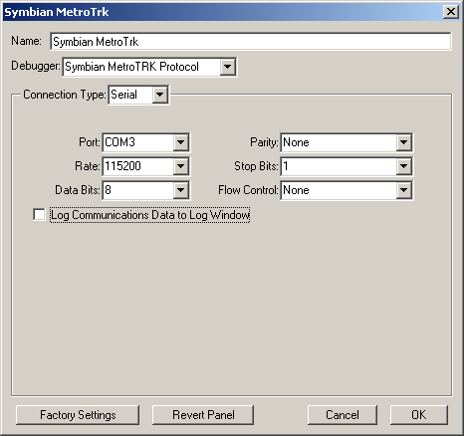
Figure 4.1 MetroTRK connection settings window
NOTE: See reference document [1] (CodeWarrior for Symbian OS) for details on setting or changing remote connections.

USB
On the target side, once TRK is launched, the connectivity option can be changed from Options → Settings. The available options are BT, USB and IR. For using USB, the user must choose USB and set the port number to 1. Port 1 is the default USB COM port on most of the devices. However, on some devices, the USB COM port might have to be set to 0.
On the host side, USB drivers must be installed for the phone, in order to create a virtual COM port. For example, with Nokia S60 phones, the latest version of PC suite should be installed. PC Suite includes USB cable drivers which install a virtual COM port. Furthermore, the COM port in the remote connection settings in CodeWarrior IDE must be changed to match the virtual COM port mapped by the USB drivers. See Section 4.1 for details on changing the port in CW.
To see the list of COM ports on the machine and learn which virtual COM port maps to the USB COM port, check Device Manager (Control Panel → Administrative Tools → Device Manager).
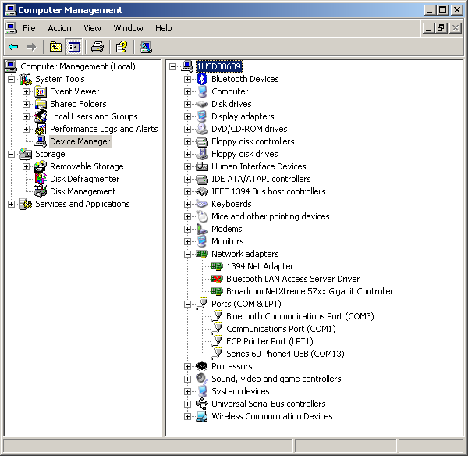
Figure 4.2 Port settings in Device Manager
With Nokia S60 phones and PC Suite, two virtual COM ports are usually installed, one under Modems and one under Ports. On some machines, both COM ports might appear under Modems. In order to find out the COM port number, go to Properties, select the Advanced tab and click on Advanced Port Settings to see the COM port number.
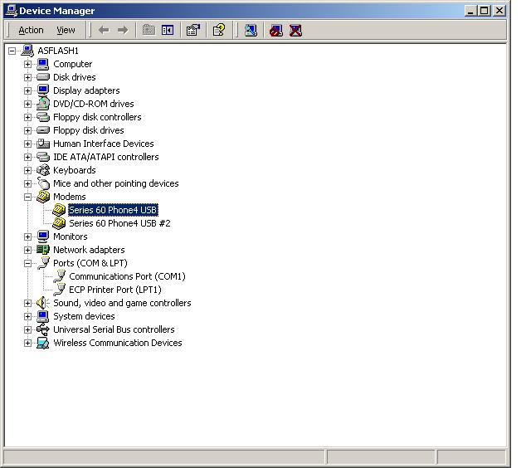
Figure 4.3 Modem settings in Device Manager
If the COM port is not visible under Modems or Ports, it is also possible to look for the list of COM ports in Registry.
Click Start → Run, type regedt32 and press OK to open Registry. In Registry, open the HKEY_LOCAL_MACHINE → HARDWARE → DEVICEMAP → SERIALCOMM item to see the list of COM ports. If more than one COM port is shown, both settings have to be checked to determine which one is used for debugging.

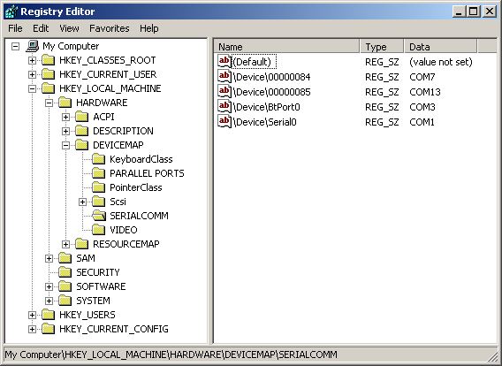
Figure 4.4 SERIALCOMM settings in Registry Editor

Using TRK from the CodeWarrior IDE
This section briefly describes how to use TRK with CW. More details on this can be found in reference document [1].
- Import the project into CW using the File → Import Project from .mmp file menu item. Choose the MMP file for the application or library that you want to debug.
- Choose the appropriate targets from the Target popup. For S60 3.0 devices, choose the ARMV5 UDEB target. Make sure that the project’s remote connection is set to use the TRK connection. This can be verified or changed in the Remote Debugging target settings panel. Select the Edit → (target type) Settings menu item, then select Remote Debugging.
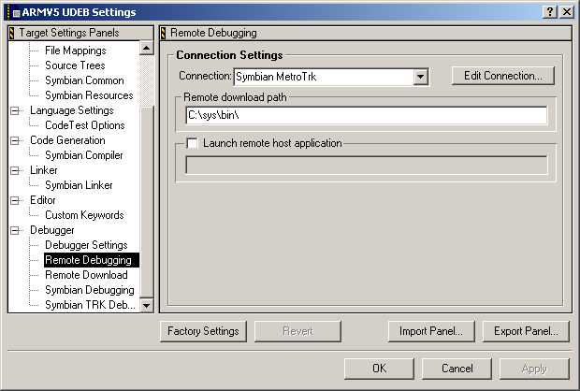
Figure 5.5 Remote Debugging settings panel in CodeWarrior
- To download and debug the application, specify the appropriate drive in the remote download path in the Remote Debugging panel in project settings. In Hello World example, it would be in C:\Sys\bin\.
- To debug the application or library that is included in the ROM image, specify z:\ as the drive with the full path. For example, if Hello World is included in the ROM image, the remote download path would be Z:\Sys\bin\.
- Any other libraries or resource files that need to be downloaded for the application to run can be specified in the Remote Download panel.
- If the RAM drive is specified, the binaries and the files specified in the Remote Download panel are downloaded.
- Once all the above settings are configured, press the debug button on the project window to start the debug session.

Known issues
The following are known issues using this release:
- Serial port emulation does not work with some of the BT dongles. Please check the manufacturer’s documentation before choosing the BT dongle for the support for Bluetooth serial port emulation.
- When using a USB connection with a Nokia S60 phone, the virtual COM port might be locked sometimes if PC Suite is installed. If the error note Unable to open the COM port is displayed in CodeWarrior, uncheck the USB check box in the PC Suite Connection Manager. In addition, make sure that the serial cable connection in the Connection Manager is not configured for the same COM port as the USB virtual COM port.

