1. Goto Settings->Network Connections->TAP-Win32 Adapter V8
2. Click right button on it. Select Properties
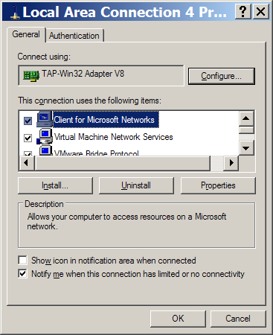

3. Select Internet Protocol (TCP/IP), Click Properties button
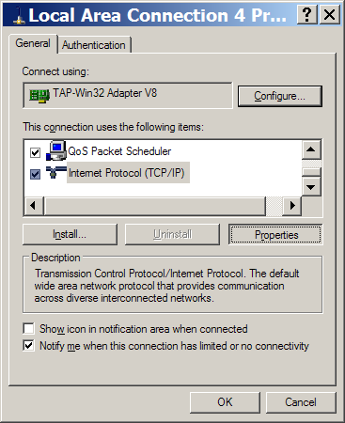

4. Check Use the following IP address, input 192.168.0.1 and 255.255.255.0
