Reference
Checked by:
Version 1.0
Date:
Orange User Emulator
Approved by:
Authors:
SANDEEP DAS Reshma
KISS Marcell
Date :
Date:
2009-08-19

Summary:

CONTENTS
Introduction 3
Introduction 3
1.1. Overview 3
1.2. Purpose 3
1.3. References 3
2. Architecture 4
2.1. High Level Architecture 4
2.2. Detailed Design 6
2.2.1. Application User Interface 6
2.2.2. Recorder Server 8
2.2.3. Recorder Client 9
3. Sequence Diagrams 10
3.1. Script Execution 10
3.2. Script Recording 11
3.3. RandomTest 12
4. Configuration 13
5. XML Script format 14
6. Command-line arguments 19
7. User Emulator Log File 19
8. Record of Document Changes 20
8.1. Document Responsible 20
8.2. Versioning history 20

Figure 1: User Emulator High Level Architecture 4
Figure 2: User Emulator Application User Interface 6
Figure 3: Recorder Server 8
Figure 4: Recorder Client 9
Figure 5: Sequence diagram for Script execution 10
Figure 6: Sequence diagram for script recording 11
Figure 8: Sequence diagram for Random test 12

Introduction

Overview
User Emulator is a tool for automated test creation, execution and management. The tool is very useful to automate functional and non-functional testing of applications. E.g. stress testing application usage over 24 hours. Regression testing, etc.
The user emulator tool programmatically simulates application UI usage as described in an XML script on the S60 device. This tool helps in writing, reusing and executing tests on the code under development.

Following are the features supported by the User Emulator tool:
- Up/down/left/right arrow key events
- Selection, LSK, RSK key events
- Menu key events
- Alpha-Numeric key events
- Launch application using UID/Name
- Loops in XML script
- Pointer/Touch events
- Take Screen shots
- Capture Panics
- Log to file
- Record and playback of Key/Pointer events
- Random Test
  - Random Test to stress all applications under S60 menu system
  - Random Test targeted to specific applications

Purpose
This document aims at describing the architecture and detailed design of the User Emulator tool

References

Architecture
This section explains the global software design of the application. A high level overview is given in the first subsection 2.1 describing the high level architecture of the User Emulator tool. Section 2.2 gives a detailed component view of the architecture.

High Level Architecture
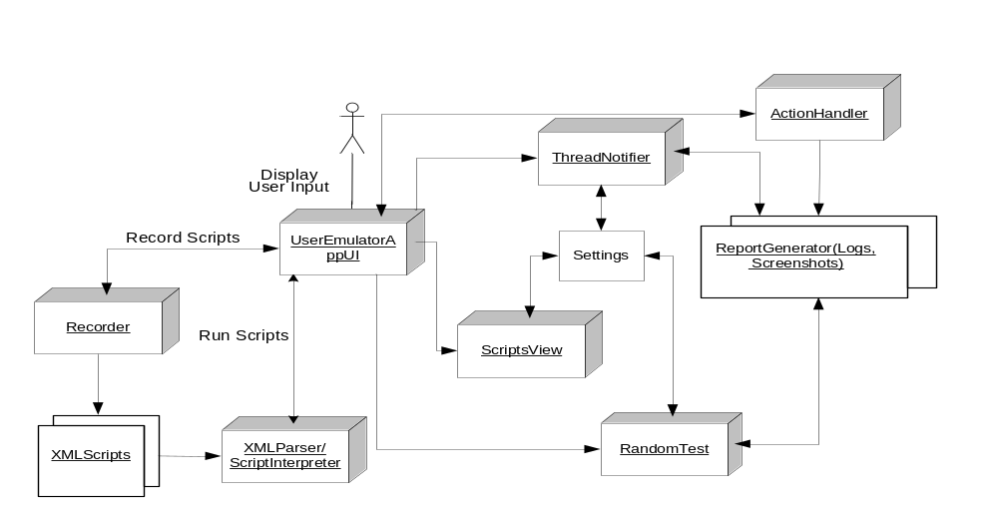
Figure 1: User Emulator High Level Architecture

Figure 1 shows a high level architecture of the User Emulator tool. A short description of each of the components is given below.

- UserEmulatorAppUI:
This class handles communication with the user. It handles inputs from the user and then displays information to the user. It interfaces with the settings dialog to set and retrieve configuration information.

- XML Scripts:
Test scripts are written or generated in an XML format which uses simple test verbs. The scripts serve as inputs to simulate key presses or screen taps on an S60 device.

- XML Parser/Script Interpreter:
The Script Parser parses the XML scripts and constructs an action object for each <action> tag in the script. The Parser fails if there are any XML parsing errors and notifies the Application UI using appropriate error codes.

- Action Handler:
The XML Parser/Script Interpreter passes the list of action objects to the Action Handler which performs or simulates the required actions. Currently the action handler supports the following actions:

- Launching applications
- Switching between application views
- Simulating key events
- Simulating pointer events
- Closing an application
- Pausing
- Taking Screenshots
- Recorder:
This class records scripts. It is a windows server plug-in class that listens for key presses or screen taps from the user and records them in an XML script. Recording can be stopped by pressing the power button once on the device and the recorder must notify the UserEmulatorAppUI when recording finishes.

- Scripts View:
The scripts view displays all of the scripts available in the path specified in the settings dialog. Scripts can be selected to run by choosing the Mark option in the options menu. This view interfaces with the settings dialog to get the necessary configuration information.
- Settings:
This class handles all configuration information for the UserEmulator.

- Report Generator/Logger:
This logs the user journey and any system-wide panics in a file which is stored in the default log directory specified in the settings dialog. It also stores screenshots requested by script execution and screenshots of any panics in the default log directory.

- RandomTest:
This class is responsible for carrying out random stress tests.

- Thread Notifier:
This class watches all the threads and gets notifications on any thread deaths. It uses the report generator to log the details and capture screenshots.

Menu options:
User Emulator tool has the following Menu options in the Scripts view.

- Run Scripts
Script execution can start by selecting the Run Scripts menu option. Script selection can be made by clicking on a script name. Single selection or multiple script selection option is available to the user. After the selection, file(s) are parsed using an XML parser and appropriate actions are performed. Visual indications of scripts execution pass/fail/cancellation are displayed using icons on the screen.

Green Icon: pass
Red Icon: Fail
Yellow Icon: Cancellation of script execution

Script run starts on idle screen after the Menu application and idle screen reset.

- Select
This option can be used for file selection and de-selection respectively. There is an option to select/de-select a single file or multiple files at the same time.

- Record input
This menu option allows users to start recording any key presses or screen taps. User has to enter a name for the recorded script. The file name cannot contain any special characters. An error message is displayed to the user and a dialog is prompted to enter correct filename. The file is stored in 'Scripts Path ' folder. Screenshot tag can be added dynamically in the script by pushing the camera button once during script recording. Recording can be cancelled any time by pressing the power button once.

- Random test run
Starts the Random test on the device and sends random key presses and screen taps to the device. Random test can be stopped by pressing the power button once.

- Settings
This menu option launches a settings dialog that has configuration information for the User Emulator tool. Detailed explanation of the Configuration settings is explained in section 4.

- System Info
Option that gives the complete system information like OS-Version, UI-Version, Machine ID,IMEI No, Family, CPU, CPUSpeed, Start-up reason, RAM, Free RAM and ROM available on the device.

- Help
Help file describing the User Emulator tool usage

- About
A brief about the tool

Detailed Design

Application User Interface
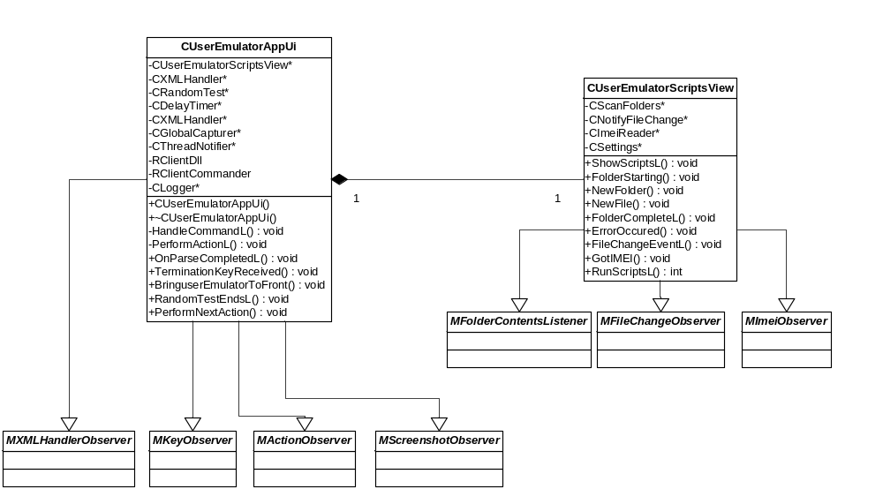
Figure 2: User Emulator Application User Interface
The above class diagram shows the design of the Application User Interface. UserEmulator AppUI is the main application class handling all the user interactions. This class is responsible for initialization of the windows server plug-in class for script recording. This class also creates and monitors the following active objects.
- CRandomTest: This is an active object implementation that manages test functionality in
Random mode or random test on focussed applications.
Random Test will stress all applications that are available through the menu system by rapidly sending keystrokes and screen taps in a random fashion. By sending a large number of user inputs very rapidly, Random Test can quickly isolate troublesome scenarios and find bugs in your applications.

- CXMLHandler: This is an active object implementation for XML parser.
- CGlobalCapturer: This is an active object implementation used for capturing keys on S60 devices.

- CDelayTimer: A simple timer active object that triggers the next actions to be performed in the XML scripts.

- CThreadNotifier: Active object implementation for capturing panics.

- MXMLHandlerObserver: AppUI class derives from this abstract class that notifies the UserEmulatorAppUI on parse completion using the OnParseCompletedL () API.

- MKeyObserver: This is an abstract interface that notifies UserEmulatorAppUi on cancellation of script execution or cancellation of Random test using the APIs TerminationKeyReceived()/RandomTestEndsL()

- MActionObserver: Notifies the UserEmulatorAPPUI class on timer expiry and allows to continue to perform/simulate next action in the action list using the API PerformActionL()

- MScreenshotObserver: Interface that notifies the UserEmulatorAPPUI class on completion of saving a screenshot using the API PerformNextActionL().
CUserEmulatorScriptsView class is a CCoeControl derived class and this class shows all the available XML scripts in the script path to the user. Scripts view creates and monitors the below active objects that help in scanning folders, getting IMEI information and notifying any file or folder changes for the specified scripts path

- CScanFolders: This is an active object implementation for folder scanning operation and notifies the scripts view of the folder scan operations using the APIs defined in the abstract class MFolderContentsListener

- CNotifyFileChange: Active object implementation for notification of any file addition, deletion or modifications in the specified folder path. And notifies the scripts view using the APIs defined in the abstract class MFileChangeObserver.

- CImeiReader: Active object implementation that helps to retrieve the device IMEI number and notifies this to the scripts view using the API defined in the abstract class MImeiObserver.

Recorder Server
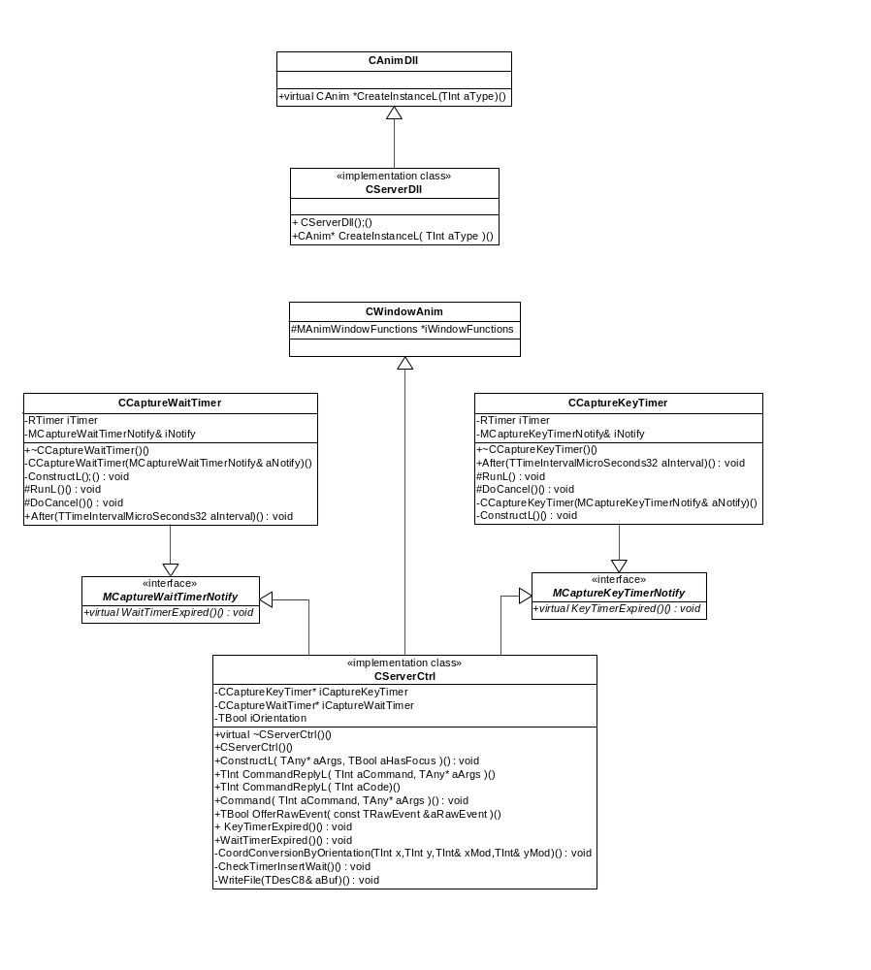
Figure 3: Recorder Server
- CAnimDll: Base class of CServerDll. Animation DLL factory interface
- CServerDll: Creates Window Server dll through CreateInstanceL function.

- CWindowAnim: Base class of CServerCtrl. This interface is provided to create animations other than sprites. A window animation can be provided by deriving from this class.
- MCaptureWaitTimerNotify: Interface which notifies CServerCtrl about time between two following events.
- CCaptureWaitTimer: Implements the timer function.
- MCaptureKeyTimerNotify: Interface which notifies CServerCtrl about time between key down and up event. (for simulation of long key presses)
- CCaptureKeyTimer: Implements the key timer function.
- CServerCtrl: Main working class. Implements script recording, communication to CGlobalCapturer and event handling through OfferRawEvent callback function.

Recorder Client

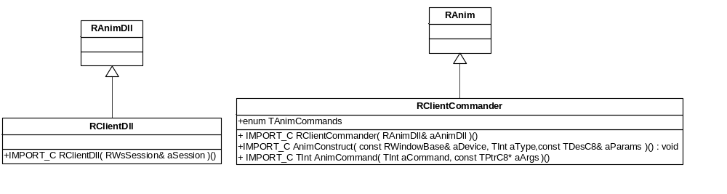
Figure 4: Recorder Client

- RAnimDll: Base class of RClientDll. Client-side interface to the server-side animation DLL.
- RClientDll: Window Server's client side object creation implementation through RAnimDll's function.

- RAnim: Base class of RClientCommander. This is a Client-side handle to a server-side animation class.
- RClientCommander: This class constructs a RAnim based class and implements communication to server side object.

Sequence Diagrams

Script Execution
Following section explains the sequence diagrams for different user operations such as script execution, recording a script and random test.
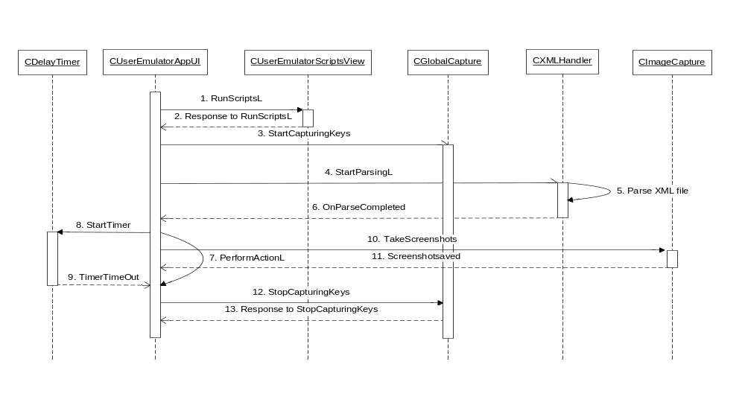
Figure 5: Sequence diagram for Script execution

The sequence of steps for the script execution is described below:
- User Emulator AppUI issues a RunScriptsL() command to the Scripts view on receiving user input to start scripts execution
- The response command indicates success or any other system wide error codes for the script execution
- User Emulator AppUI creates the CGlobalCapture active object and starts the Active object to capture the key events. The active object listens for the Power key events and notifies the User Emulator AppUI on any key event on the power key.
- User Emulator AppUI invokes the XML Handler to start parsing the XML scripts selected by the user.
- XML Handler starts the parsing of the scripts using the MContenHandler interface class and notifies the User Emulator AppUI on parse completion
- Response from XML Handler on parse completion. XML handler will populate the action lists with the set of actions defined in the XML scripts and notifies the User Emulator AppUI with OnParseCompleted callback. This is an indication to the User Emulator AppUI to start with the script execution.
- This is the main Action handler callback function which starts simulating all the actions described in the XML script.
- During the script execution, a self completing timer active object is started.
- On timeout, calls the PerformActionL () callback from User Emulator AppUI.
- If the user requires screenshots to be taken during script execution, User Emulator AppUI creates an instance of CImageCapture active object, which takes screenshots.
- Notification given to the User Emulator AppUI after saving the screenshots and to continue with the script execution.
- At the end of the script execution, User Emulator AppUI stops the CGlobalCapturer for capturing keys.
- Response to Stop key capture active object.

Script Recording
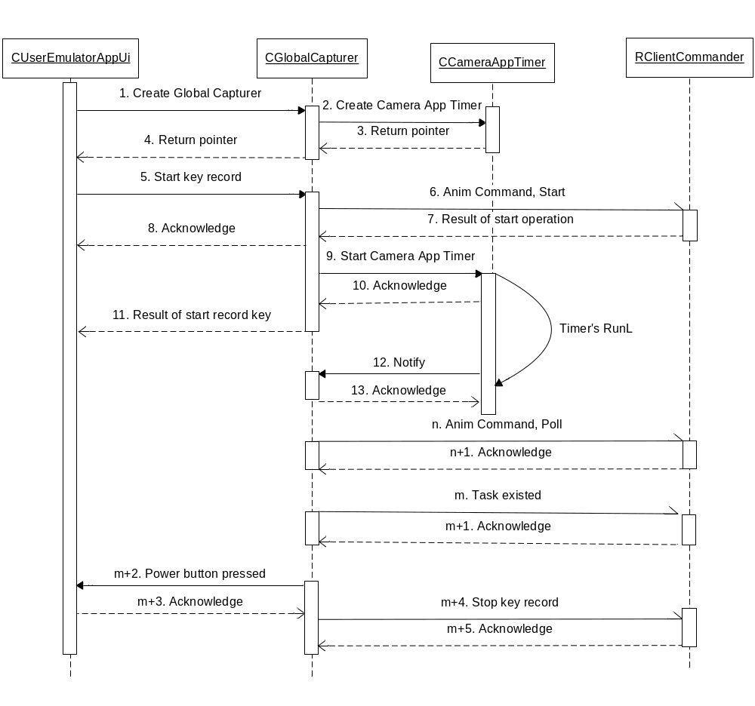
Figure 6: Sequence diagram for script recording
The sequence of steps for Script recording is described below:
- User Emulator AppUI creates Global capturer.
- CGlobalCapturer creates Camera App timer.
- Acknowledgement to Global Capturer.
- Acknowledgement to User Emulator App.
- Start key recording in Global Capturer.
- Global Capturer calls asynchronous 'Start' command on RClientCommander.
- Acknowledgement to Global Capturer.
- Acknowledgement to User Emulator AppUI.
- Start CCameraAppTimer.
- Acknowledgement to Global Capturer.
11. Result of start of key recording.
12. CCameraAppTimer notifies CGlobalCapturer every time when timer restarts.
13. Acknowledgement to CCameraAppTimer.
n. CGlobalCapturer sends a 'query' to RClientCommander if Camera Button was pressed.
n+1. GC notifies RClientCommander that camera app is closed.
m. Task existed. (And closed)
m+1. Acknowledgement.
m+2. Power button pressed (stop recording) event to UE App.
m+3. Acknowledgement.
m+4. Stop recording command to RClientCommander.
m+5. Acknowledgement.

RandomTest
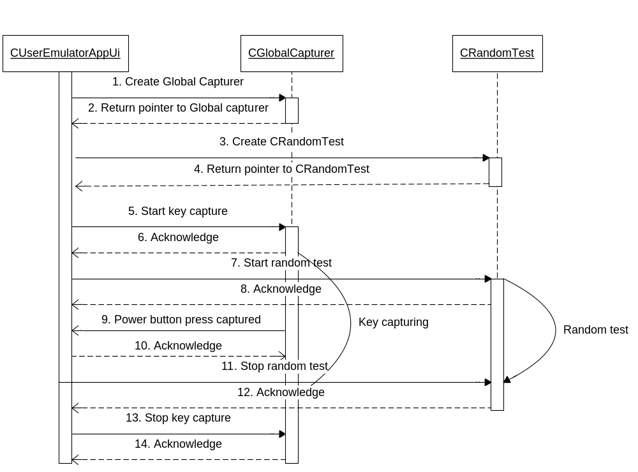
Figure 7: Sequence diagram for Random test
The sequence of steps for script recording is described below:
- User Emulator AppUI creates Global Capturer object.
- Pointer to Global Capturer object is returned.
- User Emulator AppUI creates Random Test object.
- Pointer to Random Test is returned.
- User Emulator AppUI issues request to Global Capturer to start key capturing.
- Acknowledge of the operation.
- User Emulator AppUI issues request to CRandomTest to start random test handler. Random test functionality executes continuously depending on the configuration to run on certain focussed applications or randomly on all the available applications under the S60 menu application.
- Acknowledge the operation.
- User Emulator AppUI is notified on the power key pressed event.
- Acknowledge the operation.
- On receiving the key event to stop random test, User Emulator AppUI stops random test by issuing a command to the CRandomTest class.
- Acknowledge the operation.
- Stops key capturing in Global capturer.
- Acknowledge the operation.

Configuration
User Emulator tool has the configuration settings stored in an application .ini file. These settings can be modified by the user by launching the settings dialog from the tool.

Following are the configuration options available to the user:

- Scripts Path:
This setting option indicates the path where the scripts are located on the device. User can modify the storage path of the test scripts.

- Log Status:
Logging option can be turned ON/OFF using this settings option.

- Log File Path:
Path for the log file that logs the script execution actions. This file also captures any system wide panics.
Note: User has to exit the tool in order to check the log files. Log files are overwritten every time the tool starts.

- Target for Random Test:
This settings option can be used to control the Random test functionality on applications. If the option is 'ON', it enables random tests to be performed on applications with UID specified in the App Id fields. If it is turned 'OFF', random tests are performed on all applications under Menu system in S60 device.

- App Ids of Random Test:
This settings option allows users to enter application UIDs of applications that needs to be stressed using the Random test.
(Example of IDs: 0x102f0452, 2365434542, 0xbb342c23)

XML Script format
This section describes the data format of the XML script that is generated during script recording operation from an S60 device.
The XML script has user actions (key inputs/ screen taps) recorded and can be used to simulate the same during script execution.

Each user action is written as an action element enclosed within the main tag having the following syntax:

Syntax:
<UserEmulator>
<action>
<name>. </name>
<type>. </type>
<params>. </params>
<keys>. </keys>
<screenshot> . </screenshot>
<print> . </print>
</action>
</UserEmulator>

Description of tags and elements

- <name>... </name>:
This is an optional tag which can be used to define the action. A meaningful name can be given to this tag to identify the action.

Syntax:
<name> <Application name> </name>

Example:
<name> Calculator </name>

- <type>... </type>:
This is a mandatory tag which should be defined to identify the type of action. User has to choose any one of the below mentioned values to identify the type of action.

Currently supported types of action:
- app (To launch an application)
- view (To switch the views)
- closeapp (To close any application)
- keypress (To simulate key press)
- wait (To pause for the specified duration in milliseconds)
- javaapp (To launch a java midlet)
- pointerevent (To simulate pointer events)
- orientation (Change device's screen orientation (portrait or landscape mode))
- screenreset (Resets menu screen and older version of Home Screen's idle screen )

Note:
The above types of action are case sensitive

Syntax:
<type> <action-type> </type>

Example:
<type> app </type>
<type> view </type>
<type> closeapp </type>

- <params>... </params>:
This tag should be used to pass parameters for carrying out specified action. This tag is mandatory if the <type> tag is set to any one of the following types:
"app, view, closeapp, wait, javaapp"

Syntax:
<params> <application specific params> </type>

Example:

In order to launch an application, currently the UID of the application has to be passed as the first parameter and the application name as the second parameter. Comma (',') is used as a delimiter between the parameters. The second parameter (application name) is a label which is required for logging purposes
<params> 0x10005902, Calculator </params> //Launches the calculator application

For closing an application, the UID of the application along with the application name (comma separated) to be closed should be passed.
<params> 0x10005902, Calculator </params> // Closes the calculator application

In order to switch views, application UID and view ID (comma separated) should be passed to the params tag
<params> 0x101f4cd5, 0x05 </params> // Activates Missed calls view

For wait operation, the time interval in milliseconds should be specified as follows:
<params> 100 </params> //Pause for 100 milliseconds

For launching a java midlet, midlet name should be specified in the params tag. Midlet name is case sensitive.
<params> Music Store </params> //Launches Music Store application

- <keys>… </keys>:
This tag should be used to pass any key events to the application. More than one key code can be specified in the <keys> tag. Space (" ") is used as a delimiter between the key codes. Following key codes can be passed as the key events in <keys> tag.

Key Codes Reference:
LSK = left soft key
RSK = right soft key
DAK = down arrow key
RAK = right arrow key
LAK = left arrow key
UAK = up arrow key
MSK = Middle soft key
SP = Space
BS = Backspace/clear
lt = Less Than
gt = Greater Than
amp = Ampersand
MENU = Menu
KYES = Green Key
KNO = Red Key

1 = Number 1
2 = Number 2
3 = Number 3
4 = Number 4
5 = Number 5
6 = Number 6
7 = Number 7
8 = Number 8
9 = Number 9

Alphabets:
a-z and A-Z

Special characters:
. ? @ , ' ! " - ( ) / : _ ; + % = [ ] { } \ ~ ^ | ` $

Syntax:
<keys> <key value > </type>

Example:
<keys> DAK <keys> // Press down arrow key

- Loop:
This tag should be used to specify any repetitive actions and should be defined using the tag
<loop count='2'> // begin loop
.
.
</loop> // end loop

In the above tag, 'count' indicates the number of times the set of actions has to be executed in a loop.

Syntax:
<loop count=<enter the count value for looping action>
.
.
</loop>

Example:

<loop count='5'>
<action>
<names> enter 1 </name>
<type> keypress </type>
<keys> 1 </keys>
</action>
</loop>

In the above example, key press 1 is sent to the application. This operation is carried out five times in a loop.

Note:
By specifying the count value as 'infinite', one can execute the operations in a loop infinitely.

Stopping Script Executions
Script execution can be interrupted by pressing the Power button on the device.

Example for launching a calculator application
<action>
<name> Calculator </name>
<type> app </type>
<params> 0x10005902, Calculator</params>
</action>

Example for switching views
Activates the Missed calls view

<action>
<name> Missed Calls </name>
<type> view </type>
<params> 0x101f4cd5, 0x05 </params>
<keys> MSK MSK </keys>
</action>

Example for closing a calculator application
<action>
<name> Calculator </name>
<type> closeapp </type>
<params> 0x10005902, calculator</params>
</action>

Example for keypress action
<action>
<type> keypress </type>
<keys> 1 2 </keys>
</action>

Example for wait/pause
<action>
<name> pause </name>
<type> wait </type>
<params> 4000 </params> //Time interval in milliseconds
</action>

Example for Loop action
<loop count='5'>
<action>
<name> enter 1 and 2 </name>
<type> keypress </type>
<keys> 1 2 </keys>
</action>
</loop>

Example for launching a java application
Launches the Music Store application

<action>
<name> Music Store </name>
<type> javaapp </type>
<params> Music Store </params> //Midlet name
</action>

- <print>…</print>:
This is an optional tag that can be added in the scripts to print any debug logs.

Example:
<action>
<name> Calculator </name>
<type> app </type>
<params> 0x10005902, calculator</params>
<print>Open calculator</print>
</action>

- <screenshot> … </screenshot>
User Emulator can take a screenshot of the action that has the <screenshot> tag. The image file is stored with the name specified in the <screenshot tag> under the <\Logs\script file name> directory specified in the settings dialog.
During script recording, this tag can be automatically added at any stage of recording, by just clicking on the camera button once. The name of the screenshot is added automatically and has the following format:
"app name in foreground"-"time stamp"

Example:
<screenshot> Menu-4563678 </screenshot>

- Pointer Events
User Emulator can simulate pointer events on the touch enabled devices. Following are the pointer events currently supported. The pointer events are added within the <params> tag.

pointerdownAt ,x, y: Simulates pointer down event.
x and y values are the co-ordinates of the pointer. (Start of a flick or tap, etc.)

pointerupAt, x,y: Simulates pointer up event.
x and y values are the co-ordinates of the pointer. (End of a flick or tap, etc.)

moveto x, y: Simulates pointer move event.
x and y values are the co-ordinates of the end of movement.

pointerdownAt, x, y, z: Simulates finger down event.
x and y values are the co-ordinates of the finger. Z is a threshold value. (Added to every co-ordinates)

pointerupAt, x,y,z: Simulates finger up event.
x and y values are the co-ordinates of the finger. Z is a threshold value. (Added to every co-ordinates)

moveto x, y,z: Simulates finger move event.
x and y values are the co-ordinates of the end of movement. Z is a threshold value. (Added to every co-ordinates)

Example:
<action>
<name> xxx </name>
<type> pointerevent </type>
<params> pointerdownAt,560,320,5 </params>
</action>

<action>
<name> xxx </name>
<type> pointerevent </type>
<params> moveTo, 520,310,5 </params>
</action>

<action>
<name> xxx </name>
<type> pointerevent </type>
<params> pointerupAt, 520,300,5 </params>
</action>

Note:
- Since on software level there is no difference between stylus, finger tap, thumb tap, etc. all types of pointer events have general pointer event names with a threshold value.
- In order to get the same results during script execution, all the screens on the device should be reset to its initial state before script recording and playback.
  - Currently the tool supports basic reset functionality of resetting the Menu application's scroll bar, closing any open applications on the device and resetting the idle screen.
  - If there are any changes to the application position in the Menu application or any changes on the HomeScreen, the script when played back may not produce the same results. This is a known limitation of the tool.

Command-line arguments
User Emulator can be started with command-line arguments from another application or from command prompt. Supported formats are the following:

- Without arguments at all.
- '/r' argument only. It starts random test.
- '/r' argument and UIDs (hex, dec.) with space delimiter.
Example: UserEmulator.exe /r 0x20005902 6754343234
- With xml scripts name. Delimiter is space character.
Example: UserEmulator.exe start.xml count.xml left.xml
(Script names can also be specified without the .xml extension!)

User Emulator Log File
User Emulator logs the system information such as OS-Version, UI-Version, Machine ID, IMEI No, Family, CPU, CPU Speed, Start-up reason, RAM, Free RAM and ROM available on the device at the beginning of the log file. The log file logs information on the Start/End/Cancellation of scripts and any debug logs entered by the user in the <print> tag in the XML scripts. It also logs any system wide panics on the S60 device.

Record of Document Changes

Document Responsible
For any comments on this document, please request the responsible below:
Reshma Sandeep Das | reshma.sandeepdas@orange-ftgroup.com
Marcell kiss | kiss.marcell@orange-ftgroup.com

Versioning history

Version | Date | § | Action | Description of change
0.1 | 03/07/2009 | All | C | Document creation
1.0 | 19/08/2009 | All | M | Updated with review comments

§ = Chapter(s) or paragraph(s) modified
Action = C : Creation, M : Modification, D : Deletion, A : Approbation

