How To: Execute TEF test cases on STF

D RD S60 A&F MM & Dev Tools | Matti T. Pulkkinen

Change history:

Version | Date | Status | Comments
1.1 | 12.3.2010 | Draft | Add 4. Use ATS3 for Automation Test.
1.0 | 1.12.2009 | Draft

Table of contents:
1. Introduction of TEF Test Module 4
2. Use STF to execute legacy TEF cases 5
2.1 User configuration 5
2.2 Execution using STF 6
2.2.1 Execution by UI 6
2.2.2 Execution by command 7
2.3 Use TestExecute2 to execute legacy TEF cases 7
2.4 Test Result 8
2.5 Test Report 9
3. Use ATS3 for Automation Test 10

Introduction of TEF Test Module
TEF, as one of ex-Symbian test tools, will be marked as deprecated and no longer be supported, gradually. TEF test functionalities have been migrated to STF. This provides alternative for testers to execute legacy TEF test cases under STF environment. Also testers could use ATS/STF framework to automatically run TEF testing on phones.
TEFTestModule.dll is a new STF test module to replace legacy Testexecute.exe. User could only add little configurations to start TEF tests on STF.
TEFTestModule is dedicated to process legacy TEF script / test cases and has merged all functionalities of legacy testexecute.exe. TEFTestModule is based on STF test module framework and could be load and executed by STIFUI / ConsoleUI / AtsInterface. So there are multiple ways to drive TEF case execution.

Use STF to execute legacy TEF cases
User could launch STF specifying both TEFTestModule and your TEF script file(s) to be executed. Very few configurations should be added for STF to load TEFTestModule and drive execution.

User configuration
- User doesn’t need to deploy TEF environment. TEF test cases can be built under STF environment now. Build and deploy your TEF cases firstly.
Note: Old version of TEF may conflict with TEFTestModule. If you have deployed TEF, please clean TEF environment and deploy STF environment.
- Modify c:\TestFramework\TestFramework.ini, add below content in TestFramwork.ini to use TEFTestModule and assign a .cfg file.
[New_Module]
ModuleName= TEFTestModule
TestCaseFile= c:\testframework\teftest.cfg
# StackSize=28672
# This item is optional, user can set the stack size of TEFTestModule. Default is 28672 (28k).
[End_Module]

Also you can change teftest.cfg’s file name to use another.
- Add teftest.cfg file as c:\testframework\teftest.cfg.
This is an example of teftest.cfg
[New_TEFTest]
Tcs=OFF
# Include, Exclude or OFF. This is used to specify the test cases in .tcs file to be included (Tcs=Include) or excluded (Tcs=Exclude) during execution. If OFF(Tcs=OFF), test will ignore tcs file and run all cases in script.

Debug=OFF
# ON or OFF. Used to put the system into debug mode. ON means that the PAUSE command pauses the script engine until the user hits a key.

SeparateLog=OFF
# ON or OFF. Used to specify that the test steps and the script engine must send their output to separate log files.

Pipe=OFF
# Used to output logs to pipe. OFF for not use pipe, or name a pipe as Pipe=YourPipeName.

Script= c:\xxx\yourscript1.script
TcsData= c:\xxx\yourtcs1.tcs
Script= c:\xxx\yourscript2.script
TcsData=
# Script=: Script file with path.
# TcsData=: Tcs file with path. TcsData could be cases or .tcs files, separated with “,”, for an example: “TcsData=TestCase001, TestCase002, YourTcsFile.tcs”. TcsData is useless while Tcs=OFF.
# If Tcs=Include or Tcs=Exclude, Script and TcsData should be in pairs. This means each “Script=” should comes with one “TcsData=”. You can leave 'TcsData=' with black if no tcs file used for its script.
# If Tcs=OFF, there could be only “Script=” without “TcsData=”.
[End_TEFTest]

Note: system\data\testexecute.ini is still used by TEFTestModule and user can customize TEFTestModule execution behaviors same as TEF.

Execution using STF

Execution by UI
You can use STF UI or ConsoleUI to execute legacy TEF test cases. This document will take STF UI as an example.
On STF, to execute legacy TEF test cases are as simple as normal STF cases. Start STF UI and browse into >>Test Cases >> Start Case(s). All scripts in teftest.cfg are listed as below. The TEF test scripts can be executed as normal STF cases.
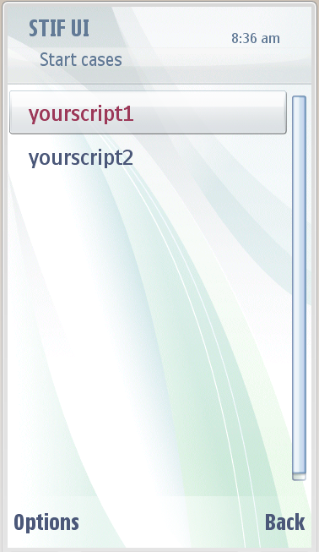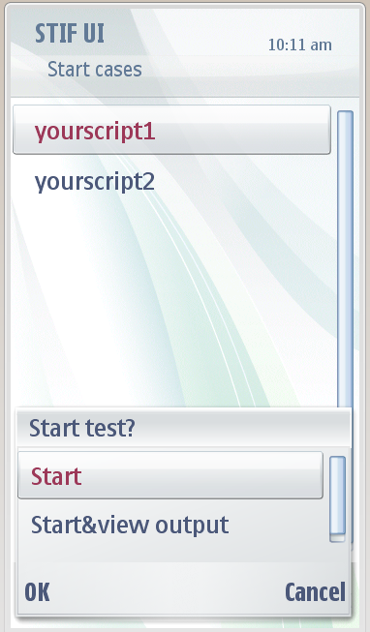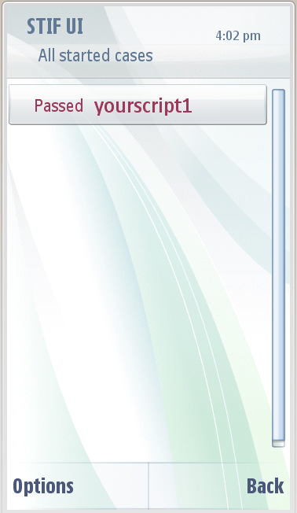

Notice: Case Granularity is different between STF and TEF cases.
In the case list, the granularity of STF is single case. Granularity of TEF is script. This means you can select TEF legacy script to execute but can not browse into cases.
Nested script is also supported. So you can use one script to execute all the other scripts.
ConsoleUI can be used the same way as STIFUI to load TEFTestModule and execute.

Execution by command
Also you can use command line to execute. The command line will be like:
STF -m teftestmodule -s c:\testframework\teftest.cfg
“-m teftestmodule” means using TEFTestModule to execute.
“-s c:\testframework\teftest.cfg” gives the .cfg file in which test script file is listed [see 2.1].

Use TestExecute2 to execute legacy TEF cases
TestExecute2.exe is a command-line interface to adapt legacy Testexecute.exe interface. User can use TestExecute2 the same way as Testexecute to start execution of legacy TEF cases.
The command line syntax of TestExecute2 is same as legacy Testexecute.exe as following format:
> testexecute2.exe <ScriptFilePath> [options]
where <ScriptFilePath> is the test script to execute.
The following options can be used:
Option | Description
-d | Used to put the system into debug mode. This means that the PAUSE command pauses the script engine until the user hits a key.  This option can appear anywhere after the <ScriptFilePath> argument.
-slf | Used to specify that the test steps and the script engine must send their output to separate log files.  This option can appear anywhere after the <ScriptFilePath> argument.
-tci | -tcx | Used to specify the test cases to be included (-tci) or excluded (-tcx) during execution. The option (-tci or -tcx) is followed by a list of test case IDs to be included or excluded. You can specify the test case IDs in three different ways as follows:  A list of comma-separated test case IDs  A range of test case IDs  A .tcs file containing the test case IDs delimited by a new-line character.  You can specify the test case IDs using all the three different ways listed above. For example, in the following TestExecute2 command, the test cases list is a combination of comma-separated test case IDs, test case ID range and a .tcs file containing IDs of the test cases to be included during execution:  > testexecute2 c:\tefintegrationtest\TEFIntegrationTest-regular.script -tci TEST-001,TEST-002,TEST-008:TEST-015,some.tcs
-help | Displays help content in the console window describing the usage of the TestExecute2 for executing script files. It is used without the <ScriptFilePath> argument.
-v | Displays the version number of TestExecute2 being used. It is used without the <ScriptFilePath> argument.

Test Result
On STF, normally the results of TEF scripts are marked as pass. If panic happens during test and causes memory leak, result of script will be fail. The detail result will not be showed on STIF UI. So the STIF UI result may not represent true status of your test cases (i.e. negative case may expect a panic). You could ignore the STIF UI result and check the detail log which is generated at the same directory of legacy TEF, under c:\ logs\testexecute (or other direction as your configuration in testexecute.ini). Test log structure is the same as legacy TEF.
STF related log will be found under c:\logs\TestFramework. For an example:
Test Server’s log is under c:\logs\TestFramework\testserver
TEF Test Module’s log is under c:\logs\TestFramework\logs\testframework\TEFTestModule
Be noticed that the directory of STF logs could be changed depends on the configuration in testframwork.ini.

Test Report
After execution, all test logs are generated exactly the same as legacy TEF. For user convenience, an additional test report will be generated base on XML format. The structure of this test report is the same as STF test report and will be generated at c:\logs\testexecute\<YourTestScriptName>[TestReport].xml.

Use ATS3 for Automation Test
ATS3 is a good tool for automation build and test. Also it’s an ideal tool to replace Testdriver. Now as a component of STF, TEFTestModule naturally has the ability to execute tests via ATS3.
To use ATS3, user needs to provide ATSDrop package as a zip file. This file will be uploaded to ATS server and executed following the description of test.xml which is included in this ATSDrop. For more information of how to use ATS3 and package ATSDrop, please refer to the wiki page of ATS3: http://wikis.in.nokia.com/SPBrowsing/ATS3_Boston_Browser
Here you have an example of test.xml. This test.xml is a simple implementation of automation test steps executed by ATS3. Basically It includes installation of test related files, driven test execution and then retrieve log files.
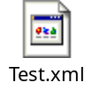
In this test.xml, there are some steps you should be noticed.
<step id="0.1.1.1.1.1" name="Test Step 1 (install)" harness="STF" enabled="true" passrate="100" significant="false">
<command>install</command>
<params>
<param src="armv5_urel\YourTestServer1.exe"/>
<param dst="c:\sys\bin\YourTestServer1.exe"/>
<param component-path="ATS3Drop"/>
</params>
</step>
Test step 1 to test step 5, by command “install”, these test steps will install any specified test related files into devices. “param src=” is the file’s relative path stored in the .zip file of your test drop. “param dst=” is the file’s destination directory of the device.

<step id="0.1.1.1.1.6" name="Test Step 6 (run-cases)" harness="STF" enabled="true" passrate="100" significant="true">
<command>run-cases</command>
<params>
<param module="TEFTESTMODULE"/>
<param testcase-file="c:\testframework\teftest.cfg"/>
<param filter="*"/>
<param timeout="600"/>
<param component-path="ATS3Drop"/>
</params>
</step>
Test step 6 will start test execution by command “run-cases”.
<param module="TEFTESTMODULE"/> names the test module been used. For TEF test module, this must be TEFTESTMODULE.
<param testcase-file="c:\testframework\teftest.cfg"/> gives the absolute directory of teftest.cfg file which needed by TEF Test Module.

<step id="0.1.1.1.1.7" name="Test Step 7 (retrieve-logs)" harness="STF" enabled="true" passrate="100" significant="true">
<command>fetch-log</command>
<params>
<param type="text"/>
<param delete="true"/>
<param path="c:\logs\testexecute\*"/>
</params>
</step>
Test step 7 will retrieve test logs by command “fetch-log”.
<param type="text"/> means to retrieve files as text format (not binary).
<param delete="true"/> means to delete files from device side.
<param path="c:\logs\testexecute\*"/> gives the absolute directory of the log files. Here be noticed that ATS3 will retrieve all files in this repository, but ATS3 does not support recursion. Files in the sub-folder(s) will not be retrieved. If logs are stored in different directories, multiple test steps should be created to retrieve the files.
When tests finished, retrieved log files could be downloaded from the web page of ATS3 as the screenshot shows.
