STF User’s Guide

D RD S60 A&F MM & Dev Tools | Matti T. Pulkkinen

Change history:

Version | Date | Status | Comments
0.1 | 2/22/2010 | First draft version | First draft version for system test.
0.2 | 3/4/2010 | First candidate version | First candidate release of this guide.

Table of contents:

1. Document Control 9
1.1 Documentation Conventions 9
1.2 Abbreviations 9
1.3 Definitions 9
2. Introduction 11
3. What is STF? 12
3.1 STF Architecture Overview 12
3.2 Interface Layer 14
3.2.1 STF Command Line Interface (CLI) 14
3.2.2 STF QT UI 15
3.2.3 Console UI 16
3.2.4 Touch Console UI 17
3.2.5 UI Engine 18
3.3 Engine Layer 18
3.3.1 Test Engine 18
3.4 Testing Layer 19
3.4.1 Test Server 20
3.4.2 Test Module 20
3.4.2.1 Hardcoded Test Module 20
3.4.2.2 Test Scripter Test Module 21
3.4.3 STF Parser 22
3.4.4 STF Logger 22
3.4.4.1 C/S-Style Based Logger 22
3.4.4.2 Logger Macros 22
3.4.5 STF Event System 23
3.5 STF Features 23
4. Getting STF to Work 24
4.1 STF Support 24
4.1.1 STF Wiki Page 24
4.1.2 Support 24
4.2 STF Binaries Deployment 24
4.2.1 How to Deploy 24
4.3 Building STF from Source 24
4.3.1 Emulator Builds 24
4.3.2 Hardware Builds 25
4.4 Configuring STF via the STF Initialization File 25
4.4.1 Configuring Test Report Settings 28
4.4.2 Configuring Test Module Settings 29
4.4.3 Configuring Logging Settings 29
4.4.4 Configuring Filters 30
5. Using STF for Test Cases Execution 31
5.1 Working with STF CLI 31
5.2 Working with STF QT UI 33
5.2.1 Setting up STF QT UI 33
5.2.1.1 Required Environment 33
5.2.1.2 Build STF QT UI 33
5.2.2 UI Introduction 34
5.2.3 Using Output Panel 36
5.2.4 Load Customized Engine Initialization File 37
5.2.5 Get Log of STF QT UI 38
5.3 Working with Console UI 38
5.3.1 Startup Parameters 38
5.3.2 Starting Console UI 39
5.3.3 Menu Navigation 39
5.3.4 Loading a Test Module 40
5.3.5 Starting a Test Case 40
5.3.6 Lists of Started Test Cases 40
5.3.7 Aborting, Suspending and Resuming a Test Case 40
5.3.8 Viewing the Test Case Output 40
5.3.9 Test Sets 40
6. Using STF for Test Cases Implementation 41
6.1 Test Module API 42
6.1.1 InitL 42
6.1.2 GetTestCasesL 42
6.1.3 RunTestCaseL 42
6.1.4 OOMTestQueryL 42
6.1.5 OOMTestInitializeL 42
6.1.6 OOMHandleWarningL 42
6.1.7 OOMTestFinalizeL 43
6.1.8 SendTestModuleVersion 43
6.2 Test Module API Features 43
6.2.1 Printf 43
6.2.2 SetExitReason 43
6.2.3 SetBehavior 44
6.2.4 StopExecution 44
6.2.5 GetTestCaseTitleL 44
6.3 Creating Test Module Templates 45
6.4 Implementing Test Cases for a Hardcoded Test Module 47
6.5 Implementing Test Cases for a Test Scripter Test Module 47
6.6 Using STF_ASSERT Macros 47
7. Using STF Parser for Test Data Parsing 50
7.1 STF Parser API 50
7.1.1 CStifParser 51
7.1.2 CStifSectionParser 54
7.1.3 CStifItemParser 58
8. Using STF Logger for Logging Purposes 66
8.1 STF Logger Server 66
8.1.1 RSTFLogger 66
8.1.2 Logger Macros 73
8.2 STF Logger API - Legacy 76
8.2.1 CStifLogger API 76
9. Using Test Scripter for Creating Scripted Test Cases 78
9.1 Test Script File 79
9.2 Setup 80
9.3 Creating a Test Class 81
9.4 Kernel Testing 81
9.5 Vocabulary 82
9.5.1 General 82
9.5.1.1 title 82
9.5.1.2 timeout 82
9.5.1.3 priority 83
9.5.1.4 print 83
9.5.1.5 setresultdescription 83
9.5.1.6 canceliferror 83
9.5.2 Test Case Control 84
9.5.2.1 create 84
9.5.2.2 createkernel 84
9.5.2.3 delete 84
9.5.2.4 allownextresult 85
9.5.2.5 expectedpanic 85
9.5.2.6 allowerrorcodes 85
9.5.2.7 waittestclass 86
9.5.2.8 pause 86
9.5.2.9 loop 86
9.5.2.10 endloop 87
9.5.2.11 Object Name 87
9.5.2.12 oomignorefailure 87
9.5.2.13 oomheapfailnext 88
9.5.2.14 oomheapsetfail 88
9.5.2.15 oomheaptonormal 88
9.5.2.16 testinterference 89
9.5.2.17 measurement 90
9.5.2.18 var 91
9.5.2.19 callsub 91
9.5.2.20 run 92
9.5.2.21 cancel 93
9.5.2.22 pausetest 93
9.5.2.23 resume 93
9.5.2.24 complete 94
9.5.3 Event Control 94
9.5.3.1 request 94
9.5.3.2 wait 94
9.5.3.3 release 95
9.5.3.4 set 95
9.5.3.5 unset 95
9.5.4 Shared Data 96
9.5.4.1 createshareobj 96
9.5.4.2 restoreshareobj 96
9.5.4.3 deleteshareobj 96
9.5.5 Remote Test Case Control 97
9.5.5.1 allocate 98
9.5.5.2 free 99
9.5.5.3 remote 99
9.5.6 Customerized Library Plug-in 99
9.5.6.1 using 100
9.5.7 Data Binding 100
9.5.7.1 Specify the Data Source 100
9.5.7.2 Specify the Bound Data 100
9.5.8 UI Testing 102
9.5.8.1 bringtoforeground 102
9.5.8.2 sendtobackground 102
9.5.8.3 presskey 102
9.5.8.4 typetext 103
9.5.8.5 sendpointerevent 104
10. Using STF Event System for Test Cases Synchronization 105
10.1 Event Interface for the Test Modules 105
10.1.1 State Events 105
10.1.2 Indication Events 106
10.2 STF Event System Usage 106
11. Using Test Combiner for Combining Test Cases 108
11.1 Test Combiner Test Case File 108
11.2 Setup 109
11.3 Vocabulary 109
11.3.1 General 109
11.3.1.1 title 109
11.3.1.2 timeout 109
11.3.1.3 priority 109
11.3.1.4 print 110
11.3.1.5 canceliferror 110
11.3.1.6 pausecombiner 110
11.3.2 Test Case Control 110
11.3.2.1 run 110
11.3.2.2 cancel 111
11.3.2.3 pause 112
11.3.2.4 resume 112
11.3.2.5 complete 112
11.3.2.6 testmeasurement 112
11.3.2.7 loop 113
11.3.2.8 endloop 114
11.3.3 STF Event Control 114
11.3.3.1 request 114
11.3.3.2 wait 114
11.3.3.3 release 115
11.3.3.4 set 115
11.3.3.5 unset 115
11.3.4 Remote Test Case Control 116
11.3.4.1 allocate 117
11.3.4.2 free 118
11.3.4.3 remote 118
12. Execute TEF Test Cases on STF 119
13. Migration from TEF to STF 120
14. Other Features 121
14.1 Platform Security 121
14.1.1 Caps Modifier Module 121
14.1.2 Architecture 121
14.1.2.1 STF architecture without Platform Security 121
14.1.2.2 STF Architecture with Platform Security 122
14.1.3 Setting up the Caps Modifier Module 123
14.1.3.1 Caps Modifier Module Creation 123
14.1.3.2 Configuration 125
14.1.3.3 Starting Testing 125
14.2 Boot during a Test Case 125
14.2.1 Boot Related Methods 126
14.2.1.1 StoreState 126
14.2.1.2 Reboot 126
14.2.1.3 GetStoredState 126
14.2.2 Example 127
14.2.3 StifHWResetStub Reset Module 128
14.2.3.1 Introduction 128
14.2.3.2 Setting up 129
14.2.4 Macros 129
14.2.5 TL 130
14.2.6 T1L 130
14.2.7 T2L 130
14.2.8 T3L 130
14.2.9 T4L 131
14.2.10 T5L 131
14.2.11 TAL, TA1L, TA2L, TA3L, TA4L and TA5L 131
14.2.12 More Macro Use Cases 131
14.3 Heap and Stack Configuring 131
14.3.1 Test Module 131
14.3.2 Test Class 132
14.3.3 Using Doxygen for Test Module Documentation 132
14.4 OOM Test Support 133
14.4.1 Test Module 133
14.4.2 Test Class 135
14.4.3 Test Interference Support 135
14.4.4 Overview 135
14.4.5 TestModule 138
14.4.6 TestClass 140
14.4.7 Test Interference Examples 140
14.5 Test Measurement Support 141
14.5.1 Overview 141
14.5.2 TestModule 142
14.5.3 TestClass 145
14.5.4 TestCombiner 145
14.5.5 StifTestMeasurementStub measurement module 145
14.5.5.1 Introduction 145
14.5.5.2 Setting up 145
14.6 Customerized Library Plug-in 145
14.7 UI Testing Support 146
14.7.1 STF configuration 146
14.7.2 Test Case Implementation 147
15. Troubleshooting 149
15.1 How to enable logging? 149
15.2 Cannot start STF Console UI from File Manager 149
15.3 STF Console UI does not start 149
15.4 Test cases are not shown 149
15.5 Why aren’t events received in master-slave testing? 150
15.6 What maybe the reason for test case crash with kill code 12? 150
Appendix: Test module’s heap and stack 151

Document Control

Documentation Conventions
Code is written with the Courier New font.

Abbreviations
DLL | Dynamic Link Library
GUI | Graphical User Interface

Definitions
Caps Modifier Module | STIF related module that handles Platform Security’s Capabilities.
CTestModuleBase | Interface, which the test module has to implement.
CTestModuleIf | Interface from the test module to the STIF functionality.
Demo module | An example test module that has all test cases implemented inside a test module.
INI file, Initialization file | The initialization file is used to specify the initial parameters for the test module. It is not necessary for the test module to have an initialization file.  STIF has its own initialization file.
Interference module | Module, which changes the environment where a test case is executed, for example, by eating up all memory.
Measurement module | Module, which provides additional information about test case execution, for example, test case memory consumption.
Model-View-Controller | A design pattern that provides the ability to vary different software components separately. The MVC paradigm divides the application into thee modules: Model, View and Controller.
OOM | Out Of Memory. A situation where no free memory is available.
Polymorphic DLL | A mechanism to allow dynamically loaded DLLs to implement and extend the common interface.
Console UI | The Console application of STIF.
STF Logger | A module of STIF that offers logging services.
STF Parser | A utility, which extracts information from text files.
STF | Symbian Test Framework, the name of the developed test tool.
TEF | Test Execution Framework, a legacy tool used in Symbian OS platform.
Test Case | A unique test, which either passes or fails.
Test Case File ( Configuration file) | Typically, test cases are specified in a test case file. Using a separate test case file allows the modification of the test cases without modifying the software module that does the actual testing.  Previously the test case file was known as the (test case) configuration file.
Test Engine | A module of STIF.
Test module | Contains test cases. A test module type can be, for example, hard-coded.
Test Module Template Wizard | A tool of STF for automatically creating a test module template. For example, test class for Test Scripter.
Test Scripter | A program of STIF for executing test cases from a test case file.
Test Server | Test Server is a wrapper around a test module.
Test Set | A collection of test cases, currently this is implemented in STIF Console UI.
UI Engine | UI Engine implements functionality that is common for different types of UIs.
WINSCW | The emulator (build with Metrowerks CodeWarrior IDE, which runs in a single process environment.

Introduction
This document describes how to use STF.
Chapter 3 describes what STF is and how its program modules are placed in the STF architecture.
Chapter 4 describes ways to get STF tool: deploy through STF binaries or build from STF source. It then describes how to configure STF to make it funct correctly.
Chapter 5 describes how to use STF for executing test cases.
Chapter 6 describes how to use STF for test case implementation.
Chapter 7 describes usage of STF Parser.
Chapter 8 describes usage of STF Logger.
Chapter 9 describes usage of Test Scripter.
Chapter 10 describes usage of Event System.
Chapter 11 describes usage of Test Combiner.
Chapter 12 provides quick reference of how to execute TEF test cases on STF.
Chapter 13 provides quick reference of how migrate from TEF to STF.
Chapter 14 describes other STF features such as how to work with Platform Security’s Capability feature, how to make a boot in a test case, and how to configure heap and stack sizes for a test thread.
Chapter 15 answers typical questions regarding the usage of STF.

What is STF?
This chapter describes what STF is and what program modules that STF consists of.
STF is a test harness for testing Symbian non-UI components. This widely used test tool can be used for both test case implementation and test cases execution.
STF separates the actual test cases from the test case execution environment. It provides different user interfaces and a common reporting mechanism, and allows executing test cases simultaneously. This test tool contains three layers: user interfaces on the interface layer, Test Engine on the engine layer and the test modules and utility classes on the test layer.
The UI can be either a console UI which runs in plain-text display mode or a QT based UI. Through visible operation menus and action buttons, both of them can be used to start and monitor test case execution.
Test Engine is responsible for loading test modules and for executing the test cases.
Test cases are collected to separate modules, known as test modules, which are easy to implement.
STF is not an automatic test case creator but allows for concentrating on the actual test case implementation.

STF Architecture Overview
STF is composed of a collection of modules, which aims at making testing easier and more efficient. The architecture is divided into three main layers: the interface layer, the engine layer and the test layer. The arrows show the direction of the data flow. Components outside STF are drawn with a dashed line. The figure does not contain detailed information for each module; for example, the utility classes used for logging and parsing the test case files are not shown.
Figure 3.1 shows the overview of the STF architecture.

TESTER
INTERFACE LAYER
STF CLI
STF Console UI
Touch Console UI
STFQT UI
UI Engine
Test Framework Initialization File
Test Engine
Test Report
Test Engine Log
ENGINE LAYER
TEST LAYER
TEST SERVER

TEST MODULE
LOG FILES
TEST CASE FILES
COMPONENTS UNDER TEST
(E.G. NETWORKING)

Figure 3.1 STF architecture
The architecture of STF is modular. These main modules are listed in Table 3.1. The interface between the modules is either a client-server interface or a function call interface. There are no cyclic dependencies between the modules. The user interface modules use UI Engine and Test Engine, Test Engine uses Test Server(s) and Test Server uses some test module.

Module | Type | Multiplicity | Implementation
User Interface | Executable | One | EXE
UI Engine | Server | One | DLL
Test Engine | Server | One | DLL and EXE
Test Server | Server | Several instances | EXE or DLL
Test Modules | Polymorphic DLL | Several separate DLLs and several instances | DLLs
Table 3.1 Modules
The STF modules on the interface layer are described in Section 3.2. The Test Engine module on the engine layer is described in Section 3.3 and the STF modules on the test layer are described in Section 3.4.

Interface Layer
Four interfaces are supported in STF:
- STF Command Line Interface (STF CLI)
- STFQT UI (requires separate QT based STFQT UI project)
- Console UI
- Touch ConsoleUI

The UI is used to start the test case execution. The UI can also show information about the test case progress to the user.
The interface modules use the R classes, provided by Test Engine and UI Engine, to access the engine functionality. There exists several asynchronous functions in Test Engine, and therefore the user interface has to handle several ongoing asynchronous requests. A typical implementation contains an active object for each ongoing request.
All above listed four interfaces are used to manually start the test case execution through similar user operation experience. STF CLI is a one line command line interface without any user interactive after issueing the command with specified options. The three other tools are interactive UI which need user’s step-by-step manipulation using input control such as keyboard or physical touching on UI widget.

STF Command Line Interface (CLI)
STF CLI (binary name: stf.exe) is the simplest and fastest way to execute STF test modules and test cases. As a console based application, it allows user to specify various of STF configuration by option values then execute it once, without any further interaction. All specified cases are executed and general command execution result showed in the output stream. More details about STF CLI options please see section 5.1.
Below features supported in STF CLI:
- Execute all test cases in a test module.
- Execute one or more cases in a given module.
- Execute case(s) in given script file.
- Specify non-default test engine initialization file (testframework.ini) used in execution. Besides, user could directly specify framework setting item(s) through options.
- Specify test module initialization file.
A screenshot of the STF CLI execution can be seen in Figure 3.2.

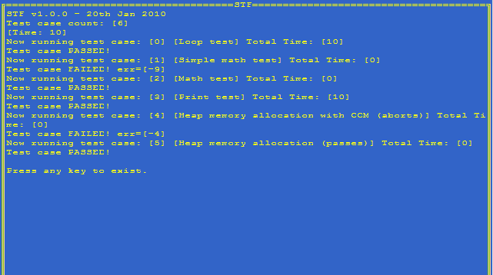
Figure 3.2 STF CLI Execution

STF QT UI
STF QT UI (binary name: stfqtui.exe) is new introduced UI system for STF modules/cases execution. It is a GUI application which is written based on QT technology. User can use it to select test modules, test cases and test sets to execute them. In or after execution of test cases, user can see directly, from the same screen, the result information and statistics. More details about usage can be seen at 5.2.
To use STF QT UI, the S60 SDK or hardware device need QT 4.6 or higher version installed.
Below features supported in STF QT UI:
- List test modules and test sets and cases included.
- Execute test cases sequentially or parallel.
- Pause, resume or abort the running cases.
- Store selected cases information into test set which can be used for later execution.
- Delete a test set (to be supported in future).
- View the test output.
- View the test statistic data of running and executed cases.
A screenshot of the STFQT UI interface can be seen in Figure 3.3.

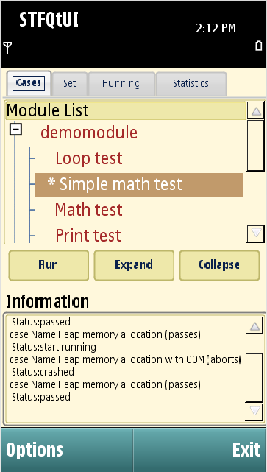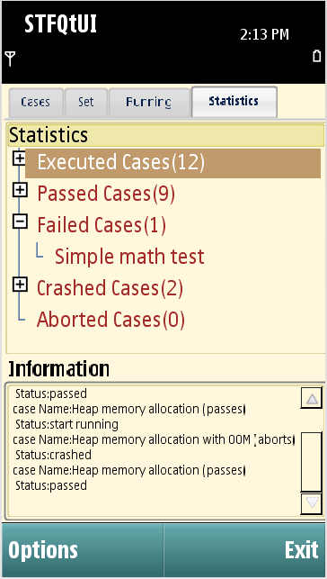
Figure 3.3 STF QT UI Interface

Console UI
Console UI is a menu-based console application, which can be used to manually execute test cases from the Symbian OS text shell in software development phase. The module under development can be tested on target before the actual UI is usable. Some screenshots of Console UI can be seen in Figure 3.4.
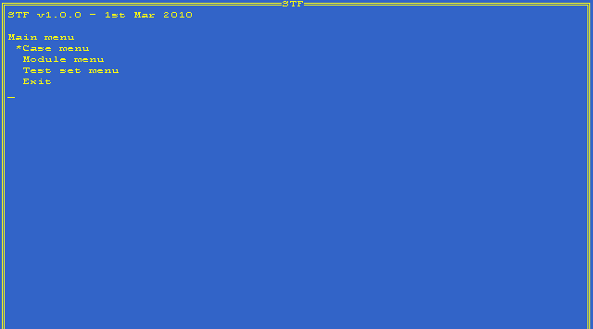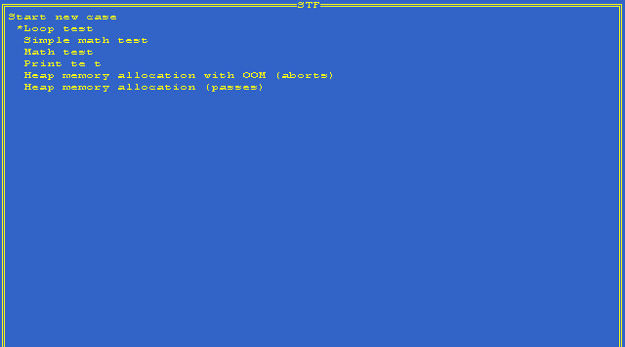
Figure 3.4 Console UI screenshots

Touch Console UI
Touch Console UI is a component that allows user to conduct interactive action by using touch screen for navigation. See below Figure 3.5, sensitive areas are marked. Touching those areas are mapped on hardware keyboard direction keys.
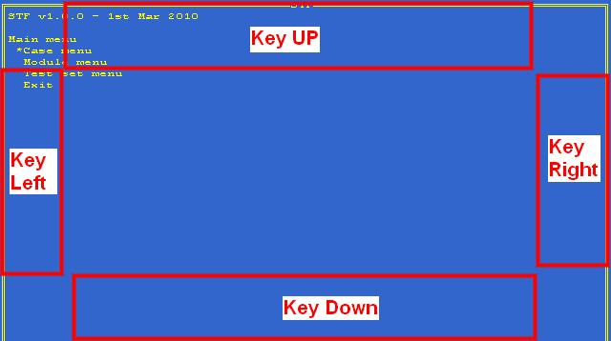
Figure 3.5 Touch Console UI screenshots
Touch Console UI has same interface layout (menu, information, display etc.) and actions as Console UI, only except the touchable interactive way. To understand the menus and actions, please see Section 3.2.3.
Note 1: Touch Console UI should be used only with environments that do not support S60 graphical user interface.
Note 2: Touch Console UI is not compiled in to STF by default. To add Touch Console user needs to perform following steps:
- Compile Touch Console UI manually using proper target. bld.inf file for Touch Console UI is available in STF\stfui\touchconsoleui\group directory
- Uncomment “file=ABI_DIR\BUILD_DIR\touchconsoleui.exe SHARED_LIB_DIR\touchconsoleui.exe“ statement in STF\rom\Stif.iby file.
Note: “Stif.iby” file name used here, while not “stf.iby”. For some technique reasons related to Symbian OS environment, we’d keep using this legacy file name ever used in STIF.

UI Engine
UI Engine implements UI functionality that is common for different types of UIs, for example monitoring test cases, updating result lists, etc. UI Engine uses Test Engine to execute these tasks. It is designed using the Model-View-Controller design pattern, so that all the logical parts of the UI are implemented there.

Engine Layer
Test Engine is the main module of STF. It is responsible for loading test modules and for executing the test cases.

Test Engine
Test Engine provides an API for UI Engine and UIs for executing test cases and loading the test modules. Test Engine can load several test modules and execute different test cases from separate test modules at the same time. Test Engine is composed of a Symbian OS server and a client. To the interface module, Test Engine is a server, which gets requests from the user via the UI, and then Test Engine forwards these requests to the corresponding Test Server.
Test Engine is a module that manages the test case execution. The engine is a Symbian OS server, which has both sessions and sub-sessions. Test Engine runs in its own thread. Test Engine is also a client to Test Server(s) and it can be a client to several Test Servers at the same time. This happens when there are several test modules loaded at the same time.
Test Engine sessions are used to control the engine level functionality, such as loading new test modules or querying the available test cases. Separate test cases are started from separate sub sessions. When the UI wants to start executing a test case, it creates a new sub-session to Test Engine. Test Engine uses the sub-session object to identify different ongoing tests.
When a new test module is added to Test Engine, it creates a corresponding Test Server, which loads the test module. Test Engine does not have a direct interface to the test modules; all operations go via the server interface.
Test Engine uses the initialization file of STF for its initial parameters. This initialization file also contains a preloading list of the test modules that can be used to automatically load and initialize the test modules on the STF startup. Preloading makes the writing of the UI easier.
Test Engine generates its own test report that can be used to analyze the test case progress after the test cases have been executed. Test Engine also creates a log file that contains detailed information about the operations that are performed in Test Engine.
Test Engine keeps a list of test modules and all asynchronous operations are handled in separate active objects. For example, there exists a separate active object that handles test case queries.

Testing Layer
The test layer consists of the following modules:
- Test Server(s)
- Test module(s)
- Utility classes
- STF Parser
- STF Logger
- STF Event System

Figure 3.6 shows how the STF test layer modules are placed in the STF architecture. Boxes with bolded font indicate the STF modules on the test layer.
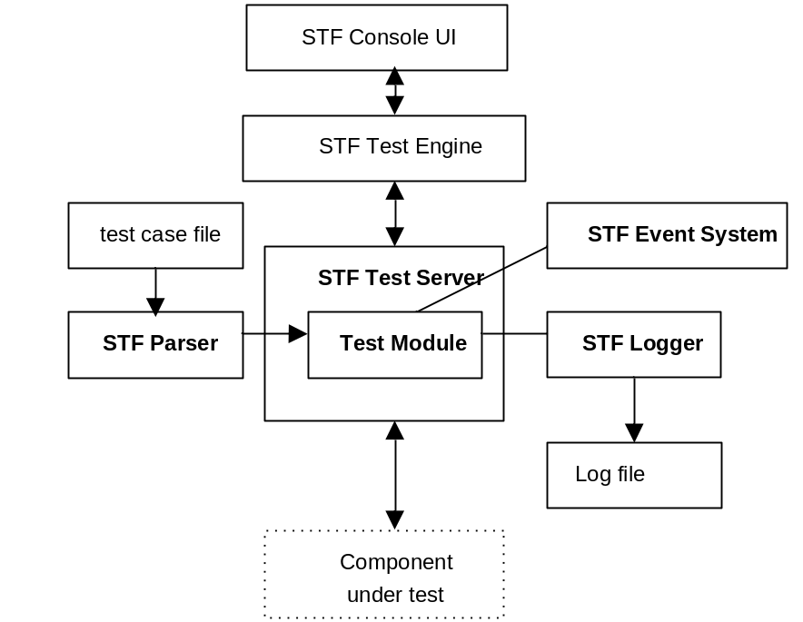
Figure 3.6 STF modules on the test layer

Test Server
For each test module, there exists one Test Server getting requests from Test Engine and either handling the requests itself or calling the corresponding function from the test module. For example, a request to execute a test case causes a function call to the test module and a request to stop the test case is handled inside Test Server.
Test Server contains several threads. One thread is the server thread, which handles the requests that came from Test Engine. That thread is created when Test Server is started. Other threads are created when needed. When a new test case is started, Test Server checks if there exists a free test execution thread. If a free thread is found, it is used to execute the test case. Otherwise, a new thread is created and a new CTestModuleBase derived object is constructed inside that thread.

Test Module
Test cases are collected and bundled into separate modules, known as test modules, which are easy to implement.
There can be several test cases implemented in one test module, and test cases can be defined, for example, via a test case file or by hard coding test cases to the test module. In addition, STF supports running different test cases simultaneously from several test modules.
A test module contains the actual test case implementation. The test module is a polymorphic DLL, which implements the CTestModuleBase interface. The most important method in that interface is TInt RunTestCaseL(const TInt aCaseNumber, const TFileName& aTestCaseFile, TestResult& aResult), which executes the test case and returns the test case result. Typically, the RunTestCaseL function contains a simple switch-case structure, which starts the corresponding test case execution. Test Server handles all the details of the client-server framework and simultaneously running threads, and the interface between Test Server and the test module is mostly based on synchronous function calls.
The interface from the test module to STF is capsulated inside a separate class that provides synchronous operations for the test module. For example, printing from the test module is implemented inside a synchronous function that causes an asynchronous request to be completed inside Test Server.
Now, three different types of test module are supported in STF:
- Hardcoded
- Test Scripter
- TEF test module
For compatibility reason STF will execute all existing cases from deprecated modules: TestCombiner, STIFUnit and Normal.

STF Test Module Template Wizard provides test module templates for test module creation. The possible test module template types of STF are:
- Hardcoded (for a hardcoded test module)
- Testclass (for test fixture used in Test Scripter test module)
- Kerneltest (for kernel test fixture used in Test Scripter test module)
- Capsmodifier (for a test module whose capabilities have to be modified)

Note: Test Combiner test module usage does not need any new test module template creation.
For more information about STF Test Module Template Wizard, see Section 6.3.

Hardcoded Test Module
The Demo module is a ready-made example test module of STF. It is a hardcoded type of test module, and it contains some ready made test cases for STF try-out purposes. Figure 3.7 shows how hardcoded test modules fit in STF. Boxes with bolded font indicate the STF modules on the test layer. The hardcoded test module is underlined in the figure.
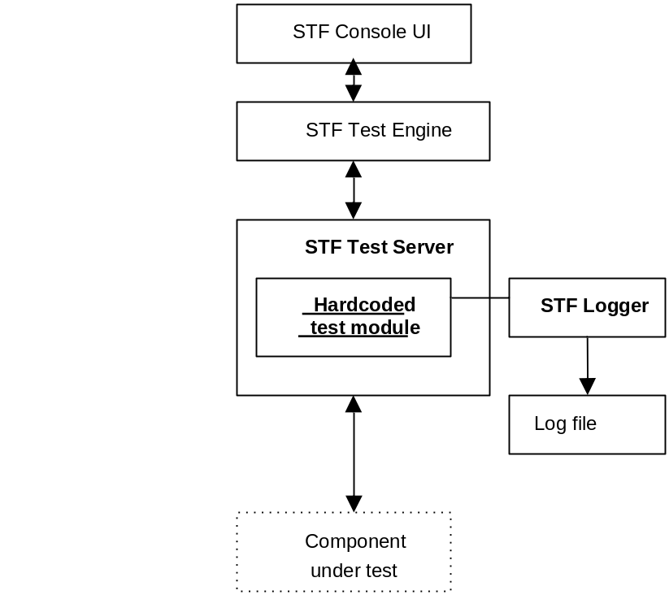
Figure 3.7 Hardcoded test module on the test layer

Test Scripter Test Module
To leverage the test class and kernel test class as test fixtures, what you need is composing a test script which will be running through Test Scripter module. Inside this test script, you could use any Test Scripter syntax to arrange your test steps. Test Scripter is a program module of STF that enables the implementing of scripted test cases.
Test Scripter provides one way to implement scripted test cases: It executes the methods listed in the script file from the test classes. Figure 3.8 shows where the Test Scripter test module fits in STF. Boxes with bolded font indicate the STF modules on the test layer. The Test Scripter test module and its test case file and test classes are underlined in the figure. For more information on Test Scripter, see Chapter 9.
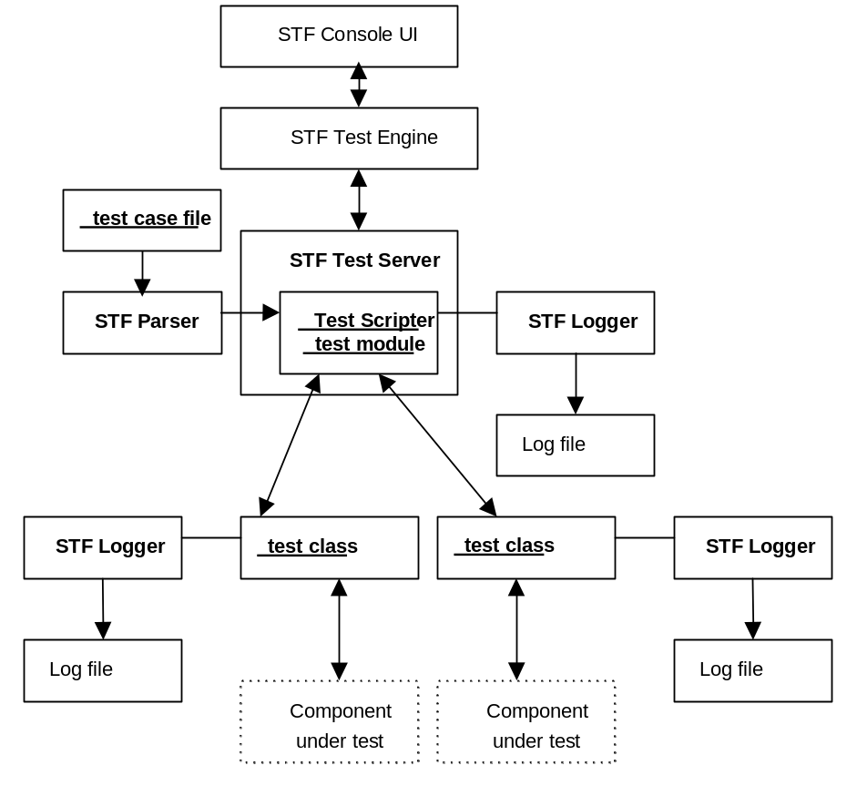
Figure 3.8 Test Scripter test module on the test layer

STF Parser
STF Parser can be used when there is a need to parse a test module’s test case files or a test module’s initialization files. By providing a common parser in STF, it can obtain better control of the test case behavior. For more information on STF Parser, see Chapter 7.

STF Logger
The purpose of STF Logger is to get information from the modules in order to write different log files or to send information to another data store via, for example, Bluetooth. By offering a common logger in STF, logging can be controlled and managed the same way. Logging can be easily enabled or disabled from the STF initialization file, and the logging storage location and format can also be specified in the same file.
Test modules can also use their own logging mechanisms, but it is preferred that the new test code use STF Logger.
For more information about STF Logger, see Chapter 8.

C/S-Style Based Logger
STF provides a C/S-style based logger. User can use RSTFLogger for logging within different threads. Basically CStifLogger will call RSTFLogger for logging. RSTFLogger is also published for usage through STFLogger.h.
For more information about RSTFLogger, see Section 8.1.1.

Logger Macros
A serial of logger macros is also provided. The macros provide easier way for logging.
For more information about logger macros, see Section 8.1.2.

STF Event System
STF Event System handles synchronization between the test cases/modules. It provides a convenient interface to STF Event System and two different types of events: state event and indication event. State event is used to indicate that some state is active or inactive, and they can be set and unset. Indication event is used to indicate that some event happened, and indication events can only be set.
STF Event System can be used to synchronize test case execution. The high-level part of STF Event System is implemented inside Test Engine and the low-level part inside Test Server. STF Event System can be taken into use in hardcoded way. Test Scripter also support STF Event System usage and provide a user-friendly interface to STF Event System. See Figure 3.6
For more information about STF Event System, see Chapter 10.

STF Features
The following features are currently supported:
- Test cases gathering through test module
- Error and exception handling
- Test Module Template Wizard
- Memory leak detection
- File parsing with STF Parser
- Logging facilities for test modules with STF Logger
- Scripted test cases with Test Scripter
- Test case synchronization with STF Event System
- Test case combining with Test Combiner
- Write once, test everywhere
For example, test cases made during the development phase can be used in system testing, automatic release testing, etc.
- Easy to use
- Multiple test cases can be executed concurrently
- All execution errors and exceptions are handled properly and reported to tester
- Excellent support for test automation
- Platform Security
- Releases bi-weekly
- Heap and stack configuring
- OOM test support
- Test Interference support

Getting STF to Work
This chapter describes how quickly you have STF deployed in your development environment. Then, with little configuration work you can run it up to use. Before starting, make sure that you have some Symbian development environment (Symbian SDK) installed.

STF Support

STF Wiki Page
STF manages its knowledge contents, including FAQ, forum, etc. through STF Customer Wiki Service. You could find all STF related information here.

Support
For further support, you could also directly write email to: stf-support@nokia.com

STF Binaries Deployment
STF publishes its release through Hydra channel with all its binary contents inside zip file(s).
Now you could get STF binary from below repository: \\besmb01.china.nokia.com\groups\hydra\TestManagementSolutions_Tools\STF1.0

How to Deploy
Unzip all STF related file(s) into your EPOCROOT of Symbian SDK. After installation, STF will deploy below contents into your SDK:
Table 4.2 STF Deployment Contents
Directory | Contents
/epoc32/data | Default STF configuration files.
/epoc32/include | To be included STF header files.
/epoc32/release | STF binaries release on variant targets, WINSCW and ARM, etc..
/epoc32/rom | .iby files for rom build/creation.
/epoc32/tools | SIS package of STF, test module templates creator for test case developers.
/epoc32/wins  /epoc32/winscw | STF configuration files.
/epoc32/localisation | Resource file of STF.

Building STF from Source
You could get latest STF source from Hydra or SVN.
Once you have STF souce code, to build STF, type the following commands in the group directory of STF:
bldmake bldfiles
abld build
Note: To build STF QT UI for all the supported platforms, see section 5.2.1.2.

Emulator Builds
To build STF for Emulator(WINSCW), type following commands in the group directory of STF:
bldmake bldfiles
abld build winscw udeb

Hardware Builds
For using STF in the target hardware, it has to be built for the target, (for example, for ARMV5) by typing the following commands in the group directory of STF:
bldmake bldfiles
abld build armv5

Configuring STF via the STF Initialization File
STF has an initialization file that is used to set up the STF functionality and behavior facets in running. The initialization file contains the default settings for the environment variables of STF. In addition, it contains information about the used test modules. The defined test modules are loaded automatically on the STF’s startup. With the initialization file, you can also force STF Logger to use specified configuration.
The default initialization file TestFramework.INI is deployed or exported (in building from source code, see section 4.3) to the \epoc32\wins\c\testframework\, \epoc32\winscw\c\testframework\ and \epoc32\data\z\system\data\ folders. The initialization file can also be given as an argument to the STF CLI and Console UI application when launching it from the command prompt and, in that case, it can be named freely and located to any folder. For more information, see Section 5.3.2.
An example of the initialization file is shown in Example 4.1.
Example 4.1 STIF initialization file
[Engine_Defaults]
TestReportMode= FullReport
CreateTestReport= YES
TestReportFilePath= C:\LOGS\TestFramework\
TestReportFileName= TestReport
TestReportFormat= TXT
TestReportOutput= FILE
TestReportFileCreationMode= OVERWRITE
[End_Defaults]

[New_Module]
ModuleName= netmodule
IniFile= c:\testframework\network.ini
TestCaseFile= c:\testframework\ip6cases.cfg
TestCaseFile= c:\testframework\ip4cases.cfg
[End_Module]

[New_Module]
ModuleName= timermodule
[End_Module]

Table 4.3 shows the possible settings in the TestFramework.INI file.
Table 4.3 Possible settings in the TestFramework.INI file
Tag | Description | Optional/Required
[Engine_Defaults] | Tag to start engine settings section. | Optional
TestReportMode | Specifies the reporting mode of the test report.  Possible values:  - Empty  - Summary (a summary of the tested cases)  - Environment (environment information)  - TestCases (test case information)  - FullReport (full information and a summary report)  - Combination of values, for example, TestReportMode= Summary TestCases | Optional  Default: FullReport
CreateTestReport | Specifies the test report creation.  Possible values: YES (creates the test report), NO (test report will not be created) | Optional  Default: YES
TestReportFilePath | Specifies the base path of the test report.  Note: Be aware of this file path setting. It must be valid for Symbian OS. If not, the test report file would not generate as expected. | Optional  Default: C:\Logs\TestFramework
TestReportFileName | Specifies the filename of the test report.  Note: Be aware of this file name setting. It must be valid for Symbian OS. If not, the test report file would not generate as expected. | Optional  Default: TestReport
TestReportFormat | Specifies the test report file type.  Possible values: TXT (creates a TXT file), HTML (creates an HTML file), XML (creates an XML file – note: to get xml report, TestReportOutput option need to be set with FILE value). | Optional  Default: TXT
TestReportOutput | Specifies the output source of the test report.  Possible values: FILE (creates a file), RDEBUG (log information in RDebug format). | Optional  Default: FILE
TestReportFile  CreationMode | Specifies the test report file creation mode.  Possible values: OVERWRITE (Overwrite the file if the file already exists), APPEND (appends log information after the old file if the file exists). | Optional  Default: OVERWRITE
DeviceResetDllName= | Sets a device reset module's DLL name (Reboot). | Optional
DisableMeasurement | For disabling Test Measurement operations. More detail, see section 14.5. | Optional
Timeout | For setting default timeout value for those test cases which do not have their own timeout value provided. Value of 0 means that no timeout is defined. | Optional  Default: 0
UITestingSupport | Changes behavior of STF that it is able to run UI tests. See section 9.5.7 for details. | Optional  Default: NO
SeparateProcesses | When this option is set, then STF will run every test case (of any test module) in separate process. | Optional  Default: NO
[End_Defaults] | Ends engine settings. | Required if [Engine_Defaults] is used.
[New_Module] | Starts module settings. | Optional
ModuleName | Test module DLL name. The name of the target that is specified in the MMP file and used in the file system. | Required if [New_ Module] is used.
IniFile | Test module initialization file.  Only one module initialization file can be defined per test module. | Optional
ConfigFile  TestCaseFile | A configuration / test case file where the test cases are defined.  There can be several configuration / test case files for one test module. | Optional
[End_Module] | Ends module settings. | Required if [New_Module] is used.
[Logger_Defaults] | Starts the overwriting of STF Logger settings. This specifies the setting to STF Logger that overwrites the default implemented settings. For example, the test module defines that STF Logger uses line breaks when logging to a file. With the WithLineBreak setting it is possible to force STF Logger log without line breaks by giving the value No for this setting. | Optional
CreateLogDirectories | An option for creating a log directory / directories. If no log directory is created by the user, they are made by the software. | Optional  Default: FALSE
EmulatorBasePath | Overwrites the emulator path setting. | Optional  Default: C:\LOGS\TESTFRAMEWORK
EmulatorFormat | Overwrites the emulator’s logging format (TXT, HTML). | Optional  Default: HTML
EmulatorOutput | Overwrites the emulator’s logging output destination (FILE, RDEBUG). | Optional  Default: FILE
HardwareBasePath | Overwrites the hardware path setting. | Optional  Default: C:\LOGS\TESTFRAMEWORK
HardwareFormat | Overwrites the hardware's logging format (TXT, HTML). | Optional  Default: TXT
HardwareOutput | Overwrites the hardware's logging output destination (FILE, RDEBUG). | Optional  Default: FILE
FileCreationMode | Indicates file overwriting if the file exists (OVERWRITE, APPEND). | Optional  Default: OVERWRITE
ThreadIdToLogFile | Defines whether the thread ID is included in the log filename. | Optional  Default: FALSE
WithTimeStamp | Defines whether time stamps are included in the log file. | Optional  Default: TRUE
WithLineBreak | Defines whether line breaks are added to the log file. | Optional  Default: TRUE
WithEventRanking | Defines whether event ranking is included in the log file. | Optional  Default: FALSE
FileUnicode | Defines whether logger and parser work in Unicode format. | Optional  Default: FALSE
AddTestCaseTitle | Defines whether test case title is added to log file name (YES or NO).  Note: With this option enabled, STF will try to create a file with test case title as part of the file name. Please remember in Symbian OS, not all letters are valid to be put in file name. In this case, the file name is invalid so that the log file might not be generated correctly.  Note: If the test case title is too long, say > 128, the log file name length would exceed Symbian OS limitation so that the file would not create correctly either. | Optional  Default: NO
[End_Logger_Defaults] | Ends STF Logger settings overwriting. | Required if [Logger_Defaults] is used.

Configuring Test Report Settings
By default, the test report is generated in the directory c:\logs\testframework. If the directory does not exist and a file base report (either TXT, HTML or XML) is requested, the directory is created. Test report settings can be configured between [Engine_Defaults] and [End_Defaults] in the engine initialization file. The test report contains general information about the executed test cases. An example of a test report file is shown in Example 4.2.
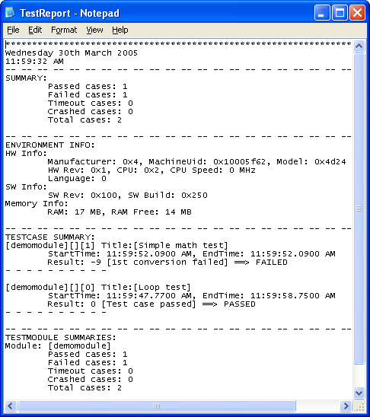
Example 4.2 Test report file

Configuring Test Module Settings
Test modules are added to STF by adding the tag [New_Module] and specifying the module name, module initialization file and module test case file(s). The module name is mandatory; the IniFile and TestCaseFile tags are optional. There can be several test case files for one test module. The test module name must be unique in modules defined in one engine initialization file. Test module initialization is ended by the [End_Module] tag.
For example, to load a hardcoded test module, such as TMHardcoded, to STF, you should add the lines shown in Example 4.3 to the initialization file (by default, c:\testframework\testframework.INI).
Example 4.3 Adding a hardcoded test module to STF
[New_Module]
ModuleName= TMHardcoded
[End_Module]

A hardcoded type of test module doesn’t have its own initialization file or test case files.

Example 4.4 shows how to load a Test Scripter test module and its test case file to STF.
Example 4.4 Adding a Test Scripter test module
[New_Module]
ModuleName= TestScripter
TestCaseFile= c:\testframework\Example.cfg
[End_Module]

A Test Scripter module has one test case file: Example.cfg. Test Scripter uses the test classes that are specified in the test case file.

Configuring Logging Settings
STF modules create log files of operations but there is no single global log file. Log files are useful when any unexpected problems occur during test case execution. STF modules create logs to their own logging directory. Note that by default, if the directory does not exist, the module does not create a log file. The base folder for logs is c:\logs\testframework\, and it is located in the \epoc32\winscw\c\logs\testframework\ in the WINSCW environment. The log file directories are listed in Table 4.4.
Table 4.4 Log file directory paths
Module | Log file directory
Test Engine | c:\logs\testframework\testengine
Test Server | c:\logs\testframework\testserver
Test Scripter | c:\logs\testframework\testscripter

Test Server creates several log files. For each test module, there exists one Test Server log file, and for each spawned test case execution thread, there exists one corresponding log file. The Test Server log and the test module thread logs are tightly coupled. Most operations that are seen in the Test Server log are also shown in the test module log.
The log file names end with _XX, where XX is the thread ID. The Test Engine log is named as testengine_XX, the Test Server log is named as testserver_modulename_XX (where modulename is the name of the test module), and the test module log is named as testserver_thread_modulename_XX.
Note: STF Logger overwrite setting definitions have no effect on Test Engine and Test Server logging. If you want to change those settings, they have to be made inside the source code.
See Chapter 8 for more information about STF Logger.

Configuring Filters
To specify rules of what kind of test cases to show, “filter” can be added to STF by using [Filters] tag and specifying filter definitions. Console UI will load them and display before it allows selecting concrete test case.
Each filter line has to start with "filter= " keyword. Filter can contain special wildcard characters:
* which stands for none or any literal;
? which stands for single character.
Filters are not case-sensitive.
Example 4.5 Defining filters in the initialization file.
[Filters]
filter= *math*
filter= *radio*
[End_Filters]

If there is at least one defined filter, through the UI interface such as Console UI, STF will add automatically “No filter” entry, which does not apply any filter to test cases. Thanks to this, user can still view all test cases without any filters applied. See below Figure 4.9.
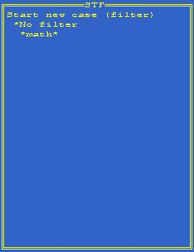
Figure 4.9 No Filter Entry in Console UI
In case when there are no filters defined, Console UI will not display any additional screen.

Using STF for Test Cases Execution
This chapter describes how the STF interfaces – STF CLI, Console UI, STF QTUI – can be used for test cases execution.

Working with STF CLI
The STF CLI is a console application that takes command line parameters to execute STF modules/cases.
The format of STF CLI command like this:
Stf [-option [item] value] [case name/case index value]

Table 5.5 describes the possible command line parameters.
Table 5.5 STF CLI command line parameters
Parameter | Description
Case name/  Case index value | Give a specific case index number or test case name to execute it. If the name of test case include blank, please include the file name by double quotation marks (“).
-m <module name> | The name of the test module.
-s <script file path> | The script file of the test module. It usually contains the test case definitions for the testing. If user provided a script file but didn’t provide module name, the application will use TestScripter to execute the script by default.
-i <engine initialization file path> | The initialization file of Test Engine (testframework.ini).
-c <module initialization file path> | The initialization file of the test module.
-engine <item> <value> | Set engine Configuration item and its value for test engine initialization file. This setting will override settings in initialization file. The setting item could be:  - TestReportMode (Possible values are: 'Empty', 'Summary', 'Environment', 'TestCases' or 'FullReport');  - CreateTestReport (Possible values: YES or NO);  - TestReportFilePath;  - TestReportFileName;  - TestReportFormat (Possible values: TXT, HTML or XML);  - TestReportOutput (Possible values: FILE or RDEBUG);  - TestReportFileCreationMode (Possible values: OVERWRITE or APPEND);
-log <item> <value> | Set log Configuration item and its value for test log initialization file. This setting will override settings in initialization file. The setting item could be:  - CreateLogDirectories (Possible values: YES or NO)  - EmulatorBasePath  - EmulatorFormat (Possible values: TXT or HTML)  - EmulatorOutput (Possible Values: FILE or RDEBUG)  - HardwareBasePath  - HardwareFormat (Possible Values: TXT or HTML)  - HardwareOutput (Possible Values: FILE or RDEBUG)  - FileCreationMode (Possible Values: OVERWRITE or APPEND)  - ThreadIdToLogFile (Possible Values: YES or NO)  - WithTimeStamp (Possible Values: YES or NO)  - WithLineBreak (Possible Values: YES or NO)  - WithEventRanking (Possible Values: YES or NO)
-p <item> <value> | Transfer additional item/value pair into test module. Test module can accept these setting values via programming (not supported in STF1.0 yet).
-v | Display the version information.
-?/-h | Display the help information.
-NOPROMPT | Application exits without prompt after the execution finished. (But this command will not take effect in –v and –help command)

If the test framework initialization file is not given as a parameter, STF CLI tries to find the default file \testframework\testframework.INI from every drive that exists, beginning from the C:\ drive.
Here are some examples:
- Execute "demomodule".
C:\>stf –m demomodule

- Execute the third case in “demomodule”
C:\>stf –m demomodule 3

- Execute case named “loop test” in “demomodule”
C:\>stf –m demomodule “loop test”

- Execute case named “loop test” and case named “math” in “demomodule”
C:\>stf –m demomodule “loop test” math

- Execute case named “loop test” and the third case in “demomodule”
C:\>stf –m demomodule “loop test” 3

- Execute No. 2,3,5 cases in “demomodule”
C:\>stf –m demomodule 2 3 5

- Execute cases definied in "mytest.cfg" via testscripter, take initialization setting from "c:\testframework\testframework.ini", and take "TestReportMode" parameter as "summary".
C:\>stf -s c:\test\mytest.cfg -engine TestReportMode Summary

- Execute cases definied in "mytest.cfg" via testscripter, take initialization setting from "c:\testframework\testframework.ini", and take "EmulatorFormat" parameter as "TXT".
C:\>stf -s c:\test\mytest.cfg -log EmulatorFormat TXT

Below Table 5.6 shows the return prompt message and values of STF CLI:
Table 5.6 Return prompt message and values of STF CLI

Return Message | Value | Description
- | 0 | Execute successfully.
Required resource not found. | -1 | Unable to find given module, script or case. STF CLI will list all the not found items.
No Enough memory. | -4 | Not enough memory to perform the execution.
Operation not supported in this version. | -5 | The operation requested is not supported.
Arguments error. | -6 | Argument is out of range.
Other unknown error. | Any other code | Any other unexpected error.

Working with STF QT UI
STF QT UI is a GUI application based on QT technology. Qt 4.6.0 for S60 or later version is needed to run STF QT UI.

Setting up STF QT UI

Required Environment
Symbian SDK and hardware devices should support QT 4.6 or later version. For detail information, please refer to the document “Qt for the Symbian platform Requirements” in QT for Symbian SDK.
Note: Qt is fully and well supported only on those Symbian SDK versions which have default Qt companied inside. It’s highly recommended you do not try below by installing separated Qt dependencies into Symbian SDK.
We recommend you to take a look of Symbian Foundation - Qt Quick Start to get more information about how to setup the development environment.
Before using STF QT UI, STF environment should be set up first. User can compile STF project to set up it.
By default, STF QT UI will not be compiled in STF project compiling process, it should be compiled separately.

Build STF QT UI
STF QT UI is written by QT C++ and Symbian C++. So it should be compiled by QT for S60. User can use command line or Carbide to build it.
Command line building process:
Open command prompt, ensure the binary folder of QT for S60 has been set into system path.
Set the correct EPOCROOT.
Make sure the source code of STF QT UI is located in the same drive with EPOCROOT.
Type the following commands in the project folder:
T:\> qmake
T:\> make debug-winscw
T:\> make release-armv5

Carbide building process:
Carbide compiler needs to be at least version 3.2.5, build 482 to be able to build Qt for Symbian properly. You can check the compiler version by executing "mwccsym2.exe" from the command line, e.g. "C:\Program Files\Nokia\Carbide.c++ v2.0\x86Build\Symbian_Tools\Command_Line_Tools\mwccsym2.exe". If your compiler version is older than what was specified above, you can use the patch. For detail information, please refer to the “required software for s60 development environment”.
Open carbide, select menu: “File” -> “Import”, in the import dialog, select “Qt Project”.
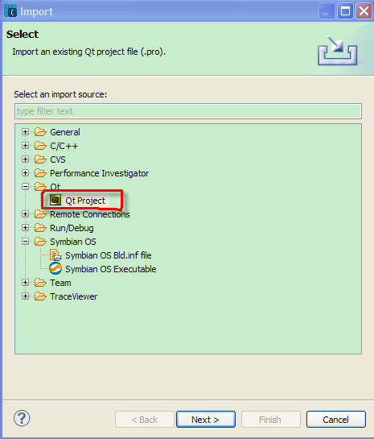
Figure 5.10 Import Qt Project in Carbide
Select the project file “stfqtui.pro” and correct SDK as build target to finish the wizard.
After the project imported, compile it to get the binaries.

UI Introduction
To start StfQtUI, click or select STFQtUI in ”Applications” menu.
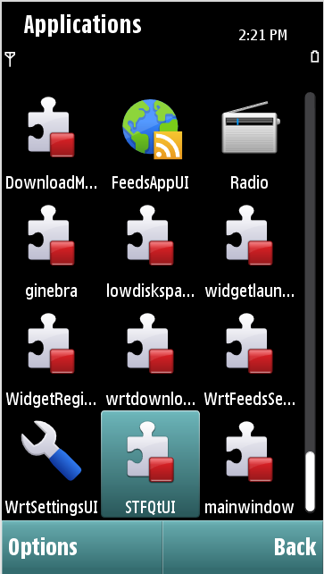
Figure 5.11 STFQtUI in Applications Category

The main window of STFQtUI can be seen in Figure 5.12.
Figure 5.12 Main Window of STFQtUI
There are two parts in the main window: a tab control based panel and an information output panel.
There are 4 tabs in the tab panel. See Table 5.7.
Table 5.7 Four Tabs in STFQtUI
Tab | Description | Screen Shot | Menu & Button Actions
Cases | List all modules and their cases in a tree view. User can select single or several cases for testing. | 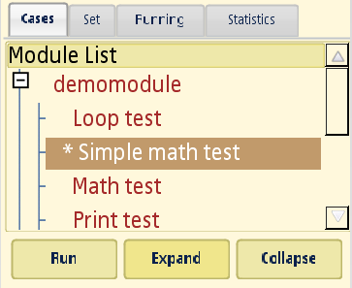 | Menu:  - Open Ini File;  - Run Selected Case(s) (Sequentially/Parallel);  - Add cases to Set;  - Select All (select modules and their cases).  - Expend All (expend each tree item);  - Collapse All (collapse each tree item);  Buttons:  - Run (Run case sequentially);  - Expand (expand tree);  - Collapse (collapse tree).
Set | List all the test sets and their cases.  All the test sets listed in a combo box. When a certain set item selected, its cases will listed in the below list box. | 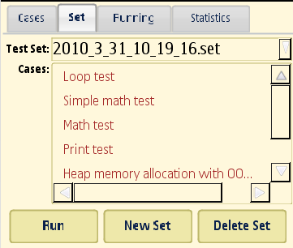 | Menu:  - Run Case(s) in Selected Set (Sequentially/Parallel);  - Create New Set;  - Delete Set (not support in STF1.0);  Buttons:  - Run (Run set sequentially);  - New Set;  - Delete Set.
Running | List the running case(s).  Provide actions to control the case. | 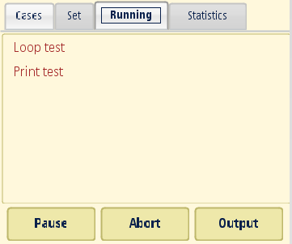 | Menu:  - Pause/Resume (Only enabled when case running);  - Abort (Only enabled when case running);  - Output (Only enabled when case running);  Buttons:  - Pause/Resume;  - Abort;  - Output;  (All the actions in this tab will enable only when test process is still ongoing.)
Statistic | Classify each executed case by status. Use tree view to show 5 categories. | 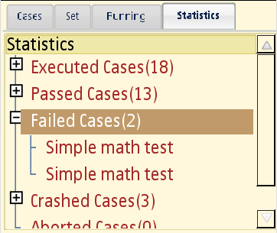 | Menu:  - Clear Statistics;

For each tab, there are application 3 menu items:
- Settings: setting output panel show/hidden.
- About: STF version and StfQtUI version.
- Exit: Exit the application.

Information panel will show the operation output. The screenshot of information panel can be seen in Figure 5.13.
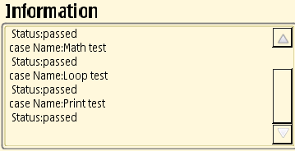
Figure 5.13 Information Panel

Using Output Panel
To view the output of a test case in the testing process, STF QT UI provides an output window. This window can be used to show the running case(s) output information. It also can be used to control the case(s).
To show this output window, User should select “Settings” in any tab.
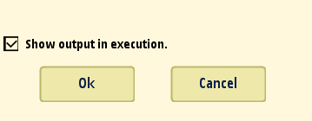
Figure 5.14 Output Panel
Select or unselect the checkbox will enable or disable the output panel.
When testing started, if the output panel is setting to enabled, the output window will show up.
User can use “Resume” and “Abort” buttons to control the case running. See Figure 5.15
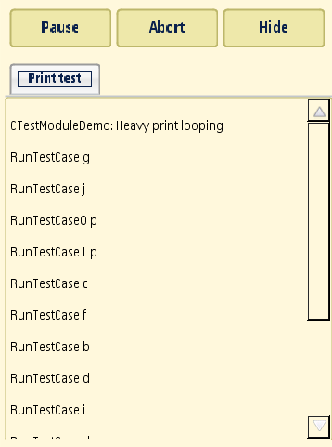
Figure 5.15 Resume/Abort Test Case
User can use “Resume” and “Abort” buttons to control the case running.
User can use “Hide” button to hide the output window and come back to STF UI main window.
When testing started, if the output panel is setting to disable, the output window will not show up. But user can use “Output” button in “Running” tab page to show up the output panel.
If user selects to start cases in parallel mode, all the selected cases will start at same time. Output panel will show each case’s output message in separated tab window. User can view each output by switch the tab window.
After all the running cases finished, output window will dispose automatically.

Load Customized Engine Initialization File
Application will load default engine initialization file when it started. The default engine initialization file is located in “c:\testframework\testframework.ini”.
User can use application to load their customized engine initialization file. At “Cases” tab page, select “Options”->”Open Ini File”. The selection dialog can be seen in Figure 5.16.
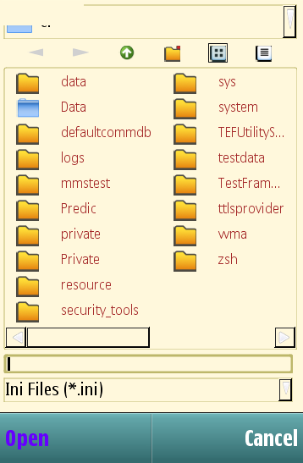
Figure 5.16 Load Customized Engine Initialization File

Select the customized initialization file and select “Open”.
The application will reload test modules and test cases from new initialization file.

Get Log of STF QT UI
To view the log of StfQtUI, please create a folder “STFQtUI” under “c:\Logs” drive (in emulator, create the folder under “epoc32\winscw\c\logs”).

Working with Console UI
Console UI can be executed either in emulator or in target hardware. It can be executed either in a plain text shell or over a normal graphical UI. Note that Console UI requires the EShell component, which is not usually included in the S60 hardware ROM build. The easiest way to take EShell to the hardware is to store it to the memory card.
The Console UI application provides a simple way to show test cases to the tester. It also shows to the tester the progress of ongoing test cases and the results of the executed test cases.
Console UI is a menu-based application, which requires that at least two navigation keys are available. One key is used to activate an item from the menu, and the other key is used to change the selection. Console UI also supports the use of S60 type five-way navigation, which allows easier navigation in the menu system. In menu navigation, it is also possible to use shortcut keys that are described in Table 5.8.
Table 5.8 Shortcut keys
PC keyboard key | Numeric key | Function
Home | 3 | Go to the beginning of the list.
End | 9 | Go to the end of the list.
Page Up | 1 | Go one page up.
Page Down | 7 | Go one page down.

Startup Parameters
The Console UI application provides startup parameters that can be used to control STF initialization. The most important parameter is the STF initialization file. The initialization file name must be given with the complete path. If the STF initialization file is not given as a parameter, Console UI tries to find the default file \testframework\testframework.INI from every drive that exists, beginning from the C:\ drive. This allows the starting of Console UI from file browsers that do not allow entering command line parameters to executables.
Other startup parameters are optional and must be given before the STF initialization file name if used. They consist of the parameter name, which begins with the mark ‘-‘ and is followed by a value. The startup parameters with their valid values are described in Table 5.9.
Table 5.9 Console UI startup options
Parameter | Value | Description
-testmodule | <test module name> | The name of the test module loaded during initialization.
-testmoduleini | <test module initialization file> | The name of the test module initialization file used when loading the test module. The -testmodule option is required.
-testcasefile | <test case file name> | The name of the test case file that is added for the test module given with the –testmodule option. The  -testmodule option is required if this option is used.
-testset | <test set name> | The name of the test set used. Can be used as the test set name to create, load or run a test set. May include a path or only the plain set name. If it does not include a path, the default C:\testframework\ is used when saving the test set. The filename without the path is always used as the test set name; the path is only used when loading or saving the test set.
-run | all  sequential  parallel | Used for running specified test cases. Either the  –testmodule or –testset option is required and used to define the started test cases. The values all and sequential mean that test cases are executed sequentially, and parallel means that all are executed at the same time.

Starting Console UI
To start the debug version of Console UI in WINSCW from the command line, start Console UI by executing \epoc32\release\winscw\udeb\ConsoleUI.EXE. To start the release version, start \epoc32\release\winscw\urel\ConsoleUI.EXE.
In the WINSCW environment, it is possible to start Console UI in different ways:
- By double-clicking in Windows Explorer (does not allow the specifying of the initialization file)
- From the command line
- By creating a shortcut
In hardware, Console UI can be started using the ESHELL shell, as in Example 5.6, or by starting it from a file browser.
Example 5.6 Starting Console UI and specifying the initialization file
C:\>consoleui c:\testframework\testframework.ini

Example 5.7 shows how to start Console UI with a hardcoded test module and with the test framework initialization file.
Example 5.7 Starting Console UI with a hardcoded test module and with testframework.INI
C:\>consoleui –testmodule demomodule –run all c:\testframework\testframework.ini

Example 5.8 shows how to start Console UI with a Test Scripter test module and its test case file.
Example 5.8 Starting Console UI with a Test Scripter test module and with test case file
C:\>consoleui –testmodule testscripter –testcasefile c:\testframework\Example.cfg

Example 5.9 shows how to start Console UI with a Test Combiner test module and its test case file.
Example 5.9 Starting Console UI with Test Combiner test module and with test case file
C:\>consoleui –testmodule testcombiner –testcasefile c:\testframework\Event.cfg

Menu Navigation
All menus are lists where pressing the Arrow down key changes the position down by one menu item and the Arrow up key changes the position up by one item. If the end of the list is reached, the position is changed to the beginning of the list, and vice versa.
A menu item is selected using either the Enter key or the Arrow right key.
The Arrow left key is used to navigate back to the previous menu.
Selecting Exit in the main menu closes Console UI.

Loading a Test Module
A new test module can be loaded from the Module menu. There are two options: either to load all the test modules that can be found from the system, or to individually load the test modules that can be found from the system. In both cases, the test module initialization file or test case file(s) cannot be specified. That can be done only via the STF initialization file as described in Section 4.4.2.
Test modules are loaded individually by selecting Add test module from the Module menu and then selecting the desired test module from the list of modules that opens. All test modules can be loaded by selecting Load all test modules from the Modules menu.

Starting a Test Case
To start a single test case, go to Start new case or Start & show output under the Case menu and select a particular case from the list. Console UI starts to execute the chosen test case. A new test case can be started while another is still being executed. When several cases are executed at the same time, they are executed in separate threads.
To start multiple test cases, go to Run multiple tests under the Case menu and select/mark test cases to be executed from the list and run selected test case either sequentially or in parallel.
Note: There is also special option Repeat run selection sequentially for repeating selected test cases running.

Lists of Started Test Cases
The Case menu offers a list of Ongoing cases, Executed cases, Passed cases, Failed cases and Aborted/Crashed cases. When selecting one of these, a list of the cases is shown on the display. The list is updated whenever the test case status is changed. For example, when a case is finished, it is moved from the Ongoing cases list to either the list of passed or failed cases, depending on the result of the test case.

Aborting, Suspending and Resuming a Test Case
When selecting a case from the Ongoing cases list, a new menu is shown that allows to abort or suspend the test case execution, or resume the execution in case it was suspended. In “Ongoing cases” list, paused cases are displayed witch “(P)” symbol preceding test title.

Viewing the Test Case Output
To view the test case output, select a case from any of the case lists. A new operation-specific menu is shown. By selecting View Output, the user will see the test case output.
By pressing any key, the focus is returned to the previous menu.

Test Sets
The Console UI application can be used to create a test set containing a set of test cases that can be run either sequentially or in parallel. Console UI supports one test set at a time, but a different test set can be selected with a command line parameter, which specifies the test set name (see Section 5.3.1).
Test set controlling is handled from the Test set menu that can be found from the main menu of Console UI. The Test set menu provides the possibility to create or load a test set, or to control a test set (add/remove test cases, save, remove or execute test set) depending of the test set status (active/inactive).
The default path for test sets is C:\testframework\. This is the location to which test sets are saved and from which they are loaded. A different test set path and name can be set via a command line parameter (see Section 5.3.1).
When test set is executed sequentially by choosing “Start sequentially not started tests”, it stores info about index of a test case which was started as last one. Next time only not executed yet tests are started. User can reset test set by saving it again.

Using STF for Test Cases Implementation
A test module contains the actual test case implementation. Test modules are implemented as separate DLLs that STF dynamically loads. Test modules can be freely implemented, as long as they provide the required interface, which Test Engine can use. Test module can be hardcoded or Test Scripter. These test module types can be seen in Figure 6.17. Test modules are indicated with bolded font. The figure does not contain detailed information for each test module; for example, the test case files are not shown.
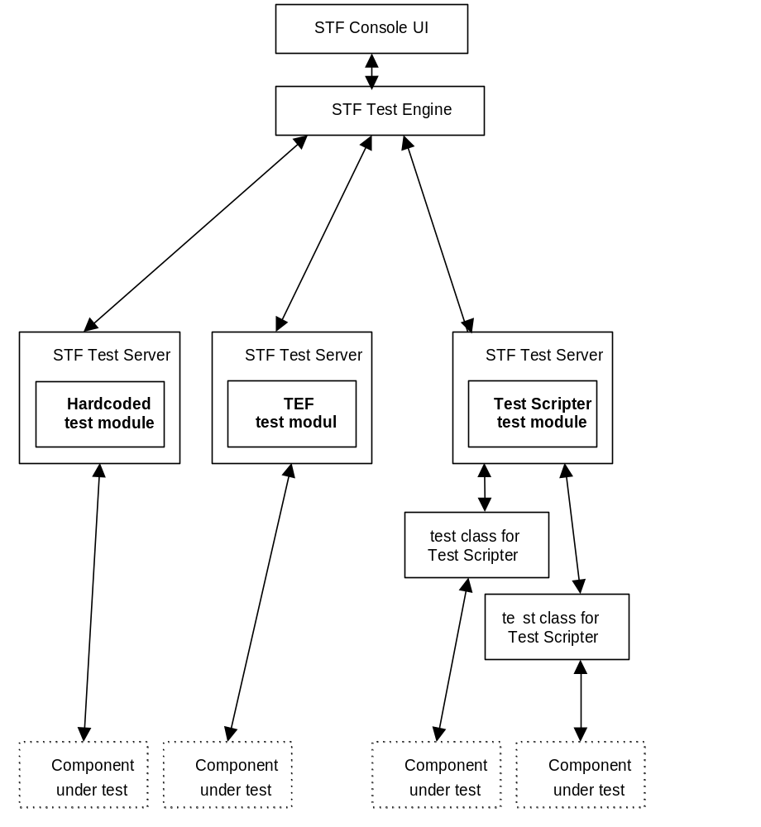
Figure 6.17 Test module types
Note: The “Test Scripter”test module is built-in part of STF. There is no need to create them by users but they must provide “Test Class” implementation (see Section 9.3) and test script file(s).

Test Module API
Test Module API is a user-friendly API for test case execution. A test module derives from CTestModuleBase and uses the CTestModuleIf class.
A test module must expose the following interfaces to STF:
- A list of the test cases
- Specified test case execution
These features are provided by the CTestModuleBase class that the test module has to inherit in order to implement the test module within STF.
In addition, there are some optional features that are offered by the CTestModuleIf class. CTestModuleIf is an interface from the test module to Test Engine. For example, the interface offers UI independent printing functions, which can be used to show the test case progress on the screen, if there is a screen available (for example, the console screen with the Console UI application).

InitL
The InitL method is called during the test module initialization (optional). The test module initialization file can be provided as a parameter.

GetTestCasesL
The GetTestCasesL method is used to query test cases from a test module. The test case file is provided as a parameter (optional). This method is called for every test case file separately.

RunTestCaseL
The RunTestCaseL method is used to execute a specified test case. The test case file is provided as a parameter (optional). The method returns the result of the executed test case.

OOMTestQueryL
The OOMTestQueryL method is used to check if the test case should be run in OOM conditions and which heap memory allocations should fail. The method returns ETrue if the test should be run in OOM conditions, and otherwise EFalse.
Note: This method is virtual and must be implemented only if a test case should be executed using OOM conditions.

OOMTestInitializeL
The OOMTestInitializeL method is used to perform the test environment setup for a particular OOM test case. The test modules may use the initialization file to read parameters for the test module initialization but they can also have their own configure file or some other routine to initialize themselves.
Note: This method is virtual and must be implemented only if a test case should be executed using OOM conditions.

OOMHandleWarningL
The OOMHandleWarningL method provides a way to the derived test module to handle warnings related to non-leaving or TRAP’ed allocations. In some cases, the heap memory allocations should be skipped, either due to problems in the OS code or in the system under test. There might also be programs that are implemented this way on purpose (by design), so it is important to give the tester a way to bypass allocation failures.
Note: This method is virtual and must be implemented only if a test case should be executed using OOM conditions.

OOMTestFinalizeL
The OOMTestFinalizeL method is used to perform the test environment cleanup for a particular OOM test case.
Note: This method is virtual and must be implemented only if a test case should be executed using OOM conditions.

SendTestModuleVersion
The SendTestModuleVersion method is used to pass version of test module to TestServer. In the end the version of test module is written to TestReport.txt under “Versions of test modules” section.
To change version of test module three #define directives must be edited, e.g.:
#define TEST_MODULE_VERSION_MAJOR 1
#define TEST_MODULE_VERSION_MINOR 2
#define TEST_MODULE_VERSION_BUILD 3
Above #defines will result in such version entry in TestReport.txt:
Versions of test modules:
testmodule.DLL 1.2.3

Test Module API Features
The API functions exposed to the test module (through CTestModuleIf interface) provide optional features to the test module:
- Printf (output to UI)
- SetExitReason (to allow a particular panic to be a valid test case result)
- SetBehavior (to allow memory, handle or request leak)
- StopExecution (to stop current case execution)
- GetTestCaseTitleL (to obtain title of currently running case)

Printf
The printing mechanism is based on asynchronous requests. In the beginning, Test Engine sends a PrintNotification request to Test Server.
Test Server has a print item queue, which has a maximum length. If the queue overflows, then the lowest priority item in the queue is discarded and the new one is added to the queue.
If the print queue is not empty when Test Server receives the PrintNotification request, then the first item from the queue is returned to Test Engine and the request is completed immediately. If the queue is empty, then the request is stored to be used when the test module prints something.

SetExitReason
SetExitReason is used to set panics and exceptions to acceptable exit reasons. If it is known that a test case causes a panic or an exception, SetExitReason can be used to set one panic or one exception as an acceptable exit reason that is translated to a passing test case.
If an exit reason is set to panic or exception, a test case must cause a panic or exception in order to pass. If the test case does not cause the correct panic or exception, the test case fails. By setting the exit reason back to normal, the test case can return normally and set the result itself.
It is recommended to use special exit reasons only when it is known that the test case will cause a panic or exception.
See Example 6.10 for how to use SetExitReason in a test case. In this case the test is passed if it panics with code 123 or if it is executed normally. Note that if the test panics with other code than 123 the test case goes to aborted category.
Example 6.10 Example how to set panic to acceptable exit reason
TInt CMyExample::TestCaseThatMayPanic( TTestResult& aResult )
{
// Set panic with code 123 to acceptable exit reason
TestModuleIf().SetExitReason( CTestModuleIf::EPanic, 123 );
// Do something that may cause panic with code 123
DoSomething();
// DoSomething did not panic, so change acceptable result back to normal
TestModuleIf().SetExitReason( CTestModuleIf::ENormal, KErrNone );
_LIT( KDescription, " TestCaseThatMayPanic passed, didn’t panic!" );
aResult.SetResult( KErrNone, KDescription );
// Test case executed properly
return KErrNone;
}

SetBehavior
The SetBehavior method is used to allow memory, handle or asynchronous request leaks.
Note: Memory leak detection is not supported since Symbian 9.0 (EKA2 kernel) environments.
An example code line of allowing a memory leak is shown in the following example. This affects only one test case at a time, but if this code line is placed to the beginning of the RunTestCaseL method, this SetBehavior request affects all test cases.
Example 6.11 How to call SetBehavior method
TestModuleIf().SetBehavior( CTestModuleIf::ETestLeaksMem );

The other possible parameters for the SetBehavior method are:
- CTestModuleIf::ETestLeaksRequests (used for allowing handle leaks)
- CTestModuleIf::ETestLeaksHandles (used for allowing asynchronous request leaks)

StopExecution
The StopExecution method is used to cancel execution of test case calling it.
It needs to be specified (first parameter) to what category cancelled test case will go: aborted/crashed (EAbort), failed (EFailed) or passed (EOk).
When EOk is specified, second parameter should not be provided, or must be equeal to KErrNone (0). For EAbort or EFail, second parameter must be provided with error code set to value different than 0. Otherwise StopExecution() will return KErrArgument (-6).
Example 6.12 How to call StopExecution method
TestModuleIf().StopExecution(EAbort, 1600);
TestModuleIf().StopExecution(EFail, 1500);
TestModuleIf().StopExecution(EOk);

GetTestCaseTitleL
This method may be used to obtain title of the test case which is currently running. See example 6.3 to get an example of GetTestCaseTitleL usage.
Example 6.13 How to use GetTestCaseTitleL method
TName title;
TestModuleIf().GetTestCaseTitleL(title);

Creating Test Module Templates
Within STF, there is a specific STF Test Module Template Wizard for automatically creating a test module project, such as hardcoded test module project, based on the templates.
The test module template type can be hardcoded, testclass, kerneltest or capsmodifier. These test module template types can be seen in Figure 6.18. In the figure, the test module template types are indicated with bolded font. The figure does not contain detailed information for each test module; for example, the test case files are not shown.
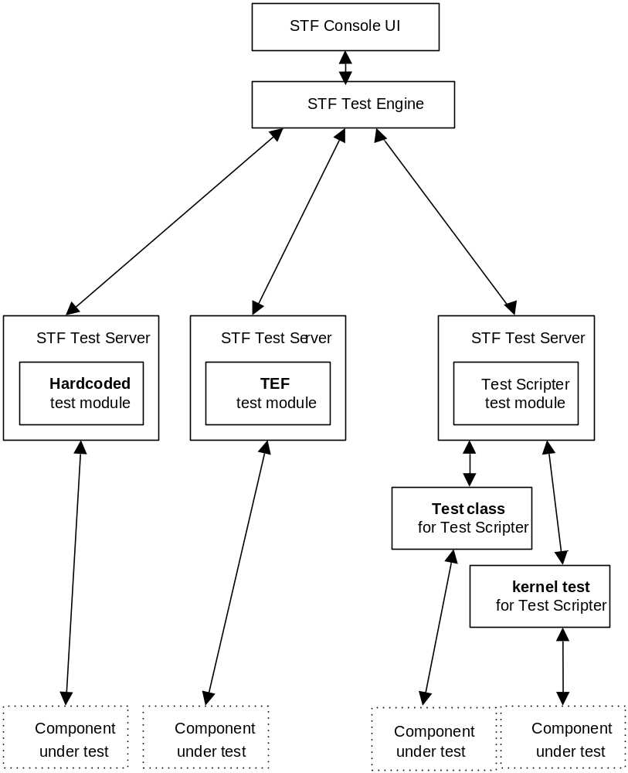
Figure 6.18 Test module template types
STF Test Module Template Wizard can be launched by running the createtestmodule script from the command line in the directory \epoc32\tools\s60rndtools\stf\TestModuleTemplates.
STF Test Module Template Wizard takes the test module template, makes a new copy of it, and changes all the class names in the code files. STF Test Module Template Wizard asks from the user the test module template type and name, as well as the path where the new test module template is created.
The test module template type hardcoded creates a test module template where every test case is implemented as a separate function.
The test module template type testclass creates a test class for Test Scripter usage. For more information about the test class creation, see Section 9.3.
The test module template type kerneltest creates a kernel test class for Test Scripter usage. For more information about the kernel test class creation, see Section 9.4.
The test module template type capsmodifier creates a capability modification module for your test module. For more information about that, see Section 14.1.3.1.
An example of the test module creation process is shown in Example 6.14:
Example 6.14 Creating a test module using the createtestmodule script
F:\STIFTestFramework\TestModuleTemplates>createtestmodule
Enter ModuleType:
(h) hardcoded = creates test module that uses hardcoded test cases.
(t) testclass = creates test class which is used with TestScripter.
(k) kerneltest = creates kernel test class which is used with TestScripter (
only for kernel testing!).
(c) capsmodifier = creates capability modification module
(e) exit = Exit.
Enter ModuleType (name/short cut): h
Enter ModuleName which has to be a valid C++ variable name.
Enter ModuleName (or exit): AudioTest
Enter path [default is drive root] (or exit): F:\tmp
Create test module of type normal with name AudioTest to F:\tmp\
Starting module creation to F:\tmp\AudioTest\
Processing .
Processing Bmarm
Processing CVS
Processing Entries
Processing Entries.Extra
Processing Repository
Processing Root
Processing TESTMODULEXXXU.DEF
Processing Bwins
Processing CVS
Processing Entries
Processing Entries.Extra
Processing Repository
Processing Root
Processing TESTMODULEXXXU.DEF
Processing createmodule.bat
Processing CVS
Processing Entries
Processing Entries.Extra
Processing Entries.Log
Processing Repository
Processing Root
Processing EABI
Processing CVS
Processing Entries
Processing Entries.Extra
Processing Repository
Processing Root
Processing TestModuleXXXU.def
Processing group
Processing Bld.inf
Processing CVS
Processing Entries
Processing Entries.Extra
Processing Repository
Processing Root
Processing TestModuleXXX.mmp
Processing inc
Processing CVS
Processing Entries
Processing Entries.Extra
Processing Repository
Processing Root
Processing TestModuleXXX.h
Processing src
Processing CVS
Processing Entries
Processing Entries.Extra
Processing Repository
Processing Root
Processing TestModuleXXX.cpp
Module created to F:\tmp\AudioTest\

F:\STIFTestFramework\TestModuleTemplates>

An example of compiling the recently created module: is shown in Example 6.15.
Example 6.15 Compiling the test module
F:\tmp\AudioTest\group>bldmake bldfiles
F:\tmp\AudioTest\group>abld test build

To take the test module into use, it must be added to the initialization file of STF. See Section 4.4.2 for instructions.

Implementing Test Cases for a Hardcoded Test Module
Implement a test case as a separate method to a <own_module_name>Cases.CPP file using the following type of method:
TInt C<own_module_name>::<test_case_name>( TTestResult& aResult )

Add the implemented function to the function table KCases in the C<own_module_name>::Case function.
If you have STF source code, see also the Demo module in the directory \examples\demomodule. It shows an example of a test module that has all the test cases implemented inside a test module.

Implementing Test Cases for a Test Scripter Test Module
Implement the building blocks (methods) of a test case to a <own_testclass_name>Blocks.CPP file using the following type of method:
TInt C<own_testclass_name>::<action>( CItemParser& aItem )

Add the implemented methods to the function table KFunctions in the C<own_testclass_name>::RunMethodL function. Create a test case file, which uses the created <own_testclass_name>, for Test Scripter. An example test case file can be found from <own_testclass_name>\group\Example.CFG. Run the created test case using Test Scripter (see Chapter 9 for more information).

Using STF_ASSERT Macros
To satisfy users’ requests about adding assertive macros to test modules, STF_ASSERT macros were implemented also for hardcoded and test class modules.
The macros for hardcoded modules is gathered in NormalHardcodedAssert.h, the macros for test classes in TestclassAssert.h.
The proper file is automatically included into test module during creation.
The list below presents set of macros for normal and hardcoded modules:
STF_ASSERT_EQUALS( aExpected, aActual )
STF_ASSERT_EQUALS_DESC( aExpected, aActual, aDescription )
STF_ASSERT_NOT_EQUALS( aExpected, aActual )
STF_ASSERT_NOT_EQUALS_DESC( aExpected, aActual, aDescription )
STF_ASSERT_NULL( aPtr )
STF_ASSERT_NULL_DESC( aPtr, aDescription )
STF_ASSERT_NOT_NULL( aPtr )
STF_ASSERT_NOT_NULL_DESC( aPtr, aDescription )
STF_ASSERT_SAME( aExpectedPtr, aActualPtr )
STF_ASSERT_SAME_DESC( aExpectedPtr, aActualPtr, aDescription )
STF_ASSERT_NOT_SAME( aExpectedPtr, aActualPtr)
STF_ASSERT_NOT_SAME_DESC( aExpectedPtr, aActualPtr, aDescription )
STF_ASSERT_TRUE( aCondition )
STF_ASSERT_TRUE_DESC( aCondition, aDescription )
STF_ASSERT_FALSE( aCondition )
STF_ASSERT_FALSE_DESC( aCondition, aDescription )
STF_ASSERT_NOT_LEAVES( aStatement )
STF_ASSERT_NOT_LEAVES_DESC( aStatement, aDescription )
STF_ASSERT_LEAVES( aStatement )
STF_ASSERT_LEAVES_DESC( aStatement, aDescription )
STF_ASSERT_LEAVES_WITH( aLeaveCode, aStatement )
STF_ASSERT_LEAVES_WITH_DESC( aLeaveCode, aStatement, aDescription )
STF_ASSERT_PANIC( aPanicCode, aStatement )
STF_ASSERT_PANIC_DESC( aPanicCode, aStatement, aDescription )

The macros can be used to assert values in test methods that return TInt and take at least a reference to a TTestResult variable as an argument.
All macros have their _DESC counterpart enabling providing a description which will be presented to the user during test run.

The set of macros for test classes is listed below:
STF_ASSERT_EQUALS( aExpected, aActual )
STF_ASSERT_EQUALS_RET( aExpected, aActual, aFailedRet )
STF_ASSERT_NOT_EQUALS( aExpected, aActual )
STF_ASSERT_NOT_EQUALS_RET( aExpected, aActual, aFailedRet )
STF_ASSERT_NULL( aPtr )
STF_ASSERT_NULL_RET( aPtr, aFailedRet )
STF_ASSERT_NOT_NULL( aPtr )
STF_ASSERT_NOT_NULL_RET( aPtr, aFailedRet )
STF_ASSERT_SAME( aExpectedPtr, aActualPtr )
STF_ASSERT_SAME_RET( aExpectedPtr, aActualPtr, aFailedRet )
STF_ASSERT_NOT_SAME( aExpectedPtr, aActualPtr )
STF_ASSERT_NOT_SAME_RET( aExpectedPtr, aActualPtr, aFailedRet )
STF_ASSERT_TRUE( aCondition )
STF_ASSERT_TRUE_RET( aCondition, aFailedRet )
STF_ASSERT_FALSE( aCondition )
STF_ASSERT_FALSE_RET( aCondition, aFailedRet )
STF_ASSERT_NOT_LEAVES( aStatement )
STF_ASSERT_NOT_LEAVES_RET( aStatement, aFailedRet )
STF_ASSERT_LEAVES( aStatement )
STF_ASSERT_LEAVES_RET( aStatement, aFailedRet )
STF_ASSERT_LEAVES_WITH( aLeaveCode, aStatement )
STF_ASSERT_LEAVES_WITH_RET( aLeaveCode, aStatement, aFailedRet )
STF_ASSERT_PANIC( aPanicCode, aStatement )

The macros can be used to assert values in test methods that return TInt. As test classes do not give at this moment a possibility of writing a description of the test result, there was added a possibility of providing a value that will be returned in case of failed assertion. Those macros have the _RET postfix.

Using STF Parser for Test Data Parsing
This chapter contains the STF Parser API description for guidance on how to use STF Parser for test data parsing.
Figure 7.19 shows how STF Parser is involved in STF. Test Engine uses STF Parser for parsing data from the STF initialization file. STF Parser can be used when parsing test data for test modules. Test data can be included in a test module’s test case file, a test module’s initialization file or a memory buffer.
Note: The header file StifParser.H needs to be included for enabling STF Parser usage.
STF Console UI
STF Test Engine
STF Test Server
Test Module
Component under test
Test Framework Initialization File
STF Parser
test data
STF Parser
Figure 7.19 STF Parser

STF Parser API
STF Parser is divided into three main classes: CStifParser, CStifSectionParser and CStifItemParser (see Figure 7.20).
Note: It’s well worth to note that the parser API keeps using “Stif” while not “Stf” prefix in file and class names for backward compatibility with STIF.
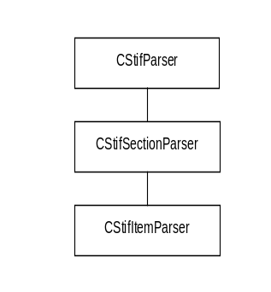
Figure 7.20 STIF Parser Main Classes
STF Parser supports hierarchical parsing for:
- Sections
- Subsections
- Lines
- Strings
- Characters
- Integers
STF Parser also supports INCLUDE command. See the following limitations of this feature:
- INCLUDE keyword must be written in capital letters and must start from the first column of the line.
- File name (with path and extension) must follow INCLUDE command. Rest of line would be ignored.
- All files included from Unicode file should also be in Unicode format (and vice versa).
- Loops in includes are not allowed (for example incorrect situation is when file A includes file B and file B includes file A). In that case, the second include will be ignored, but STF parser will continue working).

CStifParser
The CStifParser class opens and reads test data. The purpose of CStifParser is to parse a required section(s) of the test data. The section(s) may be a whole test data file or some part of the data file. Test data may be given in a text file or a serial port.
Note: Parser is able to read Unicode files. In order to do this, every Unicode file must start with “#UNICODE” keyword.
The main methods of CStifParser are:
- NewL for creating a parser with path and file information (see Table 7.10)
- NewL for creating a parser with buffer information (see Table 7.11)
- SectionL (see Table 7.12 , Table 7.13)
- NextSectionL (see Table 7.21 , Table 7.22)
Table 7.10 NewL for creating a parser with path and file information
Method | Description
NewL | Creating a parser with path and file information.
Parameters | Description
const TDesC& aPath | The source path definition.
const TDesC& aConfig | The test data file name.
TCommentType = ENoComments | Indication of the comment type.  - StifParser::ENoComments: Comments are included with parsing.  - StifParser::ECStyleComments: The user wants to parse sections without c-style comments.
Return value | Description
CStifParser* | CStifParser object.

Table 7.11 NewL for creating a parser with buffer information
Method | Description
NewL | Creating a parser with buffer information.
Parameters | Description
const TDesC& aBuffer | The buffer to be parsed.
TCommentType = ENoComments | Indication of the comment type.  - StifParser::ENoComments: Comments are included with parsing.  - StifParser::ECStyleComments: The user wants to parse sections without c-style comments.
Return value
CStifParser* | CStifParser object.

Table 7.12 SectionL
Method | Description
SectionL | Opens and reads test data and parses a required section.  This method always starts from the beginning of the file and parses the first section if the aSeeked parameter is not given. If the file includes several sections with both start and end tags, the aSeeked parameter seeks the required section. The aSeeked parameter indicates the section that is parsed.  NULL is returned if there is nothing to parse or the value of the aSeeked parameter is 0 or negative.  KErrNotFound is returned if the sought section is not found.
Parameters | Description
const TDesC& aStartTag | Start tag name.  If the start tag is empty, the parsing starts at the beginning of the file.
const TDesC& aEndTag | End tag name.  If the end tag is empty, the parsing goes to the end of the file.
TInt aSeeked = 1 | A section indicator.
Return value | Description
CStifSectionParser* | CStifSectionParser object.

Table 7.13 SectionL
Method | Description
SectionL | Same as above SectionL method but with an extra aIsHasEndTag parameter indicating whether a section has end tag. This is useful cause some legacy data format has only start tag while no end tag at all.  NULL is returned if there is nothing to parse or the value of the aSeeked parameter is 0 or negative.  KErrNotFound is returned if the sought section is not found.
Parameters | Description
const TDesC& aStartTag | Start tag name.  If the start tag is empty, the parsing starts at the beginning of the file.
const TDesC& aEndTag | End tag name.  If the end tag is empty, the parsing goes to the end of the file.
TInt aSeeked | A section indicator.
TBool aIsHasEndTag | A flag if the section has end tag.
Return value | Description
CStifSectionParser* | CStifSectionParser object.

Table 7.14 NextSectionL
Method | Description
NextSectionL | Opens and reads test data and parses the next section after the earlier section.  This method always starts from the beginning of the file and parses the first section if the aSeeked parameter is not given. If the file includes several sections with both start and end tags, the aSeeked parameter seeks the required section. The aSeeked parameter indicates the section that is parsed.  NULL is returned if there is nothing to parse or the value of the aSeeked parameter is 0 or negative.  KErrNotFound is returned if the sought section is not found.
Parameters | Description
const TDesC& aStartTag | Start tag name.  If the start tag is empty, the parsing starts at the beginning of the file.
const TDesC& aEndTag | End tag name.  If the end tag is empty, the parsing goes to the end of the file.
TInt aSeeked = 1 | A section indicator.
Return value | Description
CStifSectionParser* | CStifSectionParser object.

Table 7.15 NextSectionL
Method | Description
NextSectionL | Same as above NextSectionL method but with an extra aIsHasEndTag parameter indicating whether a section has end tag. This is useful cause some legacy data format has only start tag while no end tag at all.  NULL is returned if there is nothing to parse or the value of the aSeeked parameter is 0 or negative.  KErrNotFound is returned if the sought section is not found.
Parameters | Description
const TDesC& aStartTag | Start tag name.  If the start tag is empty, the parsing starts at the beginning of the file.
const TDesC& aEndTag | End tag name.  If the end tag is empty, the parsing goes to the end of the file.
TInt aSeeked | A section indicator.
TBool aIsHasEndTag | A flag if the section has end tag.
Return value | Description
CStifSectionParser* | CStifSectionParser object.

CStifSectionParser
The purpose of CStifSectionParser is to parse the required lines of the section to forward operations.
The main methods of CStifSectionParser are:
- GetItemLineL (see Table 7.16)
- GetNextItemLineL for getting the next line for items parsing (see Table 7.17)
- GetNextItemLineL for getting the next line for items parsing with a tag (see Table 7.18)
- SubSectionL (see Table 7.19)
- NextSubSectionL (see Table 7.20)
- GetLine (see Table 7.21)
- GetNextLine for getting the next line (see Table 7.22)
- GetNextLine for getting the next line with a tag (see Table 7.23)
- GetPosition (see Table 7.24)
- SetPosition (see Table 7.25)

Table 7.16 GetItemLineL
Method | Description
GetItemLineL | Parses a line for items parsing with a tag.  If the line starts or ends with white spaces (line break, space or tabulator), it is not included to parsing.  KerrNotFound is returned if there is nothing to parse.
Parameters | Description
const TDesC& aTag | Tag name.
TTagToReturnValue aTagIndicator = ETag | Tag indicator, which indicates whether the aTag value (if exists) is included to the returned object (i.e. the tag is added by default).
Return value | Description
CStifItemParser* | CStifItemParser object

Table 7.17 GetNextItemLineL for getting the next line for items parsing
Method | Description
GetNextItemLineL | Parses the next line for items parsing.  If the line starts or ends with white spaces (line break, space or tabulator), it is not included to parsing.  GetLine or GetItemLine must be called before the GetNextItemLineL method. If the method is not called, NULL is returned.  KerrNotFound is returned if there is nothing to parse.
Return value | Description
CStifItemParser* | CStifItemParser object.

Table 7.18 GetNextItemLineL for getting the next line for items parsing with a tag
Method | Description
GetNextItemLineL | Parses the next line for items parsing with a tag.  If the line starts or ends with white spaces (line break, space or tabulator), it is not included to parsing.  GetLine or GetItemLine must be called before the GetNextItemLineL method. If the method is not called, NULL is returned.  KerrNotFound is returned if there is nothing to parse.
Parameters | Description
const TDesC& aTag | Tag name.
TTagToReturnValue aTagIndicator = ETag | Tag indicator, which indicates whether the aTag value (if exists) is included to the returned object (i.e. the tag is added by default).
Return value | Description
CStifItemParser* | CStifItemParser object.

Table 7.19 SubSectionL
Method | Description
SubSectionL | Parses subsections from the main section with a start and an end tag.  This method always starts from the beginning of a parsed section and parses the first subsection if the aSeeked parameter is not given. If the parsed section includes several subsections with both start and end tags, the aSeeked parameter seeks the required subsection. The aSeeked parameter indicates the subsections that are parsed.  NULL is returned if there is nothing to parse.  KErrNotFound is returned if the sought section is not found.
Parameters | Description
const TDesC& aStartTag | Start tag name.  If the start tag is empty, the parsing starts at the beginning of the section.
const TDesC& aEndTag | End tag name.  If the end tag is empty, the parsing goes to the end of the section.
TInt aSeeked | A section indicator.
Return value | Description
CStifSectionParser* | CStifSectionParser object.

Table 7.20 NextSubSectionL
Method | Description
NextSubSectionL | Parses the next subsection from the main section with a start and with an end tag.  This method parses the next subsection after the earlier subsection if the aSeeked parameter is not given. If the STIF Parser section includes several subsections with both start and end tags, the aSeeked parameter seeks the required subsection. The aSeeked parameter indicates the subsection that is parsed.  NULL is returned if there is nothing to parse.  KErrNotFound is returned if the sought section is not found.
Parameters | Description
const TDesC& aStartTag | Start tag name.  If the start tag is empty, the parsing starts at the beginning of the section.
const TDesC& aEndTag | End tag name.  If the end tag is empty, the parsing goes to the end of the section.
TInt aSeeked | A section indicator.
Return value | Description
CStifSectionParser* | CStifSectionParser object.

Table 7.21 GetLine
Method | Description
GetLine | Gets a line from a section with a tag.  If a line starts or ends with white spaces (line break, space or tabulator), it is not included to parsing.  KErrNotFound is returned if there is nothing to parse.
Parameters | Description
const TDesC& aTag | Tag name.  If the tag is empty, the parsing starts beginning of the section.
TPtr& aLine | A reference to the parsed line.
TTagToReturnValue aTagIndicator = ETag | Tag indicator, which indicates whether the aTag value (if exists) is included to the aLine reference (i.e. the tag is added by default).
Return value | Description
TInt | An error code and a reference to the parsed line.

Table 7.22 GetNextLine for getting the next line
Method | Description
GetNextLine | Gets the next line.  If the line starts or ends with white spaces (line break, space or tabulator), it is not included to parsing.  GetLine or GetItemLine must be called before the GetNextLine method. If the method is not called, KErrNotReady is returned.  KErrNotFound is returned if there is nothing to parse.
Parameters | Description
TPtr& aLine | A reference to the parsed line.
Return value | Description
TInt | An error code and a reference to the parsed line.

Table 7.23 GetNextLine for getting the next line with a tag
Method | Description
GetNextLine | Gets the next line with a tag.  If a line starts or ends with white spaces (line break, space or tabulator), it is not included to parsing.  GetLine or GetItemLine must be called before the GetNextLine method. If the method is not called, KErrNotReady is returned.  KErrNotFound is returned if there is nothing to parse.
Parameters | Description
const TDesC& aTag | Tag name.  If the tag is empty, the parsing starts beginning of the section.
TPtr& aLine | A reference to the parsed line.
TTagToReturnValue aTagIndicator = ETag | Tag indicator, which indicates whether the aTag value (if exists) is included to the aLine reference (i.e. the tag is added by default).
Return value | Description
TInt | An error code and a reference to the parsed line.

Table 7.24 GetPosition
Method | Description
GetPosition | Gets the current position.
Return value | Description
TInt | The current parsing position, which can be used as a parameter for SetPosition afterwards to go back to the old parsing position.

Table 7.25 SetPosition
Method | Description
SetPosition | This method can be used to set the parsing position, for example. to rewind back to some old position retrieved with GetPosition.  The function returns KErrNone if the parameter is allowed. If the parameter is invalid, the function returns the error code KErrArgument (for example. the parameter value is over the parsed section or negative).
Parameters | Description
TInt aPos | Indicates the position of the section where STIF Parser should go.
Return value | Description
TInt | A Symbian OS error code.

CStifItemParser
The purpose of CStifItemParser is to parse strings, integers and characters.
The main methods of CStifSectionParser are:
- GetString (see Table 7.26)
- GetNextString for getting the next string (see Table 7.27)
- GetNextString for getting the next string with a tag (see Table 7.28)
- GetInt for getting an integer with a tag (see Table 7.29)
- GetNextInt for getting the next integer (see Table 7.30)
- GetNextInt for getting the next integer with a tag (see Table 7.31)
- GetInt for getting an integer with a tag and with the TRadix parameter (see Table 7.32)
- GetNextInt for getting the next integer with the TRadix parameter (see Table 7.33)
- GetNextInt for getting the next integer with a tag and with the TRadix parameter (see Table 7.34)
- GetChar (see Table 7.35)
- GetNextChar for getting the next character (see Table 7.36)
- GetNextChar for getting the next character with a tag (see Table 7.37)
- Remainder (see Table 7.38)
- SetParsingType (see Table 7.39)
- ParsingType (see Table 7.40)
- GetValueOf(see Table 7.41)
Table 7.26 GetString
Method | Description
GetString | Gets a string with a tag.
Parameters | Description
const TDesC& aTag | Tag name.  If the start tag is empty, the first string will be parsed and returned.
TPtr& aString | A reference to the parsed string.
Return value | Description
TInt | An error code and a reference to the parsed string.

Table 7.27 GetNextString for getting the next string
Method | Description
GetNextString | Gets the next string until the separator cuts the parsing.  GetString, GetInt or GetChar must be called before the GetNextString method. If the method is not called, KErrNotReady is returned.  KErrNotFound is returned if there is nothing to parse.
Parameters | Description
TPtr& aString | A reference to the parsed string.
Return value | Description
TInt | An error code and a reference to the parsed string.

Table 7.28 GetNextString for getting the next string with a tag
Method | Description
GetNextString | Gets the next string with a tag until the separator cuts the parsing.  GetString, GetInt or GetChar must be called before the GetNextString method. If the method is not called, KErrNotReady is returned.  KErrNotFound is returned if there is nothing to parse.
Parameters | Description
const TDesC& aTag | Tag name.  If the start tag is empty, the next string will be parsed and returned.
TPtr& aString | A reference to the parsed string.
Return value | Description
TInt | An error code and a reference to the parsed string.

Table 7.29 GetInt for getting an integer with a tag
Method | Description
GetInt | Gets an integer (TInt) with a tag.  Searches for an item from the section and returns an integer after the item until the separator cuts the parsing.  KErrNotFound is returned if there is nothing to parse.
Parameters | Description
const TDesC& aTag | Tag name.  If the start tag is empty, the first integer is parsed and returned.
TInt& aInteger | A reference to the parsed integer.
Return value | Description
TInt | An error code and a reference to the parsed integer

Table 7.30 GetNextInt for getting the next integer
Method | Description
GetNextInt | Gets the next integer (TInt) until the separator cuts the parsing and returns it.  GetString, GetInt or GetChar must be called before the GetNextInt method. If the method is not called, KErrNotReady is returned.  KErrNotFound is returned if there is nothing to parse.
Parameters | Description
TInt& aInteger | A reference to the parsed integer.
Return value | Description
TInt | An error code and a reference to the parsed integer.

Table 7.31 GetNextInt for getting the next integer with a tag
Method | Description
GetNextInt | Gets the next integer (TUint) with a tag until the separator cuts the parsing.  GetString, GetInt or GetChar must be called before the GetNextInt method. If the method is not called, KErrNotReady is returned.  KErrNotFound is returned if there is nothing to parse.
Parameters | Description
const TDesC& aTag | Tag name.  If the start tag is empty, the next integer will be parsed and returned.
TInt& aInteger | A reference to the parsed integer.
Return value | Description
TInt | An error code and a reference to the parsed integer.

Table 7.32 GetInt for getting an integer with a tag and with the TRadix parameter
Method | Description
GetInt | Gets an integer (TUint) with a tag and with TRadix.  If the method is not called, KErrNotReady is returned.  KErrNotFound is returned if there is nothing to parse.
Parameters | Description
const TDesC& aTag | Tag name.  If the start tag is empty, the first integer will be parsed and returned.
TUint& aInteger | A reference to the parsed integer.
TRadix aRadix = EDecimal | The TRadix parameter can convert a number into a different presentation (EBinary, EOctal, EDecimal and EHex).
Return value | Description
TInt | An error code and a reference to the parsed integer.

Table 7.33 GetNextInt for getting the next integer with the TRadix parameter
Method | Description
GetNextInt | Gets the next integer (TUint) with TRadix.  GetString, GetInt or GetChar must be called before the GetNextInt method. If the method is not called, KErrNotReady is returned.  KErrNotFound is returned if there is nothing to parse.
Parameters | Description
TUint& aInteger | A reference to the parsed integer.
TRadix aRadix = EDecimal | The TRadix parameter can convert a number into a different presentation (EBinary, EOctal, EDecimal and EHex).
Return value | Description
TInt | An error code and a reference to the parsed integer.

Table 7.34 GetNextInt for getting the next integer with a tag and with the TRadix parameter
Method | Description
GetNextInt | Gets the next integer (TUint) with a tag and with TRadix.  GetString, GetInt or GetChar must be called before the GetNextInt method. If the method is not called, KErrNotReady is returned.  KErrNotFound is returned if there is nothing to parse.
Parameters | Description
const TDesC& aTag | Tag name.  If the start tag is empty, the next integer will be parsed and returned.
TUint& aInteger | A reference to the parsed integer.
TRadix aRadix = EDecimal | The TRadix parameter can convert a number into a different presentation (EBinary, EOctal, EDecimal and EHex).
Return value | Description
TInt | An error code and a reference to the parsed integer.

Table 7.35 GetChar
Method | Description
GetChar | Gets a character with a tag.  Searches for an item from the section and returns the character after the item.  KErrNotFound is returned if there is nothing to parse.
Parameters | Description
const TDesC& aTag | Tag name.  If the start tag is empty, the first character is parsed and returned.
TChar& aCharacter | A reference to the parsed integer.
Return value | Description
TInt | An error code and a reference to the parsed character.

Table 7.36 GetNextChar for getting next character
Method | Description
GetNextChar | Gets the next character.  GetString, GetInt or GetChar must be called before the GetNextChar method. If the method is not called, KErrNotReady is returned.
Parameters | Description
TChar& aCharacter | A reference to the parsed character.
Return value | Description
TInt | An error code and a reference to the parsed character.

Table 7.37 GetNextChar for getting the next character with a tag
Method | Description
GetNextChar | Gets the next character with a tag until the separator cuts the parsing.  GetString, GetInt or GetChar must be called before the GetNextChar method. If the method is not called, KErrNotReady is returned.  KErrNotFound is returned if there is nothing to parse.
Parameters | Description
const TDesC& aTag | Tag name.  If the start tag is empty, the next character is parsed and returned.
TChar& aCharacter | A reference to the parsed character.
Return value | Description
TInt | An error code and a reference to the parsed character.

Table 7.38 Remainder
Method | Description
Remainder | Gets the remaining strings of the STIF Parser line.  KErrNotFound is returned if there is nothing to parse.
Parameters | Description
TPtrC& aString | A reference to the parsed string.
Return value | Description
TInt | An error code and a reference to the remainder of the parsed line.

Table 7.39 SetParsingType
Method | Description
SetParsingType | Sets the parsing type.  The parsing type can be set before parsing a string with the GetString or GetNextString methods.
Parameters
CStifItemParser::TParsingType aType | The parsing type.  CStifItemParser::TParsingType enumerations:  - CStifItemParser::ENormalParsing  - CStifItemParser::EQuoteStyleParsing  ENormalParsing indicates normal parsing without any modifications to the parsed information. This is the default type.  EQuoteStyleParsing indicates special parsing. This type of parsing gives special meaning to quote (“ “) characters.
Return value
Tint | A Symbian OS error code.

Note 1: CStifItemParser::EQuoteStyleParsing type parsing needs a start quote and an end quote to work correctly. For example, if the end quote is not given, then each string is parsed separately including the first quote: in the “c:\program files line, the first string is “c:\program and the next string is files.
Note 2: In string parsing, where empty quotes without spaces (“”) are used, “” is returned even if CStifItemParser::ENormalParsing or CStifItemParser::EQuoteStyleParsing type of parsing is used. See Example 7.21.
Note 3: If STIF Parser is created with StifParser::ECStyleComments that removes comments, then the following syntax is supported (for more information about STIF Parser creation, see Table 7.10):
- \/\/ changes to //
- \/\* changes to /*
- \*\/ changes to */
For example, the parsed line \/\* This is comments \*\/ becomes /* This is comments */ even if comments parsing is in use.
Example 7.16 Parsed line: c:\program files
SetParsingType( CStifItemParser::ENormalParsing );
GetString( aString ); // aString value is: c:\program
GetNextString( aString ); // aString value is: files

SetParsingType( CStifItemParser::EQuoteStyleParsing );
GetString( aString ); // aString value is: c:\program
GetNextString( aString ); // aString value is: files

Example 7.17 Parsed line: “c:\program files“
SetParsingType( CStifItemParser::ENormalParsing );
GetString( aString ); // aString value is: “c:\program
GetNextString( aString ); // aString value is: files“

SetParsingType( CStifItemParser::EQuoteStyleParsing );
GetString( aString ); // aString value is: c:\program files
GetNextString( aString ); // Error code with KErrNotFound returned

Example 7.18 Parsed line: “c:\\program files“
SetParsingType( CStifItemParser::ENormalParsing );
GetString( aString ); // aString value is: “c:\\program
GetNextString( aString ); // aString value is: files“

SetParsingType( CStifItemParser::EQuoteStyleParsing );
GetString( aString ); // aString value is: c:\\program files
GetNextString( aString ); // Error code with KErrNotFound returned

Example 7.19 Parsed line: “http://www.nokia.com“
STIF Parser is created with StifParser::ECStyleComments(Table 7.10) that remove c-style comments.

SetParsingType( CStifItemParser::ENormalParsing );
GetString( aString ); // aString value is: “http:
GetNextString( aString ); // Error code with KErrNotFound returned

SetParsingType( CStifItemParser::EQuoteStyleParsing );
GetString( aString ); // aString value is: “http:
GetNextString( aString ); // Error code with KErrNotFound returned

Example 7.20 Parsed line: “http:\/\/www.nokia.com“
STIF Parser is created with StifParser::ECStyleComments(Table 7.10) that remove c-style comments.

SetParsingType( CStifItemParser::ENormalParsing );
GetString( aString ); // aString value is: “http://www.nokia.com“
GetNextString( aString ); // Error code with KErrNotFound returned

SetParsingType( CStifItemParser::EQuoteStyleParsing );
GetString( aString ); // aString value is: http://www.nokia.com
GetNextString( aString ); // Error code with KErrNotFound returned

Example 7.21 Parsed line: ""
There is special handling in EQuoteStyleParsing type parsing when empty quotes are in use.

SetParsingType( CStifItemParser::ENormalParsing );
GetString( aString ); // aString value is: ""

SetParsingType( CStifItemParser::EQuoteStyleParsing );
GetString( aString ); // aString value is: ""

Example 7.22 Parsed line: " "
SetParsingType( CStifItemParser::ENormalParsing );
GetString( aString ); // aString value is: "
GetNextString( aString ); // aString value is: "

SetParsingType( CStifItemParser::EQuoteStyleParsing );
GetString( aString ); // Return is KErrNone and aString length is 1

Example 7.23 Parsed line: " string"
SetParsingType( CStifItemParser::ENormalParsing );
GetString( aString ); // aString value is: "
GetNextString( aString ); // aString value is: string"

SetParsingType( CStifItemParser::EQuoteStyleParsing );
GetString( aString ); // aString value is: string (‘ string’ with space)
GetNextString( aString ); // code with KErrNotFound returned

Example 7.24 Parsed line: "string "
SetParsingType( CStifItemParser::ENormalParsing );
GetString( aString ); // aString value is: "string
GetNextString( aString ); // aString value is: "

SetParsingType( CStifItemParser::EQuoteStyleParsing );
GetString( aString ); // aString value is: string (‘string ’ with spaces)
GetNextString( aString ); // code with KErrNotFound returned

Table 7.40 ParsingType
Method | Description
ParsingType | Returns the current parsing type.
Return value
CStifItemParser::TParsingType | The current parsing type.
Table 7.41 GetValueOf
Method | Description
GetValueOf | Get the value by the input key
Parameters
const TDesC& aKey | Name of the key to search in key=value pair.
TDes& aValue | String value storage of search aKey. Set only if aKey found.
Return value
Tint | KErrNone if aKey found and aValue set.  KErrNotFound if invalid key=value pair format or aKey not found at all.  Other system error code if failed to retrieve value and set to aValue.

Using STF Logger for Logging Purposes
This chapter contains the STF Logger API description for guidance on how to use STF Logger for logging purposes.
The purpose of STF Logger is to get information from the modules in order to write different log files or to send information to another data store for example via Bluetooth (for example, there may not be enough memory for logging to a file so the data is sent to an external memory or data store).
Figure 8.21 shows the basic architecture of STF Logger and how it is involved in STF. Test Engine uses STF Logger for Test Server and Test Engine logs. STF Logger can be used when logging from test modules.
Note: The header file StifLogger.H needs to be included for enabling STF Logger usage.

STF Console UI
STF Test Engine
STF Test Server
Test Module
Component under test
STF Logger
Log File
STF Logger
Log File
Figure 8.21 STIF Logger

STF Logger Server
STF provides a C/S-style based logger system. User can use RSTFLogger for logging within different threads. RSTFLogger is also published for users in STFLogger.h.

RSTFLogger
The main methods of RSTFLogger are:
- Connect for connecting STF logging server (see Table 8.42).
- Create for creating logger. Logger settings between [Logger_Defaults] and [End_Logger_Defaults] in testframework.ini will replace user’s parameters’ input (see Table 8.43).
- Create for creating logger using TLoggerSettings as input. User’s logger setting will not be replaced (see Table 8.44).
- Log for logging 16-bit information (see Table 8.45).
- Log for logging 8-bit information (see Table 8.46).
- Log for logging 16-bit information with styling text information (see Table 8.47).
- Log for logging 8-bit information with styling text information (see Table 8.48).
- Log for logging 16-bit information with several parameters (see Table 8.49).
- Log for logging 8-bit information with several parameters (see Table 8.50).
- Log for logging 16-bit information with several parameters and styling text information (see Table 8.51).
- Log for logging 8-bit information with several parameters and styling text information (see Table 8.52).
- Log for logging 16-bit _LIT macro information (see Table 8.53).
- Log for logging 8-bit _LIT macro information (see Table 8.54).
- Log for logging 16-bit _LIT macro information with styling text information (see Table 8.55).
- Log for logging 8-bit _LIT macro information with styling text information (see Table 8.56).
- WriteDelimiter for logging a 16-bit delimiter (see Table 8.57).
- WriteDelimiter for logging an 8-bit delimiter (see Table 8.58).
- SaveData for saving 16-bit data (see Table 8.59).
- SaveData for saving 8-bit data (see Table 8.60).
- CreationResult (see Table 8.61).
- OutputType (see Table 8.62).

Table 8.42 Connect for connecting STF logging server
Method | Description
Connect | connect STF logging server
Parameters
N/A
Return value
Tint | A Symbian error code.

Table 8.43 Create logger
Method | Description
Create | Creates RSTFLogger. Logger settings between [Logger_Defaults] and [End_Logger_Defaults] in testframework.ini will replace user’s parameters’ input.
Parameters
const TDesC& aTestPath | The path to the logged information.
const TDesC& aTestFile | The log name for the information.
TLoggerType aLoggerType = ETxt | The log file type (Etxt, Edata, EHtml.
TOutput aOutput = EFile | The output source (EFile, ERDebug).
TBool aOverWrite = ETrue | An indicator for the file creation mode (overwrite settings).
TBool aWithTimeStamp = ETrue | An indicator for the time stamp.
TBool aWithLineBreak = ETrue | An indicator for line breaks.
TBool aWithEventRanking = EFalse | An indicator for event ranking.
TBool aThreadIdToLogFile = ETrue | An indicator for thread ID adding to the end of the log file.
TBool aCreateLogDir = EFalse | An indicator for directory creation.
TInt aStaticBufferSize = 0 | Specifies the static buffer size for logging.
TBool aUnicode = EFalse | Specifies if file has to be written in Unicode format. Such file will start with FF FE sequence.
Return value
Tint | A Symbian error code.

Table 8.44 Create logger using TLoggerSettings as input
Method | Description
Create | Create for creating logger using TLoggerSettings as input. User’s logger setting will not be replaced.
Parameters
const TDesC& aTestPath | The path to the logged information.
const TDesC& aTestFile | The log name for the information.
TLoggerSettings& aLoggerSettings | Loger settings.
Return value
Tint | A Symbian error code.

Table 8.45 Log for logging 16-bit information
Method | Description
Log | Logs 16-bit information to some storage, for example a text file.
Parameters
const TDesC& aLogInfo | The information to be logged.
Return value
Tint | A Symbian error code.

Table 8.46 Log for logging 8-bit information
Method | Description
Log | Logs 8-bit information to some storage, for example a text file.
Parameters
const TDesC& aLogInfo | The information to be logged.
Return value
Tint | A Symbian error code.

Table 8.47 Log for logging 16-bit information with styling text information
Method | Description
Log | Logs 16-bit information to some storage, for example a text file. There is also a parameter for styling text information such as text color.
Parameters
TInt aStyle | Styling text information.
const TDesC& aLogInfo | The information to be logged.
Return value
Tint | A Symbian error code.

Table 8.48 Log for logging 8-bit information with styling text information
Method | Description
Log | Logs 8-bit information to some storage, for example a text file. There is also a parameter for styling text information such as text color.
Parameters
TInt aStyle | Styling text information.
const TDesC& aLogInfo | The information to be logged.
Return value
Tint | A Symbian error code.

Table 8.49 Log for logging 16-bit information with several parameters
Method | Description
Log | Logs 16-bit information to some storage, for example a text file. In this log, a method may set several parameters.
Parameters
TRefByValue<const TDesC> aLogInfo | The information to be logged (several parameters)
Return value
Tint | A Symbian error code.

Table 8.50 Log for logging 8-bit information with several parameters
Method | Description
Log | Logs 8-bit information to some storage, for example a text file. In this log, a method may set several parameters.
Parameters
TRefByValue<const TDesC> aLogInfo | The information to be logged (several parameters).
Return value
Tint | A Symbian error code.

Table 8.51 Log for logging 16-bit information with several parameters and styling text information
Method | Description
Log | Logs 16-bit information to some storage, for example a text file. There is also a parameter for styling text information such as text color. In this log, a method may set several parameters.
Parameters
TInt aStyle | Styling text information.
const TDesC& aLogInfo | The information to be logged (several parameters).
Return value
Tint | A Symbian error code.

Table 8.52 Log for logging 8-bit information with several parameters and styling text information
Method | Description
Log | Logs 8-bit information to some storage, for example a text file. There is also a parameter for styling text information such as text color. In this log, a method may set several parameters.
Parameters
TInt aStyle | Styling text information.
const TDesC& aLogInfo | The information to be logged (several parameters).
Return value
Tint | A Symbian error code.

Table 8.53 Log for logging 16-bit _LIT macro information
Method | Description
Log | Logs 16-bit _LIT macro information to some storage, for example a text file.
Parameters
const TLitC<S>& aLogInfo | The information to be logged.
Return value
Tint | A Symbian error code.

Table 8.54 Log for logging 8-bit _LIT macro information
Method | Description
Log | Logs 8-bit _LIT macro information to some storage, for example a text file.
Parameters
const TLitC8<S>& aLogInfo | The information to be logged.
Return value
Tint | A Symbian error code.

Table 8.55 Log for logging 16-bit _LIT macro information with styling text information
Method | Description
Log | Logs 16-bit _LIT macro information to some storage, for example a text file. There is also a parameter for styling text information such as text color.
Parameters
TInt aStyle | Styling text information.
const TLitC<S>& aLogInfo | The information to be logged.
Return value
Tint | A Symbian error code.

Table 8.56 Log for logging 8-bit _LIT macro information with styling text information
Method | Description
Log | Logs 8-bit _LIT macro information to some storage, for example a text file. There is also a parameter for styling text information such as text color.
Parameters
TInt aStyle | Styling text information.
const TLitC8<S>& aLogInfo | The information to be logged.
Return value
Tint | A Symbian error code.

Table 8.57 WriteDelimiter for logging a 16-bit delimiter
Method | Description
WriteDelimiter | Logs a 16-bit delimiter.
Parameters
const TDesC& aDelimiter = _L( "#") | The character.
TInt aCount = 60 | The repeat count.
Return value
Tint | A Symbian error code.

Table 8.58 WriteDelimiter for logging an 8-bit delimiter
Method | Description
WriteDelimiter | Logs an 8-bit delimiter.  The 8-bit delimiter includes no default values.
Parameters
const TDesC8& aDelimiter | The character.
TInt account | The repeat count.
Return value
Tint | A Symbian error code.

Table 8.59 SaveData for saving 16-bit data
Method | Description
SaveData | Used when a file or data has to be saved to storage, for example a Web page. 16-bit.
Parameters
TDesC& aData | The information to be saved.
Return value
Tint | A Symbian error code.

Table 8.60 SaveData for saving 8-bit data
Method | Description
SaveData | Used when a file or data has to be saved to a storage, for example a Web page. 8-bit.
Parameters
TDesC& aData | The information to be saved.
Return value
Tint | A Symbian error code.

Table 8.61 CreationResult
Method | Description
CreationResult | Gets the creation result and shows whether the STIF Logger creation was made successfully or if NullOutput is created.
Parameters
TInt& aResult | Returned creation result.
Return value
Tint | A Symbian error code.

Table 8.62 OutputType
Method | Description
OutputType | Gets the output type. Valid only if CreationResult returns KErrNone.
Parameters
CStifLogger::TOutput& aOutputType | Returned output type
Return value
Tint | A Symbian error code.

Logger Macros
A serial of logger macros are defined in STFLogger.h. These macros provide an easy way to log output information. To use logger macros, user needs to declare and open a logger. At the end of logging, user needs to close a logger.
The serial of Logger macros provide user a light way to log, but not full functionality of RSTFLogger. For example, __OPENLOGL only takes directory and file name as input without other configurations; different __LOG macros are provided to receive different numbers of parameters and can receive at maximum of 7 parameters.
Logger macros are defined as below:

- __DECLARE_LOG for declaring a logger (see Table 8.63).
- __OPENLOGL(D, L) for opening a logger (see Table 8.64).
- __CLOSELOG for closing a logger (see Table 8.65).
- __LOG(C) for logging with simple string content (see Table 8.66).
- __LOG1(C, Z) for logging with 1 parameter in formatted string (see Table 8.67).
- __LOG2(C, Z, Y) for logging with 2 parameters in formatted string (see Table 8.68).
- __LOG3(C, Z, Y, X) for logging with 3 parameters in formatted string (see Table 8.69).
- __LOG4(C, Z, Y, X, W) for logging with 4 parameters in formatted string (see Table 8.70).
- __LOG5(C, Z, Y, X, W, V) for logging with 5 parameters in formatted string (see Table 8.71).
- __LOG6(C, Z, Y, X, W, V, U) for logging with 6 parameters in formatted string (see Table 8.72).

Table 8.63
Method | Description
__DECLARE_LOG | Declare a logger.

Table 8.64
Method | Description
OPENLOGL | Open a logger.
Parameters
D | Output directory.
L | Output file name.

Table 8.65
Method | Description
CLOSELOG | Close a logger

Table 8.66
Method | Description
__LOG | Log out with simple string content.
Parameters
C | Log data.

Table 8.67
Method | Description
__LOG1 | Log out with 1 parameter in formatted string.
Parameters
C | Log data.
Z | Log data.

Table 8.68
Method | Description
__LOG2 | Log out with 2 parameters in formatted string.
Parameters
C | Log data.
Z | Log data.
Y | Log data.

Table 8.69
Method | Description
__LOG3 | Log out with 3 parameters in formatted string.
Parameters
C | Log data.
Z | Log data.
Y | Log data.
X | Log data.

Table 8.70
Method | Description
__LOG4 | Log out with 4 parameters in formatted string.
Parameters
C | Log data.
Z | Log data.
Y | Log data.
X | Log data.
W | Log data.

Table 8.71
Method | Description
__LOG5 | Log out with 5 parameters in formatted string.
Parameters
C | Log data.
Z | Log data.
Y | Log data.
X | Log data.
W | Log data.
V | Log data.

Table 8.72
Method | Description
__LOG6 | Log out with 6 parameters in formatted string.
Parameters
C | Log data.
Z | Log data.
Y | Log data.
X | Log data.
W | Log data.
V | Log data.
U | Log data.

Below is an example of how to use log macro:
__DECLARE_LOG
__OPENLOGL("\\LoggerTest\\", "LoggerTest.txt");

_LIT(KLogTest, "__LOG test.");
_LIT(KLogTest1, "__LOG1 test %d.");
_LIT(KLogTest2, "__LOG1 test %d, %S.");
_LIT(KTwo, "Two");

__LOG(KLogTest);
__LOG1(KLogTest1, 1);
__LOG2(KLogTest2, 1, &KTwo);

__LOG1(_L("__LOG1 test %d."),1);
__LOG2(_L("__LOG2 test %d,%S."),1,&KTwo);
__LOG3(_L("__LOG3 test %d,%S,%d."),1,&KTwo,3);
__LOG4(_L("__LOG4 test %d,%S,%d,%d."),1,&KTwo,3,4);
__LOG5(_L("__LOG5 test %d,%S,%d,%d,%d."),1,&KTwo,3,4,5);
__LOG6(_L("__LOG6 test %d,%S,%d,%d,%d,%d."),1,&KTwo,3,4,5,6);

__CLOSELOG

STF Logger API - Legacy
Note: It’s well worth to note that the parser API keeps using “Stif” while not “Stf” prefix in file and class names for backward compatibility with STIF.
Legacy STF Logger is divided into the following classes:
- CStifLogger
The purpose of CStifLogger is to get log or data information and send that forward generating the required form. Basiclly CStifLogger will call RSTFLogger for logging.
- CTxtLogger, CDataLogger and CHtmlLogger
The log or data information may be generated to different forms. The common way is to log information to a basic text file. There is also a possibility to generate a log file in HTML format that is in some cases more readable.
- COutput
A virtual class. The purpose of COutput is to route log or data information to the required output module.
- CFileOutput, CRDebugOutput and CNullOutput
The purpose of the output modules is to write log or data information to a file or serial port. For example, a serial cable, IrDA, or Bluetooth can be used with the serial port to send information to some external storage.

CStifLogger API
As mentioned above, CStifLogger exposes logging interface same as RSTFLogger and internally forward operation calls to RSTFLogger accordingly.
Unlike RSTFLogger, which exposes Connect(), Create() and Close() methods for log server connecting, logger creation and server session close operations, CStifLogger has only NewL() method to create the logger instance. All the other logging operation methods’ signatures are the same as RSTFLogger. See Section 8.1.1.
- NewL for creating STF Logger (see Table 8.73).

Table 8.73 NewL for creating STF Logger
Method | Description
NewL | Creates STF Logger.
Parameters
const TDesC& aTestPath | The path to the logged information.
const TDesC& aTestFile | The log name for the information.
TLoggerType aLoggerType = ETxt | The log file type (Etxt, Edata, EHtml.
TOutput aOutput = EFile | The output source (EFile, ERDebug).
TBool aOverWrite = ETrue | An indicator for the file creation mode (overwrite settings).
TBool aWithTimeStamp = ETrue | An indicator for the time stamp.
TBool aWithLineBreak = ETrue | An indicator for line breaks.
TBool aWithEventRanking = EFalse | An indicator for event ranking.
TBool aThreadIdToLogFile = ETrue | An indicator for thread ID adding to the end of the log file.
TBool aCreateLogDir = EFalse | An indicator for directory creation.
TInt aStaticBufferSize = 0 | Specifies the static buffer size for logging.
TBool aUnicode = EFalse | Specifies if file has to be written in Unicode format. Such file will start with FF FE sequence.
Return value
CStifLogger* | CStifLogger object.

Using Test Scripter for Creating Scripted Test Cases
This chapter describes the usage of Test Scripter for creating scripted test cases.
Test Scripter provides one way to implement scripted test cases. It executes the methods listed in the test case file from the test classes. A test case may use several instances of the test classes concurrently. From the STF point of view, Test Scripter is a test module.
The idea is to implement small test case building blocks to a test class, which are then called from Test Scripter sequentially to create a test case. Small test case building blocks can be used, for example, as API method wrappers. The building blocks can take different parameters to call API methods. Test Scripter is controlled with a scripting language for which this document specifies the vocabulary.
Figure 9.22 depicts a Test Scripter operation. First STF starts a test case by calling RunTestCaseL of Test Scripter. Test Scripter executes the test case from the test case file line by line: First it creates a test class, and then it calls the methods Init, Play and Close sequentially. Finally, Test Scripter deletes the test class instance and returns the test case result to STF.
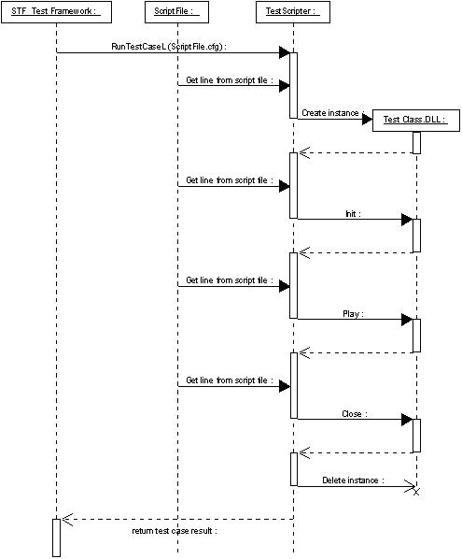
Figure 9.22 Test Scripter operation

Test Script File
The test script file collects the command lines to be executed in test case(s). Each command line is described with a simple scripting language. The test script file may contain several test cases, the descriptions of which start with the tag [Test] and end with the tag [Endtest]. The test case is executed sequentially line by line. The test case itself is described with keywords, arguments and argument value pairs between the start and end tags. An example of a test case is described below.
[Test]
title Create, print, run example and delete
create TestScriptClass test
print Call Example method
test Example pa ra me ters
print Example method called, delete instance
delete test
[Endtest]

The test case title must be given after the title keyword on the first line of the test case definition. In the example above, the create keyword creates a new instance of TestScriptClass, which is named test. The print keyword is used to print information to the UI. The fourth line of the example test case executes the Example method of the test object with four parameters: pa, ra, me and ters. The delete keyword is used to delete the test object.
The test script file and test module initialization file may contain macro definitions used in test cases. Macros are defined inside a define section, which starts with the [Define] tag and ends with the [Enddefine] tag. For example:
[Define]
KErrNotFound -1
EVENT TestScripterEvent
[Enddefine]

Macros can be used on the test case definition’s execution line (i.e., not starting with title, timeout, priority keywords) and they are replaced with defined values before the line is executed. Any isolated string can be replaced. An example test case definition:
[Test]
title Request indication event and test fail case
request EVENT
create TestScriptClass test
allownextresult KErrNotFound
test FailKErrNotFound
delete test
release EVENT
[Endtest]

The test case definition with replaced values would be:
[Test]
title Test indication events and fail case
request TestScripterEvent
create TestScriptClass test
allownextresult -1
test FailKErrNotFound
delete test
release TestScripterEvent
[Endtest]

Macro’s value can also be retrieved from testmodule level. To do this use one of the functions listed below:

TInt GetConstantValue( const TDesC& aName, TDes& aValue );
TInt GetConstantValue( const TDesC& aName, TInt& aValue );
TInt GetConstantValue( const TDesC& aName, TReal& aValue );

Local values can be retrieved from inside the test class as well as set to different value (see var keyword). There is a set of methods, which should be used in such case:

TInt GetLocalValue( const TDesC& aName, TDes& aValue );
TInt GetLocalValue( const TDesC& aName, TInt& aValue );
TInt GetLocalValue( const TDesC& aName, TReal& aValue );
TInt SetLocalValue( const TDesC& aName, const TDesC& aValue );
TInt SetLocalValue( const TDesC& aName, const TInt aValue );
TInt SetLocalValue( const TDesC& aName, const TReal aValue );

The test script file may contain settings definitions used by STF. Settings are defined inside a settings section, which starts with the [StifSettings] tag and ends with the [EndStifSettings] tag. The Settings tags are described in Table 9.74. For example:
[StifSettings]
CapsModifier= example.exe
[EndStifSettings]

Table 9.74 Settings
Tag | Description
CapsModifier= | The name of the caps modifier module. The name can be given with or without the EXE extension.
CheckHeapBalance= | *** This option works only in EKA2 environment ***  Enables or disables memory leak detection in test cases. Possible values are: on and off. By default this feature is disabled.  Note that STF internal memory leaks are also detected. Currently there are no known memory leaks in STF.

The test script file may also contain a section which defines what other test module is included to STF. The section starts with the [New_Include_Module] tag and ends with the [End_Include_Module] tag. The content of this kind of section is exactly the same as the [New_Module] section in STF’s initialization file. For more information, refer to Section 4.4.
Example:

[New_Include_Module]
ModuleName= netmodule
IniFile= c:\testframework\network.ini
TestCaseFile= c:\testframework\ip4cases.cfg
[End_Include_Module]

Setup
Test Scripter is configured for use by adding TestScripter as a test module to STF. The to be executed test script file is added as a test case file for Test Scripter. An example of configuring Test Scripter as a test module can be seen in Section 4.4.2.

Creating a Test Class
A new test class can be easily created with STF Test Module Template Wizard that comes with the STF release.

To create a new test class:
- Go to the \epoc32\tools\s60rndtools\stf\TestModuleTemplates directory.
- Run createtestmodule.BAT.
- Give testclass as ModuleType.
- Enter a name and path for the test class.
A new test class is now created with the given name to the given path. The next step is to create the building block methods to the test class.

To create the building block methods to the test class:
- Implement the building blocks to the \<testclassname>\src\<testclassname>Blocks.CPP file (there is one example method, ExampleL, that can be copy-pasted).
- Add the implemented methods to the C<testclassname> class definition in \<testclassname>\inc\<testclassname>.H (copy-paste ExampleL again).
- Add entry lines for every method to KFunctions in RunMethodL (<testclassname>Blocks.CPP):
ENTRY( "Example", CNameOfTheTestModule::SomeMethodName )
- Build the test class from the \<testclassname>\group directory.
Now the test class is created. The next step is to implement test cases in test script file used by Test Scripter. An example test script file can be found in \<testclassname>\group\Example.CFG. The test script file is constructed using the script language defined in this document.
Copy the test script file to some directory under the C:\ drive (in WINSCW, for example, \epoc32\winscw\c\testframework\<test script file>).
After that, execute the created test cases using, for example, ConsoleUI from the command line:
\epoc32\release\winscw\udeb\CONSOLEUI.EXE -testmodule testscripter -testcasefile C:\testframework\<test script file>
Test classes versions are logged to TestReport.txt. To change the version three #define directives need to be modified:
#define TEST_CLASS_VERSION_MAJOR 1
#define TEST_CLASS_VERSION_MINOR 2
#define TEST_CLASS_VERSION_BUILD 3
The above #define-s will result in such entry in TestReport.txt:
Versions of test modules:
testclass.DLL 1.2.3

For more information about using ConsoleUI, see Section 3.2.

Kernel Testing
Test Scripter also supports testing in kernel space. The steps for creating a kernel mode test class are the following:
- Compile StifKernelTestClassBase from the directory.
- Go to the \epoc32\tools\s60rndtools\stf\TestModuleTemplates directory.
- Run createtestmodule.BAT.
- Give kerneltest as ModuleType.
- Enter a name and path for the test class.
A new kernel test class is now created with the given name to the given path. Then next step is to modify PRJ_PLATFORMS in \<testclassname>\group\bld.INF to include your platform. After that, the next step is to create the building block methods. For instructions, see Section 9.3.
Kernel testing in hardware requires that stifkerneltestclassbase.DLL is added to the system, in addition to normal the STF DLLs. If creating for example a ROM image, add stifkerneltestclassbase.DLL to the image (uncomment the line in the STIFTestFramework.IBY file).

Vocabulary
The Test Scripter vocabulary is composed of keywords and arguments. The keywords are used as the first word in a line of the test case file, and they describe the main operation of the test case file line. The object names can be considered as temporary keywords, which are valid between the line where they are created and the line where they are deleted. The Test Scripter keywords with their arguments are described in the following sections.

General

title
The title keyword is used to give a verbal description for a test case. The description is placed after the keyword. The title keyword is mandatory for every test case and must be placed as the first keyword in the test case description (see Section 9.1). For example:
title Create, print, run example and delete
Note: Due to how STF script parser treats characters, % and “ are special characters to use with title keyword.
- %
Single % is not allowed to use in test case title string. If you do need to present %, use %% so that % will be displayed.
title 50%% load //will display: 50% load

- “
Because STF takes a pair of ““ as string quote marks, single “ is not allowed to use in test case title string. You could use double “” to quote the raw content you want to present but “” themselves would also display as normal characters.
title “case title to display” //will display: “case title to display”
Note: STF engine initialization file has a “AddTestCaseTitle” option which allows test case log file named with test case title as part. Be aware of title naming strategy once this option is enabled. Any violation to Symbian OS file name convention (say too long title, say > 128 or any invalid characters in title, say /?)

timeout
The timeout keyword is used to give a timeout value for a test case. The timeout value is given as an argument for the timeout keyword, as described in Table 9.75 below.
Table 9.75 timeout argument
Argument | Description
Timeout value | The timeout value in milliseconds.

When testing with Test Combiner, Test Scripter timeout is not used. Test Combiner keeps the control of the test case and this is the reason why Test Scripter timeout values will be ignored. If timeout value is wanted to take into use in test case then Test Combiner’s timeout keyword is needed. For more information, see Section 11.3.1.2.
The timeout keyword can be used, for example, in the following way (timeout 10 seconds):
timeout 10000

priority
The priority keyword is used to give a priority for a test case. The priority value is given as an argument for the priority keyword, as described in Table 9.76 below.
Table 9.76 priority argument
Argument | Description
Priority value | The priority value either as an integer or as the string high, normal or low.  Negative values are low and positive values are high. For example, –100 is low, 0 is normal, 100 is high, 1000 is very high.

The priority keyword can be used, for example, in the following ways:
priority high
priority 100
priority –100
priority 0

According to given value, STF sets the execution thread’s priority.

print
The print keyword can be used to print, for example, progress information to the UI. The printed description is placed after the print keyword; see the example in Section 9.1.
Note: Due to how STF script parser treats characters, % and “ are special characters to use with print keyword.
- %
Single % is not allowed to use in test case title string. If you do need to present %, use %% so that % will be displayed.
print 50%% load //will print: 50% load

- “
Because STF takes a pair of ““ as string quote marks, single “ is not allowed to use in test case title string. You could use double “” to quote the raw content you want to present but “” themselves would not display.
print “raw content to print” //will print: raw content to print

setresultdescription
The setresultdescription keyword can be used to set description of currently executed test case. In case of error situation, it will be shown to user in test report.
setresultdescription object creation starts

From inside the test class, there is also possible to set result description. The following method has been added to STF:
SetResultDescription(const TDesC& aDescription);
Note: Setting result description for the second time will overwrite previous value. Only last executed setresultdescription will be reflected in test report.

canceliferror
The canceliferror keyword is used to cancel the execution of the remaining test cases if one of the executed test cases has failed. This keyword is normally used to stop the test case execution when some of the test cases are long running.
Table 9.77 canceliferror argument
Argument | Description
canceliferror | If this keyword is given and one of the executed test cases has failed, the execution of the remaining test cases is cancelled. This keyword is Test Combiner test case specific.

The example below shows how this keyword can be used. The first test case fails and the ongoing execution of the second test case is cancelled.
[Test]
title Simple test case with canceliferror keyword
canceliferror
run testmodule1 myConfig.cfg 1 // test case fails
run testmodule2 mySecondConfig.cfg 2 // long running test case
[Endtest]

Test Case Control

create
The create keyword is used to create a new instance of a test class. The create keyword has two mandatory arguments, which are described in Table 9.78 below.
Table 9.78 create arguments
Argument | Description
Test class name | The test class name for the new object.
Test object name | The name of the created new instance of the test class.

The create keyword can be used, for example, in the following way:
create TestScriptClass test

createkernel
The createkernel keyword is used to create a new instance of a kernel test class. See Section 9.4 for more information about kernel testing. The createkernel keyword has two mandatory arguments, which are described in Table 9.79 below.
Table 9.79 createkernel arguments
Argument | Description
Kernel test class name | The kernel test class name for the new object.
Test object name | The name of the created new instance of the kernel test class.

The createkernel keyword can be used, for example, in the following way:
createkernel TSKernelTest test

delete
The delete keyword is used to delete an instance of a test class. The delete keyword has one mandatory argument, which is described in Table 9.80 below.
Table 9.80 delete argument
Argument | Description
Test object name | The name of the instance of the test class that is deleted.

The delete keyword can be used, for example, in the following way:
delete test

allownextresult
The allownextresult keyword is used to add valid result values for a method and for asynchronous commands. The default value for the expected result is 0, and if a value is set with allownextresult, 0 is removed from the expected values. A method may either return or leave with the specified result. Every method call removes all allowed results. That is, after every method call, the default value 0 is again the only expected result value. Multiple allownextresult keywords can be placed before a method call and before the waittestclass keyword.
Table 9.81 allownextresult argument
Argument | Description
A Symbian OS error codes | A Symbian OS error codes, which is allowed from the next method or waittestclass completion. Multiple error codes, separated by space, can be passed.

The allownextresult keyword can be used, for example, in the following way:
allownextresult –1
allownextresult –1 -5 -12

expectedpanic
The expectedpanic keyword is used to declare valid panic result value for a test case. It indicates that the test case MUST panic with this specified panic code in execution, and only can be used once with a single parameter.
NOTE: expectedpanic does not support UI Testing.
Table 9.82 allowpanic argument
Argument | Description
A panic number | An single integer, which represents the expected panic number.

The expectedpanic keyword can be used, for example, in the following way:
expectedpanic –1

allowerrorcodes
The allowerrorcodes keyword is used to add valid result values for a method and for asynchronous commands. As a default the expected result is 0 and if new value is set with allowerrorcodes, 0 will remain as an expected value. A method may either return or leave with the specified results. Every method call removes all allowed results. That is, after every method call, the default value 0 is again the only expected result value. Multiple allowerrorcodes keywords can be placed before a method call and before the waittestclass keyword.
If using STF’s macros (see Section 14.2.11), it is recommended to use allowerrorcodes keywords in test case file for allowing error codes that are not allowed by macro in test class’s test method (build block).
Table 9.83 allowerrorcodes argument
Argument | Description
A Symbian OS error codes | A Symbian OS error code, which is allowed from the next method or waittestclass completion. Multiple error codes, separated by space, can be passed.

The allowerrorcodes keyword can be used, for example, in the following way:
allowerrorcodes –1
allowerrorcodes –1 -5 -12
Note: This keyword is used to capture the error happened in the test cases. If STF exited unexceptionally, the error can not be captured any more.

waittestclass
The waittestclass keyword is used to pause test case running until the specified test class object calls the Signal function to proceed with the test case execution again. allownextresult can be used before waittestclass to change the expected return value of the asynchronous command. waittestclass has one mandatory argument, which is described in Table 9.88 below.
Table 9.84 waittestclass argument
Argument | Description
Test object name | The name of the instance of the test class, which must call Signal() to proceed with the test case execution.

The waittestclass keyword can be used, for example, in the following way:
waittestclass test

pause
The pause keyword is used to pause test case running for a specified timeout. pause has one mandatory argument, which is described in Table 9.89.
The pause keyword only stops the test case line-runner active object for the specified period. All the other user active objects will continue to be serviced. That is, no further lines of the test case file will be executed during that delay, but the thread is not halted; any user active objects may still be completed and their RunL() called.
Table 9.85 pause argument
Argument | Description
Timeout | The timeout for the pause, specified in milliseconds.

The pause keyword can be used, for example, in the following way:

pause 10000 // pause for 10 seconds

loop
The loop keyword is used to repeat a section of the test case file for the specified number of iterations or time. The section to be repeated is enclosed with the loop and endloop keywords. Nested loops are not supported. The LOOP_COUNTER macro can be used inside a section to retrieve the current loop counter value. The range of LOOP_COUNTER is from 0 to <number of iterations>-1). loop has one mandatory argument, which is described in Table 9.86 below.
Table 9.86 loop argument
Argument | Description
Loop times | The loop count, that is, the number of times that the loop is executed. 0 is incorrect argument for loop. In such case the whole script will be marked as failed.
msec | (optional) This keyword says that ‘Loop times’ argument stands for the time in milliseconds during which loop will be looped.  Note: In run-time, time-outed loop will never break during iteration execution. If time exceeds requested loop time, then currently running iteration is the last one and after it completes, script will continue after endloop..

The loop keyword can be used, for example, in the following way:
loop 5
// execute this 5 times
print LOOP_COUNTER // prints loop counter value, from 0 to <loop times>-1.
endloop

This loop example shows how to run loop for 10 seconds:
loop 10000 msec
// execute this for 10 seconds
print LOOP_COUNTER
endloop

endloop
The endloop keyword is used to specify the end of a looped section (see Section 9.5.2.9).

Object Name
The test object name can be considered as a temporary keyword, which is valid between its creation with the create keyword and its deletion with the delete keyword. The object name is used to call methods from a test object. The method name is given as the first argument for the object name, and the method may have arguments, which are forwarded to the test class method.
For example: TestObjectName MethodName <method arguments 1 2 3>.

Object as Parameter
Now you can use object name as method’s parameter. STF provides below API to get any named objects from dedicated dictionary at run-time.
Table 9.87 CTestModuleIf::GetTestObjFromCaseDict
Method | Description
GetTestObjFromCaseDict | Get named object from case dictionary.
Parameters
const TDesC& aName | Name of query object.
Return value
TScriptObject * | Pointer of found object. NULL if not found.

With above facility API, you could transfer a created object as parameter on another object’s method. See below script:
[Test]
Title test share object
create TestClassA ws
create TestClassB scrdev
ws Connect
scrdev new ws
delete scrdev
delete ws
[EndTest]

In TestClassB’s test method implementation, you could use this API to get pointer of the other object:
TInt CTestClassB::new(CStifItemParser& aItem)
{
TPtrC string;
CTestClassA *ws;
if( aItem.GetNextString ( string ) == KErrNone )
{
ws = TestModuleIf().GetTestObjFromCaseDict(string);
//user test code here
…
}
else
{
return KError;
}
return KErrNone;
}

oomignorefailure
The oomignorefailure keyword is used for OOM testing. Normally, when STF executes method from user’s test class, it checks the execution results and takes an action if result was not as expected (fails test case). With oomignorefailure STF is instructed to ignore any execution result, so script runs further like there was no error at all. This is useful in OOM testing, because test class could return KErrNoMemory error.
Table 9.88 oomignorefailure argument
Argument | Description
Indication for the result check | The possible values are on and off:  - on indicates that the method execution result will be ignored.  - off (default) indicates that the method execution result will be checked and errors will be handled.

The oomignorefailure keyword can be used, for example, in the following way:
oomignorefailure on // among others, KErrNoMemory error code is
// allowed from test class’es method execution

For more information about OOM testing related issues, see Section 14.4.

oomheapfailnext
The oomheapfailnext keyword is used for OOM testing. This keyword defines that heap allocation failure occurs in the test thread.
Table 9.89 oomheapfailnext argument
Argument | Description
Count value (rate) | The failure rate. Heap allocation fails at this time which is given as an argument. Rate is 0-based, which means, that value of 0 stands for first allocation failure, 1 for second, and so on.

The oomheapfailnext keyword can be used, for example, in the following way:
oomheapfailnext 0 // First dynamic allocation from heap is going to be failed

For more information about OOM testing related issues, see Section 14.4.

oomheapsetfail
The oomheapsetfail keyword is used for OOM testing. This keyword defines that heap allocation failure occurs in the test thread. The user can define the failure type and count (rate).
Table 9.90 oomheapsetfail argument
Argument | Description
The type of failure to be simulated | The supported value are:  - random (attempts to allocate from this heap fail at a random rate; however, the interval pattern between failures is the same every time simulation is started)  - truerandom (attempts to allocate from this heap fail at a random rate. The interval pattern between failures may be different every time simulation is started)  - deterministic (attempts to allocate from this heap fail at a rate aRate; for example, if aRate is 2, allocation fails at every third attempt)  - none (cancels simulated heap allocation failure)  - failnext (the next attempt to allocate from this heap fails; for example, if aRate is 2, allocation fails at third attempt)
Count value (rate) | The rate argument is 0-based, which means, that value of 0 stands for first allocation failure, 1 for second, and so on.

The oomheapsetfail keyword can be used, for example, in the following way:
oomheapsetfail deterministic 2 // Allocation fails at every third attempt

For more information about OOM testing related issues, see Section 14.4.

oomheaptonormal
The oomheaptonormal keyword is used for OOM testing. This keyword ends OOM testing and normal testing continues. This keyword can be used to initialize (reset) OOM parameters to the default ones. The oomheaptonormal keyword enables the test class’s building block execution result check and heap failures are not used anymore.
The oomheaptonormal keyword can be used, for example, in the following way:
oomheaptonormal // Initializes OOM related configurations that is set before

The oomignorefailure, oomheapfailnext and oomheaptonormal keywords can be used, for example, in the following way:
create Test object

// e.g. KErrNoMemory error code is allowed from build block and test will
// continue
oomignorefailure ON

// Execute operation between loop and endloop 5 times. Loop starts from 0 to 4.
loop 5

// First loop time the first heap allocation will fail and in the second loop
// time the second heap allocation will fail, etc.
oomheapfailnext LOOP_COUNTER

object DoDynamicAllocationFiveTimes

endloop

// Build block execution result will be checked and error will be handled from
// now on.
oomignorefailure OFF

// This reset ‘oomignorefailure’ to OFF,‘oomheapfailnext’ to 0
// and ‘oomheapsetfail’ to none.
oomheaptonormal

// all heap allocation will be successfully without any allocation failure
object DoDynamicAllocationFiveTimes

delete object

For more information about OOM testing related issues, see Section 14.4.

testinterference
The testinterference keyword is used for test interference testing. The testinterference arguments are described in Table 9.91.
Table 9.91 testinterference arguments
Argument | Description
STF Test Interference object name | Object name that is used for starting and stopping interference operations.
STF Test Interference command | Command for STF Test Interference control.  The supported values are:  - start for starting test interference.  - stop for stopping test interference. It also releases all allocated resources.
STF Test Interference category | Interference category.  The supported values are:  - activeobject  - thread
STF Test Interference type | Interference type.  The supported values are:  - cpuload  - filesystemreadc  - filesystemreadd  - filesystemreade  - filesystemreadz  - filesystemwritec  - filesystemwrited  - filesystemwritee  - filesystemfillandemptyc  - filesystemfillandemptyd  - filesystemfillandemptye
STF Test Interference idle time | Idle time in milliseconds. To pass microseconds use real numbers and ‘.’ ( dot ) as a decimal separator.
STF Test Interference active time | Active time in milliseconds. To pass microseconds use real numbers and ‘.’ ( dot ) as a decimal separator.
STF Test Interference set priority | Optional. Set priority for thread or active object.

The testinterference keyword can be used, for example, in the following ways (testinterference object name, command, category, type, idle, active):
. . .
testinterference object1 start activeobject cpuload 1000 1000
. . .
testinterference object1 stop
. . .

. . .
testinterference object2 start thread cpuload 1000 1000
. . .
testinterference object2 stop
. . .

. . .
#idle = 200 microseconds, active = 2 microseconds
testinterference object1 start activeobject cpuload 0.2 0.002
. . .
testinterference object1 stop
. . .

. . .
#idle = 1200 microseconds, active = 1000 milliseconds
testinterference object2 start thread cpuload 1.2 1000
. . .
testinterference object2 stop
. . .

For more information about Test Interference testing related issues, see Section 14.4.3.

measurement
The measurement keyword is used for test measurement testing. The measurement arguments are described in Table 9.92.
Table 9.92 measurement arguments
Argument | Description
STF Test measurement command | Commad for STF Test Measurement control.  The supported values are:  - start for starting test measurement.  - stop for stopping test measurement. It also releases all allocated resources.
STF Test measurement type | Test measurement type.  The supported values are:  - measurementplugin01  - measurementplugin02  - measurementplugin03  - measurementplugin04  - measurementplugin05  - bappeaprofiler
STF Test measurement parameters | Optional. Test measurement module configuring etc. user and test measurement module specific. This is returned as a descriptor to the test measurement module in Start operation.

The measurement keyword can be used, for example, in the following ways (measurement, command, type, parameters):

. . .
measurement start measurementplugin01
. . .
measurement stop measurementplugin01
. . .

. . .
measurement start measurementplugin02 c:\ConfigurationInfo.txt
. . .
measurement stop measurementplugin02
. . .

For more information about Test Measurement testing related issues, see Section 14.5.

var
The var command allows assigning some text value to specified variable. It can be then used in other part of the script. It is possible to change the already set value by assigning different one to the same variable. The life-time of local variables ends with the end of test case execution.
. . .
var MY_VALUE 1
print MY_VALUE
var MY_VALUE text
print MY_VALUE
. . .

In test class it is possible to read and change value of local variable. For more info about local values, see chapter 9.1.

callsub
The callsub command makes TestScripter executing pointed section of script.
It is possible to pass values between the calling script and script being called by local variables (see section 9.5.2.19).
Section which will be called must start with [Sub name] and end with [EndSub] tags, where name is the identifier of the sub. The execution of the sub will continue until its end is reached. There is possibility to call a sub from another sub.
Note: Be careful of the sub calling sequence to avoid any endless loop on callsub. If it does happen, say sub T1 call sub T2, which then calls T1 to create a loop calling, it’ll run into endless loop.
[Test]
title calldemo
print Starting...
callsub T1
callsub T2
print Finishing...
[Endtest]

[Sub T1]
print Inside T1 sub
callsub T11
[EndSub]

[Sub T11]
print Inside T11 sub
[EndSub]

[Sub T2]
print Inside T2 sub
[EndSub]

Note: callsub uses on-the-sport expanding of the commands in sub definition. When used with some other commands, such as allownextresult, allowerrorcodes, etc., which shall only take effect on right next one command, it might not work like you thought of. See in below example, if any commands in T1 sub, but not the first one return a -1 result, it will not be captured by the framework. This way, allownextresult doesn’t take effect though it is written just before the callsub.
[Test]
title calldemo
print Starting...
allownextresult -1 //monitor right next line command return code
callsub T1
print Finishing...
[Endtest]

[Sub T1]
print T1 sub //the right next command of allownextresult in above test case
creatobject MyClass obj //return -1 but will not captured by allownextresult
[EndSub]

run
The run keyword is used to start a specified test case. It has several mandatory and optional arguments. The mandatory arguments are described in order in Table 9.93.
Table 9.93 run mandatory arguments
Argument | Description
testmodule | The test module name.
configfile | The test case configuration file.
Test case number | The test case number to be executed from configfile.

The optional arguments are described in Table 9.94. The possible default values, which can be changed with these arguments, are listed in brackets.
Table 9.94 run optional arguments
Argument | Description
expect | The expected result (0 = KErrNone).
testid | Test case identification, which is used by other keywords to identify the test case ().  Note: This testid should be unique in one single case. Duplicated testid is not allowed.
ini | The initialization file for test module ().
category | The result category; either normal, leave, panic, exception or timeout.
timeout | Test case timeout (not supported yet).
title | Test case title. If given, following rules must be held:  - if title is given, test case number is ignored (however still must be provided);  - if title contains space chars, then the whole parameter has to be given between quotation marks (e.g. “title=My example with space”);  - test case title must not contain quotation mark (“);  - all normal modules must be 0-base indexed;  - if module has more than one test case which match the title, first one will be run;  - in master slave environment, if module does not have configuration file, dummy.cfg must be given for configfile argument.

The run keyword can be used for example in the following way:
run netmodule net.cfg 5 testid=test1 expect=3 ini=ini.txt
run netmodule net.cfg -1 testid=test1 “title=My test case example”

cancel
The cancel keyword is used to cancel a started test case. The test case is cancelled by immediately killing the thread that executes the test case. The cancel keyword has one mandatory argument as described in Table 9.95.
Table 9.95 cancel mandatory arguments
Argument | Description
testid | The test ID from the run command.

The cancel keyword can be used, for example, in the following way:
cancel test1

pausetest
The pausetest keyword is used to pause a test case. The test case is paused by pausing the thread that executes the test case. The pausetest keyword has one mandatory argument, described in Table 9.96 and one optional argument, described in Table 9.97.
Table 9.96 pausetest mandatory arguments
Argument | Description
Testid | The test ID from the run command.

Table 9.97 pausetest optional arguments
Argument | Description
Time | Pause time in milliseconds. After this time, resume is called automatically (if not given, resume needs to be called explicitly).

The pausetest keyword can be used, for example, in the following way:
pausetest test1 time=10

resume
The resume keyword is used to resume a paused test case. resume has one mandatory argument, described in Table 9.98.
Table 9.98 resume mandatory arguments
Argument | Description
testid | The test ID from the run command.

The resume keyword can be used for, example, in the following way:
resume test1

complete
The complete keyword is used to have a started test case wait to complete. It blocks until the test case has finished. complete has one mandatory argument, described in Table 9.99.
Table 9.99 complete mandatory arguments
Argument | Description
testid | The test ID from the run command.

The complete keyword can be used, for example, in the following way:
complete test1

Event Control
The keywords described in the following sections are used to control STF Event System. For information about STF Event System, see Chapter 7.

request
The request keyword is used to request an event. If someone wants to use an event, it must first be requested, and after that it can be waited. After the event is not used anymore, it must be released.
request has one mandatory argument, which is described in Table 9.100 below.
Table 9.100 request mandatory argument
Argument | Description
Event | The event name.

The request keyword can be used, for example, in the following way:
request Event1

wait
The wait keyword is used to wait for an event. A request must be called before wait, and wait blocks until the requested event is set. wait may proceed immediately if the requested event is a state event and already pending (for example, a phone call is already active). wait has one mandatory argument, which is described in Table 9.101 below.
Table 9.101 wait mandatory argument
Argument | Description
Event | The event name.

The wait keyword can be used, for example, in the following way:
wait Event1

release
The release keyword is used to release an event. Every requested event must be released explicitly when it is not used anymore. release has one mandatory argument, which is described in Table 9.102 below.
Table 9.102 release mandatory argument
Argument | Description
Event | The event name.

The release keyword can be used, for example, in the following way:
release Event1

set
The set keyword is used to set an event. Every set state event must be explicitly unset.
set has one mandatory argument and also one optional argument, as described in Table 9.103 below.
Table 9.103 set arguments
Argument | Description
Event | The event name.
State | Optional. If a state is given, sets the state event, otherwise sets an indication event. A state event remains set until it is unset explicitly with the unset keyword. An indication event is set only once to every requester and implicitly unset after that.

The set keyword can be used, for example, in the following ways:
set Event1
set Event2 state

unset
The unset keyword is used to unset a state event. Every set state event must be unset. Indication events cannot be unset. unset blocks until everyone who has requested the specified event has released the event.
unset has one mandatory argument, which is described in Table 9.104 below.
Table 9.104 unset mandatory argument
Argument | Description
Event | The event name.

The unset keyword can be used, for example, in the following way:

unset Event1

Remote Test Case Control
Test Scripter can control and use slaves when running test cases. A slave can be used for running test cases in master control. Synchronization between test cases can be done using events.
Note: The master cannot see the slave’s event system, and neither can slave see the master’s event system.
[Test]
title Events between master and slave
allocate phone slave
remote slave request event1
remote slave run testscripter c:\testframework\testcasefile.cfg 1
run testscripter c:\testframework\testcasefile2.cfg 2
remote slave wait event1
set event2
remote slave release event1
free slave
[Endtest]

In this example, testscripter allocates the slave phone and starts the slave’s testscripter type of test case. After that a local test case is started, and at some point it starts to wait for event2. STF also starts waiting for event1 from the slave test module. When the slave test case sets event1, testscripter sets event2 for local test case and it can then continue the execution (see Figure 9.23).
sd Interactions
Testscripter test
case #1 (local test
case)
TestScripter
Testscripter test
case #2 (Slave
test case)
ATS server
allocate phone slave
remote slave request event1
remote slave run testscripter c:\testframework\testcasefile.cfg 1
run testscripter c:\testframework\testcasefile2.cfg 2
wait event2
remote slave wait event1
set event1
return result
set event2
return result
remote slave release event1
free slave

Figure 9.23 - Master-slave event sequence diagram

allocate
The allocate keyword is used to allocate a slave, for example for running a test case on a remote phone. It uses Remote Control Protocol (RPC). The slave must always be allocated first before it can be used.
The allocate keyword has two mandatory arguments, described in Table 9.105.
Table 9.105 allocate mandatory arguments
Argument | Description
Slave type | The type of the slave.  STF only supports slave phone. phone indicates that slave phone is also running STF. Other types must be handled by the slave implementation, i.e. when implementing separate support for external network simulator.
Slave name | A unique name for the slave.

The allocate keyword can be used for example in the following way:
allocate phone MySlave

free
Every allocated slave must be freed with free when it becomes unused.
The free keyword has one mandatory argument, described in Table 9.106.
Table 9.106 free mandatory argument
Argument | Description
slave name | The slave name, the same that was given for allocate.

free can be used for example in the following way:

free MySlave

remote
The remote keyword is used to start the execution of a test case in a slave and also to request and release events from the slave. Other test case controlling for remote test cases is done with the same keywords as for the local test cases.
The remote keyword has two mandatory arguments, described in Table 9.107.
Table 9.107 remote mandatory arguments
Argument | Description
Slave name | The slave name, the same that was given for allocate.
Command name | The remote command name (supported: run, request, wait, set, unset, release).

The remote keyword can be used for example in the following ways:
remote MySlave run netmodule net.cfg 5 testid=test1 expect=3 ini=ini.txt
remote MySlave request Event1
remote MySlave wait Event1
remote MySlave set Event1
remote MySlave unsetEvent1
remote MySlave release Event1

The supported remote commands are run, request, release, set, unset and sendreceive. They support the same parameters as the same keywords described in Sections and 9.5.3.
sendreceive is an asynchronous remote command.
Remote sendreceive can be used for example in the following ways:
remote MySlave sendreceive user specifig parameters 1 2 3 etc

Customerized Library Plug-in
Customerized library plug-in provides mechanic to mix-in user’s self-implemented harness functions through STF script file. For more information about customerized library plug-in, see section 14.6.

using
The using keyword is used to load customerized harness library plug-in. After library loaded, user can freely use customized library built-in command script.
It has two mandatory arguments, which are described in Table 9.108 below.
Table 9.108 using arguments
Argument | Description
DLL name | The test harness library name for the new object.
DLL object name | The alias of the created new instance of the test harness library.

The using keyword can be used, for example, in the following way:
using StfFileTestLib.dll file
file Mkdir c:\tmp \\here Mkdir is library built-in harness function

Data Binding
Data binding mechanic allows test case developer to dynamically load data in test case execution through different data file specified in test script. To run the same case with another set of data, you could just “bind” it with another data input.
STF introduces this flexibility for user to write so-called “data-driven” test cases.
The below list how to use this data-binding functionality in STF:

Specify the Data Source

A new introduced [Data] section could be used for this purpose in test script file. See below example:

[Data]
File a_long_file_name.ini da
Section section_A sa

File another_file_name.ini db
Section section_A dba
[Enddata]

[Data] section defines the data source as user wanted.
“File” specifies data file name, “a_long_file_name.ini”, with “da” as a short name for it which can be used below in the script.
“Section” can be used to specify which section will be referred. Also, “sa” is its short name for below usage.
In [Data] section, if only one “File” and “Section” were specified, they could be ignored in data-binding syntax. More than one “File” and “Section” specification can be used. If it’s the case, the data-binding syntax should fully qualify the source path. See next section.

Specify the Bound Data

To bind data inside above data source within test case, user could use below defined naming schema:
[Test]
title Create, print, run example and delete
create TestScriptClass test
print Running test1
test Example $da@sa#key
delete test
[Endtest]

Three specific tags($, @, #) are used to represent different meaning. See Table 9.109 for details:
Table 9.109 tags to bind data
Tag | Description
$ | This tag leads a following specific data file. It can be a short name of above defined file in [Data] section or a full file path.  If it’s ignored, and the [Data] section only defines one “File”, then the “File” contents will be used here. If no or more than one “File” specified in [Data] section, then it’ll be treated as “confusion”.
@ | This tag leads a following specific “Section” in data file. It can be a short name of above defined section in [Data] section.  If it’s ignored, and the [Data] section only defines one “Section”, then the “Section” contents will be used here. If no or more than one “Section” is specified in [Data] section, then it’ll be treated as “confusion”.
# | This tag leads a following specific “Key” defined in $file@section. It can’t be ignored in any case. And all data entry item follows key-value pair paradigm:

The below is an example of above tags’ usage. Suppose we have a data file (mydata.ini) with contents as represented below:

#filename = mydata.ini
[section_1]
key1=value1
key2=value2

And here’s the representation of how to bind key1, key2 data from above data file, inside STF test script file:
#my.script

[Data]
File mydata.ini md
Section section_1 s1
[Enddata]

[Test]
Title demonstration of this new feature
create TestScriptClass test
print Running test1

#the below 3 lines are of same meaning in this scenario
test Example $md@s1#key1 //fully $file@section#key qualifier
test Example @s1#key1 //default $file used
test Example #key1 //both default $file@section used

#two parameters
test Example2 $md@s1#key1 $md@s1#key2

delete test
[Endtest]

UI Testing
The keywords described in the following sections are used in UI controls testing. They can’t be used in standard TestScripter test cases. For more information about UI testing, see Section 14.7.
Note: It is important to remember that presskey (excluding presskey global) or typetext keywords work properly only when UI component is added to AppUi stack. It can be done by adding code presented below to testclass method which creates UI component

CCoeEnv::Static()->AppUi()->AddToStackL( iPointerToUiComponent );

Note: Also in TestClass method which deletes UI component, proper code removing UI component from AppUi stack should be added.

CCoeEnv::Static()->AppUi()->RemoveFromStack( iPointerToUiComponent );

bringtoforeground
The bringtoforeground keyword is used to bring UI component container to foreground described in below.
The bringtoforeground keyword can be used, for example, in the following way:
bringtoforeground

sendtobackground
The sendtobackground keyword is used to send UI component container to background.
The sendtoackground keyword can be used, for example, in the following way:
sendtobackground

presskey
The presskey keyword is used to send key event to tested UI component.
presskey has one mandatory argument, which is described in table below.
Table 9.110 presskey mandatory argument
Argument | Description
Key code | Single character or constant defined in TKeyCode enumeration. Must be defined if keycode and keyscancode is not defined

Table 9.111 presskey optional arguments
Argument | Description
keycode | Numeric value or constant defined in TKeyCode enumeration. If it is defined, then mandatory argument may be omitted
keyscancode | Numeric key value or constant defined in TStdScanCode enumeration. If it is defined, then mandatory argument or keycode argument may be omitted
modifier | One of the constant values defined in TEventModifier enumeration
repeats | Count of auto repeats generated. 0 means an event without repeats. 1 or more means "this many auto repeat events". In most cases this value is ignored and treated as a single event.
local | Sends key event to focused UI control, constructed under CCoeEnv delivered by STF.
global | Sends key event to focused UI control (constructed under any CCoeEnv, not necessarily CCoeEnv delivered by STF) e.g press left softkey of global message box

The presskey keyword can be used, for example, in the following way:

presskey a
presskey 1
presskey EKeyDownArrow
presskey keycode=123
presskey keycode=EKeyDownArrow
presskey x modifier=EModifierShift
presskey keyscancode=123
presskey EKeyDevice0 // press left softkey
presskey local EKeyDevice0 // press left softkey
presskey global EKeyDevice0 // press left softkey

presskey keyword usage with global and local parameters:

presskey EKeyDevice0 // press left softkey in local mode
presskey local EKeyDevice0 // press left softkey in local mode
presskey global EKeyDevice0 // press left softkey in global mode

typetext
The typetext keyword is used to send text to tested UI component.
typetext has one mandatory argument, which is described in table below.
Table 9.112 typetext mandatory argument
Argument | Description
text | Text in quotation marks which should be send to UI component

Table 9.113 presskey optional arguments
Argument | Description
global | Sends text to focused UI control (constructed under any CCoeEnv, not necessarily CCoeEnv delivered by STF) e.g type text in global query dialog box

The typetext keyword can be used, for example, in the following way:

typetext “Text to send”
typetext global “Text to send” // type text in global mode

sendpointerevent
The sendpointerevent keyword is used to send pointer event to tested UI component.
sendpointerevent has three mandatory arguments which are described in table below.
Table 9.114 sendpointerevent mandatory argument
Argument | Description
Event type | Pointer event type. Following pointer even types are supported:  - EButton1  - EButton2  - EButton3  - EPointerMove  - EPointerSwitchOn  - EButton1Down  - EButton1Up  - EButton2Down  - EButton2Up  - EButton3Down  - EButton3Up
x | Pointer x co-ordinate
y | Pointer y co-ordinate

Table 9.115 sendpointerevent optional arguments
Argument | Description
global | Sends pointer event to focused UI control (constructed under any CCoeEnv, not necessarily CCoeEnv delivered by STF) e.g press left softkey of global message box

The sendpointerevent keyword can be used, for example, in the following way:

presskey EButton1 100 100
presskey local EButton1 100 100
presskey global EButton1 100 100

Using STF Event System for Test Cases Synchronization
This chapter describes the use of STF Event System for test cases synchronization.
Note: The header file StifTestEventInterface.H needs to be included for enabling STF Event System usage.

Event Interface for the Test Modules
The event interface for the test modules has one interface function: Event(). For more information, see Section 10.2.

State Events
The state events are used to indicate that some specific state is active or inactive. State events are cached, i.e. their state is stored in Event Server. This means that when a test case requests a state event, the state of the event is checked, and if it is active, the event is set immediately and it remains set as long as it is unset by the one who has set it. If the state is inactive, the event is set for the requesting client immediately after the event is set.
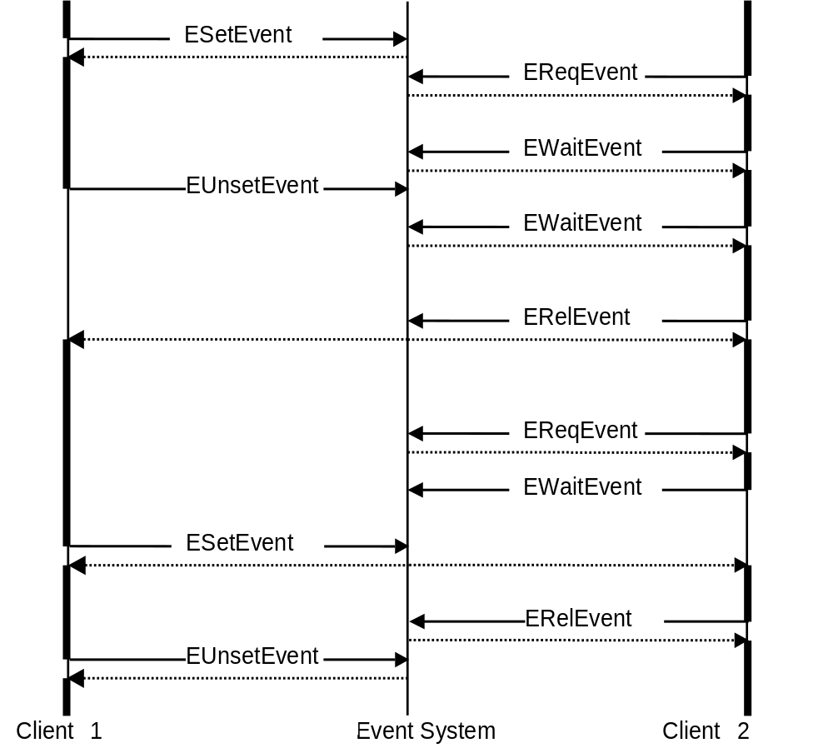
Figure 10.24 State event handling
In Figure 10.24, first client 1 sets a specific state event. Then client 2 requests the event and goes waiting for it. The waiting returns immediately because the event is already set. After some processing, client 2 checks that the event is still active and after waiting returns immediately and proceeds with processing of its tasks. In the meanwhile, client 1 unsets the event, but the unset blocks because client 2 has requested the event. After client 2 releases the event, the unset returns to client 1. Client 2 starts processing again and requests the event again and goes waiting for it. Because the event is unset, the waiting blocks until client 1 sets the event and then the waiting returns to client 2. Then client 2 does its tasks and finally releases the event and client 1 unsets the event.

Indication Events
The indication events are used to send an event that a specific occasion has happened. Indications are not cached, so in order to receive an indication, it must have been requested before the indication event is set.
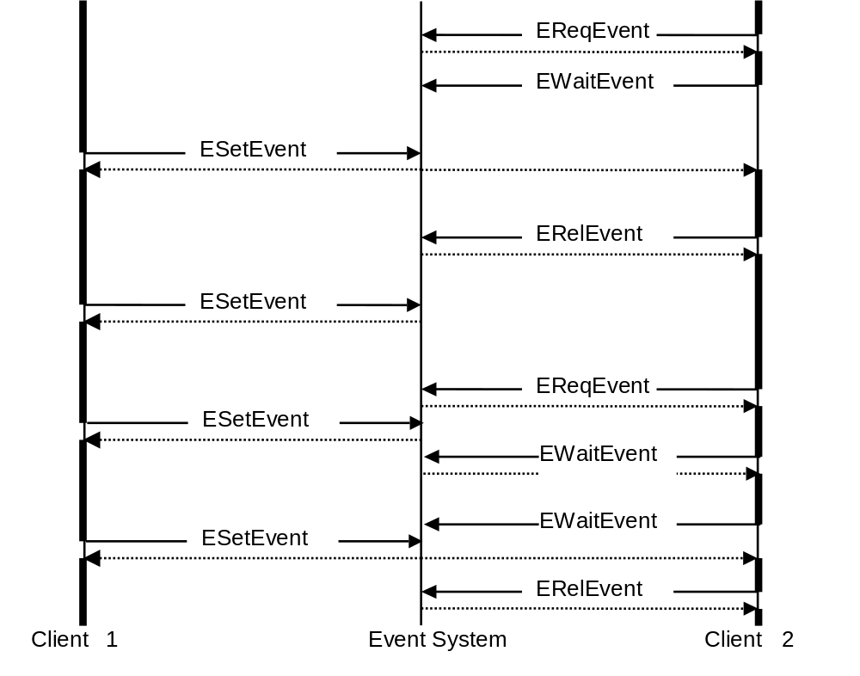
Figure 10.25 Indication event handling
Figure 10.25 depicts the indication event handling. Client 1 sets a specific indication event always after some specific occasion. After client 2 starts, it requests the indication event and goes waiting for it. After client 1 sets the event, the waiting returns to client 2 and it proceeds the processing. After client 2 has done its tasks, it releases the event. Then client 1 sets the event again, but because client 2 has no pending event request, it does not get the event. Next, client 2 requests the event again. Client 1 then sets the event and when client 2 goes waiting for the event, it returns immediately because the event is set. After that, client 2 goes waiting for the event again and the waiting returns to client 2 when client 1 sets the event again. Finally, client 2 releases the event.

STF Event System Usage
STF Event System can be used for various purposes and in different ways. As an example, a state event can be used to indicate when a phone call is active: a state event is set right after the call is connected and unset just before the call is deactivated. Some other test case may request the state event and wait until it is set, then send an SMS and release the state event after that. It is guaranteed that the state remains until the requester releases the event.
An indication event can be used, for example, to indicate that an HTTP packet is received: an indication event is set every time when an HTTP packet has been received. Some other test case may then wait for the indication event and then start heavy loading of the system to interfere with the Web page receiving.
The following is a sample code for setting a state event:
TEventIf event( TEventIf::ESetEvent, _L("TestModuleState1"), TEventIf::EState );
TestModuleIf().Event( event );

The following is a sample code for unsetting a state event:
TEventIf event( TEventIf:: EUnsetEvent, _L("TestModuleState1"), TEventIf::EState );
TestModuleIf().Event( event );

The following is a sample code for setting an indication event:
TEventIf event( TEventIf::ESetEvent, _L("TestModuleIndication1") );
TestModuleIf().Event( event );

The following is a sample code for requesting, waiting and releasing a state event:
TEventIf event( TEventIf::EReqEvent, _L("TestModuleState1"), TEventIf::EState );
TestModuleIf().Event( event );
event.SetType( TEventIf::EWaitEvent );
TestModuleIf().Event( event );
// Do something
event.SetType( TEventIf::ERelEvent );
TestModuleIf().Event( event );

The following is a sample code for requesting, waiting and releasing an indication event:
TEventIf event( TEventIf::EReqEvent, _L("TestModuleIndication1") );
TestModuleIf().Event( event );
event.SetType( TEventIf::EWaitEvent );
TestModuleIf().Event( event );
// Do something
event.SetType( TEventIf::ERelEvent );
TestModuleIf().Event( event );

Test Combiner (for more information, see Chapter 11) also supports STF Event System. The preferred way to use STF Event System is that the test modules provide some events, i.e. set and unset some state events according to the test case state and set some indication events when something happens, and Test Combiner is used to wait for those events and perform some actions (for example run another test case) after the event is set. The following sample Test Combiner test case that uses events (see Chapter 11 for more information) waits that the first test case starts its operation and after that starts another test case that should interfere the first one:
[Test]
title playDTMF, playRaw after started
request EventDTMF
run audiotest test.cfg 5 expect=-21
wait EventDTMF
run audiotest test.cfg 3
release EventDTMF
[Endtest]

When using STF Event System this way, new test cases can easily be generated without modifying the existing test code.

Using Test Combiner for Combining Test Cases
This chapter specifies Test Combiner of STF. Test Combiner is used for running test cases from different test modules and to generate new test cases by combining different test cases possibly from different test modules. Test Combiner is controlled with a scripting language for which this document specifies the vocabulary.
Note: Test Combiner module is deprecated. It is kept only for backward compatibility, and will not be developed in the future. It is strongly recommended to use Test Scripter instead, which gives even more possibilities than Test Combiner.

Test Combiner Test Case File
The Test Combiner test case file defines the commands to be executed in a test case described with a simple scripting language.
The test case file may contain several test cases for which the description starts with a [Test] tag and ends with a [Endtest] tag. The test case itself is described with keywords, arguments and argument value pairs between the start and end tag. For example:
[Test]
title Create net connection and send sms
timeout 10000
priority high
run netmodule net.cfg 4 ini=net.ini
print send sms
run smsmodule sms.cfg 1
[Endtest]

The test case is executed sequentially line by line. Some of the keywords may block execution, for example the complete keyword waits until the test case completes before the execution proceeds to the next line.
The test case file of Test Combiner and the test module initialization file may contain macro definitions used in test cases. Macros are defined inside a define section started with the [Define] tag and ended with the [Enddefine] tag, for example:
[Define]
KErrCancel -3
INIFILE ini.txt
TESTCASEFILE Demo.cfg
ZERO 0
[Enddefine]

Macros can be used in the execution line of the test case definition (i.e. not with title, timeout, priority) and they are replaced with defined values before the line is executed. Any isolated string, or any value from <parameter>=<value> structures can be replaced. The following is an example of a test case definition:
[Test]
title cancel
run demomodule TESTCASEFILE ZERO testid=demo ini=INIFILE expect=KErrCancel
pause demo time=2000
cancel demo
[Endtest]

The run line is also changed before execution:
run demomodule Demo.cfg 0 testid=demo ini= ini.txt expect=-3

The TestCombiner test case file may also contain a section which defines what other test module is included to STF. The section starts with the [New_Include_Module] tag and ends with the [End_Include_Module] tag. The content of this kind of section is exactly the same as [New_Module] section in STF’s initialization file. For more information refer to Section 4.4.
Example:

[New_Include_Module]
ModuleName= netmodule
IniFile= c:\testframework\network.ini
TestCaseFile= c:\testframework\ip4cases.cfg
[End_Include_Module]

Setup
Test Combiner is configured for use by adding Test Combiner as a test module to STF (for example to the STF initialization file) with the test case file specified.

Vocabulary
The Test Combiner vocabulary is composed of keywords and arguments. The keywords are used as the first word in a line of the test case description and they describe the main operation of the test case line. The keywords may have mandatory arguments and also optional arguments. The mandatory arguments are given as values and they have a specified sequence. The optional arguments can be given in any order and they are given with argument-value pairs. The Test Combiner keywords with their arguments are described in the following sections.

General

title
The title keyword is used to give a verbal description for a test case. The description is placed after the keyword. The title keyword is mandatory for every test case and must be placed as the first keyword in the test case description (see the example in Section 11.1).

timeout
The timeout keyword is used to give a timeout value for a test case. The timeout value is given as an argument for the timeout keyword as is described in Table 11.116.
Table 11.116 Timeout argument
Argument | Description
Timeout value | The timeout value in milliseconds.

The timeout keyword can be used, for example, in the following way (a timeout of 10 seconds):
timeout 10000

priority
The priority keyword is used to give a priority for a test case. The priority value is given as an argument for the priority keyword as described in Table 11.117.
Table 11.117 Priority argument
Argument | Description
Priority value | The priority value either as an integer or with the high, normal or low string.  Negative values are low and positive values are high, for example –100 is low, 0 is normal, 100 is high, 1000 is very high.

The priority keyword can be used for example in the following ways:
priority high
priority 100
priority –100
priority 0

print
The print keyword can be used to print, for example, progress information to UI. The printed description is placed after the print keyword; see the example in Section 11.1.

canceliferror
The canceliferror keyword is used to cancel the execution of the remaining test cases if one of the executed test cases has failed. This keyword is normally used to stop the test case execution when some of the test cases are long running.
Table 11.118 canceliferror argument
Argument | Description
canceliferror | If this keyword is given and one of the executed test cases has failed, the execution of the remaining test cases is cancelled. This keyword is Test Combiner test case specific.

The example below shows how this keyword can be used. The first test case fails and the ongoing execution of the second test case is cancelled.
[Test]
title Simple test case with canceliferror keyword
canceliferror
run testmodule1 myConfig.cfg 1 // test case fails
run testmodule2 mySecondConfig.cfg 2 // long running test case
[Endtest]

pausecombiner
The pausecombiner keyword is used to pause test combiner for a specified time. pausecombiner has one mandatory argument, which is described in Table 11.4
The pausecombiner keyword stops the test combiner for the specified period of time.
Table 11.119 pausecombiner argument
Argument | Description
Timeout | The timeout for the pause, specified in milliseconds.

The pause keyword can be used, for example, in the following way:
pausecombiner 10000 // pause for 10 seconds

Test Case Control

run
The run keyword is used to start a specified test case. It has several mandatory and optional arguments. The mandatory arguments are described in order in Table 11.120.
Table 11.120 run mandatory arguments
Argument | Description
testmodule | The test module name.
configfile | The test case configuration file.
Test case number | The test case number to be executed from configfile.

The optional arguments are described in Table 11.121. The possible default values, which can be changed with these arguments, are listed in brackets.
Table 11.121 run optional arguments
Argument | Description
expect | The expected result (0 = KErrNone).
testid | Test case identification, which is used by other keywords to identify the test case ().
ini | The initialization file for test module ().
category | The result category; either normal, leave, panic, exception or timeout.
timeout | Test case timeout (not supported yet).
title | Test case title. If given, following rules must be held:  - if title is given, test case number is ignored (however still must be provided);  - if title contains space chars, then the whole parameter has to be given between quotation marks (e.g. “title=My example with space”);  - test case title must not contain quotation mark (“);  - all normal modules must be 0-base indexed;  - if module has more than one test case which match the title, first one will be run;  - in master slave environment, if module does not have configuration file, dummy.cfg must be given for configfile argument.

The run keyword can be used for example in the following way:
run netmodule net.cfg 5 testid=test1 expect=3 ini=ini.txt
run netmodule net.cfg -1 testid=test1 “title=My test case example”

cancel
The cancel keyword is used to cancel a started test case. The test case is cancelled by immediately killing the thread that executes the test case. The cancel keyword has one mandatory argument as described in Table 11.122.
Table 11.122 cancel mandatory arguments
Argument | Description
testid | The test ID from the run command.

The cancel keyword can be used, for example, in the following way:
cancel test1

pause
The pause keyword is used to pause a test case. The test case is paused by pausing the thread that executes the test case. The pause keyword has one mandatory argument, described in Table 11.123 and one optional argument, described in Table 11.124.
Table 11.123 pause mandatory arguments
Argument | Description
testid | The test ID from the run command.

Table 11.124 pause optional arguments
Argument | Description
Time | Pause time in milliseconds. After this time, resume is called automatically (if not given, resume needs to be called explicitly).

The pause keyword can be used, for example, in the following way:
pause test1 time=10

resume
The resume keyword is used to resume a paused test case. resume has one mandatory argument, described in Table 11.125.
Table 11.125 resume mandatory arguments
Argument | Description
testid | The test ID from the run command.

The resume keyword can be used for, example, in the following way:
resume test1

complete
The complete keyword is used to have a started test case wait to complete. It blocks until the test case has finished. complete has one mandatory argument, described in Table 11.126.
Table 11.126 complete mandatory arguments
Argument | Description
testid | The test ID from the run command.

The complete keyword can be used, for example, in the following way:
complete test1

testmeasurement
The testmeasurement keyword is used for test measurement testing. The testmeasurement arguments are described in Table 11.127.
Table 11.127 testmeasurement arguments
Argument | Description
STF Test measurement command | Command for STF Test Measurement control.  The supported values are:  - start for starting test measurement.  - stop for stopping test measurement. It also releases all allocated resources.
STF Test measurement type | Test measurement type.  The supported values are:  - measurementplugin01  - measurementplugin02  - measurementplugin03  - measurementplugin04  - measurementplugin05  - bappeaprofiler
STF Test measurement parameters | Optional. Test measurement module configuring etc. user and test measurement module specific. This is returned as a descriptor to the test measurement module in start operation.

The testmeasurement keyword can be used, for example, in the following ways (testmeasurement, command, type, parameters):
. . .
testmeasurement start measurementplugin01
. . .
testmeasurement stop measurementplugin01
. . .

. . .
testmeasurement start measurementplugin02 c:\ConfigurationInfo.txt
. . .
testmeasurement stop measurementplugin02
. . .

For more information about Test Measurement testing related issues, see Section 14.5.

loop
The loop keyword is used to repeat a section of the test case file for the specified number of iterations or time. The section to be repeated is enclosed with the loop and endloop keywords. Nested loops are not supported. The LOOP_COUNTER macro can be used inside a section to retrieve the current loop counter value. The range of LOOP_COUNTER is from 0 to <number of iterations>-1). loop has one mandatory argument and some optional features, which are described in Table 11.128.
Table 11.128 loop arguments
Argument | Description
Loop times | The loop count, that is, the number of times that the loop is executed.
msec | (optional) This keyword says that ‘Loop times’ argument stands for the time in milliseconds during which loop will be looped
passlimit | (optional) This keyword turns on passlimit (endurance) feature
Passlimit value | (required and allowed only if passlimit keyword is specified) Says how many iteration must pass to let pass the whole loop

The loop keyword can be used, for example, in the following way:
loop 5
// execute this test case 5 times
run netmodule net.cfg 5 testid=test1 expect=3 ini=ini.txt
complete test1
endloop

This loop example shows how to run loop for 10 seconds:
loop 10000 msec
// execute this for 10 seconds
run netmodule net.cfg 5 testid=test1 expect=3 ini=ini.txt
complete test1
endloop

passlimit option, when specified, tells how many iterations must be passed to let pass the whole loop. If any of the test cases inside the loop fails, the whole iteration fails too. And if the number of passed iterations is lower than passlimit value, test case fails with KErrCompletion (-17) result.
passlimit has one mandatory argument, integer value.

The passlimit option may be used in the following way:

loop 5 passlimit 3
//execute something for 5 times
endloop

endloop
The endloop keyword is used to specify the end of a looped section (see Section 11.3.2.7).

STF Event Control
The keywords described in the following sections are used to control STF Event System. See Chapter 10 for more information.

request
The request keyword is used to request an event. If someone wants to use an event, it must first be requested and after that it can be waited. After the event is not used anymore, it must be released.
The request keyword has one mandatory argument, described in Table 11.129.
Table 11.129 request mandatory arguments
Argument | Description
Event | The event name.

The request keyword can be used for example in the following way:
request Event1

wait
The wait keyword is used to wait an event. request must be called before wait, and wait blocks until the requested event is set. wait may proceed immediately if the requested event is a state event and already pending (for example, a phone call is already active). wait has one mandatory argument, described in Table 11.130.
Table 11.130. wait mandatory arguments
Argument | Description
Event | The event name.

The wait keyword can be used, for example, in the following way:
wait Event1

release
The release keyword is used to release an event. Every requested event must be released explicitly after it is not used anymore. release has one mandatory argument, described in Table 11.131.
Table 11.131 release mandatory arguments
Argument | Description
Event | The event name.

The release keyword can be used for example in the following way:
release Event1

set
The set keyword is used to set an event. Every set state event must be explicitly unset.
set has one mandatory argument, described in Table 11.132, and also one optional argument described in Table 11.133.
Table 11.132. set mandatory arguments
Argument | Description
event | The event name.

Note: If no state is given the set sets indication event.
Table 11.133. set optional arguments
Argument | Description
state | If set to 1, indicates that this is a state event, i.e. it remains set until it is unset explicitly with the unset keyword. If set to 0, indicates that the event is an indication, so it is set only once to every requester and implicitly unset after that.

The set keyword can be used for example in the following way:
set Event1

unset
The unset keyword is used to unset a state event. Every set state event must be unset. Indication events cannot be unset.
unset has one mandatory argument, described in Table 11.134.
Table 11.134 unset mandatory arguments
Argument | Description
event | The event name.

The unset keyword can be used, for example, in the following way:
unset Event1

Remote Test Case Control
Test Combiner can control and use slaves when running test cases. A slave can be used for running test cases in master control. Synchronization between test cases can be done using events.
Note: The master cannot see the slave’s event system, and neither can slave see the master’s event system.
[Test]
title Events between master and slave
allocate phone slave
remote slave request event1
remote slave run testscripter c:\testframework\testcasefile.cfg 1
run testscripter c:\testframework\testcasefile2.cfg 2
remote slave wait event1
set event2
remote slave release event1
free slave
[Endtest]

In this example, testcombiner allocates the slave phone and starts the slave’s testscripter type of test case. After that a local test case is started, and at some point it starts to wait for event2. Testcombiner also starts waiting for event1 from the slave test module. When the slave test case sets event1, testcombiner sets event2 for local test case and it can then continue the execution (see Figure 11.26).
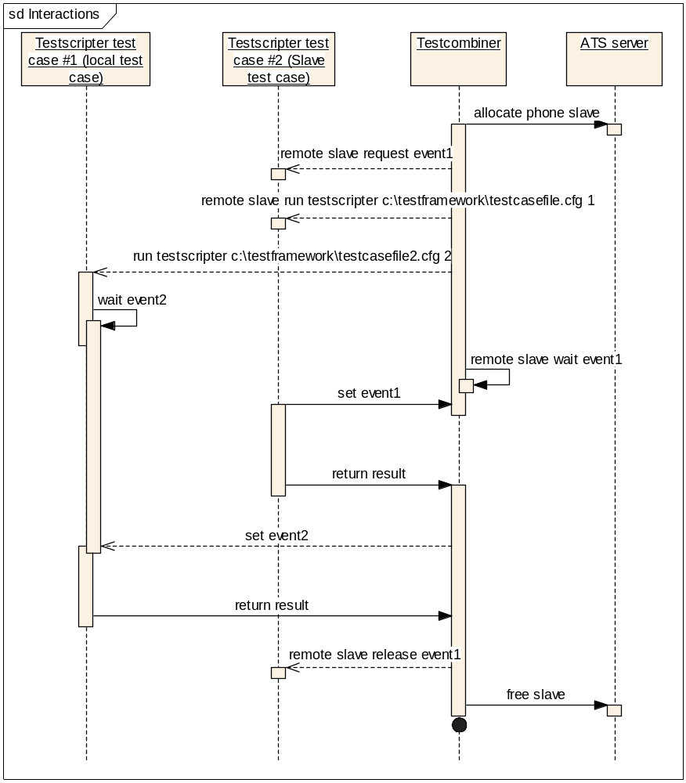

Figure 11.26 - Master-slave event sequence diagram

allocate
The allocate keyword is used to allocate a slave, for example for running a test case on a remote phone. It uses Remote Control Protocol (RPC). The slave must always be allocated first before it can be used.
The allocate keyword has two mandatory arguments, described in Table 11.135.
Table 11.135 allocate mandatory arguments
Argument | Description
Slave type | The type of the slave.  STF only supports slave phone. phone indicates that slave phone is also running STF. Other types must be handled by the slave implementation, i.e. when implementing separate support for external network simulator.
Slave name | A unique name for the slave.

The allocate keyword can be used for example in the following way:
allocate phone MySlave

free
Every allocated slave must be freed with free when it becomes unused.
The free keyword has one mandatory argument, described in Table 11.136.
Table 11.136 free mandatory argument
Argument | Description
slave name | The slave name, the same that was given for allocate.

free can be used for example in the following way:

free MySlave

remote
The remote keyword is used to start the execution of a test case in a slave and also to request and release events from the slave. Other test case controlling for remote test cases is done with the same keywords as for the local test cases.
The remote keyword has two mandatory arguments, described in Table 11.137.
Table 11.137 remote mandatory arguments
Argument | Description
Slave name | The slave name, the same that was given for allocate.
Command name | The remote command name (supported: run, request, wait, set, unset, release).

The remote keyword can be used for example in the following ways:
remote MySlave run netmodule net.cfg 5 testid=test1 expect=3 ini=ini.txt
remote MySlave request Event1
remote MySlave wait Event1
remote MySlave set Event1
remote MySlave unsetEvent1
remote MySlave release Event1

The supported remote commands are run, request, release, set, unset and sendreceive. They support the same parameters as the same keywords described in Sections 11.3.2.1, 11.3.3.1 and 11.3.3.3.
sendreceive is an asynchronous remote command.
Remote sendreceive can be used for example in the following ways:
remote MySlave sendreceive user specifig parameters 1 2 3 etc

Execute TEF Test Cases on STF
TEF, as one of ex-Symbian test tools, will be marked as deprecated and no longer be supported, gradually. TEF test functionalities have been migrated to STF. This provides alternative for testers to execute legacy TEF test cases under STF environment. Also testers could use ATS/STF framework to automatically run TEF testing on phones.
For more information of executing TEF test case on STF, please refer to <HOWTO_Execute_TEF_test_cases_on_STF.doc>

Migration from TEF to STF
As we know, TEF used to be a test harness for implementing test cases, as well as, an execution framework for running test cases within the Symbian development team.
All the TEF functionalities are supported in the STF. Most of the TEF test cases can be migrated seamlessly (just replace some TEF keywords with the STF keywords), and just a few of the TEF test cases need to be modified to work normally in the STF environment. For the more detail information, pls. refer to the document <TEF to STF Migration Guide>.

Other Features
This chapter describes other STF features such as how to work with Platform Security’s Capability feature.

Platform Security
This section describes how Platform Security’s Capability feature can be used when testing with STF.

Caps Modifier Module
The Caps Modifier module is needed for setting the correct capabilities to the test systems. The Caps Modifier module offers a possibility to change the capabilities to correspond to the system under test. A test module’s default capabilities are ALL –TCB, which in most cases means that the Caps Modifier module is not needed. If the system under test needs a different set of capabilities, then the Caps Modifier module is needed. For example, if the system under test needs some special capabilities (for example NetworkServices), the Caps Modifier module where the user can define specific capabilities is needed. This ensures that STF loads the test modules and the system under test properly. Note, that CapsModifier can be used only for limiting capabilities. User will not be able to run test case with ALL capabilities.
The supported Symbian environments that include Platform Security are listed in Table 14.138.Table 14.138 Supported environments
Symbian version | The Caps Modifier module needed if using capabilities in testing
7.0s | No
8.0a | No
8.1b | Yes
9.0 | Yes
9.1 | Yes

Section 14.1.2 describes the STF architecture issues with and without Platform Security.
Section 14.1.3 describes how to set the environment for using the Caps Modifier module.

Architecture
This section describes the STF architecture with and without Platform Security.

STF architecture without Platform Security
Figure 14.27 shows the STF architecture without Platform Security.

STF Test Server

STF UI

STF Test Engine

Component

under test

Test Modul
e

STF Test Server

Test Module

Component

under test

Figure 14.27 STF architecture without Platform Security

STF Architecture with Platform Security
Figure 14.28 shows the STF architecture with Platform Security. The new module is the Caps Modifier module. The Caps Modifier module offers functionality for changing the capabilities that are related to Platform Security.
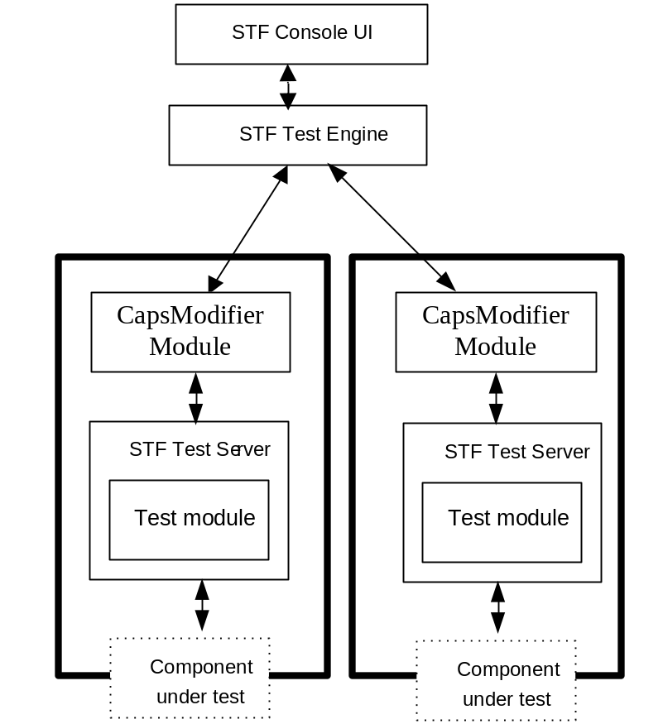
Figure 14.28 STF architecture with Platform Security

Setting up the Caps Modifier Module
This section describes how to set up the Caps Modifier module to STF and to the implemented test system.

Caps Modifier Module Creation
The Caps Modifier module offers a possibility to change capabilities to correspond with the system under test. The Caps Modifier module is created along with the test module. If a test module is implemented, the Caps Modifier module has to be implemented as well. Caps Modifier Module Template Wizard can be used by using the createtestmodule command from \epoc32\tools\s60rndtools\stf\TestModuleTemplates\ to create the template for the Caps Modifier module.
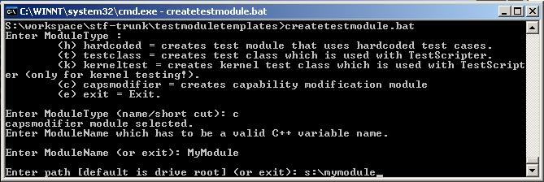
Figure 14.29 Creating a Caps Modifier template
For example, if the user creates a Caps Modifier module named TestNetwork, the wizard adds ‘_exe’ at end of the directory name. The created Caps Modifier module is TestNetwork_exe. When compiling the TestNetwork_exe module, the executed name is TestNetwork.exe (without ‘_exe’).
The Caps Modifier module must have the same name as the test module. For example:
- TestModule.DLL
- TestModule.EXE
Caps Modifiers can also be used with Test Scripter and test class. In the test case file, provide the Caps Modifier module name. According to this definition, user can set an own Caps Modifier module for each test case file.
TestClass.DLL and TestCaseFile.CFG with Caps Module name: for example example.EXE.
The following is an example of a test case file:
[StifSettings]
CapsModifier= example.exe
[EndStifSettings]

If Test Combiner is used, the Caps Modifier module must be named according to the test module.
For example:
- TestModule1.DLL
- TestModule1.EXE
- TestModule2.DLL
- TestModule2.EXE
If Test Scripter is used, the Caps Modifier module must be named as defined in the test case file. For example:
- TestScripter.DLL
- TestClass.DLL
- example.EXE

Configuration
If the Caps Modifier module is created with createtestmodule.BAT, the capabilities have to be changed to the correct ones according to the system under test. The capabilities can be changed from the MMP file’s CAPABILITY sections. The default capability is CAPABILITY ALL -TCB. Normal build operations are needed after the MMP file is changed.
The Caps Modifier module must be set to the correct place in the file system. If Platform Security’s data caging is used, the Caps Modifier module should be in the sys\bin directory. Otherwise, the Caps Modifier module should be in the system\libs directory.
In the WINS environment, the Caps Modifier module is first searched from where other modules exist, for example from the \epoc32\release\winscw\udeb\ directory. If the Caps Modifier module is not found there, it is next looked for in the drives from the a: drive to the z: drive; for example, from the \epoc32\winscw\c\sys\bin\ directory.
TestServerStarter.EXE is used by default, but capabilities cannot be set in this case and the default capability is used.
Symbian flags must be set correctly:
- If data caging is used (for example in the Symbian OS 8.1b Platform Security settings: PlatSecEnforceSysBin ON), the __SECURE_DATA__ flag (for example in Symbian_OS_v8.1b.HRH) must be defined.
- If data caging is not used, the __SECURE_DATA__ flag cannot be defined.

Starting Testing
Using the Caps Modifier module has no effect on the testing start steps. When the capabilities are set correctly and the module is in the correct place in the file system, STF handles the rest of the operations internally.

Boot during a Test Case
This section specifies the making of a boot in a test case and how to store the test case specific states for continuing testing after the boot.
Boot methods are used in test cases and they use the CTestModuleIf interface (STF Test Server and StifTestInterface.DLL).
Before making a reboot, the test case must save the current state with the StoreState() method. The StoreState() method stores the user-specific integer and other information in the descriptor. This and the STF information are written to a text file. STF also adds a module name, a configuration file, a test case number and a test case title to the file. After StoreState(), it is possible to call the Reboot() method, or the test case may reboot the device itself.
The Reboot() method boots the system. For example, when the power is switched on again, STF reads the boot information from the file. According to that information, STF starts the test case that called the reboot operation. When the boot is made, the test case is started and it can call the GetStoredState() method. GetStoredState returns the information that is saved by the test case before the boot, and according to that information, the test case can continue testing, etc. After the GetStoreState operation, the file that includes the boot information is deleted from the file system.

Boot Related Methods
A test case can do a reboot during the test case execution. The methods described in this section can be called from the test case.

StoreState
Table 14.139 StoreState
Method | Description
StoreState | Stores test case specific information.
Parameters
TInt aCode | A test case specific integer.
TName aName | A test case specific descriptor.
Return value
TInt | The returned Symbian OS error code.

StoreState stores test case specific information before rebooting the device. TInt aCode is a test case specific integer value that has a test case specific meaning. TName aName is a test case specific descriptor that has a test case specific meaning.
If the function can store the state, it returns KErrNone. If the function is called more than once, it returns KErrInUse on the second call.
The function stores a list of the ongoing test cases to the file system. All the ongoing test cases except for the current one are changed to the Suspended state.
The test case must call Reboot or do the restarting itself after calling StoreState.

Reboot
Table 14.140 Reboot
Method | Description
Reboot | Reboots the system.
Parameters
TInt aType | The reboot type.
Return value
TInt | The returned Symbian OS error code.

Reboot is a function that restarts the phone. The test case can use this to do a reboot. The reboot type can be specified (i.e. reset, power off).
The function returns KErrNotReady if the StoreState function has not been called earlier.

GetStoredState
Table 14.141 GetStoredState
Method | Description
GetStoredState | Gets stored information after a reboot.
Parameters
TInt& aCode | The test case specific integer that was given before the reboot.
TName& aName | The test case specific descriptor that was given before the reboot.
Return value
TInt | The returned Symbian OS error code.

The function gets the information stored before the reboot with StoreState.
After the reboot, the function returns KErrNone and the parameters aCode and aName contain the information that was saved with calling StoreState before the reboot.
The function returns KErrNotFound if the state was not stored, i.e. reset has not been made.
After this, the boot information is deleted from the file system.

Example
Here are some arbitrary and reduced examples about the test case of a test module. The purpose of the test case is to test that the phone is in the same state after a reboot as it was before the reboot:
TInt CTestReboot::TestCaseRebootExample( TTestResult& aResult )
{

TInt testCaseResult = KErrNone;
const TInt KFirstReboot = 1;
TInt testCaseState( 0 );
TBuf<128> rebootDes;
TInt ret = TestModuleIf().GetStoredState( testCaseState, rebootDes );
if( ret == KErrNotFound )
{
// Reboot is not called, testcase is starting

// Do
// some
// actions
// needed
// before
// reboot

testCaseState = KFirstReboot;
rebootDes.Copy( _L("RebootExample" ) );
// Store test case state before reboot,
// one integer value and one descriptor (max length 128) can be saved
ret = TestModuleIf().StoreState( testCaseState, rebootDes );
if( ret != KErrNone )
{
// StoreState failed -> can not execute testcase
return ret;
}
// Reboot (you can also choose the reboot type with parameter, now
// default reboot is done).
ret = TestModuleIf().Reboot();
if( ret != KErrNone )
{
// Reboot failed -> can not execute testcase
return ret;
}
}
else if( ret == KErrNone )
{
// Reboot was done, continue test case execution after reboot

// Do
// actions
// needed
// after
// reboot
// and set test case result (test case verdict, i.e. passed/failed)
testCaseResult = KErrNone;

// you may also use rebootDes and testCaseState
// to get information stored before reboot

}
else
{
// GetStoredState failed -> can not execute testcase
return ret;
}

// Test case is passed
aResult.iResult = testCaseResult;
return KErrNone;

}

StifHWResetStub Reset Module
If a suitable reset module is not implemented or available, a new reset module has to be implemented. StifHWResetStub can be used as a template for implementing a user-specific reset module.
This module and its operations are used in hardware rebooting. Test module’s test cases that uses reset module cannot be run with Test Combiner.

Introduction
StifHWResetStub offers a template to implement a reset module for STF. The reset module can be renamed and the module is loaded dynamically according to the name given in the STF initialization file (INI).
The test module (a reboot module made by the user) starts the reboot related operations, and STF loads the reset module. The test module may give different kinds of reboot operations, and the reset module implements those operations.
STF Test Engine
Reset Module
Test Module
Figure 14.30 Test module and reset module in STF

Setting up
The STF initialization file includes the [Engine_Defaults] and [End_Defaults] tags. The name of the reset module can be entered between the tags, after the DeviceResetDllName= field. The name of the DLL can be with or without the DLL extension. For example:
DeviceResetDllName= StifHWResetStub.dll

The reset module’s DoReset() is a function which is called from STF and the hardware rebooting starts according to the received parameter that is from the reboot module. Rebooting is hardware specific and needs implementation by the user. If rebooting fails for some reason, STF kills the process as the last option.

Macros
The purpose of the STF macros TL, T1L, T2L, T3L, T4L and T5L is to make testing easier. The macros compare different values. If the values are accepted, the test operation continues. If the values are not accepted, the macro leaves. The macro leave is handled in STF, and the test case goes to the failed category.
When the macro leaves, the test case goes to STF Console UI in the Failed cases section and contains the following information: the code file and the exact line where the failed function is located, and the value that the function returned. Another location where details can be found is in the STF log for all test cases, located in C:\logs\testframework\testreport.TXT. This log contains all the performed test cases in a single test session. Passed cases prompt =>PASSED and failed cases prompt =>FAILED with details of the cause for the failure. The code file and the exact line where the failed function is located and the value that the function returned are provided. This makes the testreport.TXT log very useful to view and distribute with every run STF test. The most detailed information is shown in the RDebug format and the C:\logs\testframework\testserver\ directory’s log files: the code file and the exact line where the failed function is located. Also the returned value and the expected values are seen when using the TxL macros. Function name information can be seen in the WINSCW and hardware environments. If macros are used, all additional debug information is recommended to be printed as Rdebug::Print, so the terminal can be used as a fast source of execution information in test run time.
Note: TL macros (in opposition to TAL macros which are discussed later) do not work with allowerrorcodes command of TestScripter.
The following is an example code without macros:
TInt CTest::OpenApplication( TTestResult& aResult )
{
TInt ret = Open();
if( ret != KerrNone )
{
aResult.SetResult( ret, _L("Error was in the opening the system ") );
}
aResult.SetResult( KErrNone, _L("Application opened succesfully ") );
return KerrNone;

}

If macros are in use, the example above can be done with a tiny amount of coding and results in many enhancements in the testing process:
TInt CTest::OpenApplication( TTestResult& aResult )
{
T1L( Open(), KErrNone );
aResult.SetResult( KErrNone, _L("Application opened succesfully ") );
return KerrNone;

}

TL
The TL macro is a generic macro for comparing Boolean values; it reports only if it is EFalse and shows only the file and line number where it is located as output. The TL macro is used to verify all the functions in the test case code returning a value and to confirm the content of variables, literals, buffers or structures via a easy-to-use, sophisticated and standard way. In addition, it is also used to fast checking of functions and variables. The following is an example use case for the TL macro:
TL( iBuildVersio == 550 );

The example above verifies that iBuildVersio is 550. If this is EFalse, the macro leaves.
Below are some other use cases for the TL macro:
TL( Open() == KErrNone );
TL( VerifyString1() == VerifyString2() );
TL( iBufferSize < 9 );

TL( 6 <= 8 );

T1L
The T1L macro is for verifying an integer value from the user-specific expected value. The macro uses the comma character for separating different parameters. Below is an example use case for the T1L macro:
T1L( iBuildVersio, 550 );

The example above verifies that iBuildVersio is 550. If this is EFalse, the macro leaves. This macro reports also what the value of iBuildVersio actually is and makes isolating, reporting and fixing the error more efficient.
Below are some other use cases for the T1L macro, expected values should be a Symbian error codes not a method calls:
T1L( Open(), KErrNone );
T1L( Open(), KErrAlreadyExists );
T1L( iStatus.Int(), KErrNone );

T2L
The T2L macro is for verifying an integer value from the user-specific expected values. The user can specify two expected values. The macro uses the comma character for separating different parameters. Below are example use cases for the T2L macro, expected values should be a Symbian error codes not a method calls:
T2L( Open(), KErrNone, KErrAlreadyExists );
T2L( iStatus.Int(), KErrNone, KErrAlreadyExists );

T3L
The T3L macro is for verifying an integer value from the user-specific expected value. The user can specify three expected values. The macro uses the comma character for separating different parameters. Below are example use cases for the T3L macro, expected values should be a Symbian error codes not a method calls:
T3L( Open(), KErrNone, KErrAlreadyExists, KErrPathNotFound );
T3L( iStatus.Int(), KErrNone, KErrAlreadyExists, KErrServerBusy );

T4L
The T4L macro is for verifying an integer value from the user-specific expected value. The user can specify four expected values. The macro uses the comma character for separating different parameters. Below are example use cases for the T4L macro, expected values should be a Symbian error codes not a method calls:
T4L( Open(), KErrNone, KErrAlreadyExists, KErrPathNotFound, KErrInUse );
T4L( iStatus.Int(), KErrNone, KErrAlreadyExists. KErrServerBusy, KErrNotReady );

T5L
The T5L macro is for verifying an integer value from the user-specific expected value. The user can specify five expected values. The macro uses the comma character for separating different parameters. Below are example use cases for the T5L macro, expected values should be a Symbian error codes not a method calls:
T5L( Open(), KErrNone, KErrAlreadyExists, KErrPathNotFound, KErrInUse, KErrServerBusy );
T5L( iStatus.Int(), KErrNone, KErrAlreadyExists, KErrServerBusy, KErrNotReady, KErrAbort );

TAL, TA1L, TA2L, TA3L, TA4L and TA5L
TAL, TA1L, TA2L, TA3L, TA4L and TA5L macros give possibility to set allowed error codes before the macro is executed. These new macros can be used similarly like TL, T1L, T2L, T3L, T4L and T5L macros.
The TAL, TA1L, TA2L, TA3L, TA4L and TA5L macros are recommended to use in TestScripter’s test classes. Macros include support for allowing results with allowerrorcodes keyword in test case file. For more information, see Section 9.5.2.5.
Test module API (see Section 6.2) provides to the normal and hardcoded type of test modules the SetAllowResult() and ResetAllowResult() methods via CTestModuleIf. Allowed result for STF Macros can be allowed by using SetAllowResult() method. Allowed result needs to be reset with ResetAllowResult() method after STF Macro execution.

More Macro Use Cases
This section includes more examples about uses cases when developing test cases.
- TL( 8 >= 6 );
- TL( ReturnBoolen() != EFalse ); // NOTE: Cannot compare to ETrue(1). // ETrue is all other but not EFalse(0).
- TInt ret = Open(); // ‘ret’ value is used in test case later.
T2L( ret, KErrNone, KErrAlreadyExists ); // Verify ‘ret’

Heap and Stack Configuring
STF includes possibility to configure the heap and stack sizes for the test thread. If the configuration is not given by the user or if the configuration is invalid, STF uses the default sizes. The default sizes are given with the KTestThreadMinHeap, KTestThreadMaxHeap and KStackSize constants.

Test Module
Before this feature is taken in use, make sure that your test module supports it. This new implementation is added to Test Module Creation Wizard from STIF200509 release onwards. For information on how to modify older test module templates to support the heap and stack feature, see Appendix.
STF uses the test module’s SetRequirements() method for getting the heap and stack sizes. STF calls dynamically SetRequirements() that sets the heap minimum, heap maximum and stack sizes defined by the user.
Method | Description
SetRequirements | For heap and stack definition.
Parameters
CTestModuleParam*& aParam | A class for heap and stack definition.
TUint32& aParameterValid | Verifies that the test module uses the correct version of the heap and stack features. If this does not match, STF uses the default sizes.

The SetRequirements method:
aParameterValid = KStifTestModuleParameterChanged; // For verifying version to
// STF

aParam = CTestModuleParamVer01::NewL(); // Evolution version 1 includes
// heap and stack features.
aParam->iTestThreadStackSize = 16384; // User defined stack size.
aParam->iTestThreadMinHeap = 4096; // User defined minimum heap size.
aParam->iTestThreadMaxHeap = 1048576 // User defined maximum heap size.
When the test module def-file has to be re-generated, it must be ensured that the order of the functions is not changed. The first function must be LibEntryL and the second SetRequirements. If the order is mixed, STF cannot set the heap and stack sizes and the default values will be used. If the def-file needs to freeze, do not remove the old def-file. Freeze your test module using the existing def-file, and the function order should not break.

Test Class
Test classes use test case files for testing. The heap and stack sizes can be defined here using the [StifSettings] and [EndStifSettings] tags. This section includes new tags for defining the heap minimum, heap maximum and stack sizes.
Test case file:
[StifSettings]
TestThreadStackSize= 16384 // 16K stack
TestThreadMinHeap= 4096 // 4K heap min
TestThreadMaxHeap= 1048576 // 1M heap max
[EndStifSettings]

Using Doxygen for Test Module Documentation
The Doxygen documentation system (www.doxygen.org) can be used for generating test module documentation.
For each test module created by STF Test Module Template Wizard, an example Doxygen’s configuration file (<module name>_DoxyFile.TXT) is generated to the group directory of the test module.
If Doxygen’s configuration file <module name>_DoxyFile.TXT does not exist, it can be generated easily by using Doxygen from the command line:

W:\ExampleTestModule\group>doxygen –g ExampleTestModule_DoxyFile.txt
Below is an example on how to use Doxygen and its configuration file for generating documentation for a test module, for example for the audiotest module:

W:\audiotest\group>doxygen audiotest_DoxyFile.txt
Note: If the example configuration file is used, documentation is created in RTF (MS-Word) format as default. The documentation (refman.RTF) is created to the test module’s \Doc folder. After that, refman.RFT needs to be imported to MS Word and renamed as audiotest.DOC (See Figure 14.31).
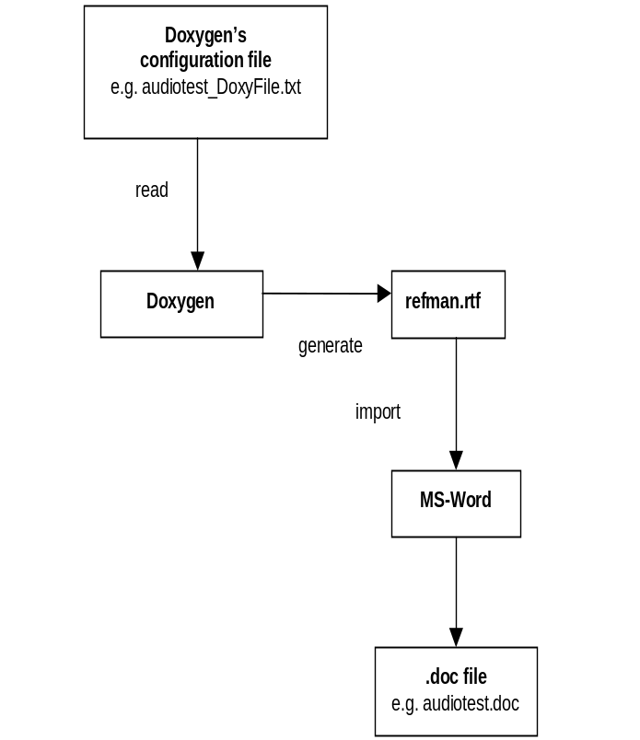
Figure 14.31 Using Doxygen for creating test module documentation

OOM Test Support
STF includes the possibility to define heap allocation failure situations in the test thread. Dynamic allocations from heap can be set to fail with OOM (Out Of Memory) functionality. OOM testing ensures that the system under test behaves correctly when no free heap memory is available.
Note: The debug version of euser.DLL is needed for OOM test support in both debug and release builds.
Note: If an OOM test case uses STF Logger, then STF Logger must be created with the static buffer size parameter (aStaticBufferSize). Otherwise STF Logger allocates memory from heap and therefore causes error situations with OOM testing. For more information about the STF Logger construction, see Chapter 8.

Test Module
OOM test support in normal and hardcoded type of test modules can be taken into use by implementing the virtual methods OOMTestQueryL, OOMTestInitializeL, OOMHandleWarningL and OOMTestFinalizeL (for more information, see Section 6.1).
Note: These methods are virtual and must be implemented only if the test case should be executed using OOM conditions.
There are also two new OOM macros for hardcoded type of test modules: OOM_ENTRY and OOM_FUNCENTRY. If the test case is to be executed using OOM features, then the test case must be added to the KCases array in a hardcoded type of test module’s case method by using these macros.
Method | Description
OOMTestQueryL | The OOMTestQueryL method specifies which test cases are to be executed with OOM conditions.
Parameters
const TFileName& aTestCaseFile | The name of the test case configuration file.
const TInt aCaseNumber | The number of the executed test case.
TOOMFailureType& aFailureType | The OOM failure type. Currently, there is only one type: failnext.
TInt& aFirstMemFailure | The number of the first memory allocation failure.
TInt& aLastMemFailure | The number of the last memory allocation failure.
Return value
TBool | Determines if the test case should be executed using OOM conditions or normally.

Method | Description
OOMTestInitializeL | Test environment specific initializations can be implemented using the OOMTestInitializeL method.
Parameters
const TFileName& aTestCaseFile | The name of the test case configuration file.
const TInt aCaseNumber | The number of the executed test case.

Method | Description
OOMHandleWarningL | There might be situations where OOM testing does not create heap memory allocation failures, for example:  - If the test case does not allocate any memory.  - The memory allocation failure is hidden for example by using a TRAP macro and therefore the test case does not leave.  For these kinds of situations, the user can implement the OOMHandleWarningL method, which is called when a test is executed in OOM and no memory allocation failure happens.
Parameters
const TFileName& aTestCaseFile | The name of the test case configuration file.
const TInt aCaseNumber | The number of the executed test case.
TInt& aFailNextValue | The number of the next heap memory allocation failure.

Method | Description
OOMTestFinalizeL | Used to perform the test environment cleanup for a particular OOM test case.
Parameters
const TFileName& aTestCaseFile | The name of the test case configuration file.
const TInt aCaseNumber | The number of the executed test case

Test Class
A test class uses test case files for testing. OOM testing related issues can be defined in the test case file using the following keywords:
- oomignorefailure (for more information, see Section 9.5.2.13)
- oomheapfailnext (for more information, see Section 9.5.2.14)
- oomheapsetfail (for more information, see Section 9.5.2.15)
- oomheaptonormal (for more information, see Section 9.5.2.16)
OOM testing is based on heap allocation failure. The test case file is parsed by Test Scripter, which uses dynamic allocations from heap in some situations. To avoid Test Scripter’s dynamic allocations during OOM testing, the following limitations should be taken into consideration when implementing the test cases.
- STF Logger in the test class should be created with a static buffer size (for more information, see Section 8.1.1).
- When creating a new instance of a test class in the test case file, the instance should be created before OOM testing, for example in the beginning of the test case.
- When using sub-classing (CallTestClass), Test Scripter forwards operations to another test class object. This operation uses dynamic allocations from heap.
- The Test Scripter test case file and the test module initialization file may contain macro definitions used in the test cases. The definitions between the [Define] and [Enddefine] tags should be given in the beginning of the test case file or before OOM testing.
- When using test Interference feature (testinterference), this operation uses dynamic allocations from heap.

Test Interference Support
STF includes the possibility to interference test execution with different kinds of operations. For example, System CPU load and file system load can be increased by using the test interference support feature. System can be loaded, but also system execution order can be interferenced with Active Object and Threads.
Test Interference support is included to STF’s Test Interface module.

Overview
Test interference can be executed with Active Object (See Figure 14.34) or with Thread (See Figure 14.35). When using test interference, the actual interference is in the same process as the test operation that is executed. If Active Object is used for test interference, these cases use the same thread. Test interference with Thread uses a new thread for interference. If test interference must be used with a different process, TestCombiner is needed for executing test case and test interference.
Using idle and active time features enables the user to create pulse format test interference. Figure 14.32 is an example of pulse format test interference for thread with 1 second idle and 2 seconds active interference.
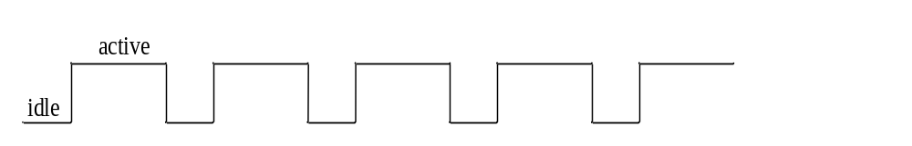
Figure 14.32 Pulse format test interference for thread
Figure 14.33 is an example of pulse format test interference for Active Object with 1 second requested idle and 2 seconds active interference. Note that this idle time duration is always at least the requested time, but it can be more than requested (as in this example), if there are other AOs running at the end of the one period in question. Running of these other AOs is not going to be interrupted, but the RunL method is going to be called immediately after these other AOs are finished.
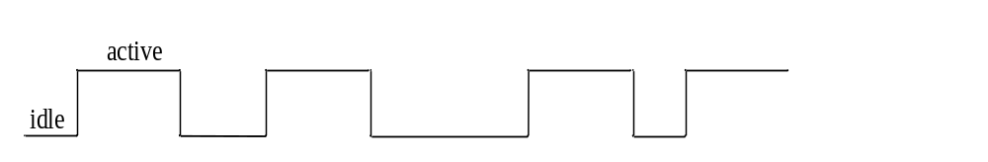
Figure 14.33 Pulse format test interference for Active Object
Note: 0 millisecond idle time is possible. It means that the load generation stops and continues immediately, but the used scheduler may give runtime for other components.
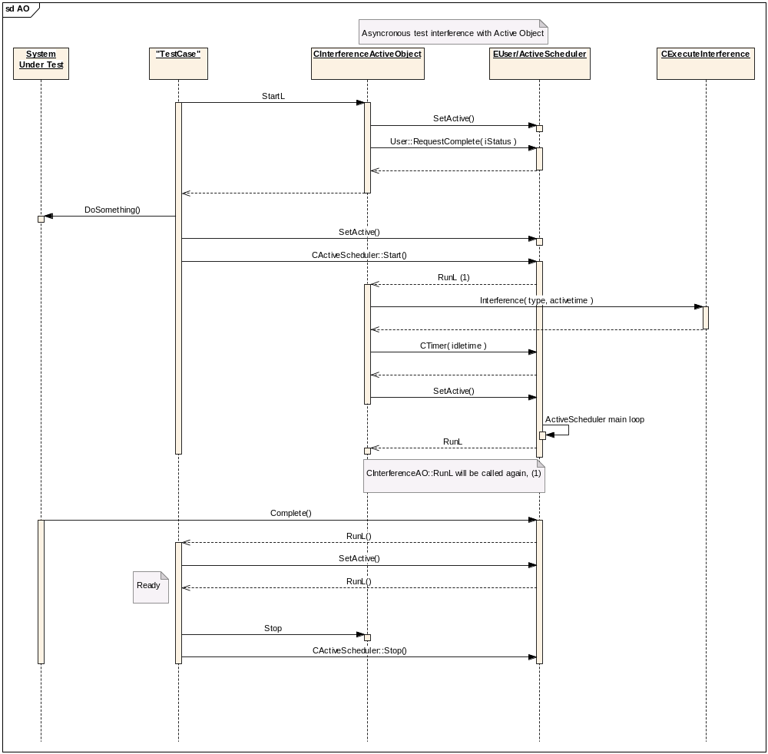
Figure 14.34 Test interference architecture with Active Object
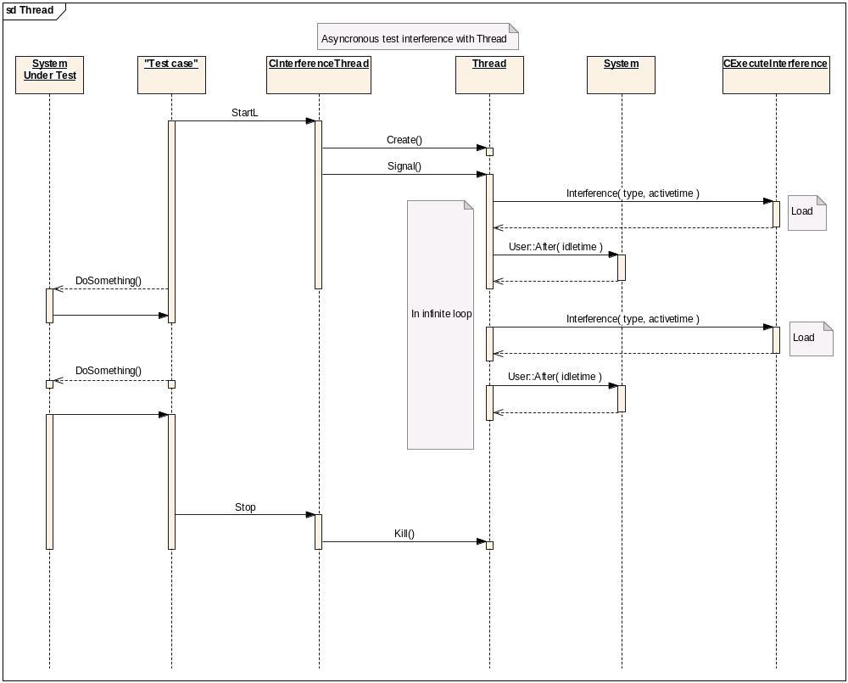
Figure 14.35 Test interference architecture with thread

TestModule
In Normal and Hardcoded type of test modules the StifTestInterference.h header file needs to be included:
#include <StifTestInterference.h>
STF Test Interference functionality is included to the StifTestInterface library, and this library is already used in test module templates (LIBRARY stiftestinterface.lib).
The main methods of MSTIFTestInterference are:
- NewL for creating STF test interference (see Table 14.142).
- StartL for starting test interference (see Table 14.143).
- Stop for stopping test interference (see Table 14.144).
- SetPriority for changing priorities (see Table 14.145).
Table 14.142 NewL for creating STF test interference
Method | Description
MSTIFTestInterference::NewL | Creates the STF test interference object.
Parameters
CTestModuleBase* aTestModuleBase | CTestModuleBase object (TestModule is inherited from CTestModuleBase).
TStifTestInterferenceCategory aCategory | Defines category of the interference.  Supported values:  - EActiveObject  - EThread
Return value
MSTIFTestInterference* | MSTIFTestInterference object.

Table 14.143 StartL for starting test interference
Method | Description
StartL | Starts the interference operation.
Parameters
TStifTestInterferenceType aType | Defines type of interference.  Supported values:  - ECpuLoad  - EFileSystemReadC  - EFileSystemReadD  - EFileSystemReadE  - EFileSystemReadZ  - EFileSystemWriteC  - EFileSystemWriteD  - EFileSystemWriteE  - EFileSystemFillAndEmptyC  - EFileSystemFillAndEmptyD  - EFileSystemFillAndEmptyE  - ECpuLoadMicroSeconds  - EFileSystemReadCMicroSeconds  - EFileSystemReadDMicroSeconds  - EFileSystemReadEMicroSeconds  - EFileSystemReadZMicroSeconds  - EFileSystemWriteCMicroSeconds  - EFileSystemWriteDMicroSeconds  - EFileSystemWriteEMicroSeconds  - EFileSystemFillAndEmptyCMicroSeconds  - EFileSystemFillAndEmptyDMicroSeconds  - EFileSystemFillAndEmptyEMicroSeconds
TInt aIdleTime | Idle time in milliseconds. If aType contains MicroSeconds in name, then idle time is interpreted as microseconds.
TInt aActiveTime | Active time in milliseconds. If aType contains MicroSeconds in name, then active time is interpreted as microseconds.
Return value
TInt | A Symbian error code.

Table 14.144 Stop for stopping test interference
Method | Description
Stop | Stops the interference operation.
Parameters
None
Return value
TInt | A Symbian error code.

Table 14.145 SetPriority for changing priorities
Method | Description
SetPriority | Changes the priority for Active Object or Thread.  Priority cannot be changed when using Active Object and StartL is called. In this case the KErrGeneral error code will be returned.  In Thread cases, the priority value can be called after StartL. Make sure that the correct priority values are used; otherwise panics occur.
Parameters
TInt aPriority | Priority value.
Return value
TInt | A Symbian error code.

TestClass
A test class uses test case files for testing. Test interference related issues can be defined in the test case file using the testinterference keyword (for more information, see Section 9.5.2.17).

Test Interference Examples
The following two examples are implemented by using hardcoded testmodule templates. In general this same functionality can also be used when implementing building blocks for test classes.
Example 14.25 Test interference with Active Object
TInt CTestModule::InterferenceExample1( TTestResult& aResult )
{
// Construct and install active scheduler
CActiveScheduler* iActiveScheduler = new CActiveScheduler;
CActiveScheduler::Install( iActiveScheduler );

MSTIFTestInterference* interference =
MSTIFTestInterference::NewL( this,
MSTIFTestInterference::EActiveObject );

interference->StartL( MSTIFTestInterference::ECpuLoad, 5, 5 );

// To pass idle/active time in microseconds call
// interference->StartL( MSTIFTestInterference::ECpuLoadMicroSeconds, 5000,
// 5000 );

// Do something, construct active object that runs actual test case
// and stop activescheduler when test operation is finished

RDebug::Print( _L( "Do test operations…." ) );

interference->Stop();

delete interference;

delete iActiveScheduler;

_LIT( KDescription, "Example1 passed" );
aResult.SetResult( KErrNone, KDescription );
return KErrNone;

}

Example 14.26 Test interference with Thread
TInt CTestModule::InterferenceExample2 ( TTestResult& aResult )
{

MSTIFTestInterference* interference =
MSTIFTestInterference::NewL( this,
MSTIFTestInterference::EThread );

interference->StartL( MSTIFTestInterference::ECpuLoad, 5, 5 );

// To pass idle/active time in microseconds call
// interference->StartL( MSTIFTestInterference::ECpuLoadMicroSeconds, 5000,
// 5000 );

RDebug::Print( _L( "Do test operations…." ) );

interference->Stop();

delete interference;

_LIT( KDescription, "Example2 passed" );
aResult.SetResult( KErrNone, KDescription );
return KErrNone;
}

Test Measurement Support
STF includes the possibility to measure a test’s operations through different kind of measurement modules. STF offers generic environment for the users to create their own type of measurement. For example, STF provides the StifTestMeasurementStub stub that can be used as a template for creating the measurement module. STF gives interface to measurement module in Hardcoded, and Test Scripter type of test modules.

Overview
STF Test Measurement support offers interface for test modules, see Figure 14.36. Via this interface the measurement type can be defined. Test measurement module is implemented by the user, and via CSTIFTestMeasurement’s NewL method it can be called for initializing test measurement module. Start and Stop methods are used for handle measurement start and stop operations. In TestScripter’s, STF offers keyword for test measurement operations.

cd STF Test Measurement
CStifTestMeasurement
+
NewL(CTestModuleBase* aTestModuleBase, TSTIFMeasurement aType, const TDesC& aConfigurationInfo)() : CStifTestMeasurement
+
Start() : TInt
+
Stop() : TInt
TestModule(Normal/Hardcoded)
TestScripter
TestCombiner
STF
STF MeasurementPlugin01
Measurement tool
STF MeasurementPlugin02
Measurement tool X
STF MeasurementPlugin03
User's implemented test measurement module
according to STIFTestMeasurementStub

Figure 14.36 TestMeasurement architecture
If test case includes Test Measurement operations they can be disabled from TestFramework.ini file. This can be used when used environment does not include measurement tools etc. If the Test Measurement operation fails for some reason (insufficient environment, error cases, etc) then test case should fail. In fail cases the user can see that measurement is not executed and the problem can be investigated and corrected. If error occurs in TestScripter or TestCombiner cases, the test case fails automatically. In Hardcoded cases the user can handle error situations by itself.

TestModule
In Hardcoded type of test module Test Measurement operations are used in test cases and they use the CTestModuleIf interface (STF Test Server and StifTestInterface.dll).
The main methods of CStifTestMeasurement are:
- NewL for initializing and loading Test Measurement module (see Table 14.146).
- Start for starting test measurement (see Table 14.147).
- Stop for stopping test measurement (see Table 14.148).
Table 14.146 NewL for initializing and loading Test Measurement
Method | Description
CSTIFTestMeasurement::NewL | Creates STF test measurement object
Parameters
CTestModuleBase* aTestModuleBase | CTestModuleBase object (TestModule is inherited from CTestModuleBase).
TSTIFMeasurement aType | Defines test measurement module type.  Supported values:  - KStifMeasurementPlugin01  - KStifMeasurementPlugin02  - KStifMeasurementPlugin03  - KStifMeasurementPlugin04  - KStifMeasurementPlugin05  - KStifMeasurementBappeaProfiler
const TDesC& aConfigurationInfo | User configuration informations. Used etc. in initializations.
Return value
CSTIFTestMeasurement * | CSTIFTestMeasurement object.

Table 14.147 Start for starting test measurement
Method | Description
Start | Starts the measurement operation.
Parameters
None
Return value
TInt | A Symbian error code.

Table 14.148 Stop for stopping test measurement
Method | Description
Stop | Stops test measurement operation.
Parameters
None
Return value
TInt | A Symbian error code.

The following two examples are implemented by using hardcoded test module templates.
Example 14.27 Test measurement with KStifMeasurementPlugin01 in generally without error checks
TInt CTestModule::TestMeasurementExample1( TTestResult& aResult )
{
_LIT( KConfigurationInfo, " C:\\MeasurementSettings.txt" );

CSTIFTestMeasurement* measurement = CSTIFTestMeasurement::NewL(
this,
CSTIFTestMeasurement::KStifMeasurementPlugin01,
KConfigurationInfo ) );

measurement->Start();

// Testing operations and measurement

measurement->Stop();

delete measurement;

_LIT( KDescription, "Example1 passed" );
aResult.SetResult( KErrNone, KDescription );
return KErrNone;

}

Example 14.28 Test measurement with KStifMeasurementPlugin01 in general
TInt CTestModule::InterferenceExample2 ( TTestResult& aResult )
{
_LIT( KConfigurationInfo, " C:\\MeasurementSettings.txt" );

CSTIFTestMeasurement* measurement = NULL;

TRAPD( ret, measurement = CSTIFTestMeasurement::NewL(
this,
CSTIFTestMeasurement::KStifMeasurementPlugin01,
KConfigurationInfo ) );
if( ret != KErrNone )
{
_LIT( KDescription1, "Measurement loading or initialization fails" );
aResult.SetResult( ret, KDescription );
return ret;
}
ret = measurement->Start();
{
_LIT( KDescription2, "Measurement start fails" );
aResult.SetResult( ret, KDescription2 );
return ret;
}

// Testing operations and measurement

ret = measurement->Stop();
{
_LIT( KDescription3, "Measurement stop fails" );
aResult.SetResult( ret, KDescription3 );
return ret;
}

delete measurement;

_LIT( KDescription, "Example1 passed" );
aResult.SetResult( KErrNone, KDescription );
return KErrNone;
}

TestClass
A test class uses test case files for testing. Test Measurement related issues can be defined in the test case file using the measurement keyword (for more information, see Section 9.5.2.18).

TestCombiner
TestCombiner uses test case files for testing. Test measurement related issues can be defined in the test case file using the testmeasurement keyword (for more information, see Section 11.3.2.6).

StifTestMeasurementStub measurement module
If a suitable test measurement module is not implemented or available by STF, a new measurement module has to be implemented. StifTestMeasurementStub can be used as a template for implementing a user-specific measurement module.

Introduction
StifTestMeasurementStub offers a template to implement a measurement module for STF. The measurement module is loaded dynamically according to the enumerations given in the test cases. Test Measurement module itself implements measurement operations or calls some existing measurement tool.

Setting up
CSTIFTestMeasurement class offers a TSTIFMeasurementType enumeration that defines measurement module types:
KStifMeasurementPlugin01 (“stifmeasurementplugin01”)
KStifMeasurementPlugin02 (“stifmeasurementplugin02”)
KStifMeasurementPlugin03 (“stifmeasurementplugin03”)
KStifMeasurementPlugin04 (“stifmeasurementplugin04”)
KStifMeasurementPlugin05 (“stifmeasurementplugin05”)

User can select module type, and STF loads the measurement module dynamically according to the name defined in brackets. User can implement this dynamically loaded measurement module by using StifTestMeasurementStub as a template.
STF includes some Nokia specific measurement modules that use/implement measurement tool related operations. The actual measurement tool also has to be set up correctly in used environments.
KStifMeasurementBappea (“stifbappeaprofiler”)

In this case STF loads dynamically “stifbappeaprofiler” STF measurement module that implements Nokia specific measurement tool creation and provides measurement start and stop operations in test case.

Customerized Library Plug-in
Customerized library plug-in enables user to implement their own harness functions, in a separated library, and sequencially call these functions through STF test script file.
Customerized library is polymorphic DLL which must implement CStfTestLibPlugin interface.
The main methods of CStfTestLibPlusin are:
- IsCommandSupported to see if a command is supported by customerized library (see ).
- ExecuteCommandL to execute command line string (see Table 14.150).

Table 14.149 IsCommandSupported
Method | Description
CStfTestLibPlugin::IsCommandSupported | Check whether given command is supported by customerzied library.
Parameters
const TDesC& aCommand | Command string for checking.
Return value
TBool | Indicates given command is supported or not.

Table 14.150 ExecuteCommandL
Method | Description
CStfTestLibPlugin::ExecuteCommandL | Execute command with given command line string.
Parameters
const TDesC& aCommandLine | Command line string to execute.
Return value
TInt | It will return KErrNone for successfully execution. Otherwise, error code in execution returned.
Plus, for each plugin DLL, it must export a plugin entry point function with the prototype. See Table 14.151
Table 14.151 LibEntryL
Method | Description
LibEntryL | DLL entry point to get a CScriptBase instance.
Return value
CStfLibPlugin* | A STF customerized library plugin instance returned.
Then in the test script file, you can directly call those customerized harness functions this way:
Example 14.29 Using Customerized Harness Functions in Test Script File
[Test]
…
using MyHarnessLib.DLL lib
lib Commmand parameters
…
[Endtest]
For more information of using keyword in test script file, see section 9.5.5.1.

UI Testing Support
This section describes how to use STF to implement test cases which needs access to CCoeEnv.

STF configuration
In order to run any UI test cases, stifui must be installed first on tested device. To enable UI components test case implementation support, new entry must be added to [Engine_Defaults] section of Testframework.ini file:
…
[Engine_Defaults]
…

UITestingSupport= Yes
[End_Defaults]
…

When this option is enabled, each testscripter test case is run in separate process. Thanks to that, all test cases are run in fresh UI environment. In addition, if test cases are run in parallel, then they do not interfere in other test cases UI environments.

Test Case Implementation
UI component test case implementation is very similar to implementation of standard testscripter test case. More information about TestScripter can be found in chapter 9.
To create UI component test case, first TestScripter testclass must be created. Testscripter testclass can be created by createtestmodule.bat script (it is available in TestModuleTemplates folder of STF).
The next step is implementation of TestScripter testclass. In UI component testing it is good idea to implement at least three methods in testscipter testclass. First method creates UI component and perform its initial setup. Second perform UI component deletion. Third and next methods executes tests on UI component. Thanks to that, UI component testing can be easily managed from TestScripter script level.
The following is an example of TestScripter testclass implementation:

TInt Cui_listboxtest::RunMethodL(
CStifItemParser& aItem )
{
static TStifFunctionInfo const KFunctions[] =
{
// Copy this line for every implemented function.
// First string is the function name used in TestScripter script file.
// Second is the actual implementation member function.

ENTRY( "CreateListBox", Cui_listboxtest::CreateListBoxL ),

ENTRY( "DeleteListBox", Cui_listboxtest::DeleteListBoxL ),

ENTRY( "CheckSelection", Cui_listboxtest::CheckSelectionL ),
//ADD NEW ENTRY HERE
// [test cases entries] - Do not remove
};
const TInt count = sizeof( KFunctions ) /
sizeof( TStifFunctionInfo );
return RunInternalL( KFunctions, count, aItem );
}

TInt Cui_listboxtest::CreateListBoxL( CStifItemParser& aItem )
{
// ListBox creation code
}

TInt Cui_listboxtest::DeleteListBoxL( CStifItemParser& aItem )
{
// ListBox deletion code
}

TInt Cui_listboxtest::CheckSelectionL( CStifItemParser& aItem )
{
// Code which checks e.g if currently selected item ( in tested

// ListBox ) is that which we expect too be
}

The following is an example of TestScripter test case, which uses ui_listboxtest testclass to perform test of list box UI control:
[Test]
title ListBox Test
create ui_listboxtest listboxtest
listboxtest CreateListBox
presskey EKeyDownArrow
listboxtest CheckSelection
listboxtest DeleteListBox
delete listboxtest
[Endtest]

Next step after testclass implementation is test case implementation.
Note: Because UI test case is implemented as testscripter test case, it is very important to set proper name of testscripter script file (.cfg). It must contain ui_ prefix at the beginning. Thanks to that prefix, STF recognizes, that it must setup proper UI environment to perform test cases from that script file.
The following is an example of TestScripter script file name:
ui_listboxtest.cfg

If TestScripter script file name does not contain ui_ prefix, then all testcases from that file are run in testserver which does not provide proper UI environment. Without this UI environment, UI component test case execution is not possible.
In UI testing all standard TestScripter features are available. In addition four new TestScripter keywords are available in UI testing: bringtoforeground, sendtobackground, presskey and typetext. For more information about this keywords see chapter 9.5.4.
When all test components (testclass and test case script) are ready, then new module entry must be added to testframework.ini file. New module entry for UI components testing looks exactly the same as standard testscripter module entry.
[New_Module]
ModuleName= testscripter
TestCaseFile= c:\testframework\ui_listboxtest.cfg
[End_Module]

Troubleshooting
This chapter briefly answers typical questions regarding the use of STF.

How to enable logging?
To enable STF logging, create the following directories:
- C:\logs\testframework\testengine
- C:\logs\testframework\testserver
- C:\logs\testframework\testscripter
- C:\logs\testframework\testcombiner
To change test module logging, configure the STF Test Framework initialization file. For more information, see Section 4.4.

Cannot start STF Console UI from File Manager
If File Manager shows the note Execution not allowed for security reasons, use the file browser to start STF Console UI.

STF Console UI does not start
If ESHELL.EXE is not available, STF Console UI cannot show anything on the display.
ESHELL.EXE must b either in the same directory as ConsoleUI.EXE or in the System\Programs directory in some drive.

Test cases are not shown
Basically there can be two reasons why test cases are not shown: either STF cannot load the test module, or the test module does not return the test cases. Use the Test Engine and Test Server log files to analyze the problem.
The following are typical reasons why test cases are not shown in the list:
- The test module is not compiled or not stored to the correct location in hardware (the \system\libs\ or \sys\bin\ directory).
- The test module is compiled for a wrong version of STF.
- Test modules are installed to several drives, for example C: and memory card.
- STF uses the test module from the first drive (usually C:\)
- The test module is not specified in the initialization file.
- The Test Engine log file shows all the modules that are found from the initialization file.
- STF is using a wrong initialization file.
- On startup, STF Console UI shows the name of the used initialization file.
- The test module cannot find its own test case files (configuration files). The test case files should be specified in the module section in the STF Test Framework initialization files with the complete path.
- The configuration files are test module specific.
- The configuration files are not in the correct location.
- The configuration files are not specified in the STF Test Framework INI file.
- The Test Engine log file lists the configuration file(s) that are specified in the initialization file.
- Test Module’s exported method order is incorrect in def-file’s list. First exported method should be LibEntryL and second SetRequirements. TestScripter’s Test Class module has only LibEntryL and it should also be first.

Why aren’t events received in master-slave testing?
Test modules cannot see other modules events, they are visible only to master’s testcombiner. For more information, see Section 11.3.4.

What maybe the reason for test case crash with kill code 12?
The reason can be for example some of the following: referencing to a null pointer or using instance after closing the library like in following example:
iSomeLibrary.Close();
if (iInstanceOfLibrary)
{
delete iInstanceOfLibrary;
iInstanceOfLibrary = NULL;
}

This kill code problem was solved by doing needed deleting operation before closing library:
if (iInstanceOfLibrary)
{
delete iInstanceOfLibrary;
iInstanceOfLibrary = NULL;
}
iSomeLibrary.Close();

Appendix: Test module’s heap and stack
The heap and stack feature’s implementation is added to Test Module Creation Wizard from STIF200509 release onwards. Some changes are needed in order to get the older test modules (normal or hardcoded) to support the heap and stack feature. The heap and stack feature needs the new exported SetRequirements() method, and because this is an exported method, there is need to update the def-files as well.
This updating is recommended because the new template includes a workaround to the ARM RVCT compiler error. This error causes that the EABI directory’s def-file includes the class’s constructor and destructor, even though they are not exported methods.
The easiest way is to generate a new test module template with Test Module Creation Wizard and then move the test cases to this new template from the old test module, or vice versa.
The test module template can also be changed manually. The introductions for doing this are the following:

Def-file updating (normal or hardcoded):

TestModuleXXX\Bmarm\TestModuleXXXu.DEF
Old:

EXPORTS

LibEntryL__Fv @ 1 NONAME R3UNUSED ; LibEntryL(void)

New:

EXPORTS
LibEntryL__Fv @ 1 NONAME R3UNUSED ; LibEntryL(void)
SetRequirements__FRP16CTestModuleParamRUl @ 2 NONAME R3UNUSED ; SetRequirements(CTestModuleParam *&, unsigned long &)

TestModuleXXX\Bwins\TestModuleXXXu.DEF
Old:

EXPORTS
?LibEntryL@@YAPAVCTestModuleBase@@XZ @ 1 NONAME ; class CTestModuleBase * __cdecl LibEntryL(void)

New:

EXPORTS
?LibEntryL@@YAPAVCTestModuleBase@@XZ @ 1 NONAME ; class CTestModuleBase * __cdecl LibEntryL(void)
?SetRequirements@@YAHAAPAVCTestModuleParam@@AAK@Z @ 2 NONAME ; int __cdecl SetRequirements(class CTestModuleParam * &,unsigned long &)

TestModuleXXX\EABI\TestModuleXXXu.DEF
Old (constructor and destructor are exported):

EXPORTS
_Z9LibEntryLv @ 1 NONAME
_ZTI14CTestModuleXXX @ 2 NONAME ; #<TI>#
_ZTV14CTestModuleXXX @ 3 NONAME ; #<VT>#

New:

EXPORTS
_Z9LibEntryLv @ 1 NONAME
_Z15SetRequirementsRP16CTestModuleParamRm @ 2 NONAME

Adding the SetRequirements() method:
Change to the (HardCoded) HardCodedTestModuleXXX.CPP or (Normal) TestModuleXXX.CPP file:
EXPORT_C TInt SetRequirements( CTestModuleParam*& /*aTestModuleParam*/,
TUint32& /*aParameterValid*/ )
{

/* --------------------------------- NOTE ---------------------------------
USER PANICS occurs in test thread creation when:
1) "The panic occurs when the value of the stack size is negative."
2) "The panic occurs if the minimum heap size specified is less
than KMinHeapSize".
KMinHeapSize: "Functions that require a new heap to be allocated will
either panic, or will reset the required heap size to this value if
a smaller heap size is specified".
3) "The panic occurs if the minimum heap size specified is greater than
the maximum size to which the heap can grow".
Other:
1) Make sure that your hardware or Symbian OS is supporting given sizes.
e.g. Hardware might support only sizes that are divisible by four.
------------------------------- NOTE end ------------------------------- */

// Normally STIF uses default heap and stack sizes for test thread, see:
// KTestThreadMinHeap, KTestThreadMinHeap and KStackSize.

// If needed heap and stack sizes can be configured here by user. Remove
// comments and define sizes.

/*
aParameterValid = KStifTestModuleParameterChanged;

CTestModuleParamVer01* param = CTestModuleParamVer01::NewL();
// Stack size
param->iTestThreadStackSize= 16384; // 16K stack
// Heap sizes
param->iTestThreadMinHeap = 4096; // 4K heap min
param->iTestThreadMaxHeap = 1048576;// 1M heap max

aTestModuleParam = param;
*/
return KErrNone;

}

Changes needed for the compiler error workaround:
Change to (HardCoded) HardCodedTestModuleXXX.H:
Old:
class CHardCodedTestModuleXXX : public CTestModuleBase

New:
NONSHARABLE_CLASS(CHardCodedTestModuleXXX) : public CTestModuleBase

Change to (Normal) TestModuleXXX.H file:
Old:
class CTestModuleXXX : public CTestModuleBase
New:
NONSHARABLE_CLASS(CTestModuleXXX) : public CTestModuleBase

