STF

Command Line Interface User’s Guide

D RD S60 A&F MM & Dev Tools | Matti T. Pulkkinen

Change history:

Version | Date | Status | Comments
1.0 | 13.01.2010 | Draft

Table of contents:

1. Introduction 4
2. Working with STF CLI 5

Introduction
STF CLI, STF Command Line Interface.
STF CLI (binary name: stf.exe) is the simplest and fastest way to execute STF test modules and test cases. STF CLI is a console based application. User input several parameters to execute test and view the output stream. More details about parameters can be seen at X.X.X.
It can be used to replace former STIF consoled based applications (ATS Interface and STIF Console UI).
These futures supported in STF CLI:
- Execute a whole test module, includes hardcode module, script based module and TEF test module.
- Execute one or more cases in a given module.
- Execute test module with specific engine initialization file (testframework.ini).
- Execute test module with specific engine initialization setting items.
- Execute test module with specific module initialization file.
A screenshot of the STF CLI interface can be seen in Figure X.X.

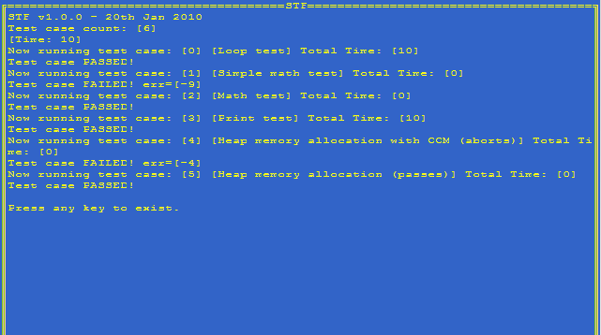

Working with STF CLI
The STF CLI is a console application that takes command line parameters to execute STF modules/cases.
The format of STF CLI command like this:
Stf [-option [item] value] [case name/case index value]

Table X.X describes the possible command line parameters.
Parameter | Description
Case name/  Case index value | Give a specific case index number or test case name to execute it. If the name of test case include blank, please include the file name by double quotation marks (“).
-m <module name> | The name of the test module.
-s <script file path> | The script file of the test module. It usually contains the test case definitions for the testing. If user provided a script file but didn’t provide module name, the application will use TestScripter to execute the script by default.
-i <engine initialization file path> | The initialization file of Test Engine (testframework.ini).
-c <module initialization file path> | The initialization file of the test module.
-engine <item> <value> | Set engine Configuration item and its value for test engine initialization file. This setting will override settings in initialization file. The setting item could be:  - TestReportMode (Possible values are: 'Empty', 'Summary', 'Environment', 'TestCases' or 'FullReport');  - CreateTestReport (Possible values: YES or NO);  - TestReportFilePath;  - TestReportFileName;  - TestReportFormat (Possible values: TXT, HTML or XML);  - TestReportOutput (Possible values: FILE or RDEBUG);  - TestReportFileCreationMode (Possible values: OVERWRITE or APPEND);
-log <item> <value> | Set log Configuration item and its value for test log initialization file. This setting will override settings in initialization file. The setting item could be:  - CreateLogDirectories (Possible values: YES or NO)  - EmulatorBasePath  - EmulatorFormat (Possible values: TXT or HTML)  - EmulatorOutput (Possible Values: FILE or RDEBUG)  - HardwareBasePath  - HardwareFormat (Possible Values: TXT or HTML)  - HardwareOutput (Possible Values: FILE or RDEBUG)  - FileCreationMode (Possible Values: OVERWRITE or APPEND)  - ThreadIdToLogFile (Possible Values: YES or NO)  - WithTimeStamp (Possible Values: YES or NO)  - WithLineBreak (Possible Values: YES or NO)  - WithEventRanking (Possible Values: YES or NO)
-p <item> <value> | Transfer additional item/value pair into test module. Test module can accept these setting values via programming (not supported in STF1.0).
-v | Display the version information.
-?/-h | Display the help information.
-NOPROMPT | Application exit without prompt after the execution finished. (But this command will not take effect in –v and –help command)

If the test framework initialization file is not given as a parameter, STF CLI tries to find the default file \testframework\testframework.INI from every drive that exists, beginning from the C:\ drive.
Here are some examples:
- Execute "demomodule".
C:\>stf –m demomodule

- Execute 3rd case in “demomodule”
C:\>stf –m demomodule 3

- Execute case named “loop test” in “demomodule”
C:\>stf –m demomodule “loop test”

- Execute case named “loop test” and case named “math” in “demomodule”
C:\>stf –m demomodule “loop test” math

- Execute case named “loop test” and 3rd case in “demomodule”
C:\>stf –m demomodule “loop test” 3

- Execute No 2,3,5 cases in “demomodule”
C:\>stf –m demomodule 2 3 5

- Execute cases definied in "mytest.cfg" via testscripter, take initialization setting from "c:\testframework\testframework.ini", and take "TestReportMode" parameter as "summary".
C:\>stf -s c:\test\mytest.cfg -engine TestReportMode Summary

- Execute cases definied in "mytest.cfg" via testscripter, take initialization setting from "c:\testframework\testframework.ini", and take " EmulatorFormat" parameter as "TXT".
C:\>stf -s c:\test\mytest.cfg -log EmulatorFormat TXT

- Execute cases definied in "mytest.cfg" via testscripter, take initialization setting from "c:\testframework\testframework.ini", and exit without prompt after the cases running finished.
C:\>stf -s c:\test\mytest.cfg -NOPROMPT

Return Value and Prompt String
Return Message | Value | Description
- | 0 | Execute successfully.
Required resource not found. | -1 | Unable to find given module, script or case. STF CLI will list all the not found items.
No Enough memory. | -4 | Not enough memory to perform the execution.
Operation not supported in this version. | -5 | The operation requested is not supported.
Arguments error. | -6 | Argument is out of range.
Other unknown error. | Any other code | Any other unexpected error.

