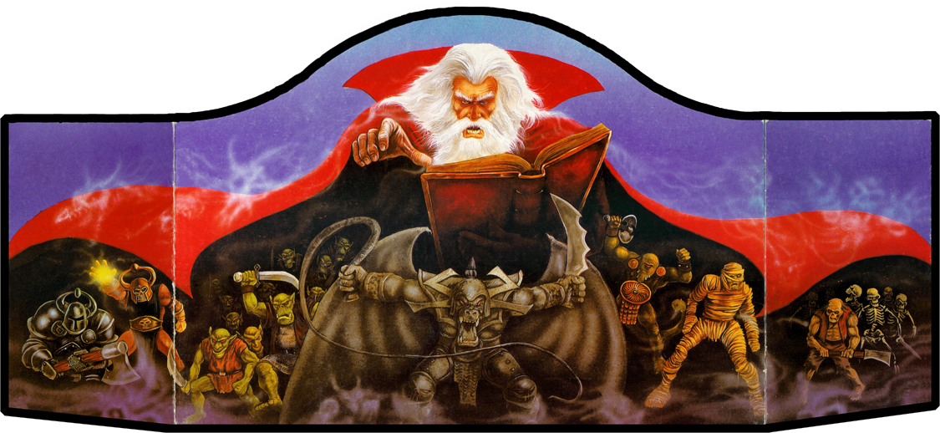

**Table 1-6**

|  |  |  |  |  |  |  |  |  |  |  |  |  |  |  |  |  |  |  |  |
| --- | --- | --- | --- | --- | --- | --- | --- | --- | --- | --- | --- | --- | --- | --- | --- | --- | --- | --- | --- |
| **Strength** | | | | | | | **Ability**  **Score** | **Dexterity** | | | **Constitution** | | **Intelligence** | | | **Wisdom** | **Charisma** | | |
| **bility Score** | **Hit Prob.** | **Dmg.**  **Adj.** | **Weight Allow.** | **Max.**  **Press** | **Open Doors** | **Bend Bars/**  **Lift Gates** | **React.**  **Adj.** | **Missile**  **Attack**  **Adj.** | **Defensive**  **Adj.** | **System Shock Resurrection** | **Resurrection**  **Survival Save** | **Spell Level** | **Chance to Learn Spell** | **Max. # of Spells/Level** | **Magical Defense Adj.** | **Maximum**  **# of**  **Henchmen** | **Loyalty**  **Base** | **Reaction**  **Adjustment** |
| 1 | -5 | -4 | 1 | 3 | 1 | 0% | 1 | -6 | -6 | +5 | 25% Save | 30% | -- | -- | -- | -6 | 0 | -8 | -7 |
| 2 | -3 | -2 | 1 | 5 | 1 | 0% | 2 | -4 | -4 | +5 | 30% | 35% | -- | -- | -- | -4 | 1 | -7 | -6 |
| 3 | -3 | -1 | 5 | 10 | 2 | 0% | 3 | -3 | -3 | +4 | 35% | 40% | -- | -- | -- | -3 | 1 | -6 | -5 |
| 4-5 | -2 | -1 | 10 | 25 | 3 | 0% | 4 | -2 | -2 | +3 | 40% | 45% | -- | -- | -- | -2 | 1 | -5 | -4 |
| 6-7 | -1 | None | 20 | 55 | 4 | 0% | 5 | -1 | -1 | +2 | 45% | 50% | -- | -- | -- | -1 | 2 | -4 | -3 |
| 8-9 | Normal | None | 35 | 90 | 5 | 1% | 6 | 0 | 0 | +1 | 50% | 55% | -- | -- | -- | -1 | 2 | -3 | -2 |
| 10-11 | Normal | None | 40 | 115 | 6 | 2% | 7 | 0 | 0 | 0 | 55% | 60% | -- | -- | -- | -1 | 3 | -2 | -1 |
| 12-13 | Normal | None | 45 | 140 | 7 | 4% | 8 | 0 | 0 | 0 | 60% | 65% | -- | -- | -- | 0 | 3 | -1 | 0 |
| 14-15 | Normal | None | 55 | 170 | 8 | 7% | 9 | 0 | 0 | 0 | 65% | 70% | 4 | 35 | 6 | 0 | 4 | 0 | 0 |
| 16 | Normal | +1 | 70 | 195 | 9 | 10% | 10 | 0 | 0 | 0 | 70% | 75% | 5 | 40 | 7 | 0 | 4 | 0 | 0 |
| 17 | +1 | +1 | 85 | 220 | 10 | 13% | 11 | 0 | 0 | 0 | 75% | 80% | 5 | 45 | 7 | 0 | 4 | 0 | 0 |
| 18 | +1 | +2 | 110 | 255 | 11 | 16% | 12 | 0 | 0 | 0 | 80% | 85% | 6 | 50 | 7 | 0 | 5 | 0 | 0 |
| 18/01-50 | +1 | +3 | 135 | 280 | 12 | 20% | 13 | 0 | 0 | 0 | 85% | 90% | 6 | 55 | 9 | 0 | 5 | 0 | +1 |
| 18/51-75 | +2 | +3 | 160 | 305 | 13 | 25% | 14 | 0 | 0 | -1 | 88% | 92% | 7 | 60 | 9 | 0+1 | 6 | +1 | +2 |
| 18/76-90 | +2 | +4 | 185 | 330 | 14 | 30% | 15 | +1 | +1 | -2 | 90% | 94% | 7 | 65 | 11 | +2 | 7 | +3 | +3 |
| 18/91-99 | +2 | +5 | 235 | 380 | 15(3) | 35% | 16 | +2 | +2 | -3 | 95% | 96% | 8 | 70 | 11 | +3 | 8 | +4 | +5 |
| 18/00 | +3 | +6 | 335 | 480 | 16(6) | 40% | 17 | +2 | +2 | -4 | 97% | 98% | 8 | 75 | 14 | +4 | 10 | +6 | +6 |
| 19 | +3 | +7 | 485 | 640 | 16(8) | 50% | 18 | +3 | +3 | -4 | 99% | 100% | 9 | 85 | 15 | +4 | 15 | +8 | +7 |
| 20 | +3 | +8 | 535 | 700 | 17(10) | 60% | 19 | +3 | +3 | -4 | 99% | 100% | 9 | 95 | All | +4 | 20 | +10 | +8 |
| 21 | +4 | +9 | 635 | 810 | 17(12) | 70% | 20 | +4 | +4 | -5 | 99% | 100% | 9 | 96 | All | +4 | 25 | +12 | +9 |
| 22 | +4 | +10 | 785 | 970 | 18(14) | 80% | 21 | +4 | +4 | -5 | 99% | 100% | 9 | 97 | All | +4 | 30 | +14 | +10 |
| 23 | +5 | +11 | 935 | 1,130 | 18(16) | 90% | 22 | +4 | +4 | -5 | 99% | 100% | 9 | 98 | All | +4 | 35 | +16 | +11 |
| 24 | +6 | +12 | 1,235 | 1,440 | 19(17) | 95% | 23 | +5 | +5 | -6 | 100% | +3 | 9 | 99 | All | +4 | 40 | +18 | +12 |
| 25 | +7 | +14 | 1,535 | 1,750 | 19(18) | 99% | 24 | +5 | +5 | -6 | 100% | +3 | 9 | 100 | All | +4 | 45 | +20 | +13 |
|  |  |  |  |  |  |  | 25 | +5 | +5 | -6 | 100% | +4 | 9 | 100 | All | +4 | 50 | +20 | +14 |

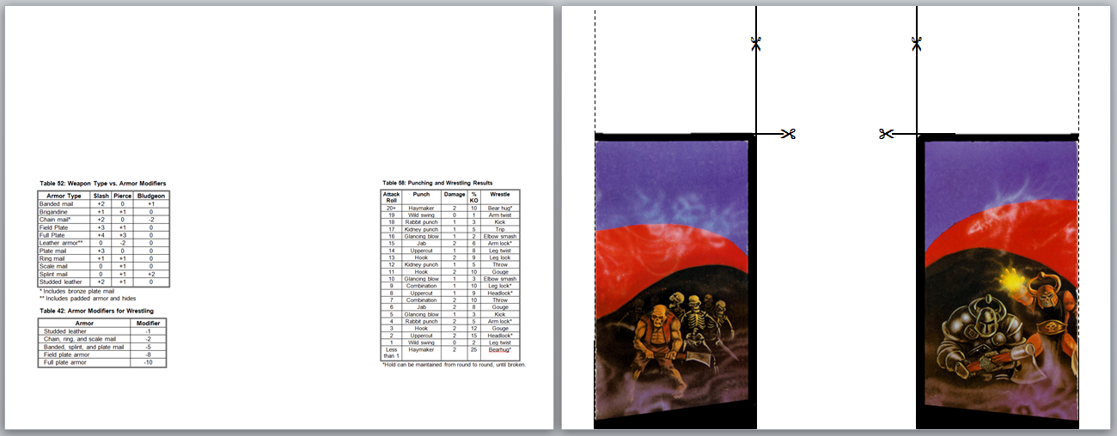

**Table 52: Weapon Type vs. Armor Modifiers**

|  |  |  |  |
| --- | --- | --- | --- |
| **Armor Type** | **Slash** | **Pierce** | **Bludgeon** |
| Banded mail | +2 | 0 | +1 |
| Brigandine | +1 | +1 | 0 |
| Chain mail* | +2 | 0 | -2 |
| Field Plate | +3 | +1 | 0 |
| Full Plate | +4 | +3 | 0 |
| Leather armor** | 0 | -2 | 0 |
| Plate mail | +3 | 0 | 0 |
| Ring mail | +1 | +1 | 0 |
| Scale mail | 0 | +1 | 0 |
| Splint mail | 0 | +1 | +2 |
| Studded leather | +2 | +1 | 0 |

* Includes bronze plate mail

** Includes padded armor and hides

**Table 42: Armor Modifiers for Wrestling**

|  |  |
| --- | --- |
| **Armor** | **Modifier** |
| Studded leather | -1 |
| Chain, ring, and scale mail | -2 |
| Banded, splint, and plate mail | -5 |
| Field plate armor | -8 |
| Full plate armor | -10 |

|  |  |  |  |  |
| --- | --- | --- | --- | --- |
| Attack Roll | Punch | Damage | %  KO | Wrestle |
| 20+ | Haymaker | 2 | 10 | Bear hug* |
| 19 | Wild swing | 0 | 1 | Arm twist |
| 18 | Rabbit punch | 1 | 3 | Kick |
| 17 | Kidney punch 1 5 Trip | 1 | 5 | Trip |
| 16 | Glancing blow 1 2 Elbow smash | 1 | 2 | Elbow smash |
| 15 | Jab | 2 | 6 | Arm lock* |
| 14 | Uppercut | 1 | 8 | Leg twist |
| 13 | Hook | 2 | 9 | Leg lock |
| 12 | Kidney punch 1 5 Throw | 1 | 5 | Throw |
| 11 | Hook | 2 | 10 | Gouge |
| 10 | Glancing blow 1 3 Elbow smash | 1 | 3 | Elbow smash |
| 9 | Combination | 1 | 10 | Leg lock* |
| 8 | Uppercut | 1 | 9 | Headlock* |
| 7 | Combination | 2 | 10 | Throw |
| 6 | Jab | 2 | 8 | Gouge |
| 5 | Glancing blow 1 3 Kick | 1 | 3 | Kick |
| 4 | Rabbit punch | 2 | 5 | Arm lock* |
| 3 | Hook | 2 | 12 | Gouge |
| 2 | Uppercut | 2 | 15 | Headlock* |
| 1 | Wild swing | 0 | 2 | Leg twist |
| Less than 1 | Haymaker | 2 | 25 | Bearhug* |
| **\*Hold can be maintained from round to round, until broken.** | | | | |

**Table 58: Punching and Wrestling Results**