2019

Nathan Hall

Acting Secretary

9/3/2019

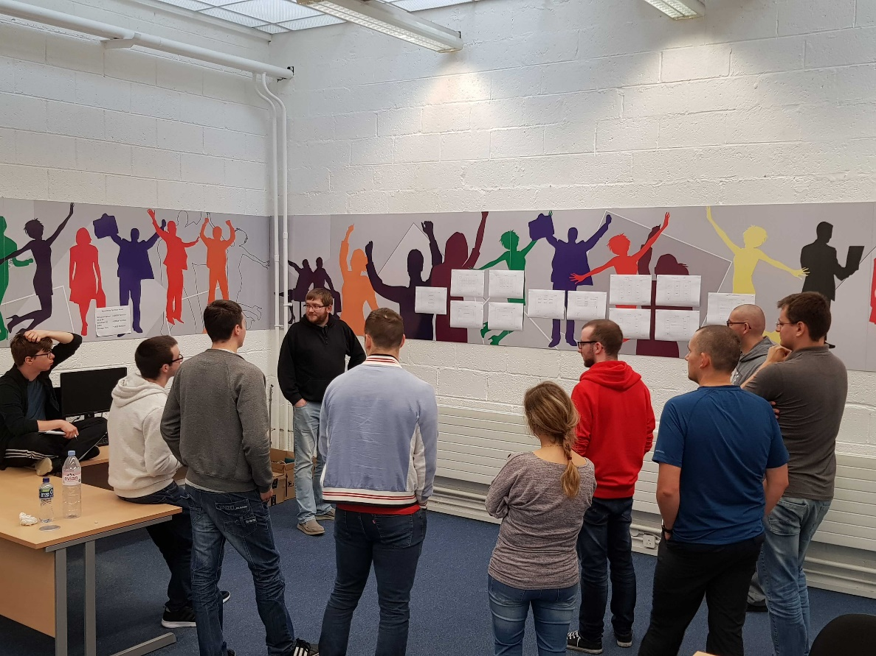

DRAGAN TALAMH: TEAM MEETING

# Abstract

A brainstorming meeting was held this morning in Dundalk RSTC with the full development team to review and discuss a low fidelity wireframe model of the project. The aim was to clarify the flow of the program and to identify any potential issues or improvements on the current design.

# Notes

The following points of design to address were taken from the meeting:

## Windows

1. Race:
   1. Data to be provided by Mark
   2. Race details to be displayed below character name;
      1. Description
      2. Racial abilities -> impact on Overview
      3. Racial traits -> impact on Overview & Ability points
2. Class:
   1. “Hit Dice” and “Overview” to be displayed in class preview window
      1. Hit Dice -> impact on Class Abilities
3. Ability Points:
   1. Display a short description for each ability type
   2. Each class to have an ability preference. Dynamically display a short explanation of the preferred ability’s relevance to the class
   3. Review the “Point Buy” score system
   4. Colour code stat boxes to reflect strengths or weaknesses;
      1. <10 : red
      2. 10 – 13 : amber
      3. 13< : green
   5. Manual: User should have choice of selecting values or rolling dice to get values
4. Class Abilities:
   1. Make calculation function for “Adjust Health” using class, character level and constitution
   2. Health field has an average value by default
   3. Display list of class abilities based only on the class
5. Layout Select:
   1. Layouts to be define by Mark
6. Background Select:
   1. Add feature allowing user to upload background images.
   2. Background to have 10% opacity
7. Overview:
   1. Save functionality to be added. JSON file to be created for saved character
   2. User to be able to select where to save the file
   3. Final PDF to be displayed with all fields and calculated values

## Additional

1. Side panel for navigating between windows to be developed. User can select window they want to navigate to
2. Bottom panel for navigating between windows to be developed. This is to include “Next”, “Back” and “Clear” buttons
3. Source royalty free images for characters and backgrounds
4. Character background profiles to be developed in a future iteration

# Conclusion

The flow of the program has been agreed upon. The responsibilities for implementing these design points will be distributed by the Project Manager and designated to the Back-End and GUI teams.