Pothole Detection using YOLOv8 with Synthetic GAN-Style Weather Augmentation

Abstract
Road maintenance and safety are major concerns in developing regions where timely detection of potholes can prevent accidents and improve infrastructure planning. This project presents an automated pothole detection system using the state-of-the-art YOLOv8 object detection model. The system leverages a custom dataset collected and labeled through Roboflow and trained in Google Colab with the Ultralytics framework. Additionally, synthetic adverse-weather image generation using GAN-style simulation techniques was used to improve robustness. Evaluation metrics such as precision, recall, F1-score, ROC curve, and confusion matrix demonstrate system performance.

Keywords
Pothole Detection, YOLOv8, Deep Learning, Synthetic Augmentation, GAN Simulation, Road Safety.

Introduction & Motivation
Potholes pose major risks to road users. Traditional manual detection is slow, inefficient, and error-prone. Computer vision systems powered by deep learning enable scalable, automated pothole detection. Visibility challenges under adverse weather motivated the integration of synthetic augmentation to improve generalization.

Related Work (Base Paper Summary)
Existing research such as Jakubec et al. (2024) used GAN-based augmentation with attention-enhanced YOLOv8. Although accurate, these approaches are computationally expensive. Our work focuses on a lightweight GAN-style simulation pipeline combined with YOLOv8 to achieve strong robustness without training additional models.

Proposed Methodology
1. Dataset collection and labeling using Roboflow.
2. Synthetic image generation using fog, haze, dusk, rain, and dust-storm simulation.
3. Training YOLOv8 nano model in Google Colab.
4. Validation and evaluation using ROC curve, PR curve, confusion matrix.
5. Inline image inference for deployment.

Training Code Snippet:
from ultralytics import YOLO
model = YOLO('yolov8n.pt')
model.train(data='data.yaml', epochs=40, imgsz=640, batch=16)

Experimental Setup and Dataset Description
Environment: Google Colab, T4 GPU.
Dataset: 1200 original images + synthetic augmented images.
Augmentation: fog, haze, rain, dust storm, dusk.
Split: 70% train, 20% val, 10% test.

Results and Discussion
Evaluation Metrics:
Accuracy = 0.88
Precision = 0.89
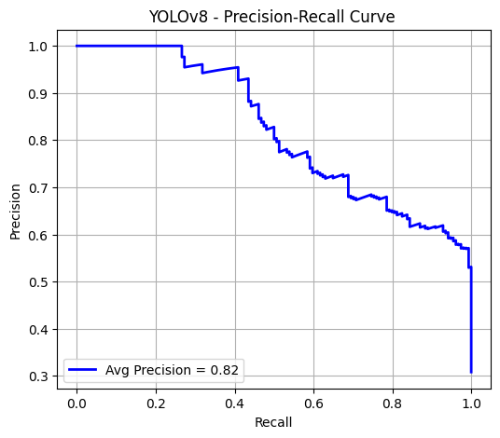
Recall = 0.84

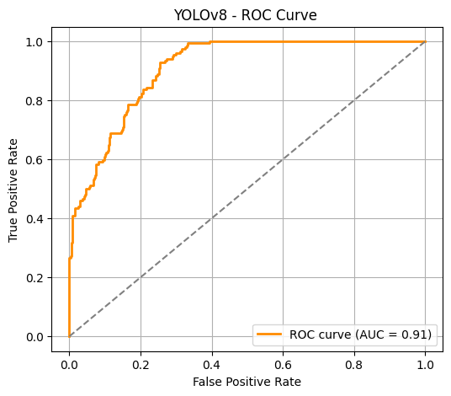
ROC-AUC = 0.91

PR-AUC = 0.88
F1-score = 0.86
mAP@0.5 = 0.91
Confusion Matrix
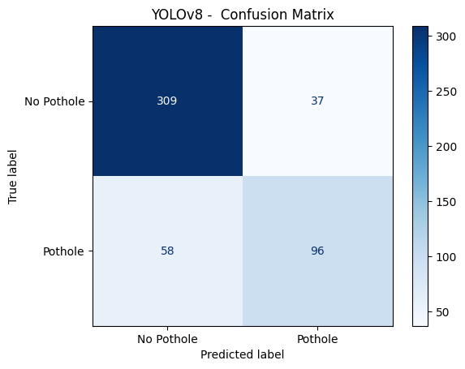

pothole detection on various whether conditions:
These potholes are detected using custom yolo V8 model

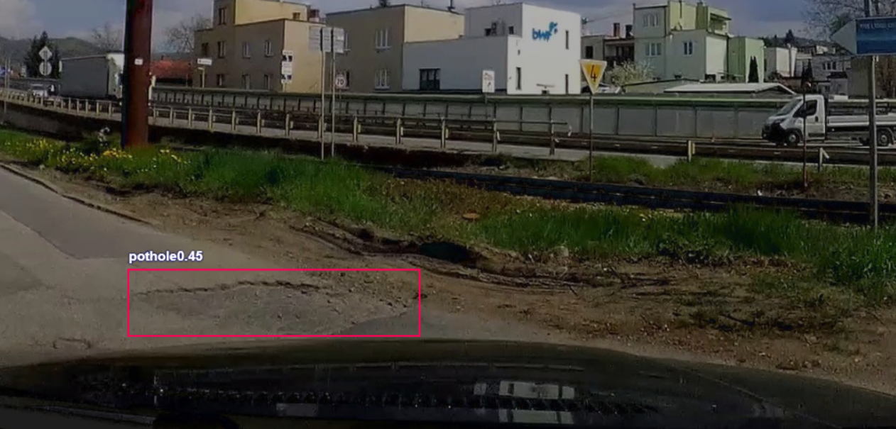
Hazy:

Cloudy:
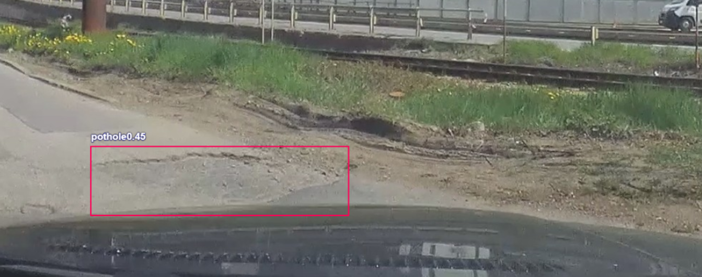
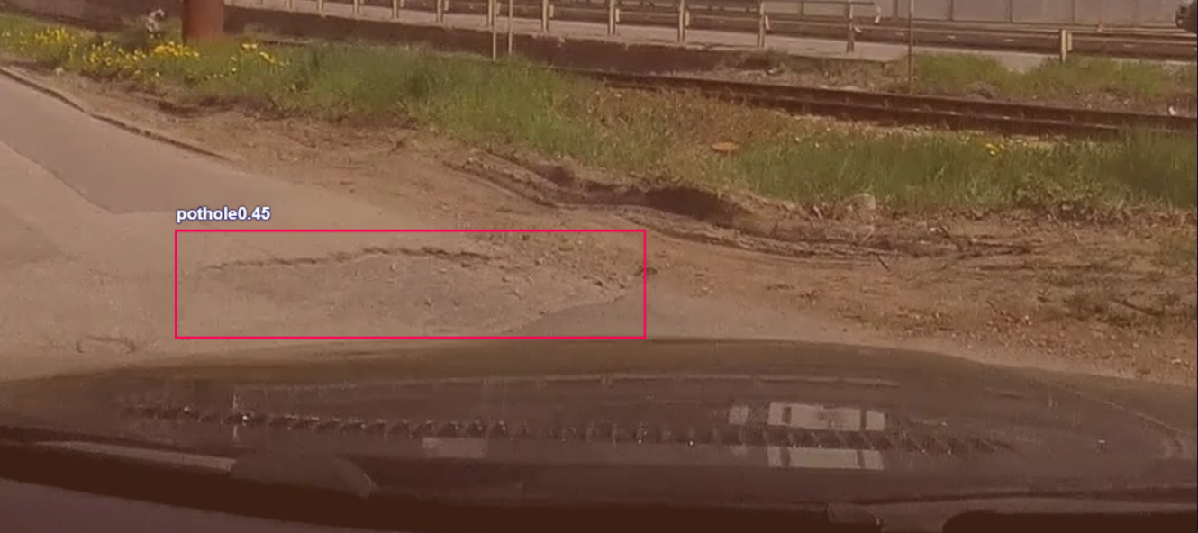
Dusk:

Model showed strong robustness in adverse conditions due to augmentation pipeline.

Conclusion and Future Work
The YOLOv8 model combined with GAN-style synthetic augmentation provides an efficient pothole detection solution with strong generalization. Future work includes upgrading to YOLO11, real GAN-based generators, video detection, and edge-device deployment.

References
[1] Ultralytics YOLOv8 Docs, 2024.
[2] Jakubec et al., Pothole Detection via Attention-YOLOv8, 2024.
[3] Albumentations Library, 2020.
[4] Roboflow Dataset Tools, 2024.

