Lorem ipsum Lorem ipsum Lorem ipsum Lorem ipsum Lorem ipsum Lorem ipsum Lorem ipsum Lorem ipsum Lorem ipsum: 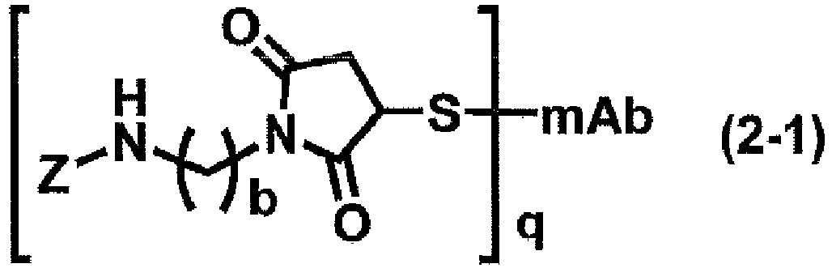Lorem ipsum Lorem ipsum Lorem ipsum Lorem ipsum Lorem ipsum Lorem ipsum.

